Experiment No: 5a Date:
Aim: Design a registration page using javascript and validate the following fields
1. name (should contain only alphabets and len should not exceed 6 chararacters)
2. password has to be protected, and should not be less than 6 chararacters
3. email-id should not contain any invalid characters and must follow the standard pat-
tern
4. contact number should contain only 10 digits

Theory:

Regular Expressions
A regular expression is a sequence of characters that forms a search pattern. When you search for data in a text, you can use this search pattern to describe what you are searching for. A regular expression can be a single character, or a more complicated pattern. Regular expressions can be used to perform all types of text search and text replace operations.

Regular expressions in JS
The RegExp test() Method in JavaScript is used to test for match in a string. If there is a match this method returns true else it returns false.
In JavaScript, regular expressions are also often used with the two string methods: search() and replace(). The search() method uses an expression to search for a match, and returns the position of the match. The replace() method returns a modified string where the pattern is replaced.

Code:
const name = document.getElementById('name')
const password = document.getElementById('password')
const birthday = document.getElementById('birthday')
const email = document.getElementById('email')
const phone = document.getElementById('phone')
const form = document.getElementById('form')
const errorName = document.getElementById('error-name')
const errorPass = document.getElementById('error-pass')
const errorPhone = document.getElementById('error-phone')
const errorMail = document.getElementById('error-mail')

form.addEventListener('submit', (e) =>{
let messagename = []
let messagepass = []
let messagephone = []
let messagemail = []
let regname=/^[a-zA-Z]{1,6}$/
let regpass=/^[a-zA-Z0-9\._]:{6,}$/
let regmail=/^[a-zA-Z0-9_.]{4,15}@[a-z]*\.com$/
if (!regname.test(name.value)){
messagename.push('Invalid Name')
}
if (!regpass.test(password.value)){
messagepass.push('Invalid Password')
}
if (phone.value === '' || phone.value ===null){
messagephone.push('Phone Number is required')
}
if (phone.value.length > 0 && phone.value.length != 10 ){
messagephone.push('Phone Number must be 10 digits')
}
if(email.value.length > 0 && !regmail.test(email.value)){
messagemail.push('Email is Invalid')
}
if (messagename.length > 0){
e.preventDefault()
errorName.innerText = messagename.join(', ')
}
if (messagepass.length > 0){
e.preventDefault()
errorPass.innerText = messagepass.join(', ')
}
if (messagephone.length > 0){
e.preventDefault()
errorPhone.innerText = messagephone.join(', ')
}
if (messagemail.length > 0){
e.preventDefault()
errorMail.innerText = messagemail.join(', ')
}
})

Output:
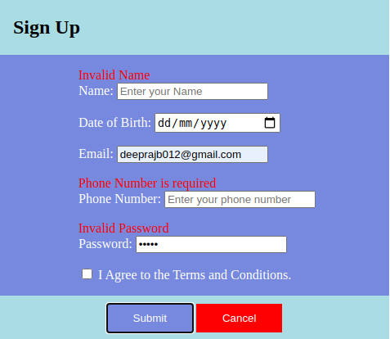

Conclusion: A registration page using javascript to validate the given fields is succesfully
coded and executed

