Experiment No: 5b Date: 05.10.2021
Aim: Implement XML for books catalogue with at least 4 instances. The contents should be displayed in the table. Header of the table should be in gray color and authors name column should be displayed in one standard color and should be capitalised and bold. Use XSL and CSS to implement the above page, i.e. style it in each of these two ways

Theory:

XML
XML stands for Extensible Markup Language. It is a text-based markup language derived from Standard Generalized Markup Language (SGML).
XML tags identify the data and are used to store and organize the data, rather than specifying how to display it like HTML tags, which are used to display the data. XML is not going to replace HTML in the near future, but it introduces new possibilities by adopting many successful features of HTML.
There are three important characteristics of XML that make it useful in a variety of
systems and solutions :
• XML is extensible - XML allows you to create your own self-descriptive tags, or language, that suits your application.
• XML carries the data, does not present it - XML allows you to store the data irrespective of how it will be presented.
• XML is a public standard - XML was developed by an organization called the World Wide Web Consortium (W3C) and is available as an open standard.

XSL
XSL is a language for expressing style sheets. An XSL style sheet is, like with CSS, a file that describes how to display an XML document of a given type. XSL shares the functionality and is compatible with CSS2 (although it uses a different syntax).
XSL consists of four parts:
• XSLT - a language for transforming XML documents
• XPath - a language for navigating in XML documents
• XSL-FO - a language for formatting XML documents (discontinued in 2013)
• XQuery - a language for querying XML documents

Code:
XSL with CSS
<xsl:stylesheet version = "1.0" xmlns:xsl ="http://www.w3.org/1999/XSL/Transform">
<xsl:template match="/books">
<html>
<style>
table, th, td {
border: 1px solid black;
}

th{
color:grey;
}

.author{
text-transform:uppercase;
font-weight:bold;
color:blue;
}
</style>
<body>
<table>
<tr>
<th>Title</th>
<th>Author</th>
<th>Publisher</th>
<th>Year First Published</th>
</tr>
<xsl:for-each select="book">
<tr>
<td><xsl:value-of select="title"/></td>
<td class="author"><xsl:value-of select="author"/></td>
<td><xsl:value-of select="publisher"/></td>
<td><xsl:value-of select="year"/></td>
</tr>
</xsl:for-each>
</table>
</body>
</html>
</xsl:template>
</xsl:stylesheet>

XSL without CSS
<xsl:stylesheet version = "1.0" xmlns:xsl ="http://www.w3.org/1999/XSL/Transform">
<xsl:template match="/">
<html>
<body>
<table border='1'>
<tr>
<th><font color='grey'>Title</font></th>
<th><font color='grey'>Author</font></th>
<th><font color='grey'>Publisher</font></th>
<th><font color='grey'>Year First Published</font></th>
</tr>
<xsl:apply-templates/>
</table>
</body>
</html>
</xsl:template>

<xsl:template match="book">
<tr>
<td><xsl:apply-templates select="title"/> </td>
<td><xsl:apply-templates select="author"/></td>
<td><xsl:apply-templates select="publisher"/></td>
<td><xsl:apply-templates select="year"/></td>
</tr>
</xsl:template>

<xsl:template match="title">
<tr><xsl:value-of select="."/></tr>
</xsl:template>

<xsl:template match="author">
<tr style="text-transform:uppercase"><font color="blue"><b><xsl:value-of select="."/></b></font></tr>
</xsl:template>

<xsl:template match="publisher">
<tr><xsl:value-of select="."/></tr>
</xsl:template>

<xsl:template match="year">
<tr><xsl:value-of select="."/></tr>
</xsl:template>

</xsl:stylesheet>

Output:
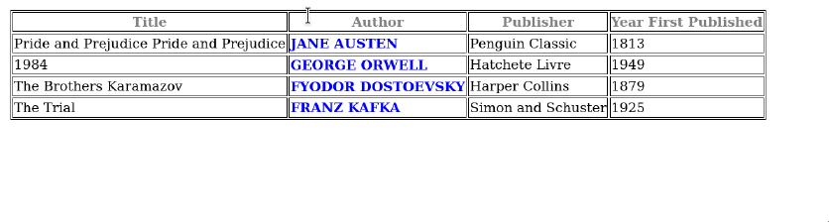
Conclusion: Given XML catalogue was successfully displayed in a table with the specified styling using
XSLT and CSS

