Experiment No: 7 Date:
Aim: Implementation of MYSQL with PHP (Demonstrate DB connection, Insert, Delete and Update functionality )

Theory:

MySQL
MySQL is an open-source relational database management system (RDBMS). It is the most popular database system used with PHP. MySQL is developed, distributed, and supported by Oracle Corporation.
- The data in a MySQL database are stored in tables which consists of columns and rows.
- MySQL is a database system that runs on a server.
- MySQL is ideal for both small and large applications.
- MySQL is very fast, reliable, and easy to use database system. It uses standard SQL
- MySQL compiles on a number of platforms.

PHP
The term PHP is an acronym for PHP: Hypertext Preprocessor. PHP is a server-side scripting language designed specifically for web development. It is open-source which means it is free to download and use. It is very simple to learn and use. The files have the extension “.php”.

Output:

Insert

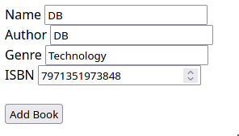


View
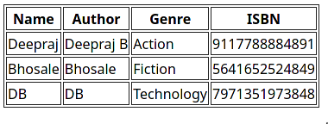
Update
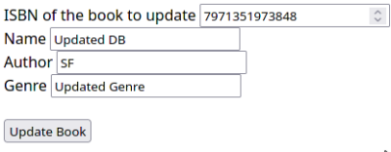


Delete



Conclusion: Implementation of MYSQL with PHP was successfully written.

