Experiment No: 3

Aim: Write a Python program to read an image from a file system and write the negative of the image back with a different name.

Algorithm:
- Read the image and store it into some container to perform operations on it
- Get rgb value of the pixel
- Calculate new RGB values as shown :
  - R = 255 - R
  - G = 255 - G
  - B = 255 - B
- Save the new RGB value in the pixel
- Repeat step 2 - 4 for each pixel of the image
- Choose a directory to store the new image
- Store the negative image into the selected directory

Program:
Python Code:
def show_image(self):
file_filter = 'Image File (*.jpg *.png)'
fname = QtWidgets.QFileDialog.getOpenFileName(parent=self.centralwidget,
caption='Select an Image',
directory="/run/media/deeprajb/HDD/Important Photos/Wallpapers",
filter=file_filter)
self.img = cv2.imread(fname[0])
self.img1 = QtGui.QImage(self.img.data, self.img.shape[1], self.img.shape[0], QtGui.QImage.Format_RGB888).rgbSwapped()
self.imageinput.setPixmap(QtGui.QPixmap.fromImage(self.img1))
def convert_to_negative(self):
(row, col) = self.img.shape[0:2]
for i in range(0,row-1):
for j in range(0,col-1):
pixel = self.img[i, j]
# get red pixel
pixel[0] = 255 - pixel[0]
# get green pixel
pixel[1] = 255 - pixel[1]
# get blue pixel
pixel[2] = 255 - pixel[2]
self.img[i, j] = pixel
cv2.imwrite('negative_output.jpg',self.img)
self.imageoutput.setPixmap(QtGui.QPixmap("negative_output.jpg"))

Output:
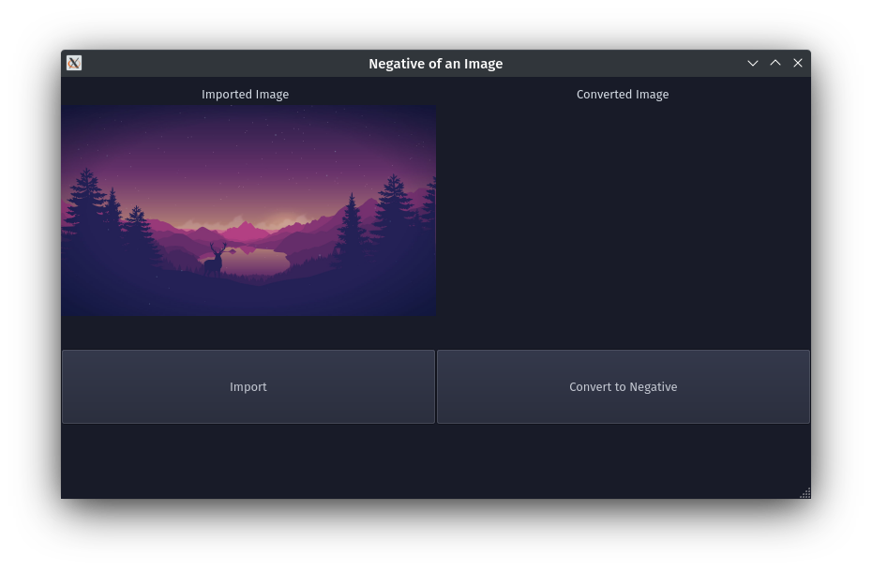
Python GUI Output:
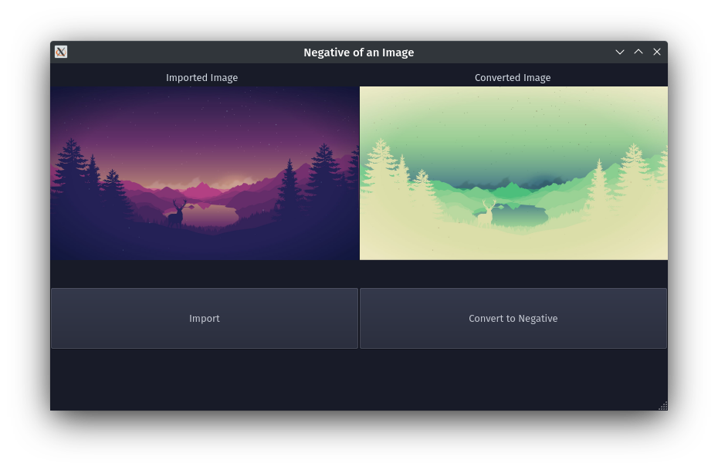
Conclusion: Program to read an image and convert it into negative was written and executed successfully.
Deepraj Bhosale
Batch-A
181105016

