Experiment No: 4

Aim: Write a Python program to read an image from a file system and perform the grayscale slicing of the image and write it back with a different name.

Algorithm:
- Read the image and store it in a container to perform operations on it.
- Convert this image into grayscale image
- Input 2 values for upper limit and lower limit
- Get the RGB value of the pixel
- Calculate new RGB value based on : If the value of pixel :
  - Within limits of upper & lower limits → new RGB value = 255, 255, 255 resp.
  - Out of limits → new RGB values = 0, 0, 0
- Save the new RGB value in the pixel
- Repeat step 4 -6 for each pixel of the image
- Choose a directory to store the new image
- Store the sliced image into the selected directory

Program:
Python Code:
def show_image(self):
file_filter = 'Image File (*.jpg *.png)'
fname = QtWidgets.QFileDialog.getOpenFileName(parent=self.centralwidget,
caption='Select an Image',
directory="/run/media/deeprajb/HDD/Important Photos/Wallpapers",
filter=file_filter)
self.img = cv2.imread(fname[0], cv2.IMREAD_GRAYSCALE)
self.img1 = QtGui.QImage(self.img.data, self.img.shape[1], self.img.shape[0], QtGui.QImage.Format_Grayscale8)
self.imageinput.setPixmap(QtGui.QPixmap.fromImage(self.img1))
def gray_level_slicing(self):
(row, col) = self.img.shape[0:2]
min_range = self.lowerbound.value()
max_range = self.upperbound.value()
wbg = self.img.copy()
wobg = self.img.copy()
for i in range(0,row-1):
for j in range(0,col-1):
if self.img[i,j]>min_range and self.img[i,j]<max_range:
wbg[i,j] = 255
wobg[i,j] = 255

else:
wbg[i,j] = self.img[i,j]
wobg[i,j] = 0
cv2.imwrite('gls_withbg_output.jpg',wbg)
cv2.imwrite('gls_withoutbg_output.jpg',wobg)
self.imageoutput_2.setPixmap(QtGui.QPixmap("gls_withbg_output.jpg"))
self.imageoutput.setPixmap(QtGui.QPixmap("gls_withoutbg_output.jpg"))

Output:
Python GUI Output:
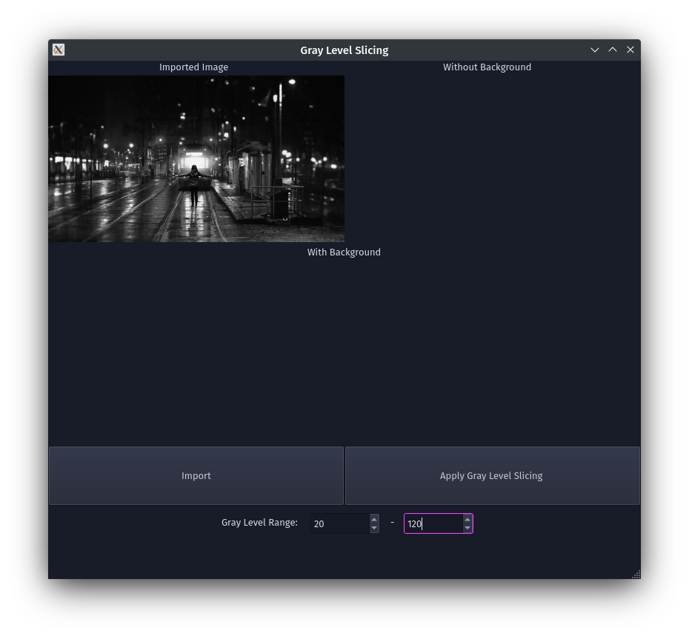

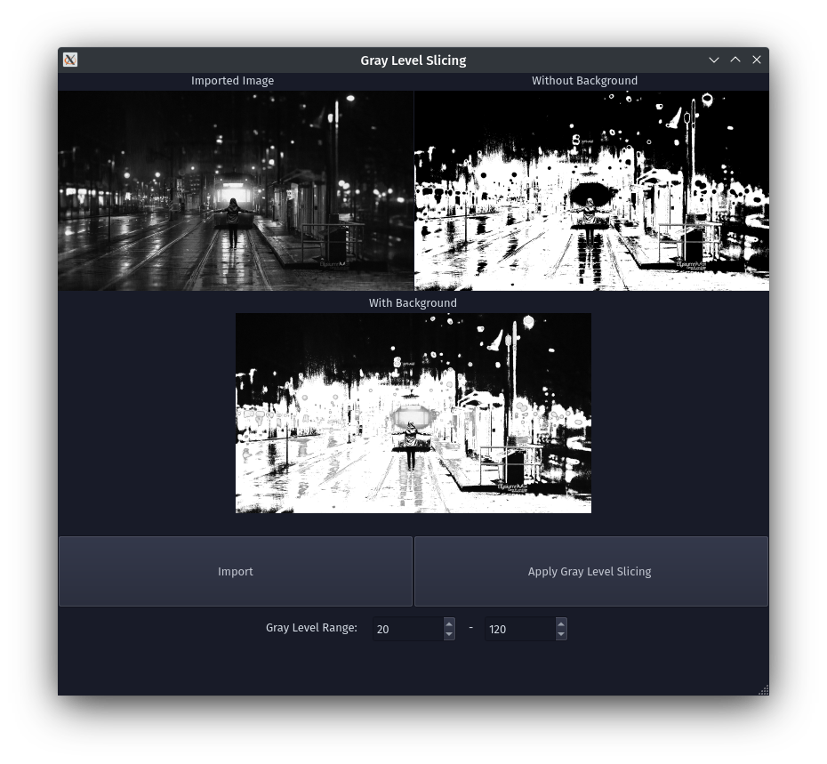

Conclusion: Program to read an image and perform grayscale slicing was written and executed successfully.
Deepraj Bhosale
Batch-A
181105016

