Experiment No: 11 Date:
Aim: Explore the virtual lab in image processing
- Image histogram
- Image arithmetic

Theory: Image Histogram
A histogram of an image represents the distribution of pixel intensities in the image. Histograms provide statistical information about the image. These are of use in applications such as image enhancement, compression and segmentation. For instance, based on the information present in histogram, it is possible to develop a transformation function which improves the quality or visual appearance of an image.
Given an image A, its histogram H(k) is derived by counting the number of pixels at every grey level k.

H(k) = Nk k = 0,1,2 K-1.

where Nk is the count of pixels at gray level k. The total number of bins in this histogram is K
. Theoretically, the maximum value for K is determined by the pixel depth M of the image. For instance, for an M=8-bit greyscale image, we can have up to 2M = 256 = K bins and for a binary image (1-bit) we can have just 2 bins.

Sometimes, the value of K is chosen to be different from2M. This will alter the appearance of the histogram. The example below illustrates this effect.
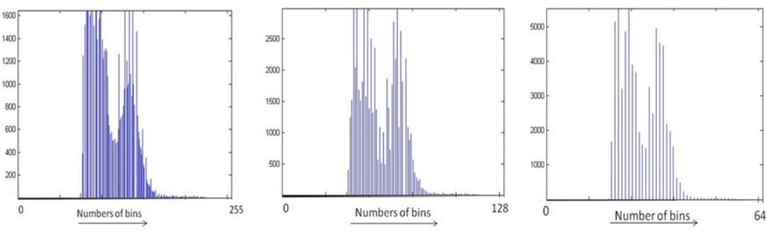
The histogram of an image is a good indicator of the contrast and brightness of a given image.

Image appearance | Histogram
Dark | confined to low gray levels
Bright | confined to high gray levels
Poor contrast | narrow
High contrast | wide with good spread
This property of a histogram is used in content-based retrieval applications to roughly categorise images. Other uses for image histograms are to quantitatively describe an image via its pixel statistics: mean value (intensity), median value, standard deviation and the number of modes.

These information in turn are useful for processing a given image to enhance or analyse the content of the image which is described in detail next.

Histogram Processing:

The contrast of an image can be modified by manipulating its histogram. A popular method is via Histogram equalization. Here, the given histogram is manipulated such that the distribution of pixel values is evenly spread over the entire range 0 to K-1.

Histogram equalization can be done at a global or local level. In the global level the histogram of the entire image is processed whereas at the local level, the given image is subdivided and the histograms of the subdivisions (or subimages) are manipulated individually. When histogram equalization is applied locally, the procedure is called Adaptive Histogram Equalization.
The experiment is designed to understand and learn the image histogram concepts.

Steps to run the experiments

- Histogram:

  - Select image from the mosaic using 'select image' option

a) Select region of the image to load it in the input image panel

  - Select one option from 'Full Image Histogram' and 'Divided Histogram'
  - Select run option to perform the operations

a) Output result will be displayed in the output panel

- Processing:

  - Select image from the mosaic using 'select image' option

a. Select region of the image to load it in the input image panel

  - Select one option from Global histogram equalization, Local histogram equalization and Filtering on histogram
  - Select the size of filter from Filtering on histogram option

Image Arithmetic
In image arithmetic, we consider operations such as I(x,y) = A (x,y) o B(x,y) where o is an arithmetic operation such as addition, subtraction, multiplication or division. Here, A and B could be derived from different sources. Such operations are particularly used in modelling image acquisition as a result of a perfect image corrupted with (additive or multiplicative) noise. The noise is often introduced either by a transmission medium or the camera.
A (x,y) o B(x,y) = I(x,y)

The important requirement in image arithmetic is that all (input and output) the images are of the same size MxM.

Arithmetic operations are done pixelwise. Let p = A(x,y) and q = B(x,y) be the pixel values to be operated on and r =I(x,y) be the result of the operation.

Addition :

I(x,y) = A(x,y) + B(x,y) → r = p + q Subtraction :
I(x,y) = A(x,y) - B(x,y) → r = p - q Difference :
I(x,y) = |A(x,y) - B(x,y)| → r = |p - q| Multiplication :
I(x,y) = A(x,y) X B(x,y) → r = p x q Division :
The experiment is design to understand and learn the image arithmetic concepts. This experiment consists five parts:

    - Image addition
    - Image Subtraction
    - Image Difference
    - Image Multiplication
    - Image Division

Steps to run the experiments

- Select image from the mosaic using 'select imag' option
  - Select region of the image to load it in the input image panel
  - Select secondary image by choosing either of the 'dull' , 'bright' or 'gradient' images
- Select one option from 'addition', 'subtraction', 'difference', 'multiplication' and 'division'
- Select the one option from 'clipping' and 'auto-scaling'
- Select run option to perform the operations
  - Output result will be displayed in the output panel
  - Along with intermediate results
Outputs:
- Image Histogram
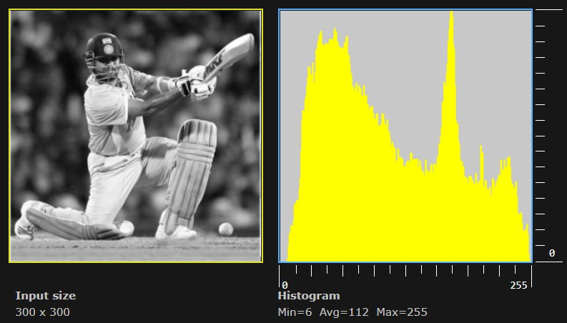
For Full Image Histogram:
For global histogram Equalization:
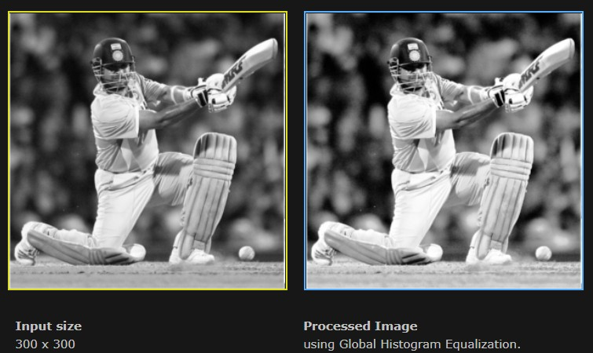
For Adaptive histogram Equalization(50x50):
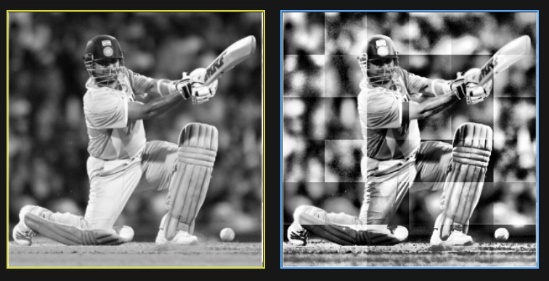

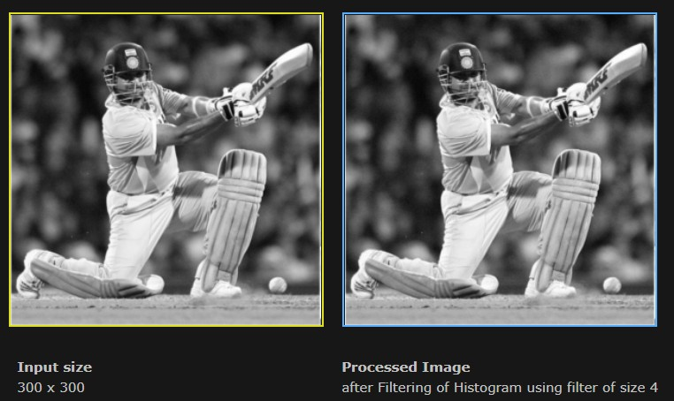
For Filtering on Histogram(size 4):
For SubImage Histogram:
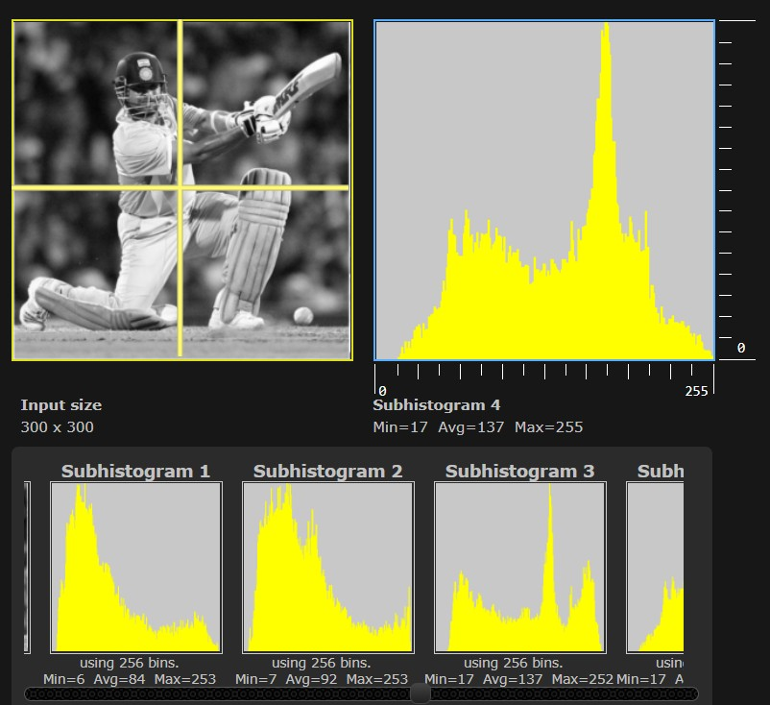

- Image Arithmetic Addition(clipping)
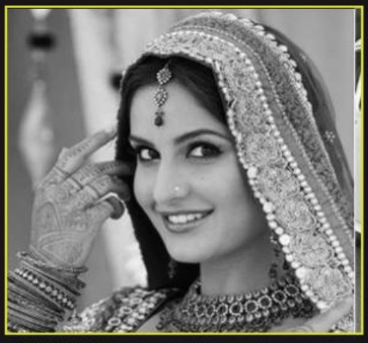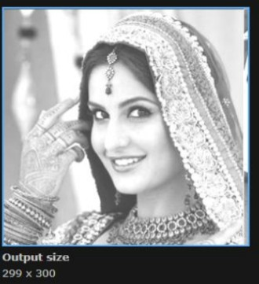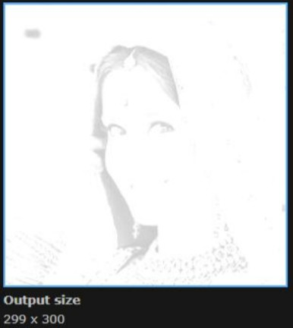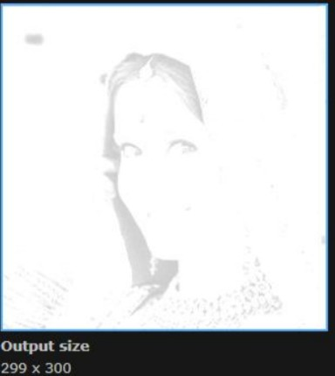
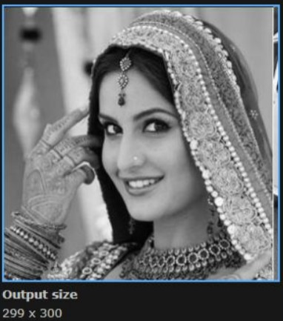
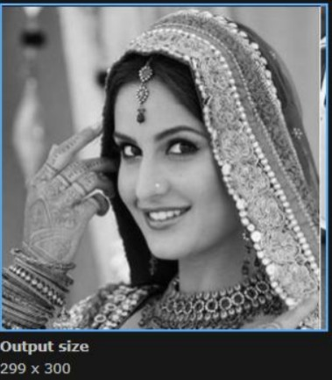
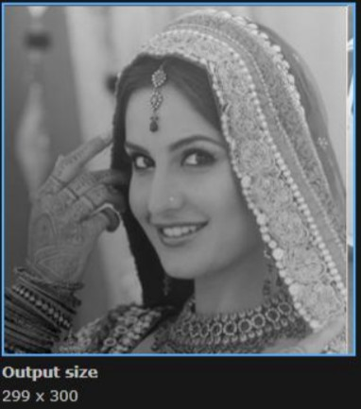
Original dull bright gradient Addition(Auto-Scaling)
Dull bright gradient Subtraction(clipping)

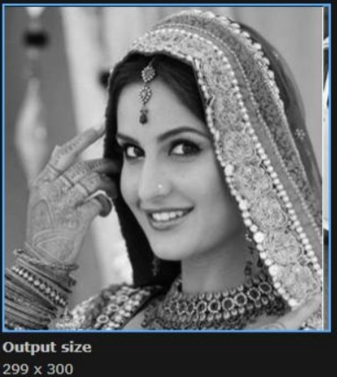
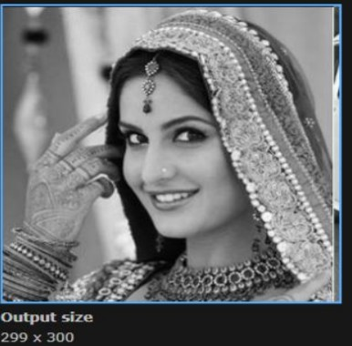
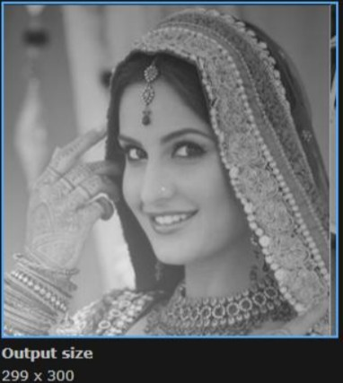
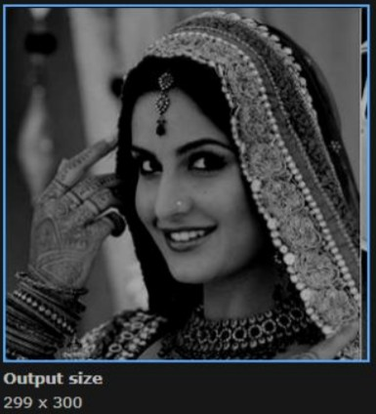
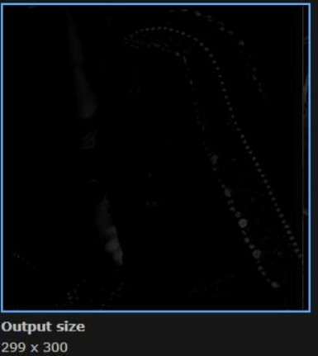
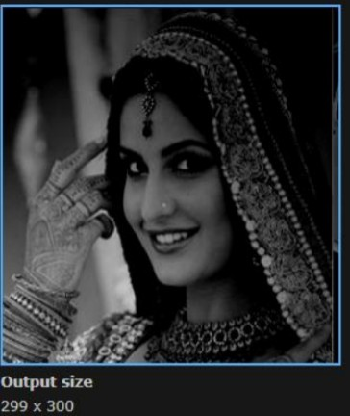
Dull bright gradient Subtraction(Auto-Scaling)
Dull bright gradient

Conclusion:
Image histogram and Image arithmetic in virtual lab was studied.

