Experiment No: 12 Date:
Aim: Explore the virtual lab in image processing: Image Segmentation

Theory:
Image segmentation is a common task which arises in many situations such as extracting a face or a character in a text from an image before performing automatic recognition. Generally, it is used to separate the foreground pixels belonging to the object(s) of interest, from the background pixels. Segmentation aims to partition a given image into a set of regions having following properties: connectivity and homogeneity in terms of color or texture.

An object or region can be a characterized using multiple low-level features such as brightness, colour, texture, etc. In this experiment, we will restrict ourselves to objects defined by brightness. We will aim to partition a given image into two (foreground and background) and study two techniques namely, histogram-based thresholding and region growing, to perform this partitioning.
When the object(s) of interest in an image are clearly differentiated from the background in terms of brightness, then the image histogram can help in characterizing the foreground and background pixels. Fig.1 shows the histogram representing foreground and background regions of such an image. By selecting an appropriate gray-value point on the x-axis as a threshold, all pixels with value below the threshold can be considered to belong to the foreground and all those above belong to the background (and vice versa). This process is known as thresholding. There are many ways to threshold an image subject to the task in hand. In this experiment, few basic techniques of obtaining pixels of interest are explained. Single Threshold

Let I(x,y) be the intensity value at pixel location (x,y) and T is the threshold value. The segmentation is done as follows. If I(x,y) >= T then it is labeled 1 in the output image otherwise it is labeled as 0. The pixel value corresponding to 1 and 0 depends on the application. For instance, Figure 2 shows a fingerprint image. By selecting a threshold value T=120 yields an output where 1 is set to white or pixel value of 255. Thus, in this case, the white pixels are background and black pixels are of the object of interest (fingerprint) or the foreground.

Double Threshold:

Here, two threshold values are chosen instead of one. Let T1 > T2 be the two threshold values . If I(x,y) > T1 and I(x,y) <=T2 then pixel (x.y) in the output image is labeled 1 and 0 otherwise. Consider the image in Figure 3 with two objects. Figure 4 shows the output obtained at different threshold settings. Note how this results in extraction of different objects in the image. The selection of threshold is usually manual and depends on the image content.

The experiment is designed to understand and learn two classes of Image Segmentation methods. This experiment consists of two different segmentation methods:

- Histogram based Segmentation methods b. Region growing based segmentation method
Steps to run the experiments

  - Select image from the mosaic using 'select image' option
a. Select region of the image to load it in the input image panel
  - Select one option from Histogram based Segmentation and Region growing
- For Histogram based Segmentation
- Select one of the options: Manual Threshold or Automatic Threshold
- Manual Thresholding
  - Select Single threshold or Double threshold and press Run
  - Adjust the threshold on the image histogram space and press the Proceed
- Automatic threshold
  - Press Run
c. For Region growing
a. Select seed point on the image panel and choose one of the following option b. Mean-based
- Select range for different underlying parameters
c. Variance-based , Select the range
- Select range for different underlying parameters Select run option to perform the operations3. Output result will be displayed in the output panel
Outputs:
Histogram based:otsu
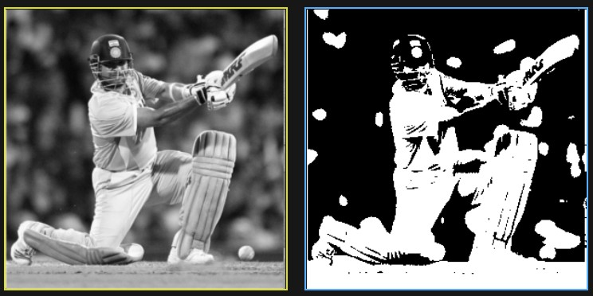

Single thresholding
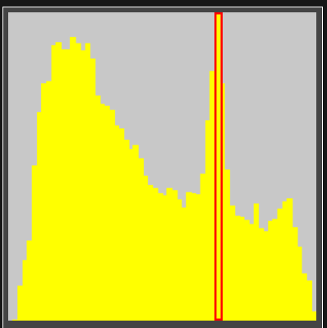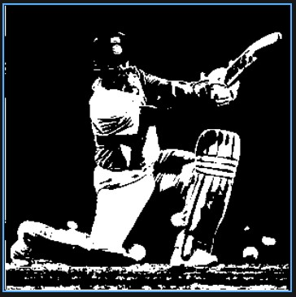

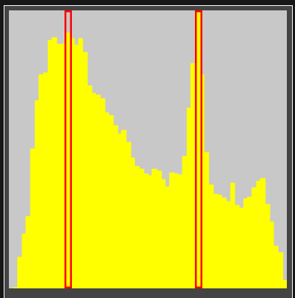
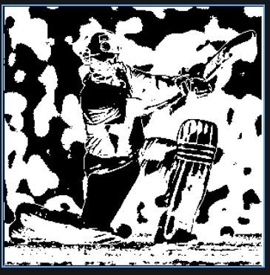
Double Thresholding

Region Based:
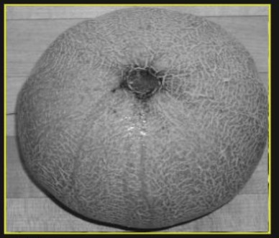
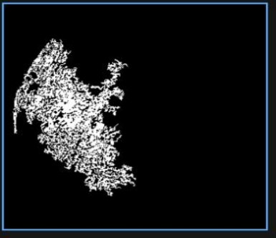

Based on variance:-10% all included pixels

Conclusion:
Image segmentation in virtual lab was studied.

