Experiment No: 13 Date:
Aim: Explore the virtual lab in image processing: Fourier Transform

Theory:
A number can be represented in many ways such as decimal, binary, hexadecimal etc. (ex. 15dec = 1111binary = Fhex). Likewise, a signal can also be represented in many ways that are more convenient for certain types of analysis. The most common representation is the Fourier transform which converts a spatial domain image into a spatial-frequency domain representation.

The Fourier transform (FT) is a way to express the imageÂ in terms of a set of pure sinusoidal functions. It transforms the image from spatial domain to frequency domain. In FT image , each pixel represents a particular frequency contained in spatial domain image.
The DFT does not contain all the frequencies which forms the image but only some samples which are sufficient to represent the information in spatial domain image. Given an image f[m,n] of size MxN, the mathematical expressions for DFT and inverse DFT (IDFT) are given below.

DFT: 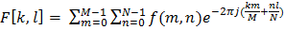 (1)
IDFT: 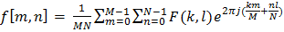(2)
The Eq(1) can be interpreted as the value of F[k,l] at each point is obtained by multiplying the spatial image with the corresponding exponential function (base function) followed by summation. Basis functions are pure sinusoidals with increasing frequency. In Eq(2), term is corresponds to normalization constant.

The output of FT of an image is complex valued image which can be displayed by two images: magnitude and phase. Often only the magnitude of FT is displayed because it consists of the most of the information about the geometric structure of the image in spatial domain.

It is very easy to examine or process certain frequencies of the image in Fourier domain, it influences the geometric structure in the spatial domain.

In general, the FT image is shifted in such a way that the DC-value (i.e. the image mean) F[0,0] is displayed in the center of the image. The distance from the center is proportional to its corresponding frequency.

The experiment is design to understand and learn the Fourier transform concepts. This experiment consists two parts:

- Forward Fourier Transform
- Importance of Phase Steps to run experiment:
- Select image from the mosaic using 'select image' option
  - Select region of the image to load it in the input image panel
- Select one option from 'Forward Fourier Transform' and 'Importance of phase'
  - For 'Forward Fourier Transform'
- Press 'Run'.
- For 'Importance of phase'
a. Select one option
- Choice 1
- Choice 2
- Choice 3
- Choice 4
- Choice 5
- Choice 6
- Press 'Run'.
- Output result will be displayed in the output panel.
Outputs:

Forward fourier transform
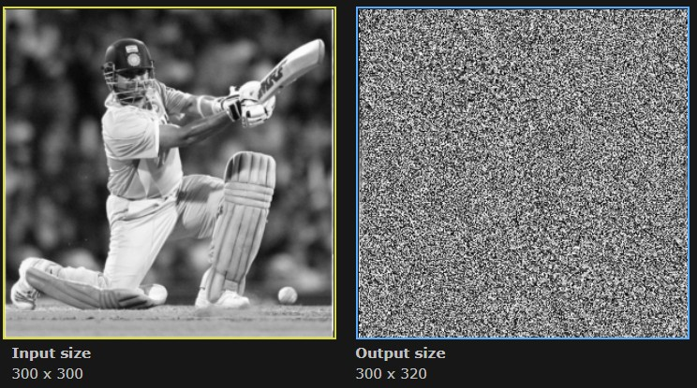

Importance of phase(choice 1)
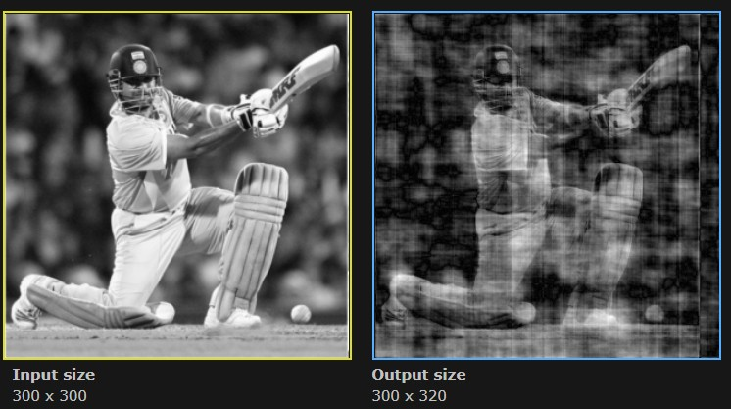

Inverse Fourier
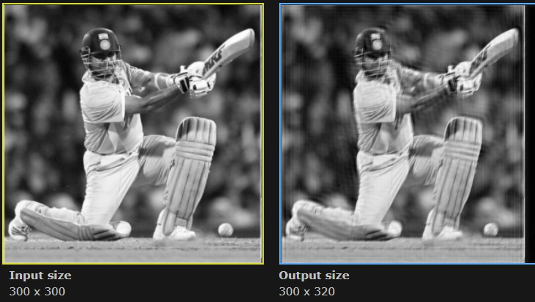

Conclusion: Fourier Transform in virtual lab was studied.

