Experiment No: 14 Date:
Aim: Explore the virtual lab in image processing: Morphology

Theory:
Mathematical morphology deals with set-theoretic operations. In image processing, morphological operations are typically used to extract information about forms and shapes of structures. These are neighborhood operations which investigate an image using a template image of certain shape and size. This template is called a structuring element. The operation can be used to alter the shape (ex. make it bigger or smaller) or detect the presence of a particular form in a given image.

The structuring element

The structuring element is a small matrix of pixels akin to the mask used in filtering operations you studied in an earlier experiment. The dimension of this matrix specifies the size of the structuring element and spatial organization of pixel value specifies the shape of the structural element. The size and shape of the structuring element decides the effect of operation on the objects in the image.

Originally morphological operations were defined for binary images and later extended to grayscale images.
A key difference between linear filtering, which is also a neighborhood operation, and morphological processing is that the mask operation is defined in the latter using set theory. The other is the choice of shape. While a square shape dominates linear filtering, the shape of the structuring element is variable and is usually empirically determined based on the application or type of images. Generally, the desirable shape of a structuring element depends on the geometric shape of interest in the image. For instance, a typical medical image contains very few straight lines or objects therefore circular structural element is preferred over oriented structuring element. In contrast, aerial images usually contain oriented objects such as building, roads, etc. therefore oriented or rectangle structuring elements are preferred to better deal with such shapes. The size of the structuring element is determined based on the size of the feature of interest in the image. To preserve larger objects (features) a large structure element is preferred while a small one is used to preserve the finer structural details in the image.

The experiment is designed to understand and learn the morphological operations in the images.

Steps to run the experiments

- Select image from the mosaic using 'select image' option
- Select one option from 'Dilation','Erosion','Closing'and 'Opening'
- Select options from 'Shape' and 'Size' of structuring elements properties
- Select run option to perform the operations.

Outputs:

Dilation
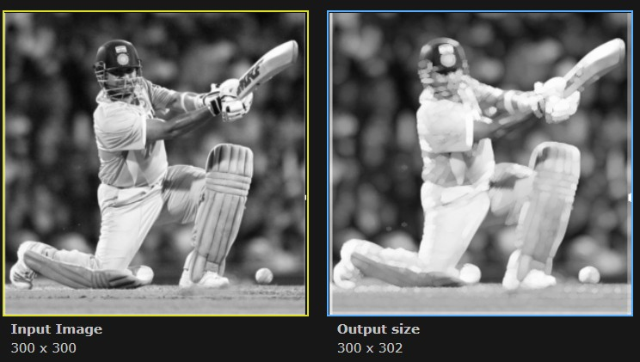
Erosion
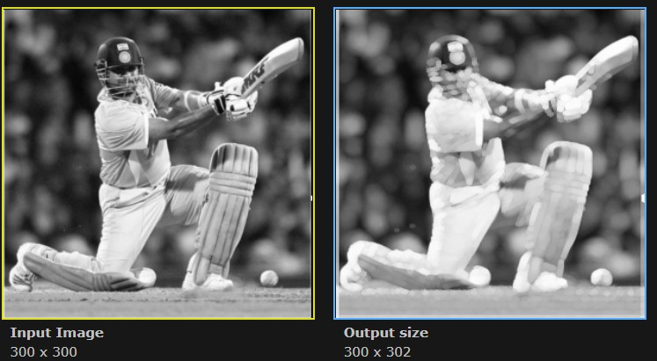

Cloning
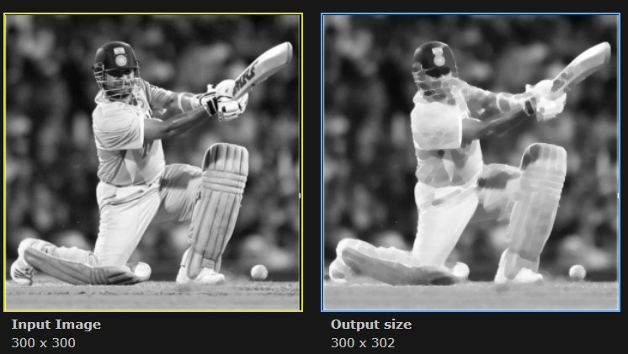

Opening
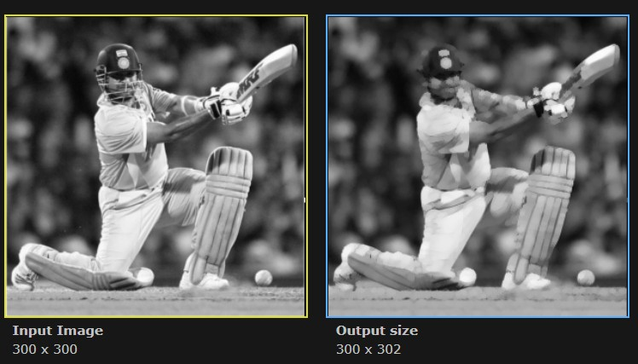

Conclusion: Morphology in virtual lab was studied.

