Experiment No: 8 Date:
Aim: Write a program to perform smoothing of an image using various filters like box filter,median filter, weighted averaging filter.

Theory: Image smoothing is an operation thats used to remove noise, sharpness and clutter in the image to give you much more smoother and blended effect. With power of opencv and python, you can achieve several smoothing effects with few lines of code. Basically the way it works is first selecting a kernel (3x3, 5x6 etc) and then convolving with image. The intensity of center pixel is determined by pixel intensities of neighborhood pixel. Depending upon kernel values and the type of aggregation you get several smoothing effects.
Average Smoothing: Here the kernel has uniform weights as shown below. Convolving with this filter simply yields average of pixel intensities in the neighborhood.
Median Blur: Here we used median values instead of mean to determine pixel intensity of center pixel. Because of median value, this technique is much more robust for outliers. This technique is very effective for removing salt and pepper noise in the image.

Program:
Python Code:
def show_image(self):
file_filter = 'Image File (*.jpg *.png)'
fname = QtWidgets.QFileDialog.getOpenFileName(parent=self.centralwidget,
caption='Select an Image',
directory="/run/media/deeprajb/HDD/Important Photos/Wallpapers",
filter=file_filter)
self.img = cv2.imread(fname[0])
self.img1 = QtGui.QImage(self.img.data, self.img.shape[1], self.img.shape[0], QtGui.QImage.Format_RGB888).rgbSwapped()
self.imageinput.setPixmap(QtGui.QPixmap.fromImage(self.img1))
def smoothening(self):
img_b_blur_50 = cv2.boxFilter(self.img, -1, (50,50))
img_median = cv2.medianBlur(self.img, 35)
img_blur_50 = cv2.blur(self.img, (50,50))
cv2.imwrite('bf_output.jpg',img_b_blur_50)
cv2.imwrite('mf_output.jpg',img_median)
cv2.imwrite('wa_output.jpg',img_blur_50)
self.imageoutput.setPixmap(QtGui.QPixmap("bf_output.jpg"))
self.imageoutput_2.setPixmap(QtGui.QPixmap("mf_output.jpg"))
self.imageoutput_3.setPixmap(QtGui.QPixmap("wa_output.jpg"))

Output:
Python GUI Output:
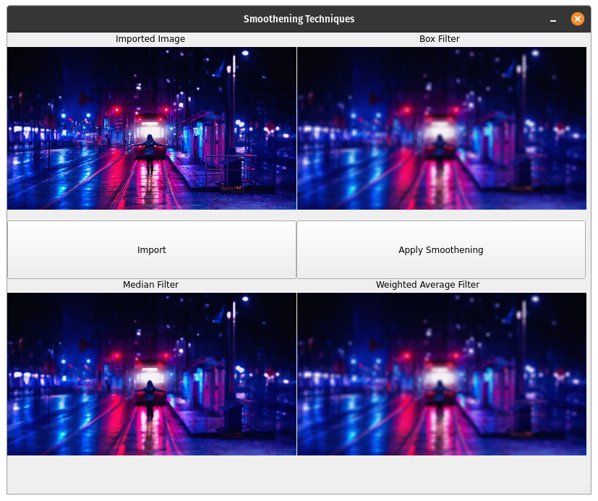
Conclusion: Program to read an image and perform Image Smoothing was studied and the code was implemented successfully.

