Experiment No: 9 Date:
Aim: Write a program to perform sharpening of an image using various filters like Laplacian filter, Sobel filter, Prewitt filter.

Theory: Image sharpening refers to any enhancement technique that highlights edges and fine details in an image. Image sharpening is widely used in printing and photographic industries for increasing the local contrast and sharpening the images. In principle, image sharpening consists of adding to the original image a signal that is proportional to a high-pass filtered version of the original image.
Laplacian Operator is also a derivative operator which is used to find edges in an image. The major difference between Laplacian and other operators like Prewitt, Sobel, Robinson and Kirsch is that these all are first order derivative masks but Laplacian is a second order derivative mask. In this mask we have two further classifications one is Positive Laplacian Operator and other is Negative Laplacian Operator.
Prewitt operator is used for edge detection in an image. It detects two types of edges:horizontal and vertical. Edges are calculated by using difference between corresponding pixel intensities of an image. All the masks that are used for edge detection are also known as derivative masks. Because as we have stated many times before in this series of tutorials that image is also a signal so changes in a signal can only be calculated using differentiation. So that’s why these operators are also called as derivative operators or derivative masks.

Program:
Python Code:
def show_image(self):
file_filter = 'Image File (*.jpg *.png)'
fname = QtWidgets.QFileDialog.getOpenFileName(parent=self.centralwidget,
caption='Select an Image',
directory="/run/media/deeprajb/HDD/Important Photos/Wallpapers",
filter=file_filter)
self.img = cv2.imread(fname[0])
self.img1 = QtGui.QImage(self.img.data, self.img.shape[1], self.img.shape[0], QtGui.QImage.Format_RGB888).rgbSwapped()
self.imageinput.setPixmap(QtGui.QPixmap.fromImage(self.img1))
def sharpening(self):
blur = cv2.GaussianBlur(self.img,(3,3),0)
laplacian = cv2.Laplacian(blur,cv2.CV_64F)
sobel_64 = cv2.Sobel(blur,cv2.CV_64F,1,0,ksize=3)
abs_64 = np.absolute(sobel_64)
sobel_8u = np.uint8(abs_64)
kernelx = np.array([[1,1,1],[0,0,0],[-1,-1,-1]])
kernely = np.array([[-1,0,1],[-1,0,1],[-1,0,1]])
img_prewittx = cv2.filter2D(blur, -1, kernelx)
img_prewitty = cv2.filter2D(blur, -1, kernely)
cv2.imwrite('lap_output.jpg',laplacian)
cv2.imwrite('sobel_output.jpg',sobel_8u)
cv2.imwrite('pre_output.jpg',img_prewittx + img_prewitty)
self.imageoutput.setPixmap(QtGui.QPixmap("lap_output.jpg"))
self.imageoutput_2.setPixmap(QtGui.QPixmap("sobel_output.jpg"))
self.imageoutput_3.setPixmap(QtGui.QPixmap("pre_output.jpg"))

Output:
Python GUI Output:
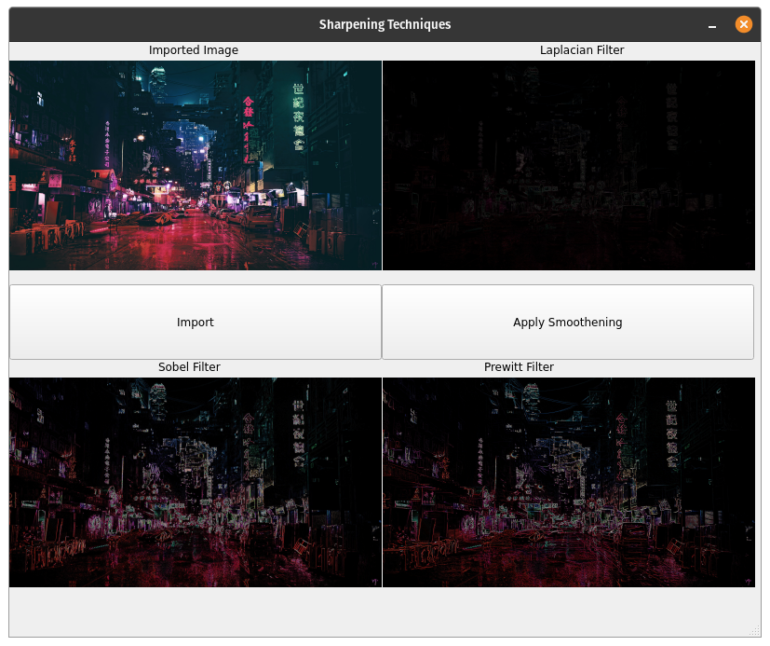
Conclusion: Program to read an image and perform image sharpening was studied and the code was implemented successfully.

