Experiment No: 6a Date:
Aim: To implement form validation using AngularJs

Theory:

AngularJS
AngularJS is a JavaScript framework written in JavaScript. AngularJS is distributed as a JavaScript file, and can be added to a web page with a script tag AngularJS extends HTML with ng-directives. The ng-app directive defines an AngularJS application. The ng-model directive binds the value of HTML controls (input, select, textarea) to application data. The ng-bind directive binds application data to the HTML view.

Code:
<form ng-submit="ctrl.submit()" name="myForm">
<input type="text"
name="uname"
ng-model="ctrl.user.username"
required
ng-minlength="4">
<span class="error" ng-show="myForm.uname.$error.required && !myForm.uname.$pristine">
This is a required field <br> </span>
<span class="error" ng-show="myForm.uname.$error.minlength && !myForm.uname.$pristine">
Minimum length required is 4<br>
</span>
<span class="error" ng-show="myForm.uname.$invalid && !myForm.uname.$pristine">
This field is invalid
</span>
<input type="password"
name="pwd"
ng-model="ctrl.user.password"
required>
<span class="error" ng-show="myForm.pwd.$error.required && !myForm.uname.$pristine
">
This is a required field
</span>
<br>
<input type="submit"
value="Submit"
ng-disabled="myForm.$invalid">
</form>

Output:
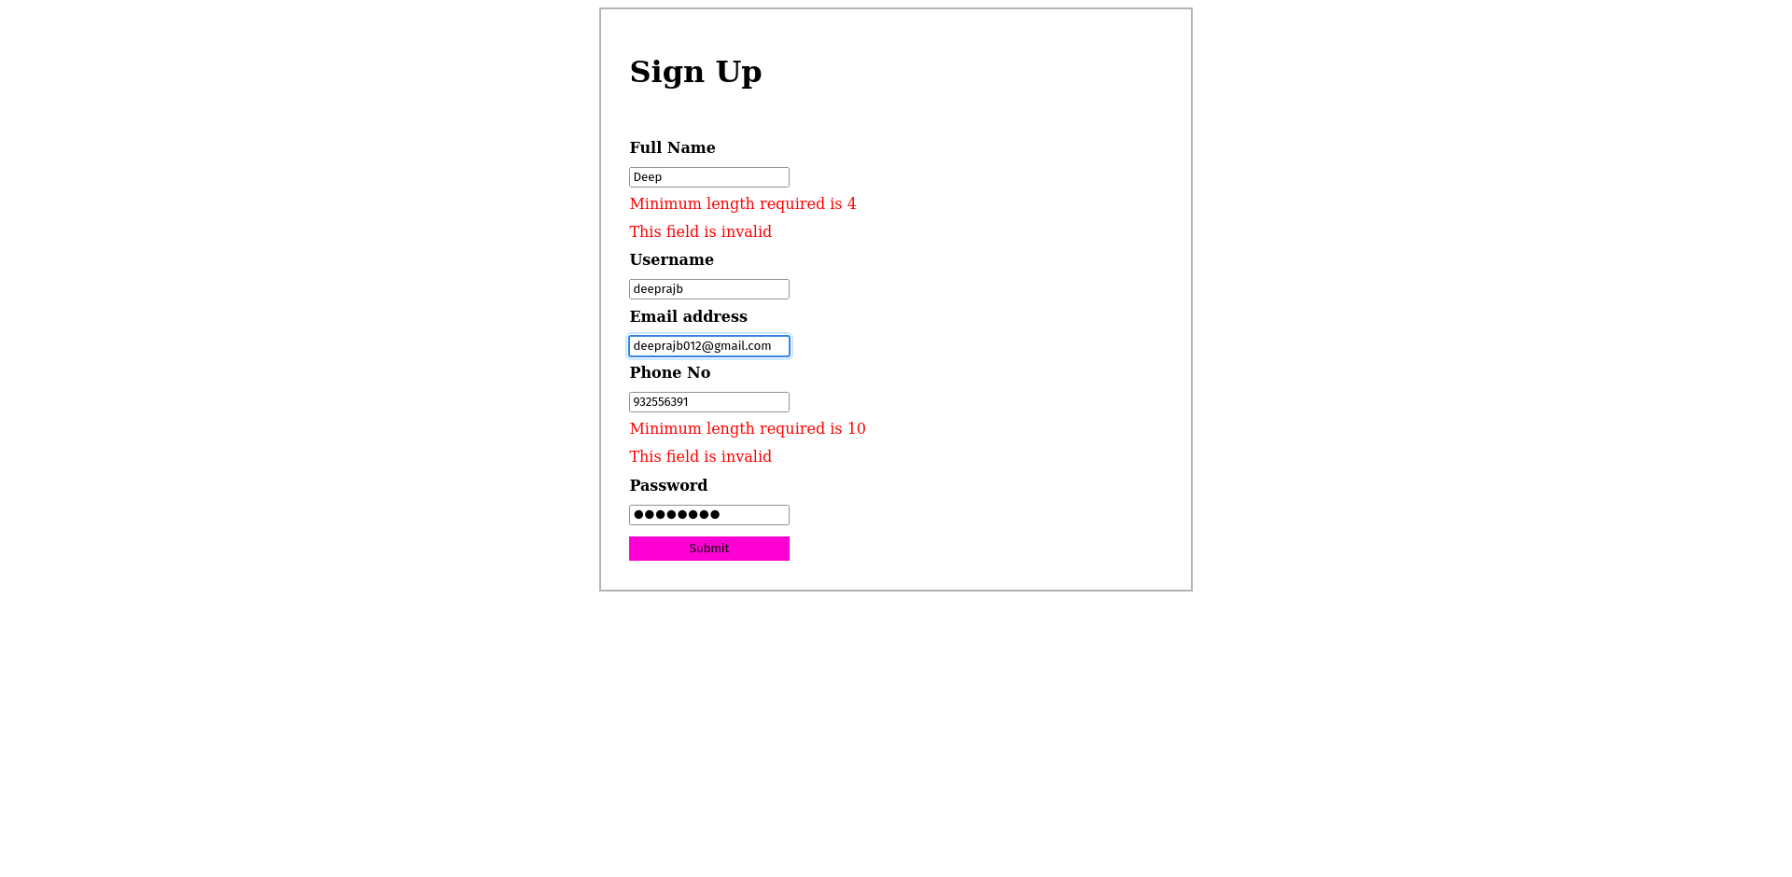

Conclusion: Form validation using AngularJs was succesfully implemented

