Experiment No: 6b Date:
Aim: To implement a todo list using AngularJS

Theory:

Directives in AngularJs
AngularJS lets you extend HTML with new attributes called Directives. AngularJS has a set of built-in directives which offers functionality to your applications. AngularJS also lets you define your own directives. AngularJS directives are extended HTML attributes with the prefix ng-. The ng-app directive initializes an AngularJS application. The ng-init directive initializes application data. The ng-model directive binds the value of HTML controls (input, select, textarea) to application data.

ng-show directive
The ng-show directive shows the specified HTML element if the expression evaluates to true, otherwise the HTML element is hidden. The expression can be a js expression using attributes ffrom the controller

ng-click directive
The ng-click directive tells AngularJS what to do when an HTML element is clicked. Unlike the onclick attribute, ng-click allows access to methods of the controller.

Code:
angular.module("noteApp",[]).controller("NoteCtrl", ['$scope','$compile',function($scope,$compile) {
let self=this;
self.noteNum=0;
self.takeNote=false;
self.currentNote=null;

self.newNote=function(){
self.takeNote=true;
}
self.edit=function(noteNum){
self.takeNote=true;
let note=document.getElementById(`note${noteNum}`);
document.getElementById("note-content").value=note.innerText;
self.currentNote=note;
}
self.createAndPushNote=function(content){
let notesContainer=document.getElementById('notes-container')
let newNote=$compile(`
<div class="note" id="note${self.noteNum}" ng-click="ctrl.edit(${self.noteNum})">
${content}
</div>
`
)($scope)
self.noteNum+=1;
angular.element(notesContainer).append(newNote);
}
self.leaveNote=function(){
self.takeNote=false;
document.getElementById("note-content").value="";
}
self.saveNote=function(){
let noteContent=document.getElementById("note-content").value;
if(self.currentNote==null){
self.createAndPushNote(noteContent);
}
else{
let p=self.currentNote
if(noteContent==""){
p.parentNode.removeChild(p) ;
}
else{
p.innerHTML=noteContent;
}
self.currentNote=null;
}
self.leaveNote();
}
}]);

Output:
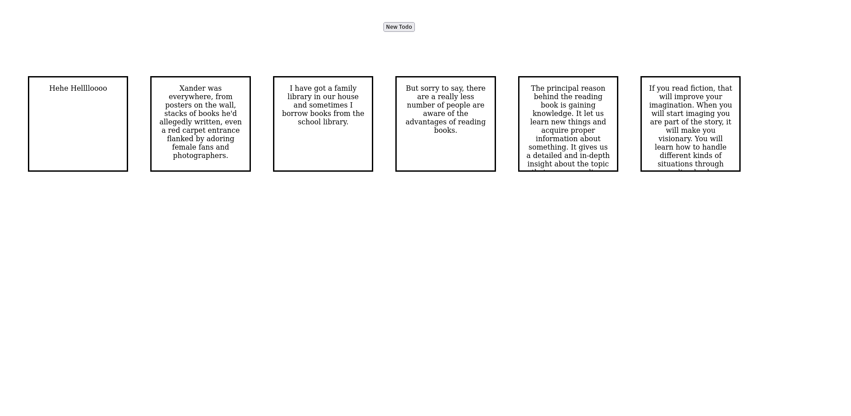

Conclusion: A Todo list app was successfully written using angular js

