Experiment No: 2
Aim: To create an animation using Javascript
Theory:
Animation is a method in which figures are manipulated to appear as moving images. Generally the effect of animation is achieved by a rapid succession of sequential images that minimally differ from each other. In computer animation this is achieved by changing the image every few milliseconds. These changes act like frames.
Canvas
<canvas> is an HTML element which can be used to draw graphics via scripting (usually JavaScript). This can, for instance, be used to draw graphs, combine photos, or create simple animations. At first sight a ¡canvas¿ looks like the <img> element, with the only clear difference being that it doesn’t have the src and alt attributes. Indeed, the ¡canvas¿ element has only two attributes, width and height. These are both optional and can also be set using DOM properties. When no width and height attributes are specified, the canvas will initially be 300 pixels wide and 150 pixels high.
Code:
Javascript Code:
var canvas;
var ctx;
var dx = 1;
var dy = 2;
var bar=new Bar(400,500);
var circle=new Circle(400,30,10);
var dxBar=6;
var timer;
var barImg;
function Bar(x,y){
this.x=x;
this.y=y; }
function Circle(x,y,r){
this.x=x;
this.y=y;
this.r=r;
}
function drawBall(c) {
ctx.beginPath();
ctx.arc(c.x, c.y, c.r, 0, Math.PI*2, true);
ctx.fill();
}
function doKeyDown(e){
if(e.keyCode==37){
if(bar.x-dxBar>0)
bar.x-=dxBar;
}
else if(e.keyCode==39){
if(bar.x+dxBar<canvas.width)
bar.x+=dxBar;
}
}
function init() {
window.addEventListener("keydown",doKeyDown,false);
barImg=document.getElementById("bar");
canvas = document.getElementById("canvas");
ctx = canvas.getContext("2d");
timer=setInterval(draw, 10);
return timer;
}
function draw() {
ctx.clearRect(0, 0, canvas.width, canvas.height);
ctx.fillStyle = "#FAF7F8";
ctx.fillRect(0,0,canvas.width,canvas.height);
ctx.fillStyle = "#003300";
drawBall(circle);
if (circle.x +dx > canvas.width || circle.x +dx < 0)
dx=-dx;
if(circle.y+dy>bar.y && circle.x>bar.x && circle.x<bar.x+barImg.width)
dy=-dy;
if (circle.y +dy > canvas.height || circle.y +dy < 0)
dy=-dy;
circle.x += dx;
circle.y += dy;
ctx.drawImage(barImg,bar.x,bar.y);
if(circle.y>bar.y){
clearTimeout(timer);
ctx.clearRect(0, 0, canvas.width, canvas.height);
alert("Game Over");
}
}
HTML Code:
<!DOCTYPE html>
<html>
<head>
<title>Canvas Demo</title>
<script type="text/javascript" src="bouncingball.js" ></script>
</head>
<body onload="init();">
<div>
<canvas id="canvas" width="800" height="600">
Sorry, browser does not support canvas.
</canvas>
</div>
<img src="bar.png" id="bar" style="display: none" />
</body>
</html>

Output:
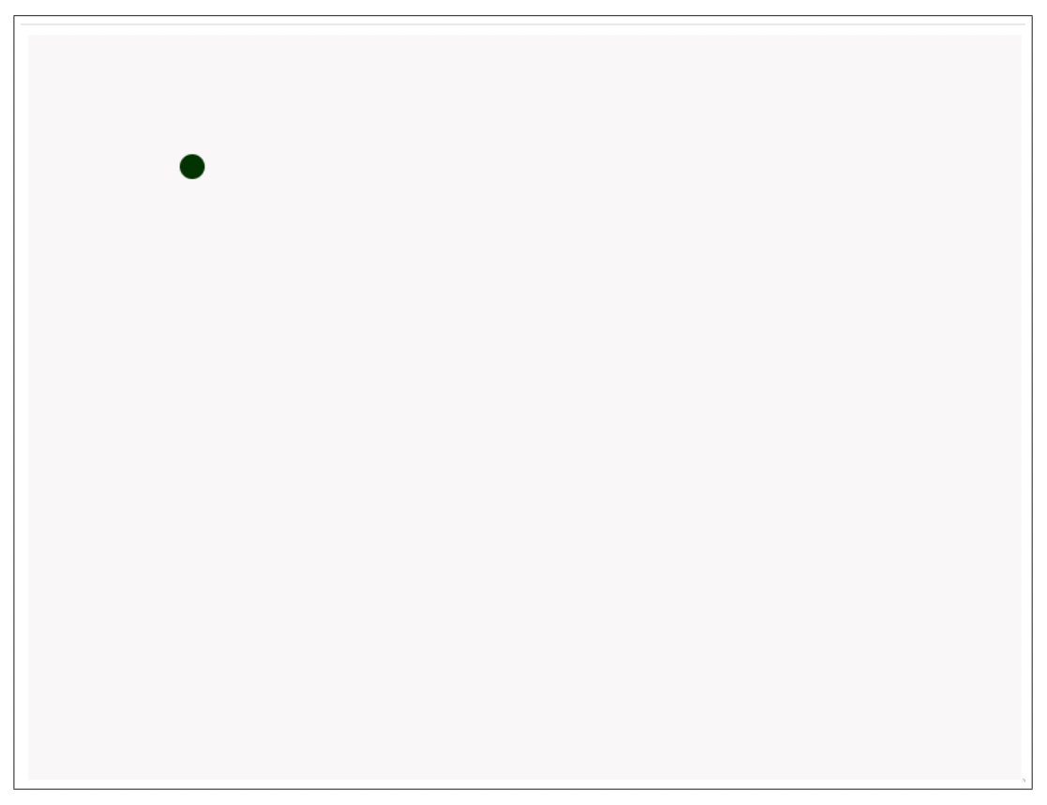

Conclusion: A program implementing animation in Javascript was successfully implemented and executed.

