Experiment No: 3
Aim: To study various image editors and animation softwares
Theory:
Image Editors
Alternatively referred to as graphic software or photo software, an image editor is a soft- ware program used to edit or otherwise manipulate an image, picture or graphic. Image editing encompasses the processes of altering images, whether they are digital photographs, traditional photo-chemical photographs, or illustrations. Traditional analog image editing is known as photo retouching, using tools such as an airbrush to modify photographs or edit- ing illustrations with any traditional art medium. Graphic software programs, which can be broadly grouped into vector graphics editors, raster graphics editors, and 3D modelers, are the primary tools with which a user may manipulate, enhance, and transform images. Many image editing programs are also used to render or create computer art from scratch. One of the most popular and powerful image editors is Adobe Photoshop. A free alternative to Photoshop is GIMP.
GIMP
GIMP (GNU Image Manipulation Program) is a free and open-source raster graphics editor used for image manipulation (retouching) and image editing, free-form drawing, transcoding between different image file formats, and more specialized tasks. It is not designed to be used for drawing, though some artists and creators have used it for such. GIMP is primarily developed by volunteers as a free and open source software project associated with both the GNU and GNOME projects. Development takes place in a public git source code repository, on public mailing lists and in public chat channels on the GIMPNET IRC network. Tools used to perform image editing can be accessed via the toolbox, through menus and dialogue windows. They include filters and brushes, as well as transformation, selection, layer and masking tools.
Krita
Krita is a free and open-source raster graphics editor designed primarily for digital painting and 2D animation. The software runs on Windows, macOS, Linux, Android, and Chrome OS, and features an OpenGL-accelerated canvas, colour management support, an advanced brush engine, non-destructive layers and masks, group-based layer management, vector artwork support, and switchable customisation profiles. The most prominent feature of Krita is arguably its UX design with graphics tablet users in mind. It uses a combination of pen buttons, keyboard modifiers and an icon-based HUD to ensure frequently-used functions can be accessed by fewer clicks, without the need to search through text-based menus. Most- used drawing commands can be accessed via touch by combining keyboard modifiers with pen/mouse buttons and gestures: The Krita Foundation was created in 2013 to provide support for Krita’s development. It collaborated with Intel to create Krita Sketch as a marketing campaign and Krita Studio with KO GmbH as a commercially supported version for movie and VFX studios. Kickstarter campaigns have been used to crowdfund Krita’s development since 2014.
Inkscape
Inkscape is a free and open-source vector graphics editor used to create vector images, primarily in Scalable Vector Graphics (SVG) format. Other formats can be imported and exported.
Inkscape can render primitive vector shapes (e.g. rectangles, ellipses, polygons, arcs, spirals, stars and 3D boxes) and text. These objects may be filled with solid colors, patterns, radial or linear color gradients and their borders may be stroked, both with adjustable transparency. Embedding and optional tracing of raster graphics is also supported, enabling the editor to create vector graphics from photos and other raster sources. Created shapes can be further manipulated with transformations, such as moving, rotating, scaling and skewing.

Logo in GIMP:
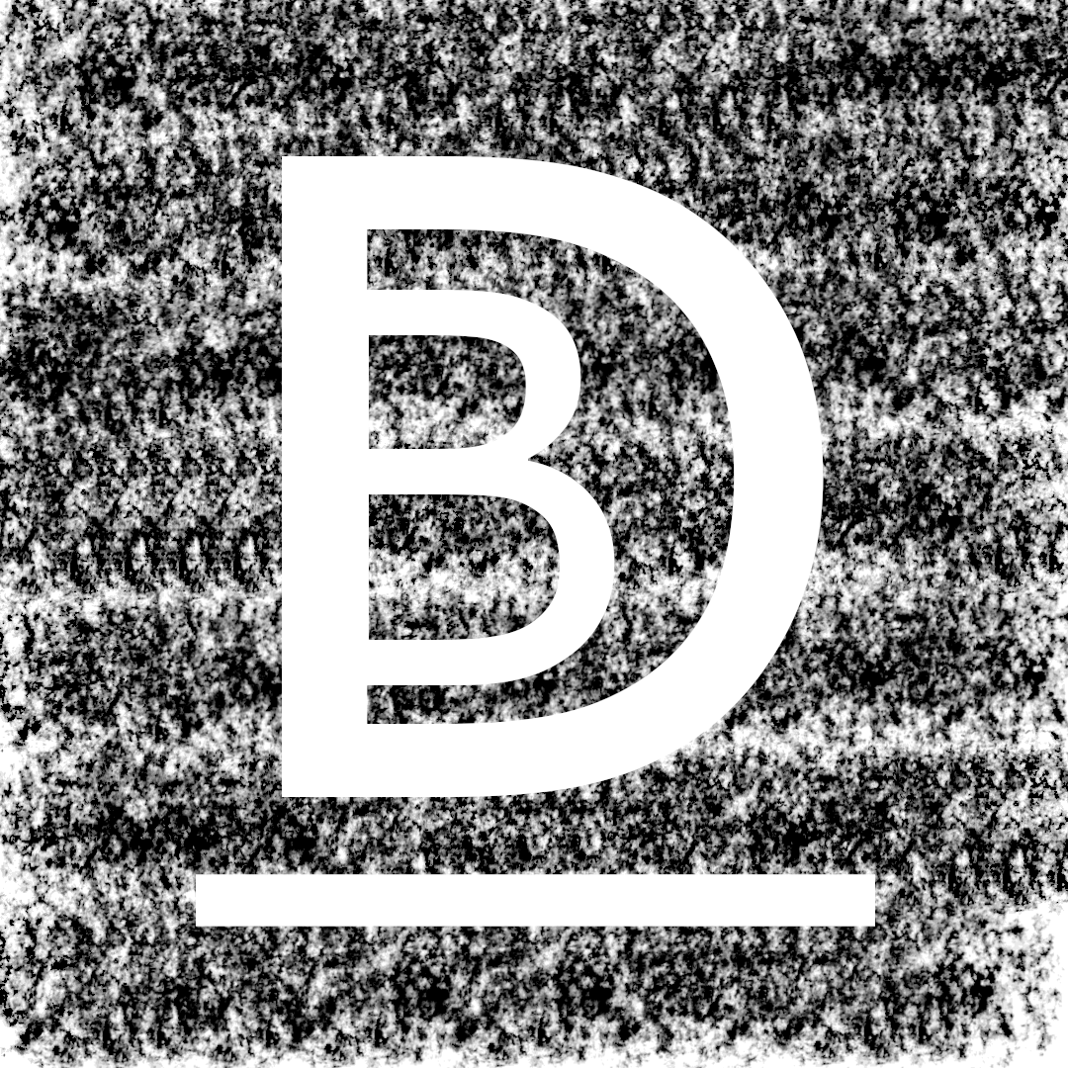

Tools Used:
1. BrushTool
2. Crop Tool
3. Text Tool

Character Drawing in Krita:
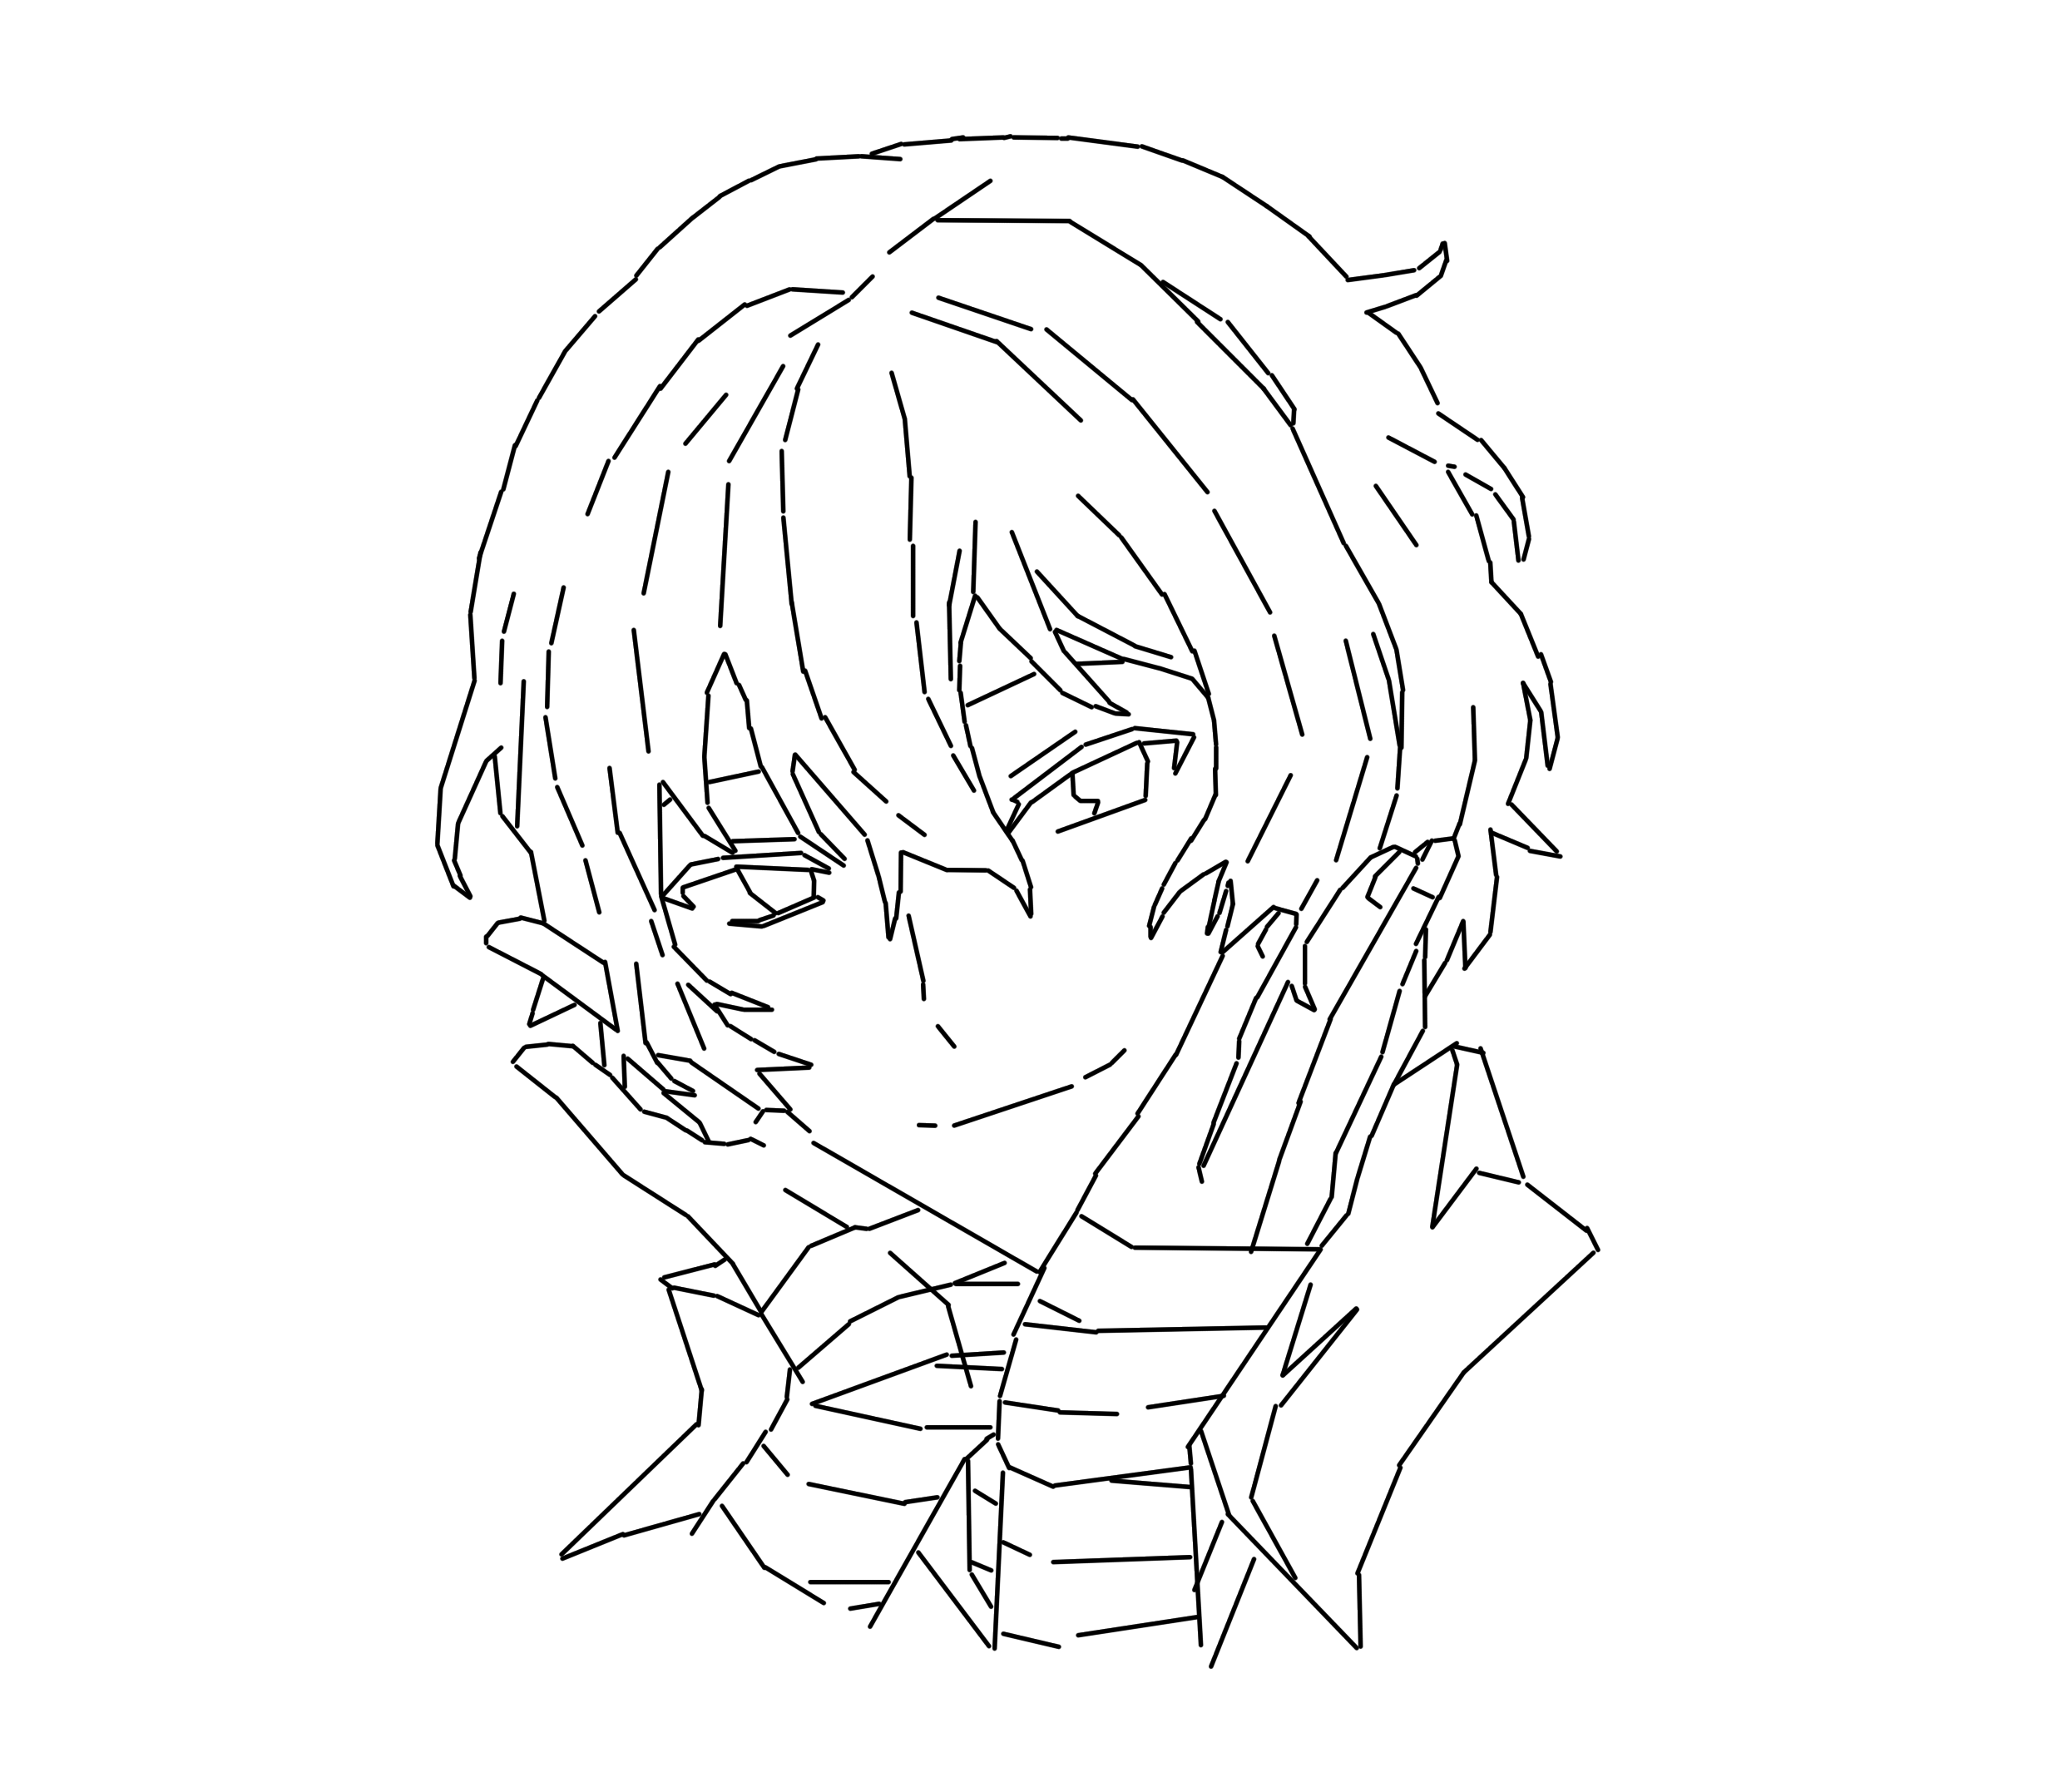
Tools Used:
1. Brush Tool
2. Line Tool.
3. Layer Select

Poster in Inkscape:
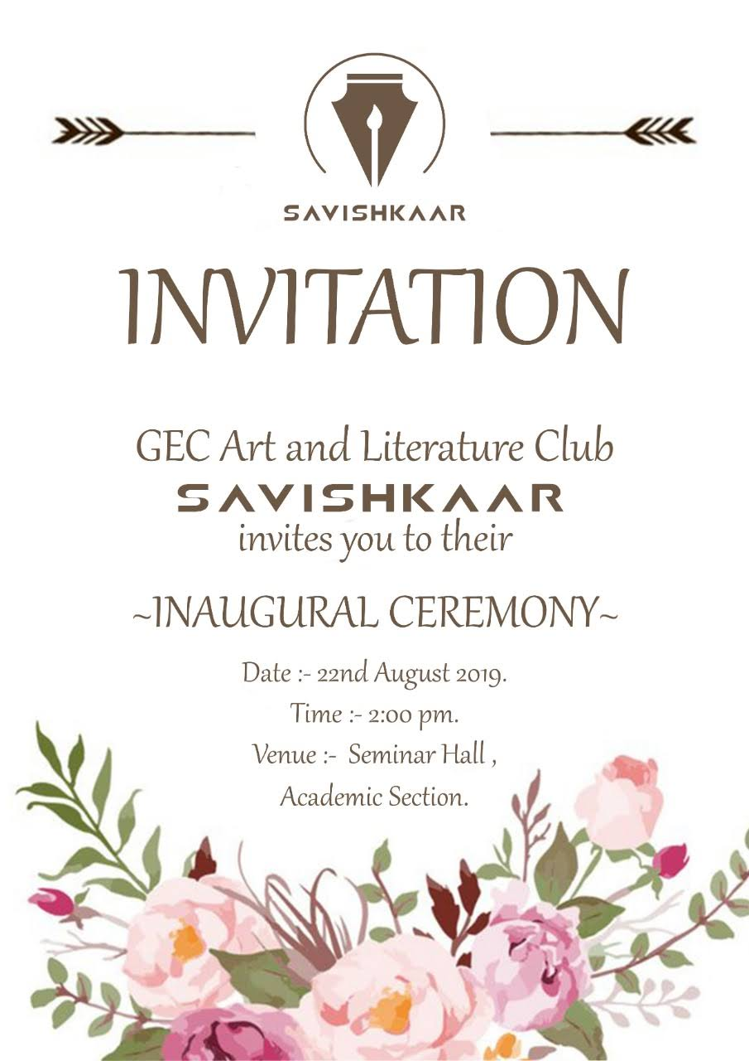

Tools Used:
1. Text Tool.
2. Image Toolbox.

Conclusion: The study of various image editors and animation softwares was successfully conducted.

