Experiment No: 4
Aim: To study video editing softwares
Theory:
Video Editing Software
Video editing software, or a video editor is software used performing the post-production video editing of digital video sequences on a non-linear editing system (NLE). It has replaced traditional flatbed celluloid film editing tools and analog video tape-to-tape online editing machines.
Video editing software serves a lot of purposes, such as filmmaking, audio commentary, and general editing of video content.
In NLE software, the user manipulates sections of video, images, and audio on a sequence. These clips can be trimmed, cut, and manipulated in many different ways. When editing is finished, the user exports the sequence as a video file.
Some examples of video editing softwares are
1. Adobe Premier Pro
2. Apple Final Cut Pro
3. DaVinci Resolve
4. Kdenlive

Adobe Premier Pro
Adobe Premiere Pro is a timeline-based video editing software application developed by Adobe Inc. and published as part of the Adobe Creative Cloud licensing program. First launched in 2003, Adobe Premiere Pro is a successor of Adobe Premiere (first launched in 1991). It is geared towards professional video editing, while its sibling, Adobe Premiere Elements, targets the consumer market. Premiere Pro is the successor to Adobe Premiere and was launched in 2003. Premiere Pro refers to versions released in 2003 and later, whereas Premiere refers to the earlier releases. Premiere was based on ReelTime, a product acquired from SuperMac Technologies Inc. and was one of the first computer-based NLEs (non-linear editing system), with its first release on Mac in 1991 Premiere Pro supports high resolution video editing at up to 10,240 × 8,192 resolution, at up to 32 bits per channel color, in both RGB and YUV. Audio sample-level editing, VST audio plug-in support, and 5.1 surround sound mixing are available. Premiere Pro’s plug-in architecture enables it to import and export formats beyond those supported by QuickTime or DirectShow, supporting a wide variety of video and audio file formats and codecs on both MacOS and Windows. When used with CineForm’s Neo line of plug-ins, it supports 3D editing with the ability to view 3D material using 2D monitors, while making individual left and right eye adjustments.
Final Cut Pro
Final Cut Pro is a series of non-linear video editing software programs first developed by Macromedia Inc. and later Apple Inc. The most recent version, Final Cut Pro 10.6.3, runs on Mac computers powered by macOS Big Sur 11.5.1 or later. The software allows users to log and transfer video onto a hard drive (internal or external), where it can be edited, processed, and output to a wide variety of formats. The fully rewritten Final Cut Pro X was introduced by Apple in 2011, with the last version of the legacy Final Cut Pro being version 7.0.3.
Since the early 2000s, Final Cut Pro has developed a large and expanding user base, mainly video hobbyists and independent filmmakers. It has also made inroads with film and television editors who have traditionally used Avid Technology’s Media Composer. Accord- ing to a 2007 SCRI study, Final Cut Pro made up 49% of the United States professional editing market, with Avid at 22%. A published survey in 2008 by the American Cinema Editors Guild placed their users at 21% Final Cut Pro (and growing from previous surveys of this group), while all others were on an Avid system of some kind
DaVinci Resolve
DaVinci Resolve application for macOS, Windows, and Linux, originally developed by da Vinci Systems, and now developed by Blackmagic Design following its acquisition in 2009. The software includes modules for video editing, color correction, audio mixing/effects (in- cluding Fairlight), and visual effects (including Fusion). It can either be used as an interme- diary between other NLE software and Digital Cinema Package (DCP) creation software, or as a standalone end-to-end video editing application.
For content delivery to services such as Netflix, Resolve provides functionality to create and validate IMF (Interoperable Master Format, standardized by SMPTE) packages, known as IMPs (which comprise multiple components, such as MXF content, a composition playlist (CPL), and XML package data), without the use of separate DCP software.
Kdenlive
Kdenlive is a free and open-source video editing software based on the MLT Framework, KDE and Qt. KDE’s Kdenlive makes use of MLT, Frei0r effects, SoX and LADSPA libraries. Kdenlive supports all of the formats supported by FFmpeg or libav , and also supports 4:3 and 16:9 aspect ratios for both PAL, NTSC and various HD standards, including HDV and AVCHD. Video can also be exported to DV devices, or written to a DVD with chapters and a simple menu.
Some of the features of kdenlive include:
- Multi-track editing with a timeline and supports an unlimited number of video and audio tracks.
- A built-in title editor and tools to create, move, crop and delete video clips, audio clips, text clips and image clips.
- Ability to add custom effects and transitions.
- A wide range of effects and transitions. Audio signal processing capabilities include normalization, phase and pitch shifting, limiting, volume adjustment, reverb and equalization filters as well as others. Visual effects include options for masking, blue-screen, distortions, rotations, colour tools, blurring, obscuring and others.
- Rendering is done using a separate non-blocking process so it can be stopped, paused and restarted.
- Project files are stored in XML format
- An archiving feature allows exporting a project among all assets into a single folder or
compressed archive
- Built-in audio mixer
Screenshots:
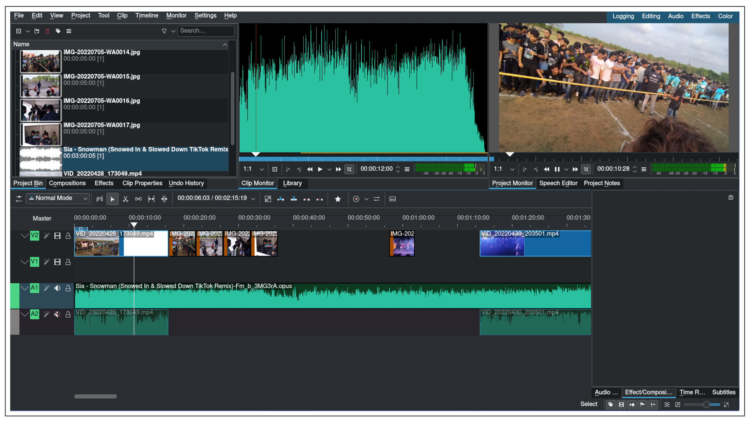

Conclusion: The study of video editing softwares was successfully conducted.

