Experiment No: 1
Case Study of Mobile Computing
Aim: To study different applications of Mobile Computing.
Theory:
Mobile Computation: It is the ability to compute while on the move. The mobile invokes services from a server to run the application on the mobile. Mobile computing allows transmission of data, voice and video via a computer or any other wireless-enabled device without being connected to a fixed physical link. In this technology, data transmission is done wirelessly with the help of wireless devices such as mobiles, laptops etc. It requires application for design and development, and requires hardware support at the client and server side.

Characteristics of mobile computing:
i. Ubiquity: Can send and retrieve information from anywhere
ii. Location aware services
iii. Adaptation: Ability of system to adapt to bandwidth fluctuation without any inconvenience to user.
iv. Broadcast: Once we reach a particular place, we automatically get push notifications of a particular service.
v. Personalization: We can create a profile and based on that profile, we can filter out the services.

Structure of Mobile Computing:
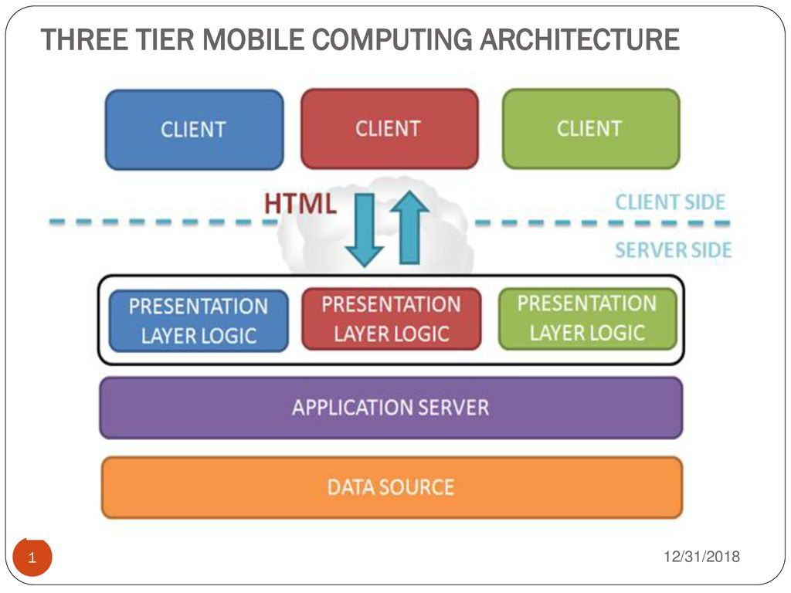

Applications of Mobile Computing:
1. Vehicles: Music, news, road conditions, weather reports, and other broadcast information are received via digital audio broadcasting (DAB). For remote areas, satellite communication can be used, while the current position of the car is determined via the global positioning system (GPS). Cars driving in the same area build a local ad-hoc network for the fast exchange of information in emergency situations or to help each other keep a safe distance. In case of an accident, not only will the airbag be triggered, but the police and ambulance service will be informed via an emergency call to a service provider. Figure 1.1 shows a typical scenario for mobile communications with many wireless devices. Networks with a fixed infrastructure like cellular phones (GSM, UMTS) will be interconnected with trunked radio systems (TETRA) and wireless LANs (WLAN). Satellite communication links can also be used. The networks between cars and inside each car will more likely work in an ad-hoc fashion. Wireless pico networks inside a car can comprise personal digital assistants (PDA), laptops, or mobile phones, e.g., connected with each other using the Bluetooth technology.

2. Emergencies: Only wireless networks can communicate during natural disasters such as Earth Quakes, tsunamis, floods and fires. In worst conditions, only decentralized, wireless ad hoc networks survive. The breakdown of all cabling not only implies the failure of the standard wired telephone system, but also the crash of all mobile phone systems requiring base stations!

3. Business: A traveling salesman today needs instant access to the company’s database: to ensure that files on his or her laptop reflect the current situation, to enable the company to keep track of all activities of their traveling employees, to keep databases consistent etc. With wireless access, the laptop can be turned into a true mobile office, but efficient and powerful synchronization mechanisms are needed to ensure data consistency.

4. Replacement of Wired Network: In some cases, wireless networks can also be used to replace wired networks, e.g., remote sensors, for trade shows, or in historic buildings. Due to economic reasons, it is often impossible to wire remote sensors for weather forecasts, earthquake detection, or to provide environmental information. Wireless connections, e.g., via satellite, can help in this situation. Trade shows need a highly dynamic infrastructure, but cabling takes a long time and frequently proves to be too inflexible. Many computer fairs use WLANs as a replacement for cabling. Other cases for wireless networks are computers, sensors, or information displays in historical buildings, where excess cabling may destroy valuable walls or floors. Wireless access points in a corner of the room can represent a solution.

5. Location Dependent Services: It includes:-
Follow-on services: Using mobile computers, a follow-on service could offer, for instance, the same desktop environment wherever you are in the world. All e-mail would automatically be forwarded and all changes to your desktop and documents would be stored at a central location at your company. If someone wanted to reach you using a multimedia conferencing system, this call would be forwarded to your current location.
Location aware services: Imagine you wanted to print a document sitting in the lobby of a hotel using your laptop. Thus, there could be a service in the hotel announcing that a standard laser printer is available in the lobby or a color printer in a hotel meeting room etc. Your computer might then transmit your personal profile to your hotel which then charges you with the printing costs.
Privacy: The two service classes listed above immediately raise the question of privacy. You might not want video calls following you to dinner, but maybe you would want important e-mails to be forwarded. There might be locations and/or times when you want to exclude certain services from reaching you and you do not want to be disturbed. You want to utilize location dependent services, but you might not want the environment to know exactly who you are.
Information services: While walking around in a city you could always use your wireless travel guide to ‘pull’ information from a service. However, a service could also actively ‘push’ information on your travel guide, e.g., the Mexican restaurant just around the corner has a special taco offer.
6. Infotainment: Wireless networks are capable of delivering latest information at any suitable regions and can download knowledge such as knowledge about shows using wireless networks. Another growing field of wireless network applications lies in entertainment and games to enable, e.g., ad-hoc gaming networks as soon as people meet to play together.

Conclusion: The various applications of mobile computing were successfully studied.

