Assignment No: 2
1. Explain the following:
  - Source Coding: It is a lossy technique. It takes into account the semantics of the data. The amount of compression that can be reached by source coding depends on the contents of the data stream and the encoded data stream exists; the data streams are similar but not identical. It uses the characteristics of the specific medium. eg: sound source coding where sound is transformed from time dependent to frequency dependent concatenations followed by encoding of the formants.
  - Entropy Coding: It is an example of lossless encoding as the decompression process regenerates the data completely. The data stream is considered to be a simple digital sequence and the semantics of the data is ignored. It is used regardless of the media’s specific characteristics. eg: Run Length Coding.
  - Transformation Encoding: It transforms the data into another mathematical domain that is more suitable for compression. The inverse transformation must exist as is known to the encoding process. eg: Fourier transform, transforms the data from the time domain to frequency domain. The most effective transformations for image compression are DCT and FFT.
  - Delta Modulation: It is a modification of DPCM. When coding the differences, it uses exactly one bit which indicates whether the signal increases and decreases in strength. This leads to incorrect coding of steep edges. This technique is profitable if the coding does not depend on 8-bit grid units.
2. Explain the steps of data compression with the help of a neat diagram.
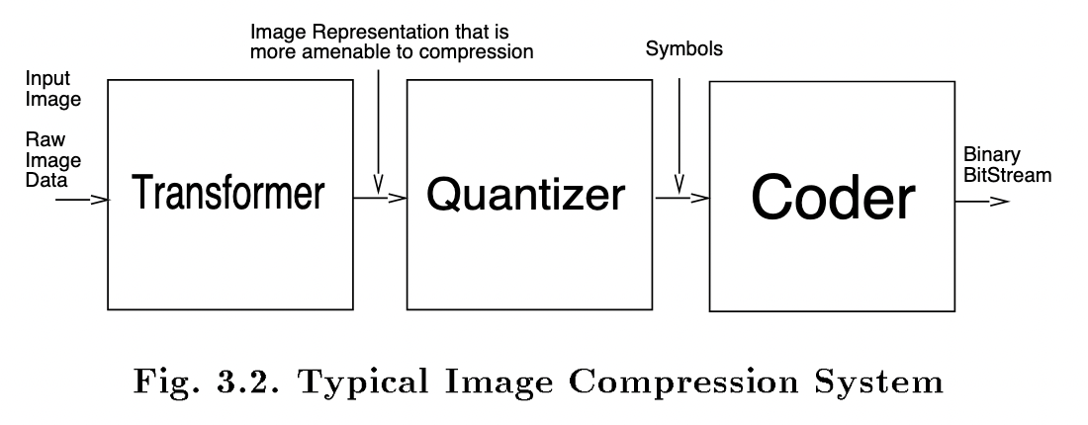
Transformer applies a one-to-one transformation to the input image data. The output of the transformer is an image representation which is more amenable to efficient compression than the raw image data. Unitary mappings such as Discrete Cosine Transform, which pack the energy of the signal to a small number of coefficients, is a popular method with image compression standards.
Quantizer generates a limited number of symbols that can be used in the representation of the compressed image. Quantization is a many-to-one mapping which is irreversible. It can b e performed by scalar or vector quantizers. Scalar quantization refers to element-by-element quantization of data and vector quantization refers to quantization of a block at a time.
Coder assigns a co de word, a binary bit-stream, to each symbol at the output of the quantizer. The coder may employ fixed-length or variable- length codes. Variable Length Co ding (VLC), also known as entropy co ding, assigns co de words in such a way as to minimize the average length of the binary representation of the symbols. This is achieved by assigning shorter co de words to more probable symbols, which is the fundamental principle of entropy co ding.
3. Compare Run Length Encoding with Diatomic Encoding
Run-length encoding (RLE) is a lossless compression method where sequences that display redundant data are stored as a single data value representing the repeated block and how many times it appears in the image. Later, during decompression, the image can be reconstructed exactly from this information.
This type of compression works best with simple images and animations that have a lot of redundant pixels. It's useful for black and white images in particular. For complex images and animations, if there aren't many redundant sections, RLE can make the file size bigger rather than smaller. Thus it's important to understand the content and whether this algorithm will help or hinder.
eg: uncompressed data: ABCCCCCCCCDEFGGG
Run length coded: ABC18DEFGGG
Diatomic Encoding is a variation of run-length coding based on a combination of two data bytes. For a given media type the most common co-occurring pairs of data bytes are identified. These are then replaced in the data stream by single bytes that do not occur anywhere else in the stream.
eg: The most frequently occurring pairs are: “E”, “T”, “TH”, “A”, “S”, “RE”, “IN”, “HE”. Replacement of these pairs by special swingle bytes that do not occur anywhere else in the text leads to a data reduction of more than 10%.
4. Explain Huffman Encoding with the help of an example.
- Huffman coding is a lossless data compression algorithm. The idea is to assign variable-length codes to input characters, lengths of the assigned codes are based on the frequencies of corresponding characters.
- The most frequent character gets the smallest code and the least frequent character gets the largest code.
- The variable-length codes assigned to input characters are Prefix Codes, means the codes (bit sequences) are assigned in such a way that the code assigned to one character is not prefix of code assigned to any other character. This is how Huffman Coding makes sure that there is no ambiguity when decoding the generated bit stream.
- Let us understand prefix codes with a counter example. Let there be four characters a, b, c and d, and their corresponding variable length codes be 00, 01, 0 and 1. This coding leads to ambiguity because code assigned to c is prefix of codes assigned to a and b. If the compressed bit stream is 0001, the de-compressed output may be “cccd” or “ccb” or “acd” or “ab”.
- Example
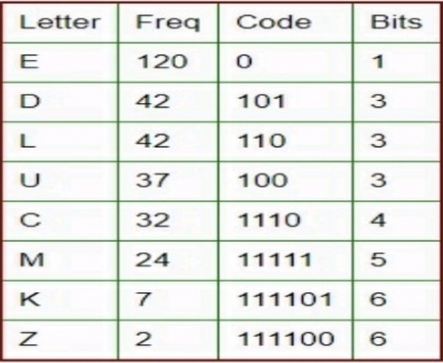

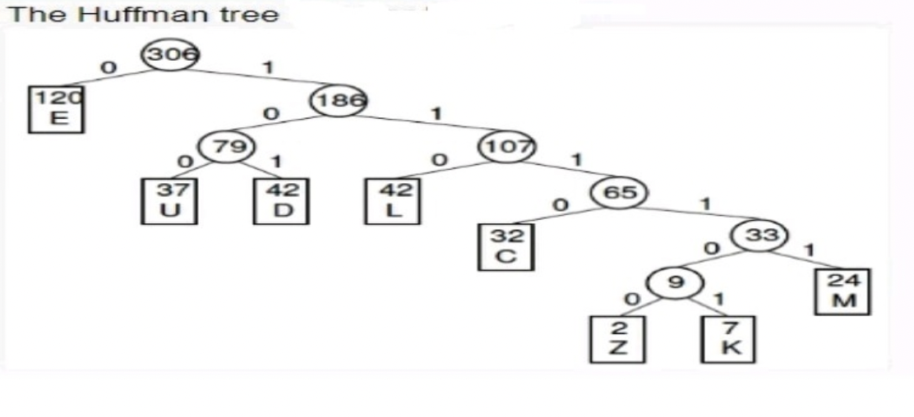

5. Explain in brief H.261 video encoding standard.
Typical operating bit rates for H.261 applications are between 64 and 384 kbps. At the time of development, packet-based transmission over the Internet was not expected to be a significant requirement, and the limited video compression performance achievable at the time was not considered to be sufficient to support bit rates below 64 kbps. A typical H.261 CODEC is very similar to the 'generic' motion-compensated DCT-based CODEC. Video data is processed in 4 : 2 : 0 Y: Cr: Cb format. The basic unit is the macroblock', containing four luminance blocks and two chrominance blocks (each 8 x 8 samples) (see Figure 4.6). At the input to the encoder, 16 x 16 macroblocks may be (optionally) motion compensated using integer motion vectors. The motion-compensated residual data is coded with an 8 x 8 DCT followed by quantisation and zigzag reordering. The reordered transform coefficients are run—level coded and compressed with an entropy encoder (see Chapter 8). Motion compensation performance is improved by use of an optional loop filter, a 2-D spatial filter that operates on each 8 x 8 block in a macroblock prior to motion compensation (if the filter is switched on). The filter has the effect of 'smoothing' the reference picture which can help to provide a better prediction reference. Chapter 9 discusses loop filters in more detail (see for example Figures 9.1 l and 9.12). In addition, a forward error correcting code is defined in the standard that should be inserted into the transmitted bit stream. In practice, this code is often omitted from practical implementations of H.261: the error rate of an ISDN channel is low enough that error correction is not normally required, and the code specified in the standard is not suitable for other channels (such as a noisy wireless channel or packet-based transmission). Each macroblock may be coded in 'intra' mode (no motion-compensated prediction) or inter' mode (with motion-compensated prediction). Only two frame sizes are supported, CIF (352 x 288 pixels) and QCIF (176 x 144 pixels). H.261 was developed at a time when hardware and software processing performance was limited and therefore has the advantage of low complexity. However, its disadvantages include poor compression performance (with poor video quality at bit rates of under about 100 kbps) and lack of flexibility. It has been superseded by H.263, which has higher compression efficiency and greater flexibility, but is still widely used in installed video conferencing systems.
6. List and Explain 4 types of images in MPEG
Intra Pictures
  - I-frames (Intra-coded Images) are self-contained without any references to other images. It is treated as a still image.
  - MPEG uses JPEG for I-frames.
  - This compression must be executed in real-time. Hence, the compression rate of I-frame is the lowest within MPEG.
  - I-frames are points to random-access in MPEG stream.
  - I-frames use 8 x 8 blocks defined within a macroblock. On these blocks, DCT is performed. Quantization is by constant value for all DCT coefficients. (i.e.,no quantization table as in JPEG)
Intra pictures, or I-Pictures, are coded using only the information present in the picture itself, and provide potential random access points into the compressed video data. It uses only transform coding and provides moderate compression. Typically it uses about two bits per coded pixel.
Predicted Pictures
  - Information of the previous I-frame and/or previous P-frames are required for encoding and decoding.
  - The coding of P-frames utilizes successive images where their areas often do not change at all. The whole area is shifted (temporal redundancy).
  - Temporal redundancy - It is required to determine the last P or I-frame that is most similar to the block under consideration.
  - Motion Estimation Method is used at the encoder.
Predicted pictures, or P-pictures, are coded with respect to the nearest previous I- or P-pictures. This technique is called forward prediction and is illustrated in the above figure. Like I-pictures, P-pictures also can serve as a prediction reference for B- pictures and future P-pictures. Moreover, P-pictures use motion compensation to provide more compression than is possible with I-pictures.
Bidirectional Pictures
Bidirectional pictures, or B-pictures, are pictures that use both a past and future picture as a reference. This technique is called bidirectional prediction. B-pictures provide the most compression since it uses the past and future picture as a reference, however, the computation time is the largest.
7. Explain MPEG basic step of audio encoding with the help of a neat diagram.
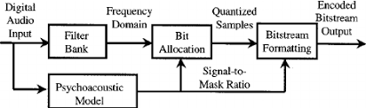

  - The frequency has to be computed from the samples. This is why the first step in MPEG audio encoding is a discrete Fourier transform, where a set of S12 consecutive audio samples is transformed to the frequency domain.
  - Since the number of frequencies can be huge, they are grouped into 32 equal width frequency sub bands (Layer III uses different numbers but the same principle).
  - For each sub band, a number is obtained that indicates the intensity of the sound at the sub-band’s frequency range. These numbers (called signals) are then quantized. The coarseness of the quantization in each sub-band and by the number of bits still available to the encoder.
  - The masking threshold is computed for each sub band using psychoacoustic model. MPEG uses psychoacoustic models to implement frequency masking and temporal masking.
  - Each model describes how loud sound masks other sounds that happen to be close to it in frequency or in time. The model partitions the frequency range into 24 critical bands and specifies how masking effects apply within each band.
  - The masking effects depend of course on the frequency and amplitude of the tones. When the sound is decompressed and played, the user (listener) may select any playback amplitude which is why the psychoacoustic model has to be designed for the worst case.
  - The masking effects also depend on the nature of the source of the sound being compressed. The two psychoacoustic models employed by MPEG are based on experimental work done by researchers over many years.

8. Explain the phases of resource reservation and management process.
  - Schedulability Test: The resource manager checks with the given QoS parameters (eg: throughput & reliability) to determine if there is enough remaining resource capacity available to handle this additional request.
  - Quality of Service Calculations: After the schedulability test, the resource manager calculates the best possible performance (eg: delay) the resource can guarantee for the new request.
  - Resource Reservation: The resource manager allocates the required capacity to meet the QoS guarantees for each request.
  - Resource Scheduling: Incoming messages from connections are scheduled according to the given QoS guarantees. For process management, for instance, the allocation of the resource is done by the scheduler at the moment the data arrives for processing.
  - With respect to the last phase, for each resource a scheduling algorithm is defined. The schedulablity test, QoS calculation and resource reservation depend on this algorithm used by the scheduler.

