Experiment No: 1
Socket Programming TCP using Python
Aim: To implement socket programming using TCP connection between client and server.
Theory:
TCP Server –
- using create(), Create TCP socket.
- using bind(), Bind the socket to server address.
- using listen(), put the server socket in a passive mode, where it waits for the client to
approach the server to make a connection
- using accept(), At this point, connection is established between client and server, and
they are ready to transfer data.
- Go back to Step 3.
TCP Client –
- Create TCP socket.
- connect newly created client socket to server.
Client: When we talk the word Client, it means to talk of a person or an organization using a particular service. Similarly in the digital world a client is a computer (Host) i.e., capable of receiving information or using a particular service from the service providers (Servers).
Servers: Similarly, when we talk the word Servers, it means a person or medium that serves something. Similarly in this digital world a Server is a remote computer which provides information (data) or access to particular services.
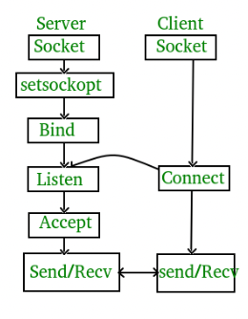

Program:
//server code
import socket
s = socket.socket(socket.AF_INET,socket.SOCK_STREAM)
print("Socket successfully created!") port = 700
s.bind(('', port))
print("Socket binded to %s" %(port)) s.listen(5)
print("Socket is listening...")
while True:
c, addr = s.accept()
print('Connected ', addr)
c.send('Thank you for connecting!'.encode())
c.close()
//client code import socket while True:
s = socket.socket(socket.AF_INET,socket.SOCK_STREAM) serverAddressPort = ("127.0.0.1", 700)
msgFromClient = input()
if msgFromClient == "exit":
break
else:
s.connect(serverAddressPort)
print(s.recv(1024).decode())
s.close()

Output:
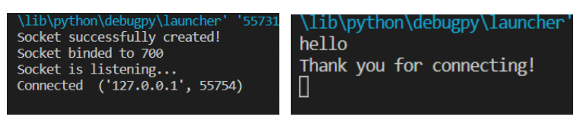

Conclusion: Socket Programming TCP using python was successfully implemented.

