Experiment No: 2
Socket Programming UDP using Python
Aim: To implement socket programming using UDP connection between client and server.
Theory:
The Client-server model is a distributed application structure that partitions task or workload between the providers of a resource or service, called servers, and service requesters called clients. In the client-server architecture, when the client computer sends a request for data to the server through the internet, the server accepts the requested process and deliver the data packets requested back to the client. Clients do not share any of their resources. Examples of Client-Server Model are Email, World Wide Web, etc.
Client: When we talk the word Client, it means to talk of a person or an organization using a particular service. Similarly in the digital world a client is a computer (Host) i.e., capable of receiving information or using a particular service from the service providers (Servers).
Servers: Similarly, when we talk the word Servers, it means a person or medium that serves something. Similarly in this digital world a Server is a remote computer which provides information (data) or access to particular services.
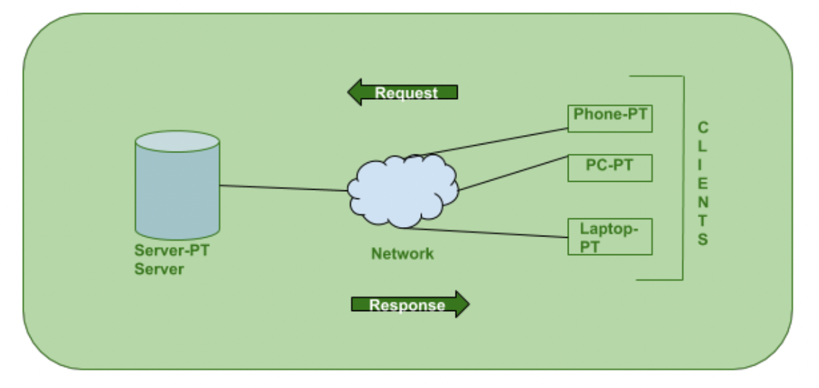

Program:
1) Client side import socket
msgFromClient = ""
bytesToSend = ""
serverAddressPort = ("127.0.0.1", 8090) bufferSize = 1024
def UserInput():
msgFromClient=input("\nEnter message for server") bytesToSend=str.encode(msgFromClient) UDPClientSocket.sendto(bytesToSend, serverAddressPort)
# Create a UDP socket at client side
UDPClientSocket = socket.socket(family=socket.AF_INET, type=socket.SOCK_DGRAM)
# Send to server using created UDP socket
while(True):
UserInput()
msgFromServer = UDPClientSocket.recvfrom(bufferSize) msg = "Message from Server {}".format(msgFromServer[0]) print(msg)
2) Server side
import socket
localIP = "127.0.0.1" localPort = 8090 bufferSize = 1024
msgFromServer = "Hello UDP Client” bytesToSend = str.encode(msgFromServer)
# Create a datagram socket
socketUDP = socket.socket(socket.AF_INET,socket.SOCK_DGRAM)
# Bind to address and ip socketUDP.bind((localIP, localPort))
print("UDP server up and listening")
# Listen for incoming datagrams while(True):
bytesAddressPair = socketUDP.recvfrom(bufferSize) message = bytesAddressPair[0]
address = bytesAddressPair[1]
clientMsg = "Message from Client:{}".format(message) clientIP = "Client IP Address:{}".format(address)
print(clientMsg,"\n")
print(clientIP,"\n")
# Sending a reply to client socketUDP.sendto(bytesToSend, address)

Output:
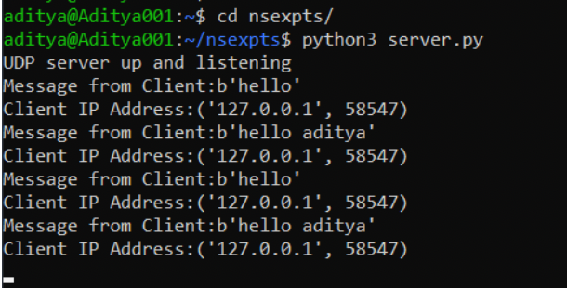

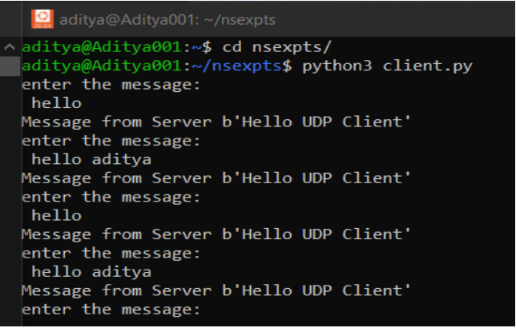

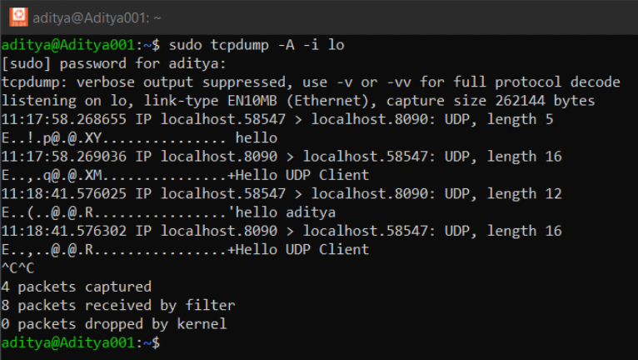

Conclusion: Socket Programming UDP using python was successfully implemented.

