Experiment No: 5
Threads

Aim: To implement threads in Distributed Operating systems.
Theory:
A thread is a single sequential flow of execution of tasks of a process so it is also known as thread of execution or thread of control. There is a way of thread execution inside the process of any operating system. Apart from this, there can be more than one thread inside a process. Each thread of the same process makes use of a separate program counter and a stack of activation records and control blocks. Thread is often referred to as a lightweight process.
User-level thread
The operating system does not recognize the user-level thread. User threads can be easily implemented and it is implemented by the user. If a user performs a user-level thread blocking operation, the whole process is blocked. The kernel level thread does not know nothing about the user level thread. The kernel-level thread manages user-level threads as if they are single-threaded processes Java thread, POSIX threads, etc.
Kernel level thread
The kernel thread recognizes the operating system. There is a thread control block and process control block in the system for each thread and process in the kernel-level thread. The kernel-level thread is implemented by the operating system. The kernel knows about all the threads and manages them. The kernel-level thread offers a system call to create and manage the threads from user-space. The implementation of kernel threads is more difficult than the user thread.

Any thread has the following components.
- Program counter
- Register set
- Stack space

Program:
import threading
# global variable x
x = 0

def increment():
"""
function to increment global variable x
"""
global x
x += 1

def thread_task():
"""
task for thread
calls increment function 100000 times.
"""
for _ in range(100000):
increment()
def main_task():
global x
# setting global variable x as 0
x = 0

# creating threads
t1 = threading.Thread(target=thread_task)
t2 = threading.Thread(target=thread_task)

# start threads
t1.start()
t2.start()

# wait until threads finish their job
t1.join()
t2.join()

if __name__ == "__main__":
for i in range(10):
main_task()
print("Iteration {0}: x = {1}".format(i,x))
Output:
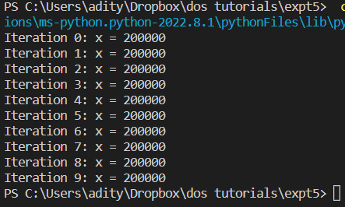

Conclusion: Threads execution experiment was implemented and executed successfully.

