Experiment No: 8
Case Study of DSDV
Theory:
Destination-Sequenced Distance-Vector Routing (DSDV) is an important MANET routing protocol. It is based on the table-driven approach to packet routing. It extends the distance vector protocol of wired networks just as the traditional algorithm makes use of classical Bellman-Ford routing algorithm. An improvement made here is the avoidance of routing loops through the use of a number sequencing scheme. In DSDV, each node in a MANET maintains a routing table in which all of the possible destinations are recorded. Hence, routing information is always readily available, regardless of whether the source node requires a specific route or not.
Each node maintains information regarding routes to all the known destinations. The routing information is updated periodically. This can be considered a shortcoming of the protocol since it deprives a node from going into sleeping mode. Also, there is a traffic overhead even if there is no change in network topology. Further, nodes maintain routes which they may never use.
A sequenced numbering system is used to allow mobile nodes to distinguish stale routes from new ones. Updated routing tables are exchanged periodically among the nodes of the network to maintain table consistency. A naive table exchange approach would generate a lot of control traffic in the network leading to inefficient utilisation of the network resources. To alleviate this problem, DSDV uses two types of route update packets. The first is known as full dump. This type of packet carries all the available routing information and can require multiple network protocol data units (NPDU’s) to be transmitted. During periods of occasional movement, these packets are transmitted infrequently. Smaller incremental packets are used to disseminate only the information that has changed since the last full dump. These incremental broadcasts usually fit into a standard NPDU, thereby decreasing the amount of traffic generated. the mobile nodes maintain an additional table where they store the data received through the incremental routing information packets from various nodes.
New route broadcasts contain the address of the destination, the number of hops to reach the destination, as well as a unique sequence number. The route labelled with the most recent sequence number is always used. Up on a change, a node might receive several messages from different sources. The weighted average time that routes to a destination will fluctuate before the route with the best metric received. Mobiles also keep track of this settling time of routes. By delaying the broadcast of a routing update by the length of the settling time, mobiles can reduce network traffic and optimize routes by eliminating the suboptimal ones.
Important steps in the operation of DSDV
The important steps in the operation of DSDV are summarized below:
- Each router (node) in the network collects route information from all its neighbours.
- After gathering information, the node determines the shortest path to the destination based on the gathered information.
- Based on the gathered information, a new routing table is generated.
- The router broadcasts this table to its neighbours. On receipt by neighbours, the neighbour nodes recompute their respective routing tables.
- This process continues till the routing information becomes stable.
DSDV incorporates a sequenced numbering scheme. Each routing advertisement comes with a sequence number. Within an ad hoc network, advertisements may propagate along many paths. Sequence numbers help a node to consider the advertisements in the correct order. This avoids the loops that may form while using the unchanged distance vector algorithm. Figure 7.3 shows an example of a MANET. Table 7.1 is the routing table of the node N4 at the moment before the movement of nodes . The metric field in the routing table helps to determine the number of hops required for a packet to traverse to its destination. The install time indicates when the entry was made. It is used to delete stale entries from the table.
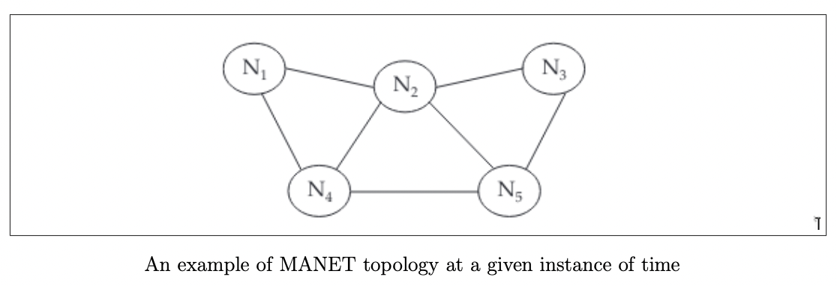
Conclusion: A case study of DSDV routing was successfully conducted

