Experiment No: 9
Case Study of DSR
Theory:
Dynamic Source Routing (DSR) (Johnson and Maltz 1996, 2001) protocol was developed to be suitable for use in a MANET having a reasonably small diameter of about 5 to 10 hops and when the nodes do not move very fast. DSR is a source initiated on-demand (or reactive) routing protocol for ad hoc networks. It uses source routing, a technique in which the sender of a packet determines the complete sequence of nodes through which a packet has to travel. The sender of the packet then explicitly records this list of all nodes in the packet’s header. This makes it easy for each node in the path to identify the next node to which it should transmit the packet for routing the packet to its destination.
In this protocol, the nodes do not need to exchange the routing table information peri- odically, which helps to reduce the bandwidth overhead associated with the protocol. Each mobile node participating in the protocol maintains a routing cache which contains the list of all routes that the node has learnt. Whenever a node finds a new route, it adds the new route to its routing cache. Each mobile node also maintains a sequence counter called request id to uniquely identify the last request it had generated. The pair < source address, request id > uniquely identifies any request in the ad hoc network. DSR works in two phases: (i) Route discovery and (ii) Route maintenance. We discuss these two phases in the following
Route Discovery
Route discovery allows any host to dynamically discover the route to any destination in the ad hoc network. When a node has a data packet to send, it first checks its own routing cache. If it finds a valid route in its own routing cache, it sends out the packet using this route. Otherwise, it initiates a route discovery process by broadcasting a route request packet to all its neighbours. The route request packet contains the source address, the request id and a route record in which the sequence of hops traversed by the request packet, before reaching the destination is recorded
A node upon getting a route request packet does the following. If a packet does not have the required route in its routing cache, it forwards the packet to all its neighbours. A node forwards a route request message only if it has not yet seen it earlier, and if it is not the destination. The route request packet initiates a route reply upon reception either by the destination node or by an intermediate node that knows a route to the destination. Upon arrival of the route request message at the destination, this information is piggybacked on to the route reply message that contains the path information and is sent to the source node.
The route discovery process is schematically shown in the figure below. As shown in the figure, suppose a node N1 wishes to send a message to the destination node N8. The
intermediate nodes are N2, N3, N4, N5, N6, N7. The node N1 initiates the route discovery process by broadcasting a route request packet to its neighbours N2 and N3. Note that each node can have multiple copies of the route request packet arriving at it.
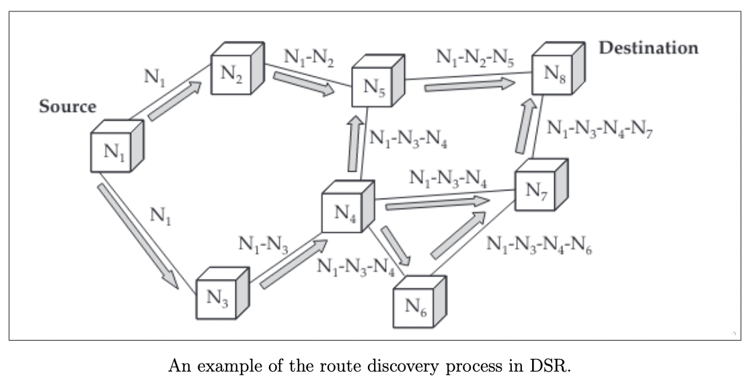
The propagation of route reply is shown below, and the acknowledgement messages from destination to source are indicated by thick arrows

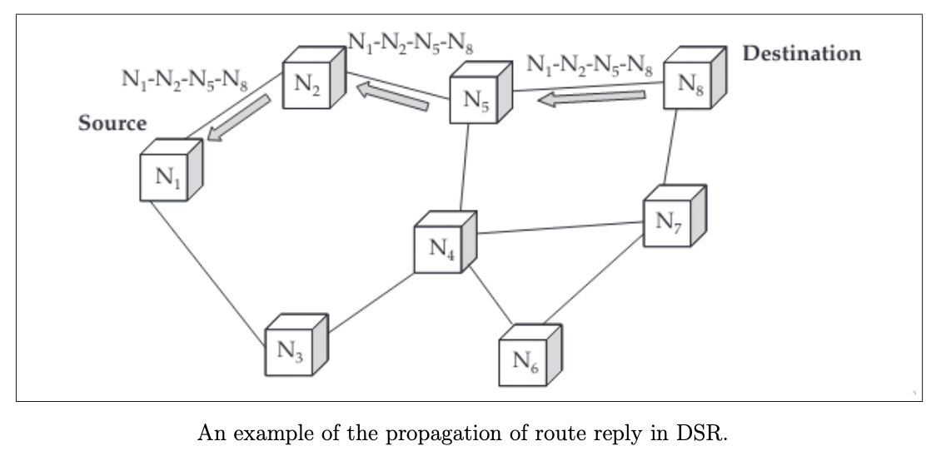
Route Maintenance
A known route can get broken either due to the movement of some nodes making up the route or the battery of a node forming part of the route getting exhausted. Route maintenance is the process of monitoring the correct operation of a route in use and taking any corrective action when needed. When a host (source) while using a route, finds that it is inoperative, it carries out route maintenance. Whenever a node wanting to send a message finds that the route is broken, it would help if it already knows of some alternative routes. Since the nodes do not exchange any routing information in this protocol, whenever a node detects that one of its next hop neighbour node is not responding, it sends back a route error packet containing its own address and the address of the hop that is not working. As soon as the source node receives the RouteError message, it deletes the broken-link-route from its cache. If it has another route to the destination, it starts to retransmit the packet using the alternative route. Otherwise, it initiates the route discovery process again
Conclusion: A case study of DSR routing was successfully conducted

