Tutorial No: 1
1. What is the difference between a data network and a voice network? What are the relative advantages? What types of communication services are usually offered on each of these?
Differences between data network and voice network:
In a voice network, analog traffic is usually modulated on a carrier signal for spectral and transmission efficiency. Whereas, data networks carry data in digital form. The data signals are also modulated on an analog carrier signal for spectral and transmission efficiency.
Data networks are more recent in origin compared to Voice networks. Traditional voice networks such as PSTN (public switched telephone networks) relied on circuit switching, whereas data networks are based on store and forward packet switching mechanism.
Relative Advantages:
A big advantage of the packet-switched networks is that they make efficient use of the transmission medium and therefore are much more cost effective compared to circuit-switched networks
The modern day networks deploy high-speed, powerful switches and routers. This has made it possible for voice to be transmitted over packet-switched networks and hence VoIP (Voice over Internet Protocol) has become a very popular and cheap medium of communication
2. What are the main difficulties that would be experienced if digitized voice signals are to be transmitted over a data network? How can these difficulties be overcome?
Data networks are based on store and forward packet switching mechanism. An inherent shortcoming of using a store and forward network for digitized voice signal transmission is that in a store-and-forward network, every switch inspects the packet to determine its destination and based on this information the network sends the packet on its way forward. Further, depending on the traffic conditions, packets can get stored at a switch for a signif icant amount of time causing queues to get built up at various switches. The cumulative delays that a packet undergoes at various switches can be hundreds of times longer than the propagation delay. So, the different packets of a voice call can undergo different amounts of delay causing degraded sound quality. In a voice call, even a moderate delay at a switch can cause crackling or popping sounds at the receiver. Unless the switches are built using very high-speed hardware, the receiver of a call would hear such distracting noises. This was possibly a reason why packet switching was not used for voice calls until recently. The modern day networks deploy high-speed, powerful switches and routers. This has made it possible for voice to be transmitted over packet-switched networks and hence VoIP (Voice over Internet Protocol) has become a very popular and cheap medium of communication.
3. What is CAN (Controller Area Network)? How is it different from LAN? What are the important applications of CAN?
A Controller Area Network (CAN) is essentially a very small network that is typically used to connect the different components of an embedded controller whereas, a Local Area Network (LAN) is typically deployed in a building or a campus and is usually privately owned. For example, a LAN can be used to connect a number of computers within an organization to share data and other resources such as files, printers, FAX services, etc. The end-to-end length of a CAN is usually less than 50 metres. Since the propagation time of a CAN is very small, it behaves more like a local bus in a computer. A special requirement placed on CAN is that it should be able to effectively handle noise. Automotive components such as electric motors, ignition systems, as well as RF transmissions, are heavy producers of noise. Another requirement imposed on CAN is the use by it of the 12-volt power supply that was mandated by the conventional 12-volt automotive power supply. CAN specifies only the physical and data link layers of the ISO/OSI model while the higher layers are left open for specific implementations
Applications:
The limitations of fixed point-to-point wiring techniques in handling the demands of modern automated cars and other embedded applications, gave rise to the development of CAN. Because of its robustness, the use of CAN has extended beyond its automotive origins and can now be found in diverse application areas such as industrial automation systems, trains, ships, agricultural machinery, household appliances, office automation systems and elevators. Now CAN is an international standard under ISO 11898 and ISO 11519–2
4. What is a transceiver? What is the role of a transceiver in a wireless communication network?
In a transceiver, a transmitter and a receiver are co-located for supporting fullduplex com- munications. In this case, the same antenna is usually shared by both the transmitter and the receiver. Access point is a radio receiver/transmitter (also called transceiver) that con- nects to the wired network. These are typically mounted on the roofs at different locations of a building. The transceiver exchanges signals with the wireless LAN card in desktop or notebook PCs
5. Discuss the architecture of a mobile telecommunication network using a schematic diagram.
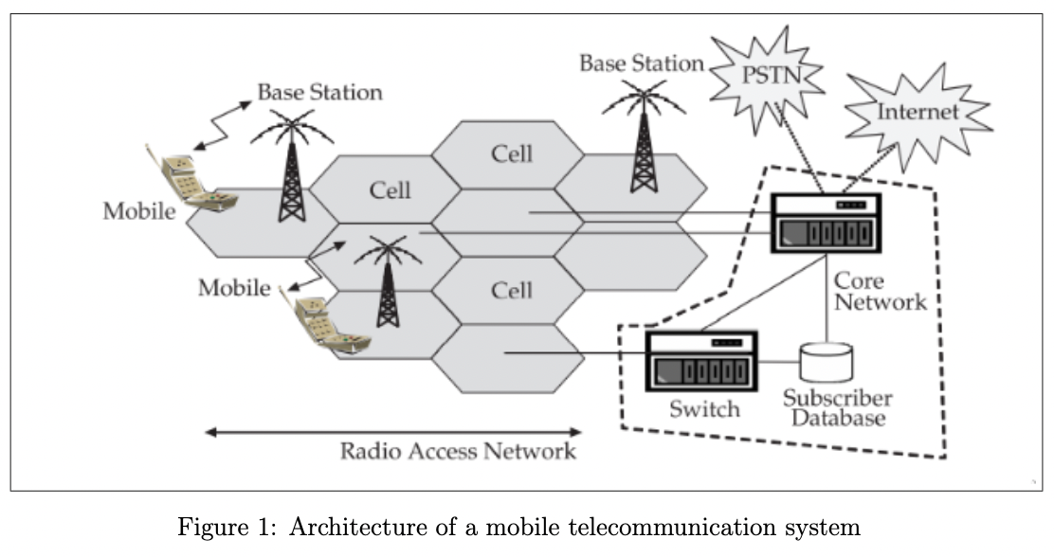

It has three main components: the core network, the radio access network, and the mobile phones. Mobile handsets communicate over the radio access network. The radio access network is primarily composed of the base stations which communicate with the mobile phones using radio frequency electromagnetic waves. As shown in Fig. 1.4, the coverage area is decomposed into hexagonal cells. In each hexagonal cell, one base station is located. Two types of radio channels are usually involved in the communication between a base station and the cell phones: control channels and voice channels. Control channels typically use frequency shift keying (FSK) and are used for transferring control messages (data) between the mobile phone and the base station. Voice channels typically use frequency modulation (FM). A base station typically has two antennas of different characteristics. One antenna is used for receiving and the other for transmitting. The use of the two different types of antennas at the base station increases the ability of the base station to receive the radio signal from mobiles that use very low transmitter power levels. On the other hand, mobile handsets typically use the same antenna for both receiving and transmitting.
The core network interconnects the base stations, switches the mobile switching centre (MSC), and also provides an interface to other networks such as the traditional telephone network (PSTN) and the Internet. The interconnect used in the core network is required to provide highspeed connectivity. Therefore, usually fibre optic cables are used as the inter- connect in the core network. But based on the terrain conditions, microwave communication is also sometimes used. This interconnection in the core network must allow both voice and control information to be exchanged between the switching system and the base station. The MSC is connected to the landline telephone network to allow mobile telephones to be connected to standard landline telephones. The core network is responsible for transmitting voice calls, SMS (Short Message Service), etc. from one phone to another through switches. The core network also maintains a database that contains information about the subscribers and the information about billing.

