Tutorial No: 2
1. What is the role of a MAC protocol? At which ISO/OSI layer does it operate?
The primary responsibility of a MAC protocol is to enforce discipline in the access of a shared channel when multiple nodes contend to access that channel. At the same time, two other objectives of any MAC protocol are maximization of the utilization of the channel and minimization of average latency of transmission.
The MAC protocol is a sublayer of the data link layer protocol and it directly invokes the physical layer protocol.
2. What is a hidden terminal? What problem does it create during wireless communications? Explain your answer using a suitable schematic diagram.
The hidden terminal problem arises when at least three nodes (A, B, and C), as shown in figure, communicate among each other. As shown in this figure, B is in the radio range of A, and B is also within the radio range of C. However, the nodes A and C are not in the radio range of each other. Note that if both A and C start to transmit to B at the same time, the data received at node B would get garbled. Such a situation can arise because A and C are “hidden” from each other, because they are outside each other’s transmission range. In this situation, when one node starts to sense the medium before transmission, it cannot sense that the other node is also transmitting. This creates a very difficult and important arbitration problem that a MAC protocol needs to resolve
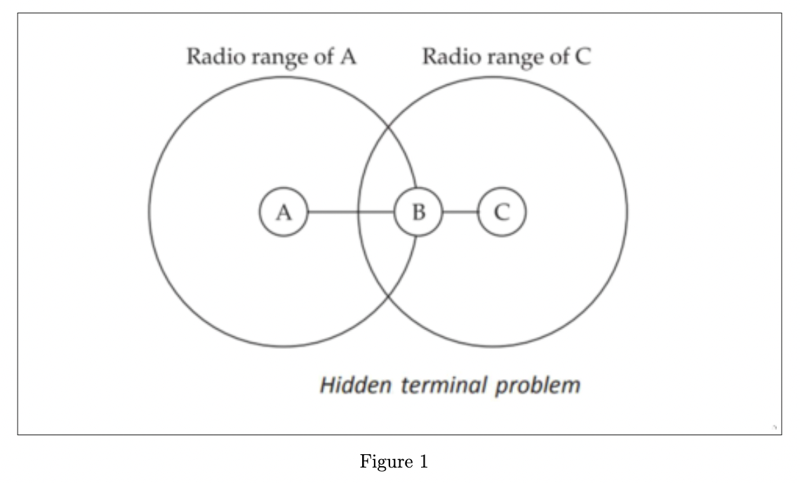

3. When does the exposed terminal problem arise? Explain your answer using a suitable example.
A related problem called exposed terminal could arise in a scenario such as that depicted in figure. MAC protocols usually inhibit transmission when transmission from another terminal is detected. As a result, node A will not be able to transmit to any node when B is transmit- ting to C. On the other hand, had A transmitted to D, it would have been received correctly by D and B’s transmission would have also been correctly received at C. The problem arose only because A and B are within each other’s transmission range, though the destination nodes are in the transmission range of only one of the nodes. In other words, the problem occurs because A is exposed to B’s transmission. The overall effect of this problem is that it leads to inefficient spectrum usage as well as unnecessary transmission delays unless these are carefully addressed by a wireless MAC protocol
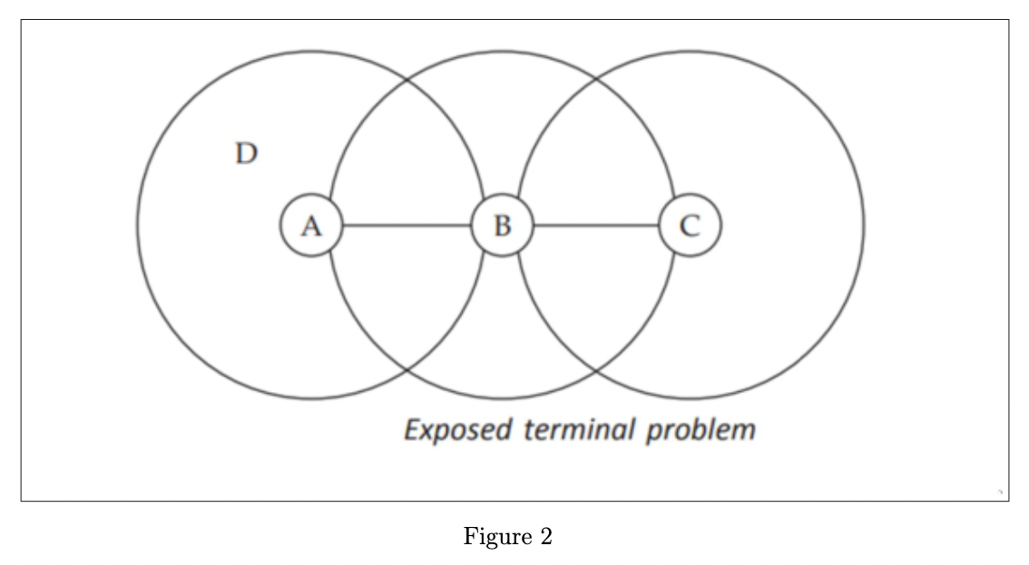

4. What are the principal responsibilities of the MAC protocols? How do MAC protocols for wireless networks differ from those in wired networks?
The primary responsibility of a MAC protocol is to enforce discipline in the access of a shared channel when multiple nodes contend to access that channel. At the same time, two other objectives of any MAC protocol are maximization of the utilization of the channel and minimization of average latency of transmission.
A MAC protocol in a wireless medium is much more complex than its wired counterpart. First, a collision detection scheme is difficult to implement in a wireless environment, since collisions are hard to be detected by the transmitting nodes. Also, in infrastructure-less net- works, the issue of hidden and exposed terminals make a MAC protocol extremely inefficient unless special care is taken to overcome these problems.

5. What are the broad categories of MAC protocols? Name one popular protocol from each of these categories
MAC protocols can be broadly divided into the following three categories:
Fixed assignment schemes
The fixed assignment schemes are usually called circuit-switched schemes. In the fixed assignment schemes, the resources required for a call are assigned for the entire duration of the call. A few important categories of fixed assignment MAC protocols are the following: Frequency Division Multiple Access (FDMA), Time Division Multiple Access (TDMA), Code Random assignment schemes
The random assignment schemes and the reservation schemes are called packet switched schemes. The random assignment schemes are comparable to the connection-less packet- switching schemes. In this, no resource reservations are made, the nodes simply start to transmit as soon as they have a packet to send. A few important ones are the following: ALOHA, Slotted ALOHA, CSMA, CSMA/CD
Reservation-based schemes
the reservation schemes, a node makes explicit reservation of the channel for an entire call before transmitting. This is analogous to a connection-based packet-switching scheme. The reservation-based MAC schemes are suitable to handle calls with widely varying traffic characteristics. A basic form of the reservation scheme is the RTS (Ready to Send)/CTS (Clear to Send)
6. Why are collision-detection based protocols not suitable for wireless networks?
A collision detection scheme is difficult to implement in a wireless environment, since collisions are hard to be detected by the transmitting nodes. Wireless transceivers can’t send and receive on the same channel at the same time, so they cant detect collisions

7. What is FDMA? Briefly explain its working and at least one of its important applications.
In Frequency Division Multiple Access (FDMA), the available bandwidth (frequency range) is divided into many narrower frequency bands called channels. Figure shows a division of the existing bandwidth into many channels (shown as Ch 1, Ch 2, etc.). For full duplex communication to take place, each user is allocated a forward link (channel) for communicating from it (mobile handset) to the base station (BS), and a reverse channel for communicating from the BS to it. Thus, each user making a call is allocated two unique frequency bands (channels), one for transmitting and the other for receiving signals during the call. Obviously, when a call is underway, no other user would be allocated the same frequency band to make a call. Unused transmission time in a frequency band that occurs when the allocated caller pauses between transmissions, or when no user is allocated a band, goes idle and is wasted. FDMA, therefore, does not achieve a high channel
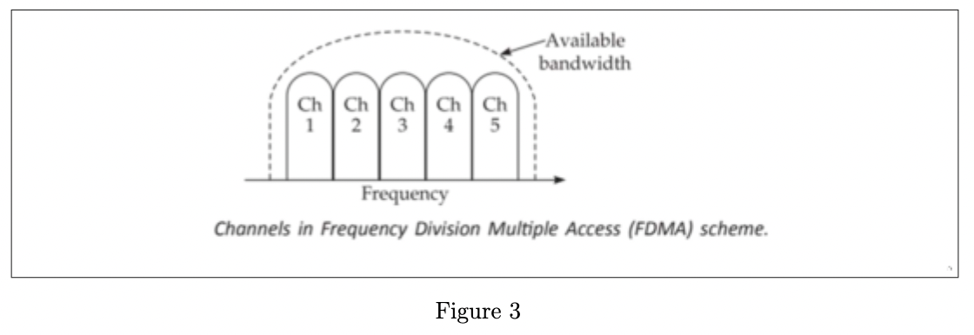

8. What is TDMA? Briefly explain its working and at least one of its important applications.
Time Division Multiple Access (TDMA) is an access method in which multiple nodes are al- lotted different time slots to access the same physical channel. That is, the timeline is divided into fixed-sized time slots and these are divided among multiple nodes who can transmit. Note that in this case, all sources use the same channel, but take turns in transmitting. Figure shows the situation where time slots are allocated to users in a round robin manner, with each user being assigned one time slot per frame. In TDMA, each user of the chan- nel owns the channel for exclusive use for one time slot at a time in a round robin fashion. Applications of TDMA are GSM, Satellite System, IS-136, Digital Cellular Communication.
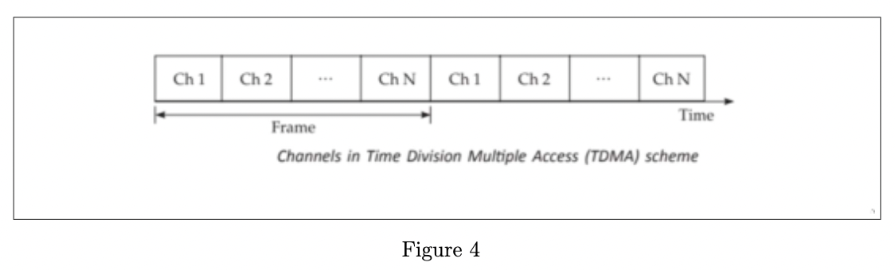

9. Explain the basic scheme of the CDMA protocol. What is the role of a pseudorandom sequence generator in the working of the CDMA protocol?
In Code Division Multiple Access (CDMA), multiple users are allotted different codes that consist of sequences of 0 and 1 to access the same channel. As shown in figure, a special coding scheme is used that allows signals from multiple users to be multiplexed over the same physical channel. As shown in the figure, three different users who have been assigned separate codes are multiplexed on the same physical channel.
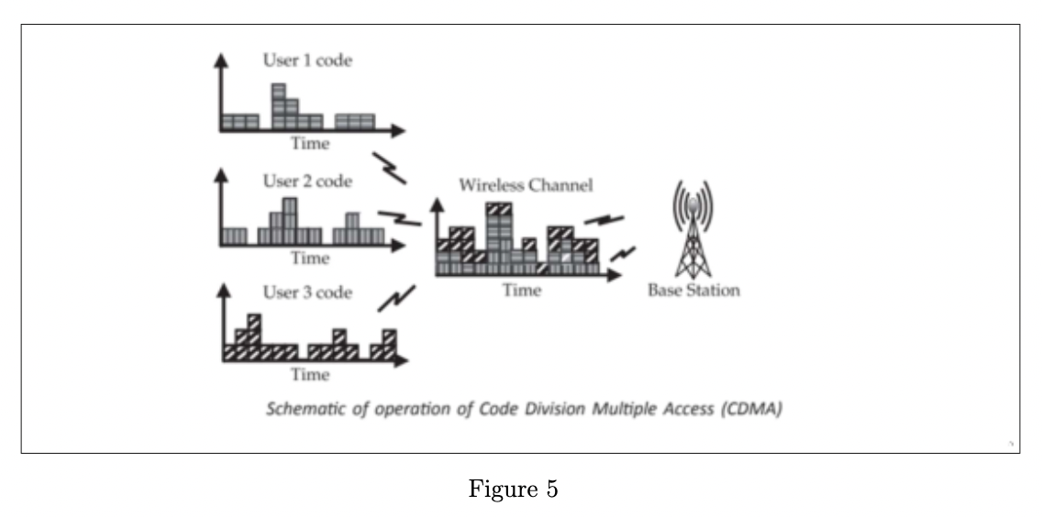

In CDMA, multiple users use the same frequency at the same time and no time scheduling is applied. All the senders send signals simultaneously through a common medium. The bandwidth of this medium is much larger than the space that would be allocated to each packet transmission during FDMA and the signals can be distinguished from each other by means of a special coding scheme that is used.
In CDMA, a code actually denotes a starting point (seed) for a pseudorandom sequence generator. Pseudorandom Sequence Generator generates a series of bits at a frequency which is much higher than the actual user data (such as digitized voice). These bits are XORd with the user data and subsequently the results are transmitted. They hop around many times per bit of user data. The pseudorandom sequence determines this hopping, rather than a fixed assignment to each

