Tutorial No: 3
Q1) Explain the term interference in the space, time, frequency and code domain? what are the counter measures in SDMA, TDMA, FDMA and CDMA systems?
Interference and countermeasures in:
• SDMA: Interference happens if senders are too close to each other. Terminals or base stations have to keep a minimum distance.
• TDMA: Interference happens if senders transmit data at the same time. Counter measures are tight synchronisation and guard spaces (time gap between transmissions).
• FDMA: Interference happens if senders transmit data at the same frequency. Thus, different frequencies have to be assigned to senders by organisations, algorithms in base stations, common frequency hopping schemes etc. Furthermore, guard bands between used frequency bands try to avoid interference.
• CDMA: Interference happens if senders transmit data using non-orthogonal codes, i.e., the correlation is not zero. Thus, senders should use orthogonal or quasi-orthogonal codes.
Q2) Assume all stations can hear all other stations. one station wants to transmit and senses the carrier idle. Why can a collision still occur after the start of the transmission?
Even in vacuum radio waves have limited velocity - the speed of light. As soon as matter is in the way waves travel even slower.
Thus, it can happen that a sender senses the medium idle, starts the transmission and just in a moment before the waves reach another sender this second sender senses the medium idle and starts another transmission. This is the reason for CD (listen while talk) in classical CSMA/CD Ethernets.
Q3) What are the benefits of reservation schemes? How are collisions avoided during data transmission, Why is the probability of collisions lower compared to classical aloha? what are the disadvantages of reservation schemes?
After reservation of the medium succeeded no more collisions can occur (if the system is error free). Reservation schemes can also guarantee bandwidth, delay, and maximum jitter. Thus, during the transmission nothing can happen.
Compared to classical Aloha the collision probability is lower because the contention period is kept short compared to the contention-free period where transmission takes place.
A disadvantage of reservation schemes is the latency for data transmission. Before terminals can start transmission, they have to reserve the medium. This wastes time in case of a very lightly loaded medium.

Q4) How can MACA still fail in the case of hidden/exposed terminals? MACA - (medium access collision avoidance)
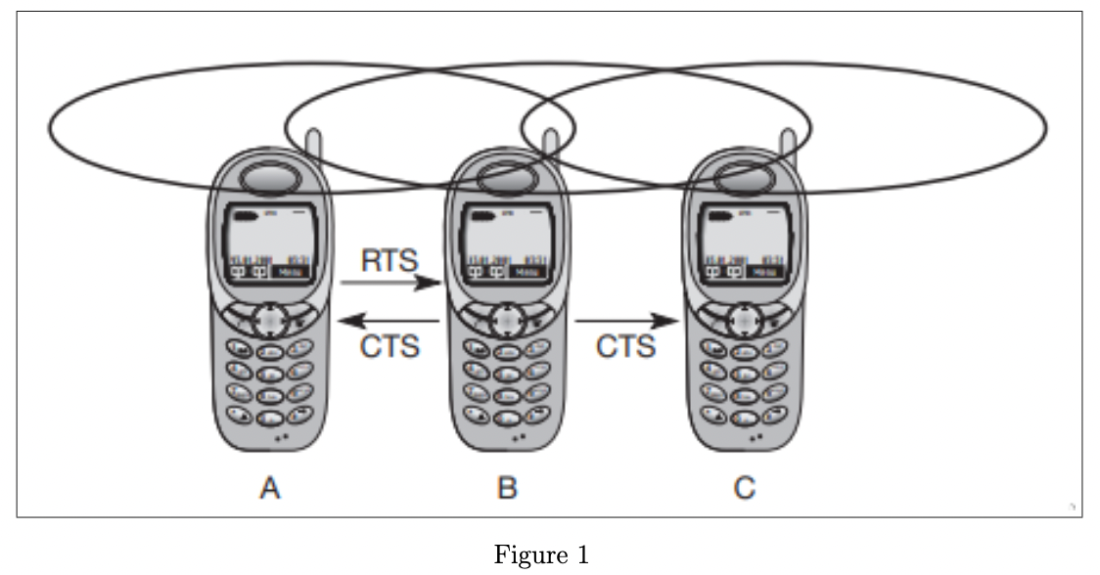
Multiple access with collision avoidance (MACA) presents a simple scheme that solves the hidden terminal problem, does not need a base station. Remember, A and C both want to send to B. A has already started the transmission, but is hidden for C, C also starts with its transmission, thereby causing a collision at B. With MACA, A does not start its trans- mission at once, but sends a request to send (RTS) first. B receives the RTS that contains the name of sender and receiver, as well as the length of the future transmission.
This RTS is not heard by C, but triggers an acknowledgement from B, called clear to send (CTS). The CTS again contains the names of sender (A) and receiver (B) of the user data, and the length of the future transmission. This CTS is now heard by C and the medium for future use by A is now reserved for the duration of the transmission. After receiving a CTS, C is not allowed to send anything for the duration indicated in the CTS toward B. A collision cannot occur at B during data transmission, and the hidden terminal problem is solved – provided that the transmission conditions remain the same. (Another station could move into the transmission range of B after the transmission of CTS.)
Think of asymmetric transmission conditions and, for example, the hidden terminal scenario. What if station C in the above figure transmits with a lot of power while it cannot receive anything from B? Then MACA fails because CTS is not received but C causes a collision at B.

