**Python Tasks – Day11**

1. **Write Python Code to print these patterns**

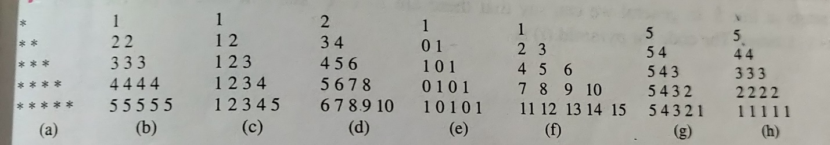

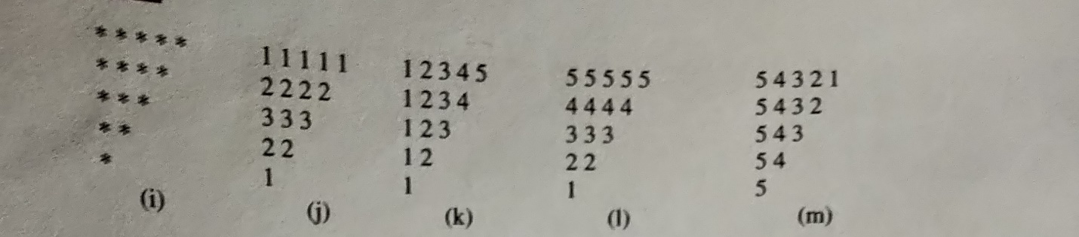

1. **Write Python Code to print these patterns**

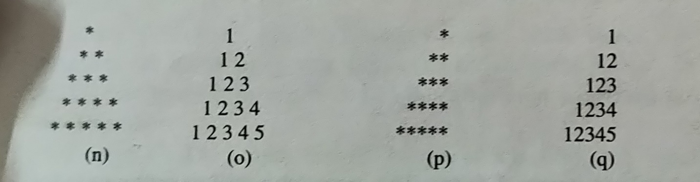

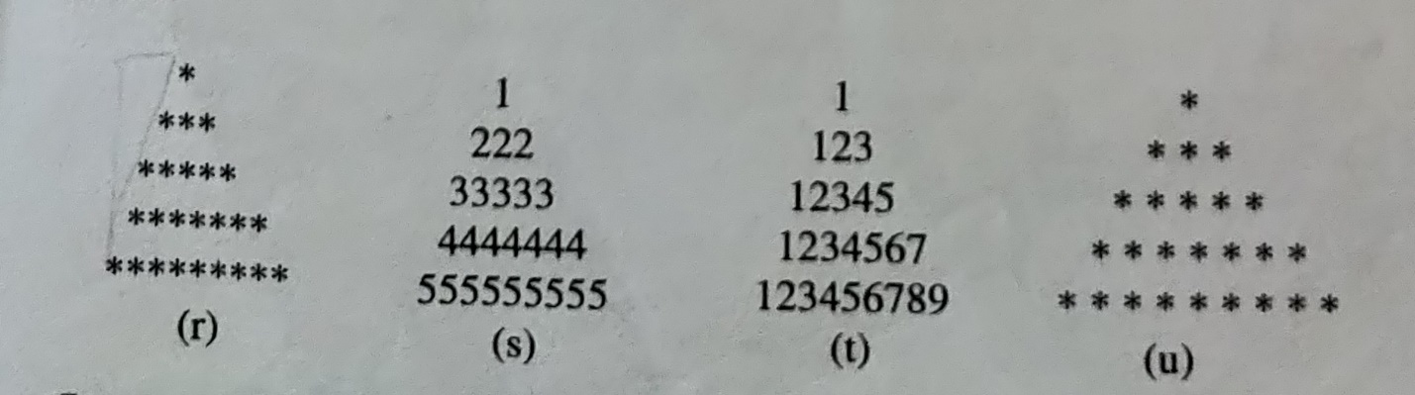

1. **Write Python Code to print these patterns**

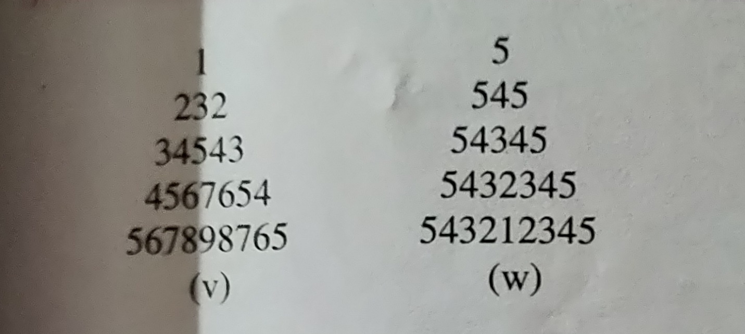

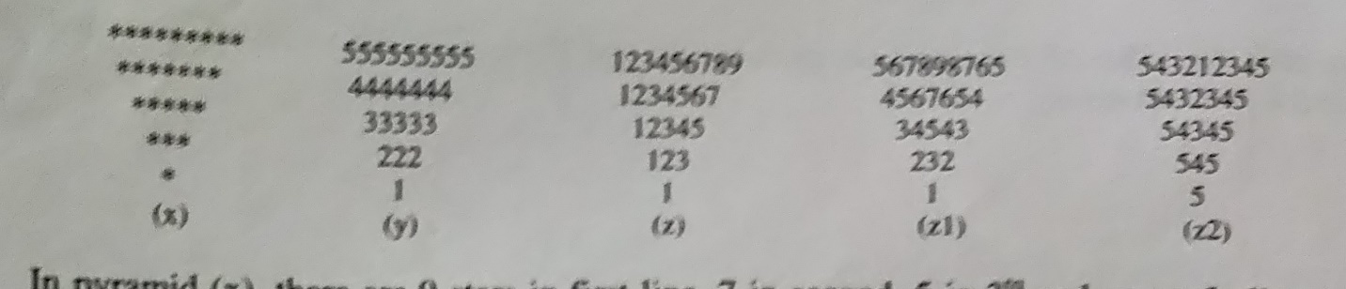

1. **Write Python Code to print these patterns**

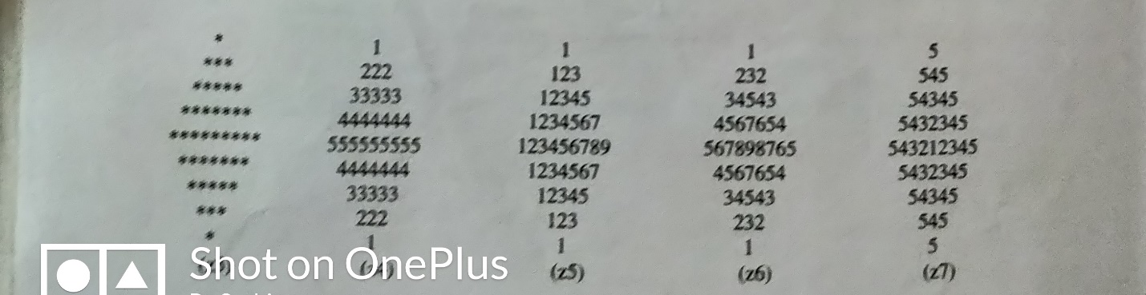

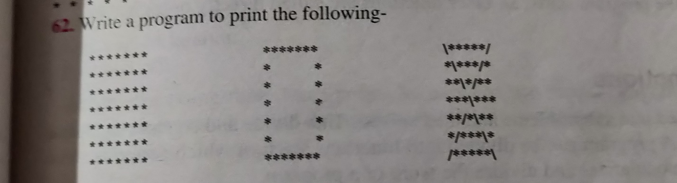

1. **Write Python Code to print these patterns**

