Output
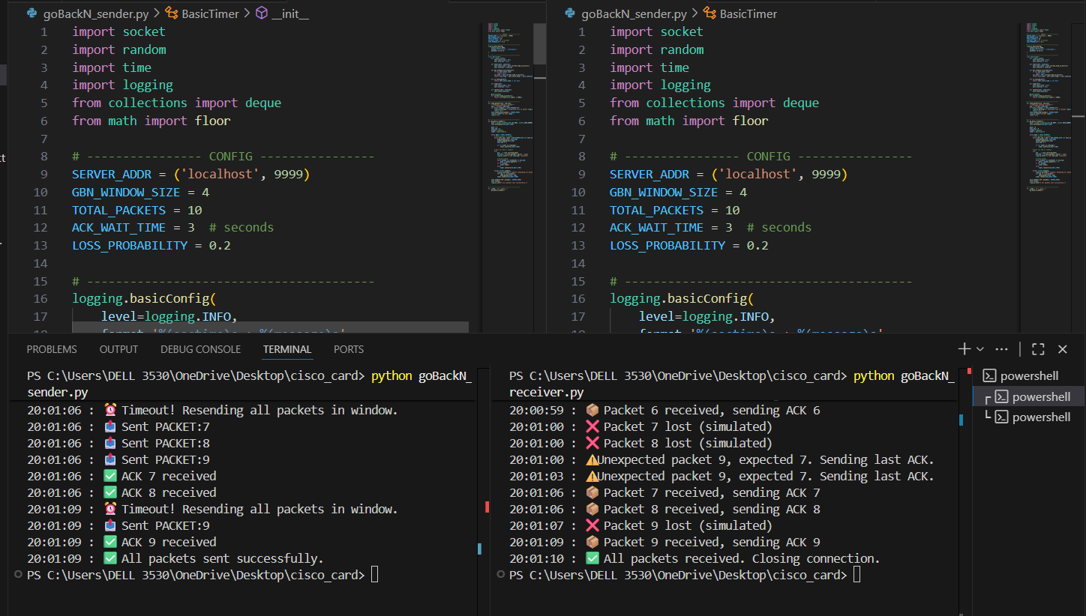
Gbn sender:
import socket
import random
import time
import logging
from collections import deque
from math import floor

# ---------------- CONFIG ----------------
SERVER_ADDR = ('localhost', 9999)
GBN_WINDOW_SIZE = 4
TOTAL_PACKETS = 10
ACK_WAIT_TIME = 3 # seconds
LOSS_PROBABILITY = 0.2

# ----------------------------------------
logging.basicConfig(
level=logging.INFO,
format='%(asctime)s : %(message)s',
datefmt='%H:%M:%S'
)

# ----------------------------------------
class BasicTimer:
def __init__(self):
self.start_time = None
self.interval = None

def start(self, interval):
self.start_time = self.current_time_in_millis()
self.interval = interval

def has_timeout_occurred(self):
if not self.start_time:
return False
cur_time = self.current_time_in_millis()
return (cur_time - self.start_time) > self.interval * 1000

def is_running(self):
return self.start_time is not None

def stop(self):
self.start_time = None
self.interval = None

def restart(self, interval):
self.start(interval)

@staticmethod
def current_time_in_millis():
return int(floor(time.time() * 1000))

# ----------------------------------------
def send_packet(sock, seq_num):
"""Simulate sending a packet"""
msg = f"PACKET:{seq_num}"
if random.random() < LOSS_PROBABILITY:
logging.warning(f"❌ Simulated loss of packet {seq_num}")
return False
sock.sendto(msg.encode(), SERVER_ADDR)
logging.info(f"📤 Sent {msg}")
return True

# ----------------------------------------
def go_back_n_sender():
sock = socket.socket(socket.AF_INET, socket.SOCK_DGRAM)
sock.settimeout(ACK_WAIT_TIME)

base = 0
next_seq = 0
window = deque()
timer = BasicTimer()

while base < TOTAL_PACKETS:
# Send packets in window
while next_seq < base + GBN_WINDOW_SIZE and next_seq < TOTAL_PACKETS:
send_packet(sock, next_seq)
window.append(next_seq)
next_seq += 1

if not timer.is_running():
timer.start(ACK_WAIT_TIME)

# Wait for ACK or timeout
try:
ack, _ = sock.recvfrom(1024)
ack_num = int(ack.decode().split(':')[1])
logging.info(f"✅ ACK {ack_num} received")

# Slide window
while window and window[0] <= ack_num:
base = window.popleft() + 1
if not window:
timer.stop()
else:
timer.restart(ACK_WAIT_TIME)

except socket.timeout:
logging.warning("⏰ Timeout! Resending all packets in window.")
for seq in list(window):
send_packet(sock, seq)
timer.restart(ACK_WAIT_TIME)

sock.sendto("END".encode(), SERVER_ADDR)
sock.close()
logging.info("✅ All packets sent successfully.")

# ----------------------------------------
if __name__ == "__main__":
go_back_n_sender()

gbn receiver:
import socket
import random
import time
import logging
from collections import deque
from math import floor

# ---------------- CONFIG ----------------
SERVER_ADDR = ('localhost', 9999)
GBN_WINDOW_SIZE = 4
TOTAL_PACKETS = 10
ACK_WAIT_TIME = 3 # seconds
LOSS_PROBABILITY = 0.2

# ----------------------------------------
logging.basicConfig(
level=logging.INFO,
format='%(asctime)s : %(message)s',
datefmt='%H:%M:%S'
)

# ----------------------------------------
class BasicTimer:
def __init__(self):
self.start_time = None
self.interval = None

def start(self, interval):
self.start_time = self.current_time_in_millis()
self.interval = interval

def has_timeout_occurred(self):
if not self.start_time:
return False
cur_time = self.current_time_in_millis()
return (cur_time - self.start_time) > self.interval * 1000

def is_running(self):
return self.start_time is not None

def stop(self):
self.start_time = None
self.interval = None

def restart(self, interval):
self.start(interval)

@staticmethod
def current_time_in_millis():
return int(floor(time.time() * 1000))

# ----------------------------------------
def send_packet(sock, seq_num):
"""Simulate sending a packet"""
msg = f"PACKET:{seq_num}"
if random.random() < LOSS_PROBABILITY:
logging.warning(f"❌ Simulated loss of packet {seq_num}")
return False
sock.sendto(msg.encode(), SERVER_ADDR)
logging.info(f"📤 Sent {msg}")
return True

# ----------------------------------------
def go_back_n_sender():
sock = socket.socket(socket.AF_INET, socket.SOCK_DGRAM)
sock.settimeout(ACK_WAIT_TIME)

base = 0
next_seq = 0
window = deque()
timer = BasicTimer()

while base < TOTAL_PACKETS:
# Send packets in window
while next_seq < base + GBN_WINDOW_SIZE and next_seq < TOTAL_PACKETS:
send_packet(sock, next_seq)
window.append(next_seq)
next_seq += 1

if not timer.is_running():
timer.start(ACK_WAIT_TIME)

# Wait for ACK or timeout
try:
ack, _ = sock.recvfrom(1024)
ack_num = int(ack.decode().split(':')[1])
logging.info(f"✅ ACK {ack_num} received")

# Slide window
while window and window[0] <= ack_num:
base = window.popleft() + 1
if not window:
timer.stop()
else:
timer.restart(ACK_WAIT_TIME)

except socket.timeout:
logging.warning("⏰ Timeout! Resending all packets in window.")
for seq in list(window):
send_packet(sock, seq)
timer.restart(ACK_WAIT_TIME)

sock.sendto("END".encode(), SERVER_ADDR)
sock.close()
logging.info("✅ All packets sent successfully.")

# ----------------------------------------
if __name__ == "__main__":
go_back_n_sender()

