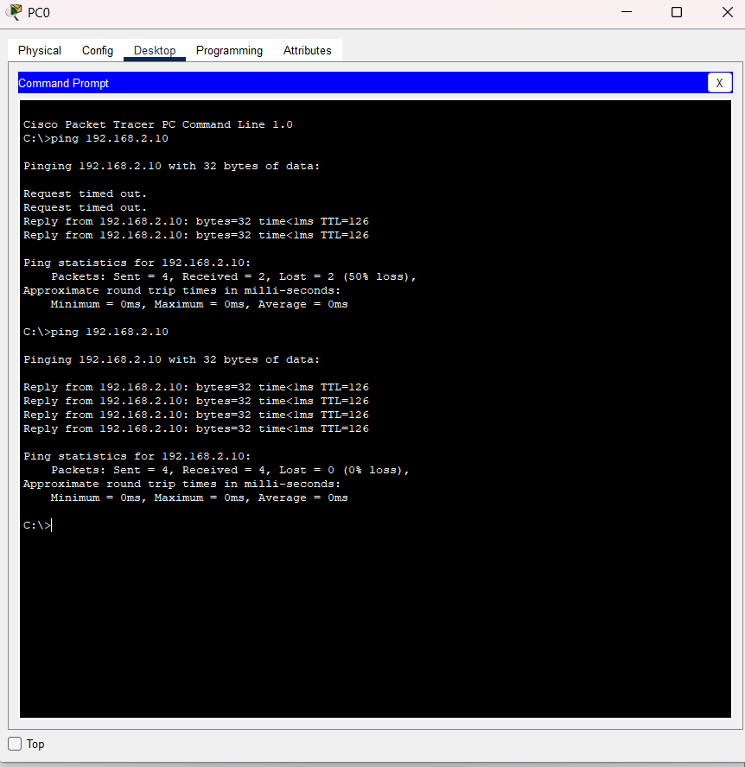  Figure 1: asgn8 | 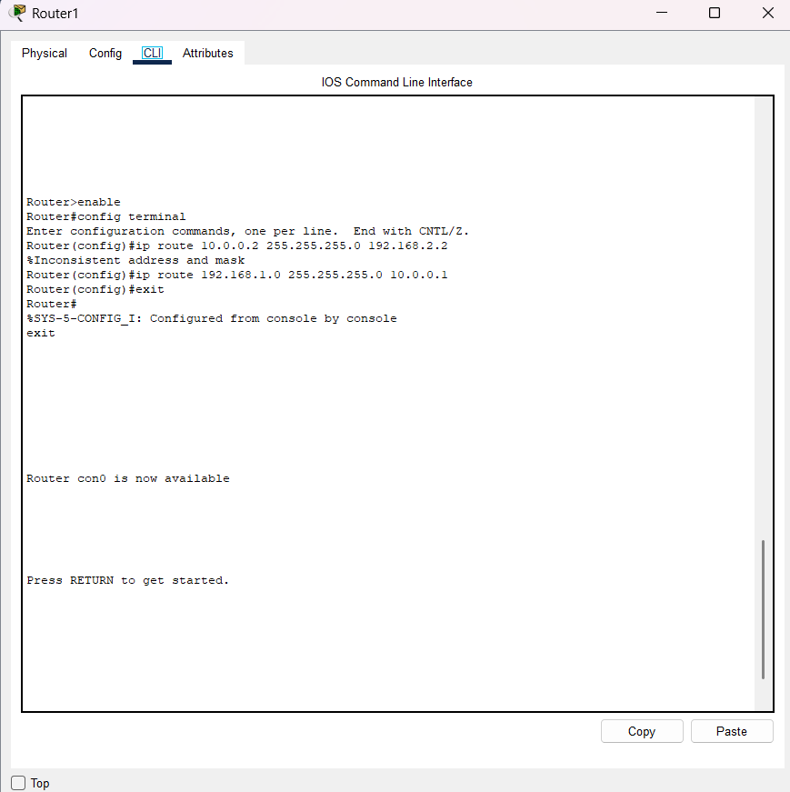  Figure 2: asgn 8
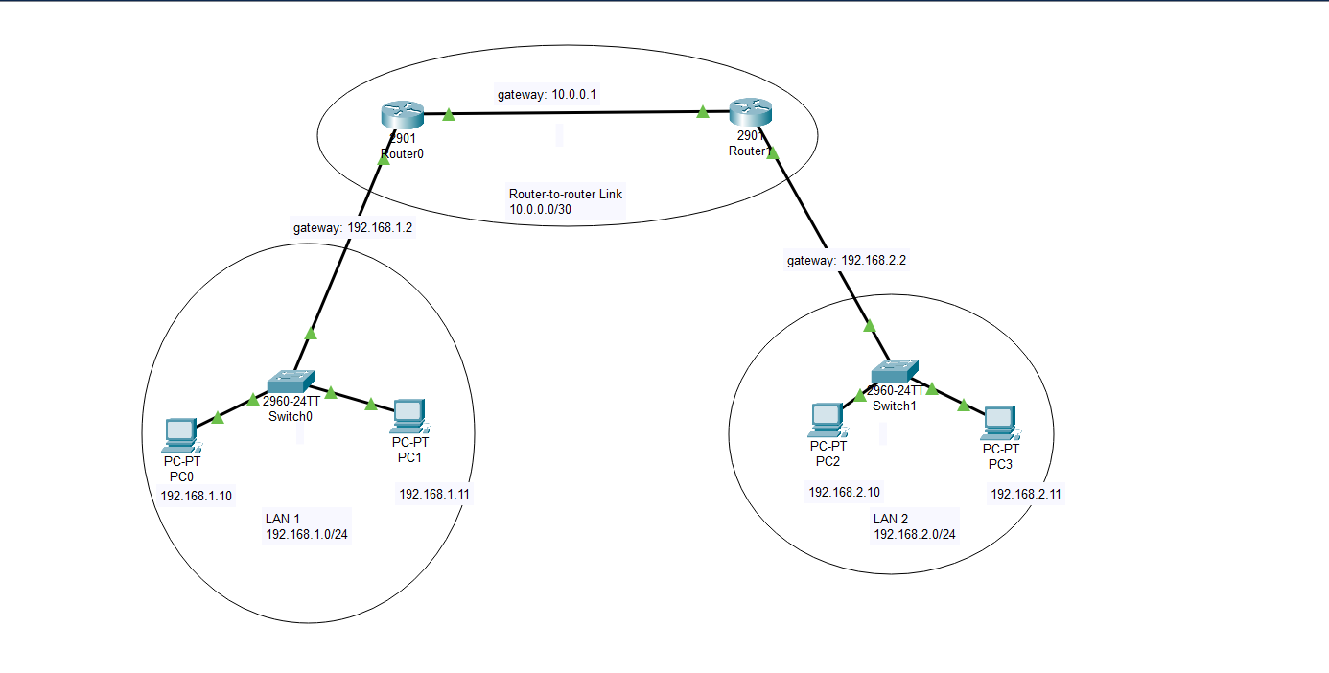
Figure 3: asgn 8
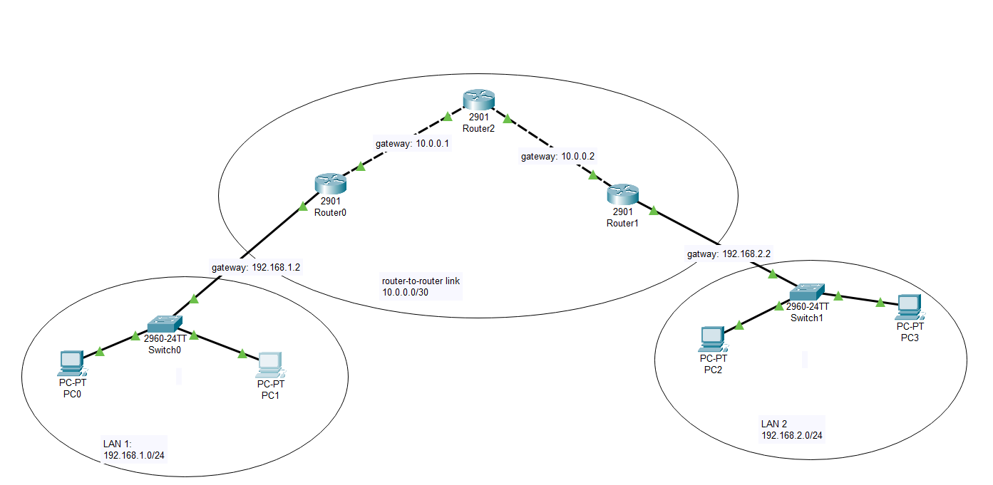
Figure 4: asgn 9
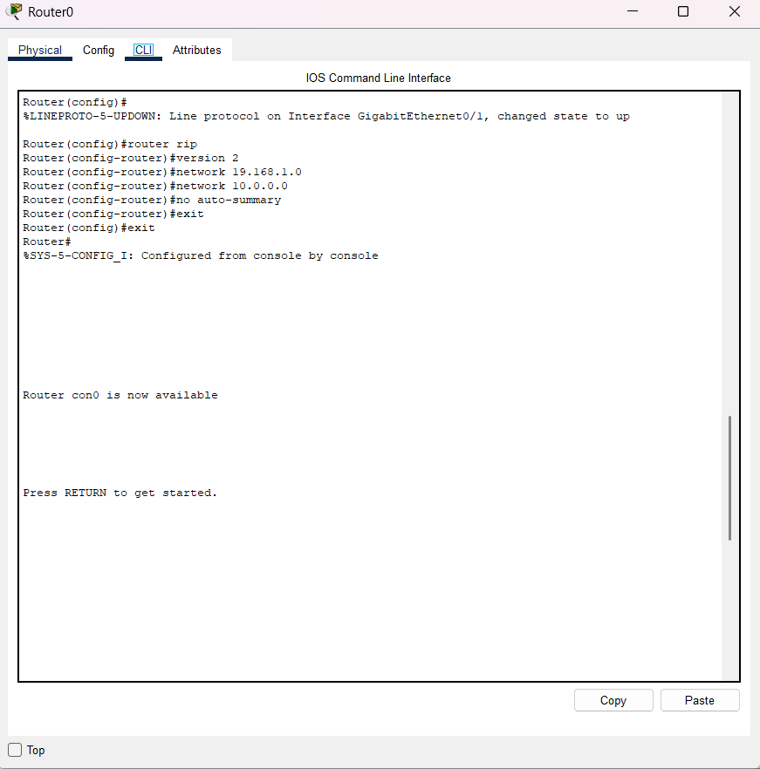  Figure 5: asgn 9 | 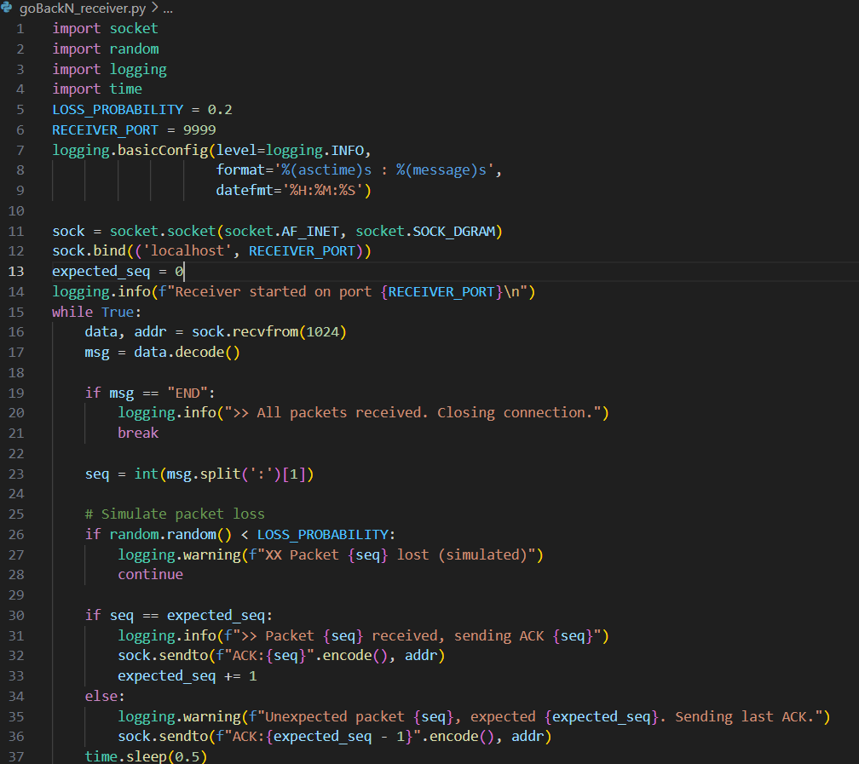  Figure 6: asgn 7 gbn rec
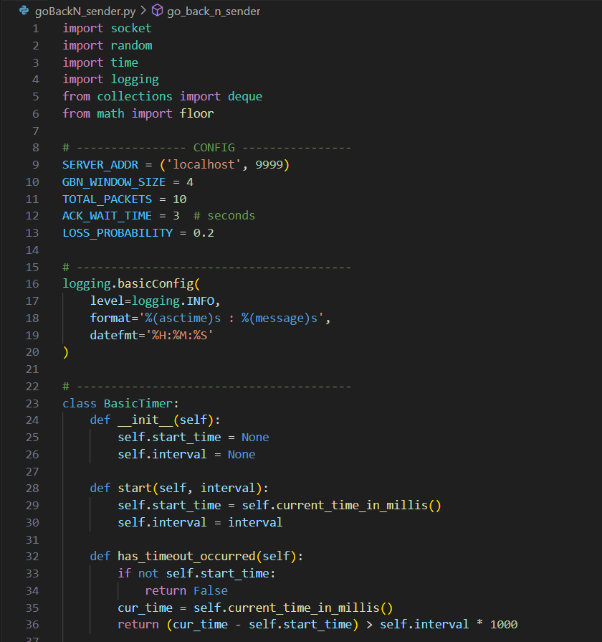  Figure 7: asgn 7 gbn1 sen | 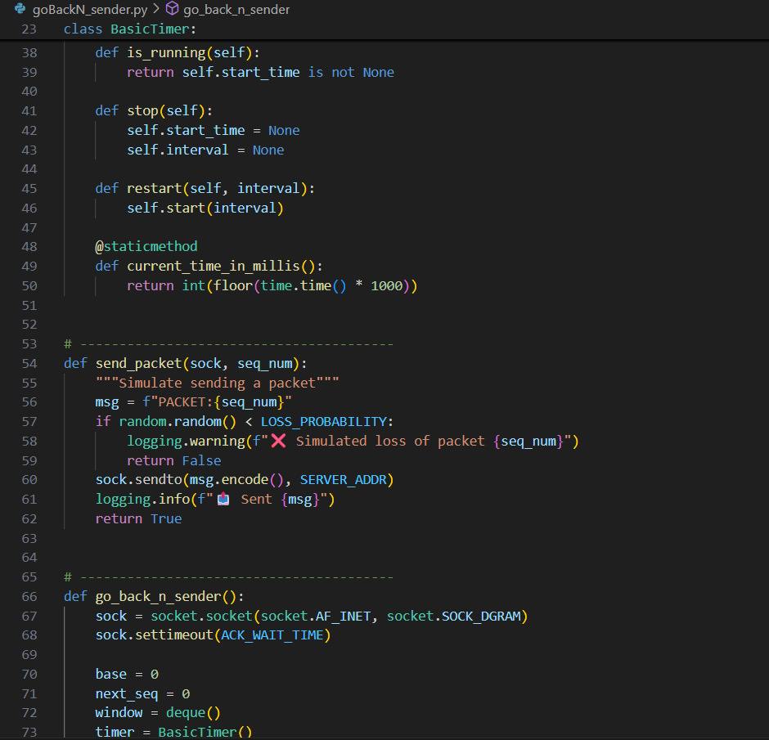  Figure 8: asgn7 gbn2 sen
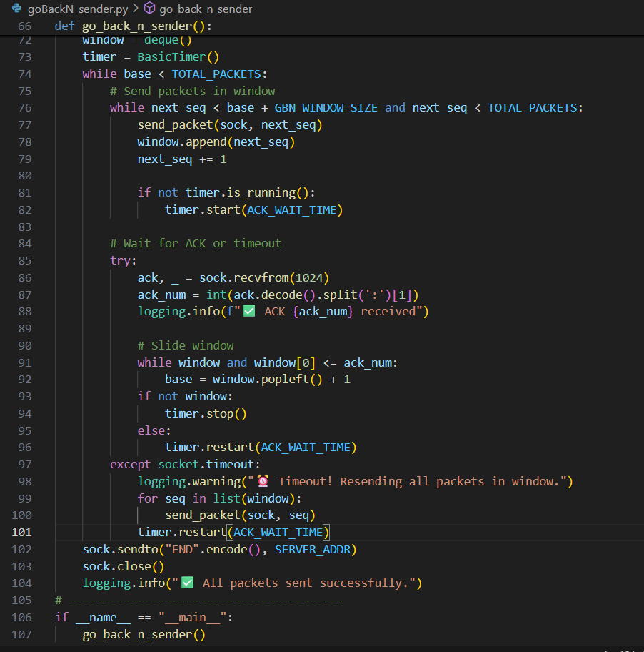  Figure 9: asgn 7 gbn3 sen | 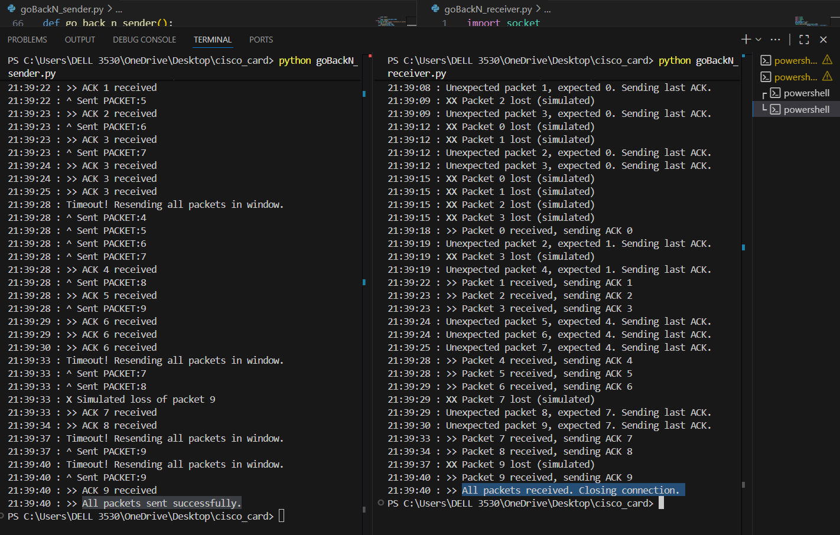  Figure 10: asgn gbn op
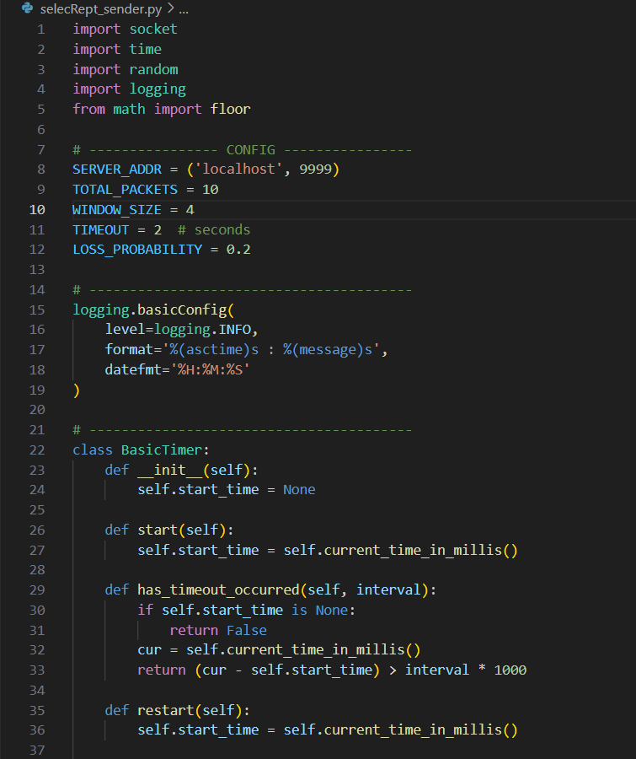  Figure 11: asgn 7 SR1 send | 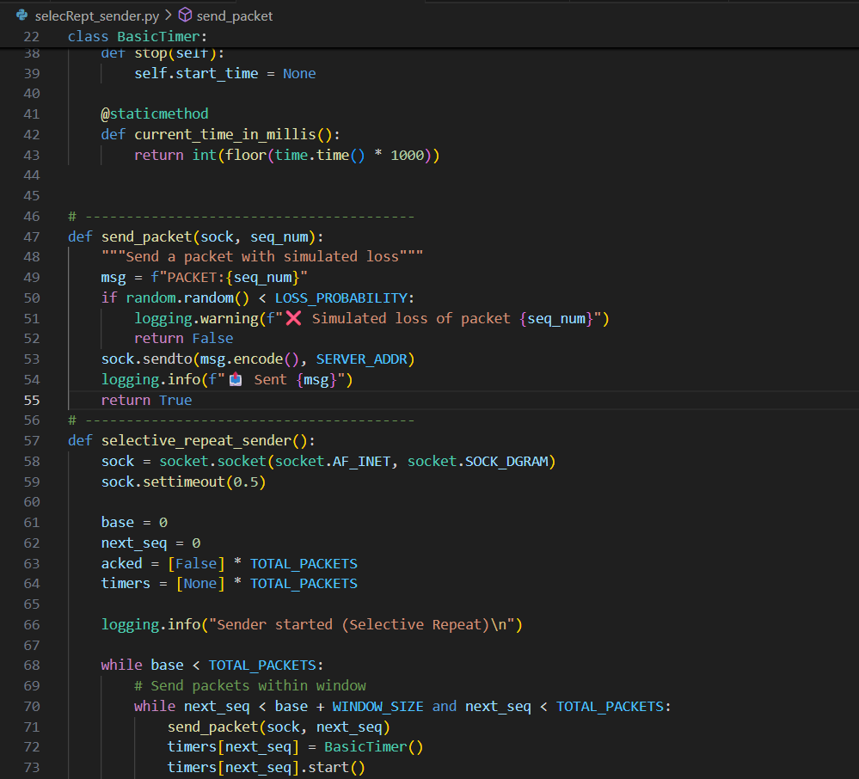  Figure 12: asgn 7 sr2 send
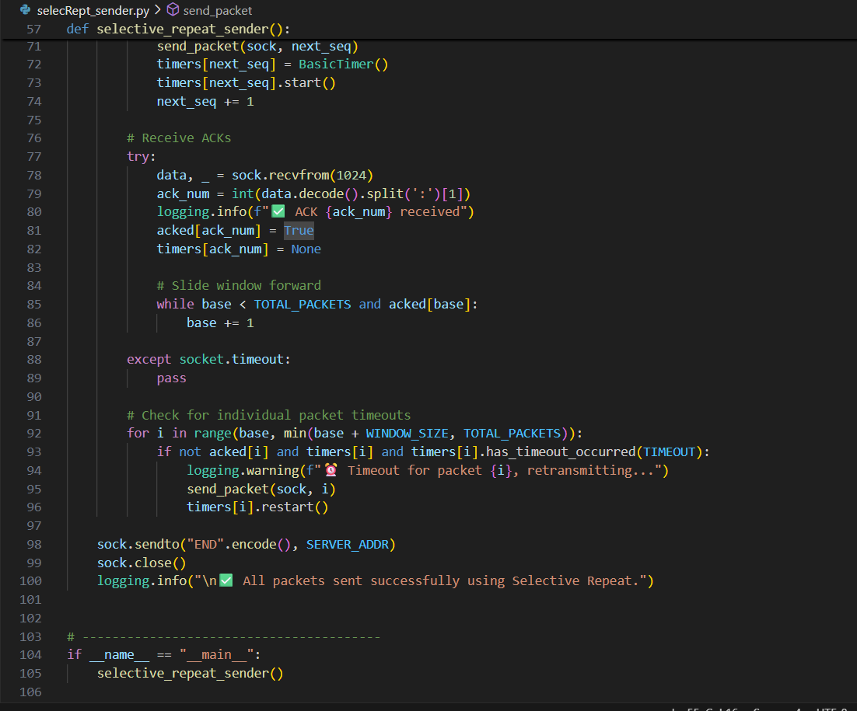  Figure 13: asgn 7 sr3 send | 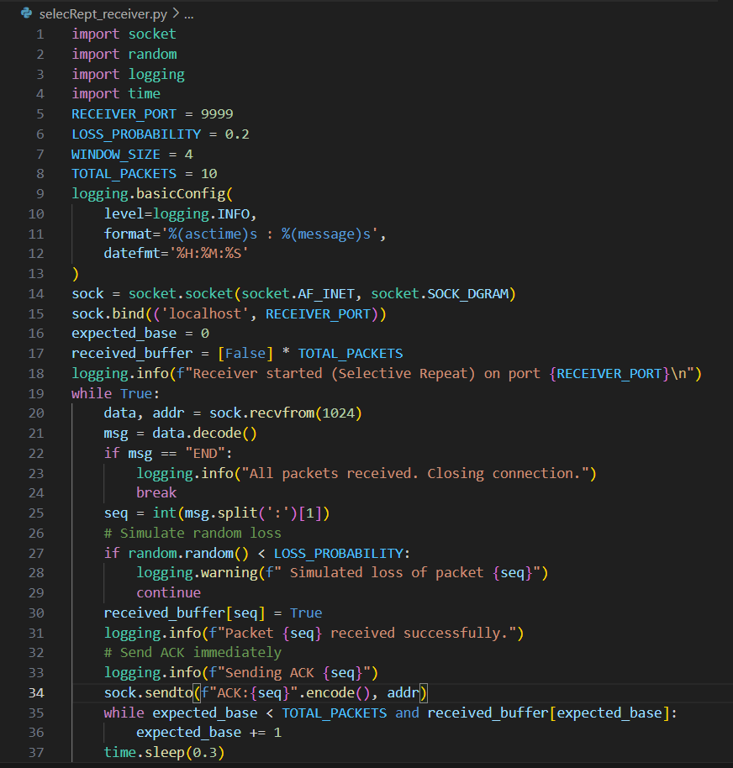  Figure 14: asgn 7 sr rec
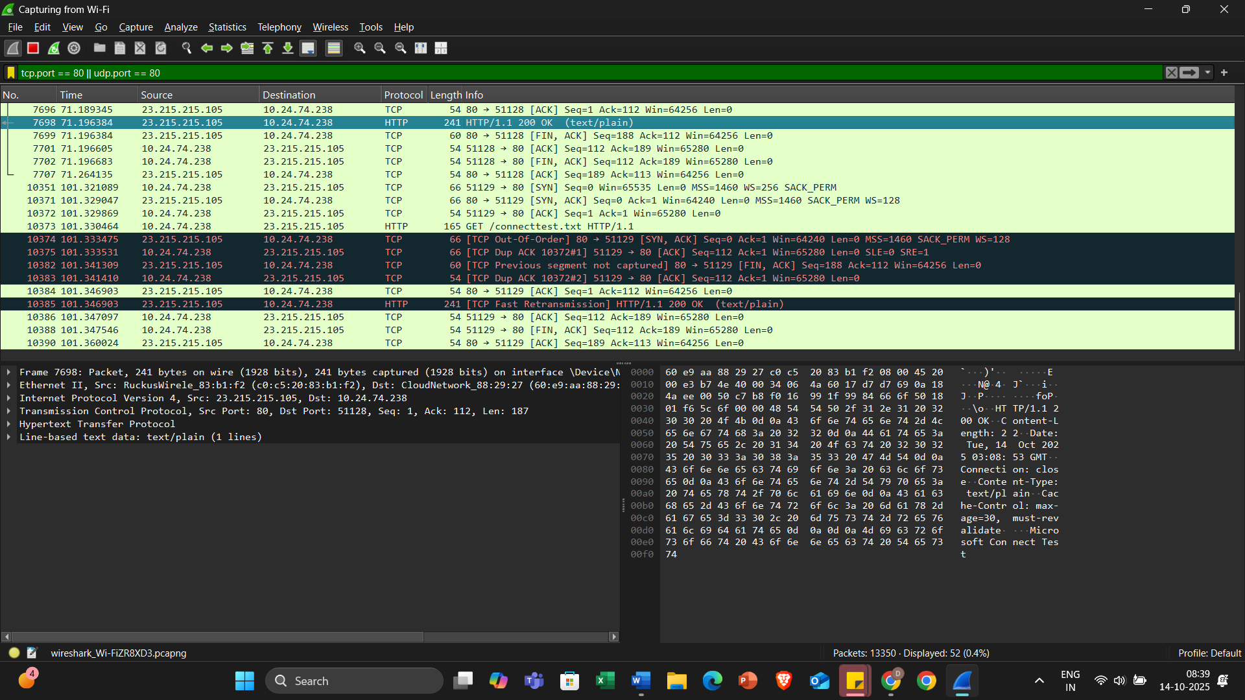  Figure 15: asgn 10 | 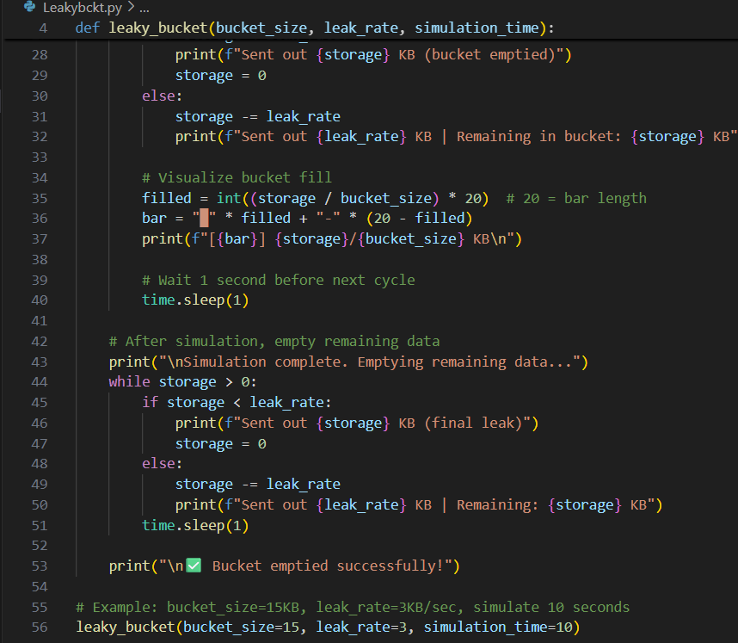  Figure 16: asgn 11 ip2

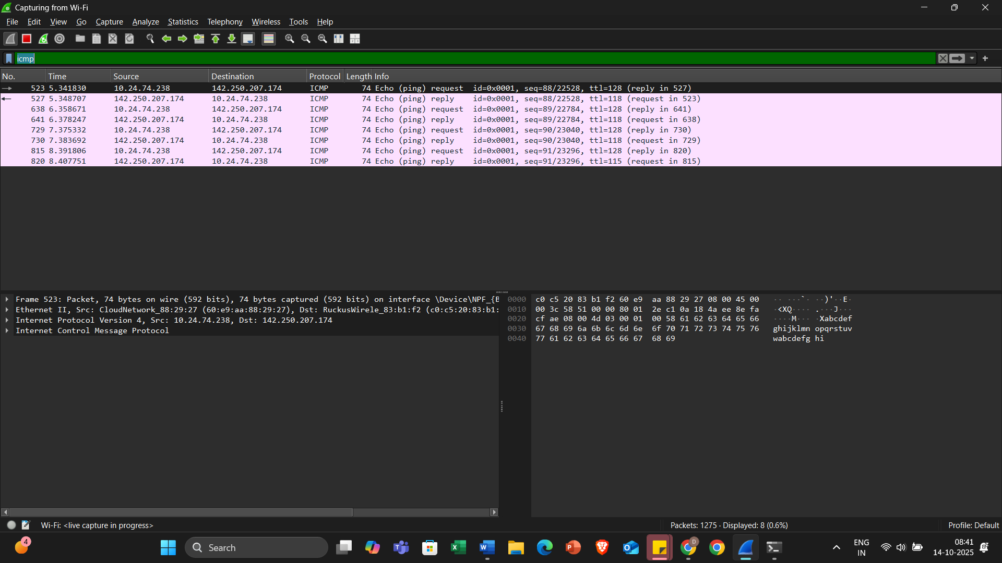
Figure 17: asgn 10
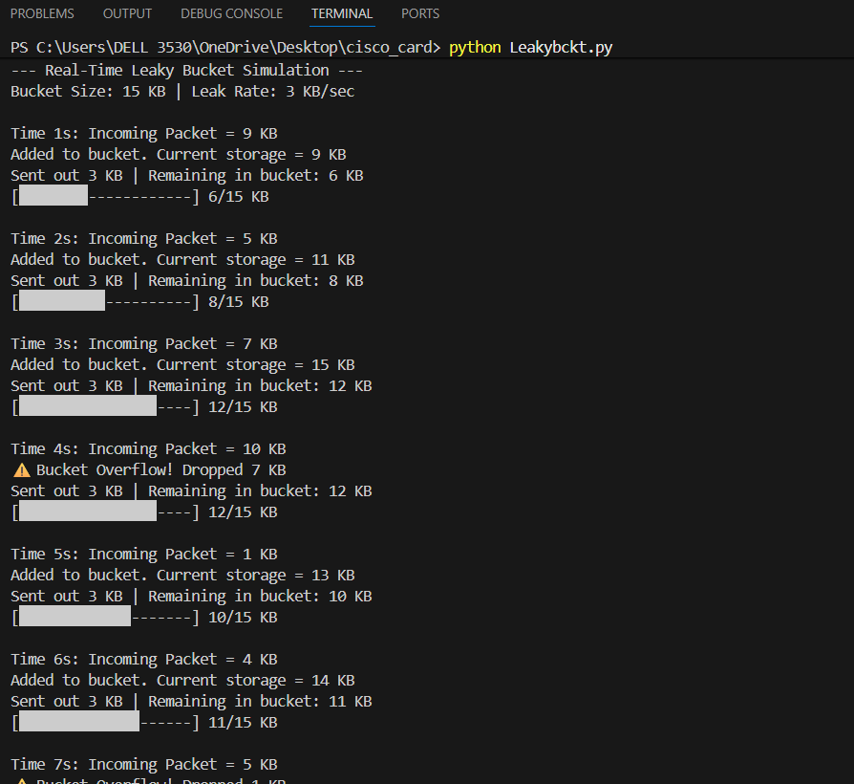  Figure 18: asgn 11 | 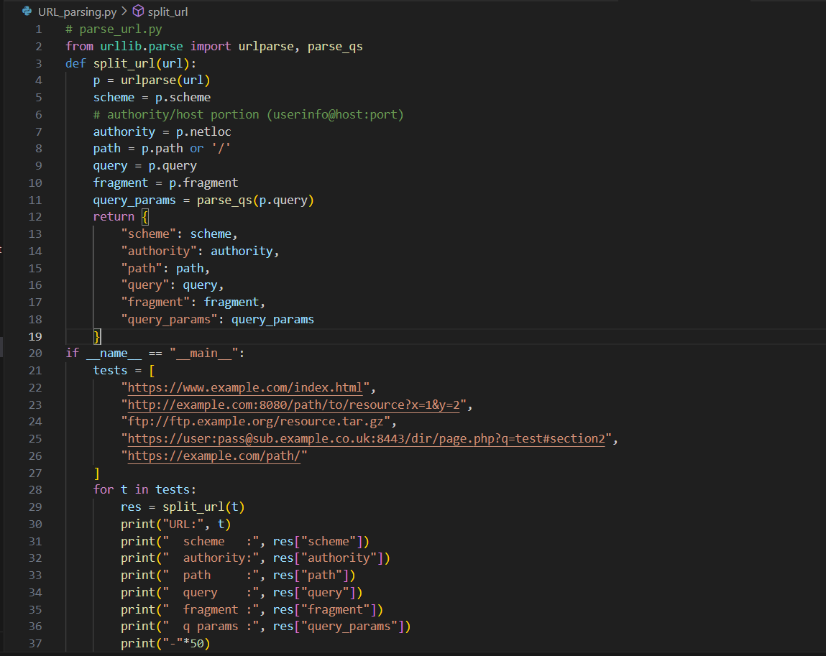  Figure 19: asgn 12-I
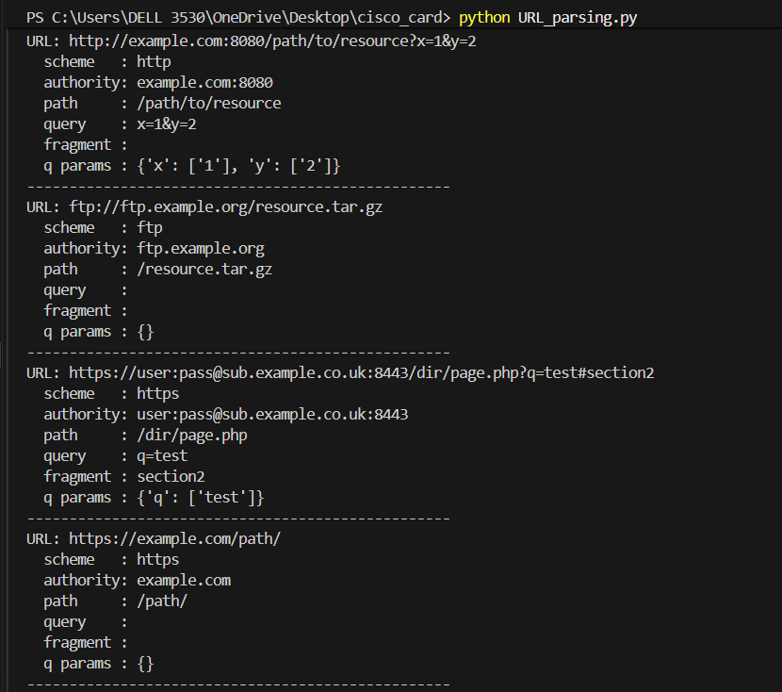  Figure 20: asgn 12 | 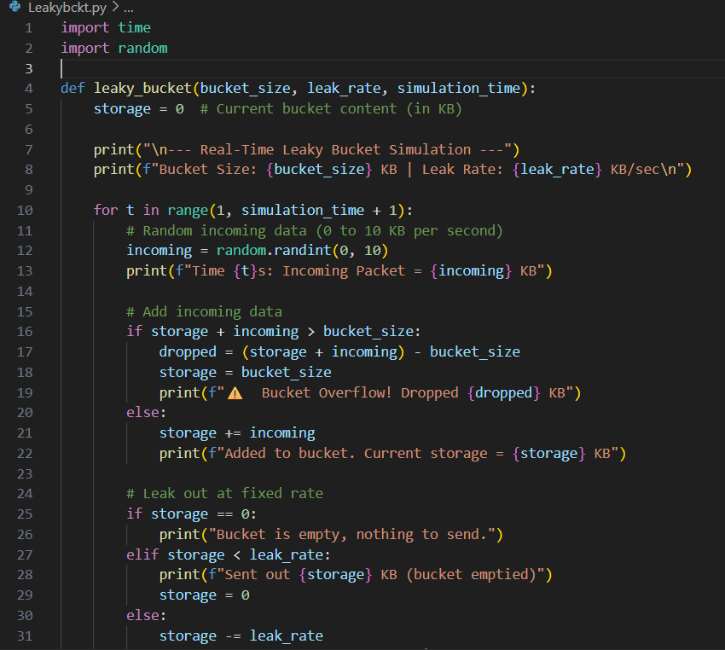  Figure 21: asgn 11 ip1

