8. Project Demonstration Phase

Objective
To demonstrate the completed standard laptop procurement automation and explain how the flow reduces manual processing.

Activities Performed
- Introduce the project problem and objective.
- Explain the standard laptop request process.
- Show the configured Flow Designer flow.
- Demonstrate the trigger and condition.
- Show the approval process.
- Demonstrate the approved path and the resulting fulfilment/notification actions.
- Demonstrate the rejected path.
- Show the flow execution details and test evidence.
- Summarize the benefits and possible future enhancements.

Expected / Produced Output
The demonstration should show a complete end-to-end request lifecycle from submission to final outcome.

Screenshots:

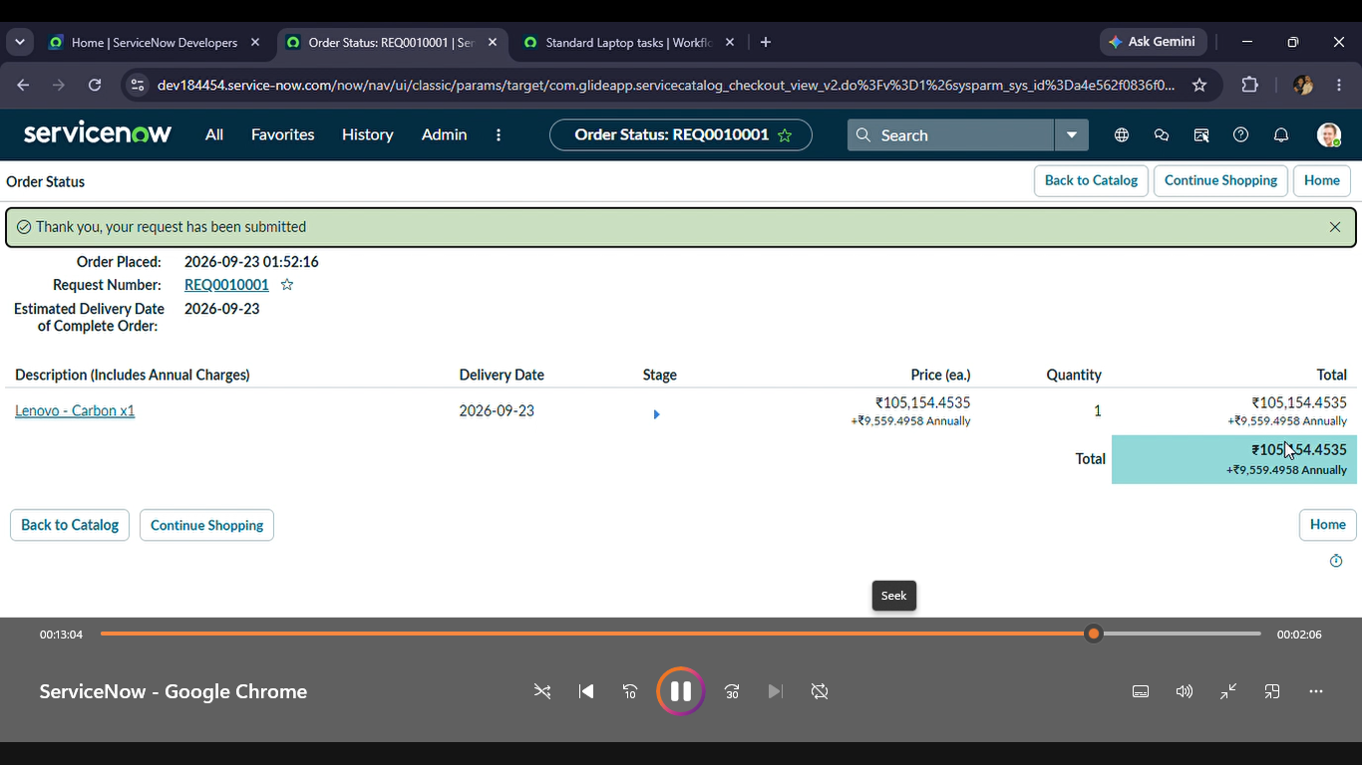

9. Conclusion
The project demonstrates how ServiceNow Flow Designer can be used to streamline a standard IT procurement process. By automating the steps involved in standard laptop requests, the process can be made more structured, consistent, and easier to track. The phase-wise approach covers idea generation, requirement analysis, design, planning, development, testing, documentation, and demonstration. The same automation approach can be extended to other standard IT equipment and service requests in the future.

Future Enhancements
- Add automatic inventory availability checking before approval or fulfilment.
- Integrate with asset management to automatically reserve or assign an available laptop.
- Add SLA tracking and escalation for delayed approvals.
- Provide dashboards for procurement status, pending approvals, and fulfilment metrics.
- Extend the automation to standard monitors, keyboards, headsets, and other IT equipment.
- Add automated email or in-platform notifications at important stages.
- Brainstorming – project idea / initial concept
- Requirement Analysis – request fields and requirements
- Design – workflow/Flow Designer structure
- Planning – task or implementation plan
- Development – configured trigger, conditions, approvals and actions
- Testing – flow execution and test results
- Documentation – final document/configuration evidence
- Demonstration – end-to-end execution and final result

