**IOT BASED PuBLIC TRANSPORT OPTIMISATION.**

|  |  |  |
| --- | --- | --- |
| **NAME** | **REGISTER NO** | **NAAN MUDHALVAN ID** |
| S DEEPALAKSHMI | 811221106005 | au811221106005 |
| SP JAYAKAMAKSHE RADHA | 811221106012 | au811221106012 |
| S PARKAVI | 811221106022 | au811221106022 |
| S THRISHA | 811221106034 | au811221106034 |

**INTRODUCTION**

With the expansion of bus transit plays an increasing important role in urban transportation reasonable network design is of great important to the operation of bus transit system, while irrational layout of bus routes leads to the poor operation and a low service quality of bus transit system for example much overlapping amount routes would lead to the traffic jam and low network density reveals the low accessibility of bus in areas without routes passing by .Now a days factors for bus network planning become more complex with the construction of rail transmit the integration of the bus and rail network is a new challenge in transit planing. Based on passenger travel impedance travel path probability and passenger travel demand the links are weight and the network efficiency as the objective function. In order to verify the effectiveness of the model and the solution method .the efficiency of the optimized network is 8.5% higher than of the original network. Generalized cost is used to comprehensively consider the impedance of bus travel from the origin and destination of various main factors. Generalized travel cost=waiting time +in vehicle time+transfer time. It is necessary to further expolre the impact of different transfer modes on the networkThe objective of this research is to optimize the layout of the bus routes in using a GIS based platform "transit net" to alleviate or slave the problem exposed from the layout of current existing the network coverage, and reducing the burden of main road this research has employed a method for multi modal transit design based on stop ,which treals certain rail routes.

**MODELING AND DESIGING**

Architecture design: - It makes the architecture of system understandable.

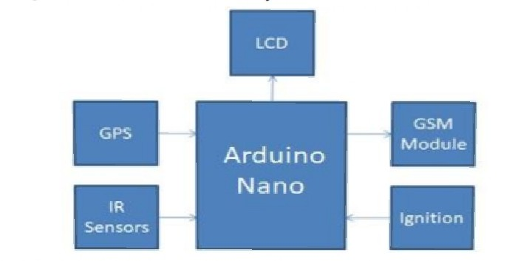

Block design: - It helps to clarify the controlling functionalities of the system.

The system built around Arduino nano. GPS module, GSM module IR sensor and LCD are connected to the Arduino nano. The GSM is used to accesses wireless internet in the bus. GPS is used to get the latitude and longitude that is position of bus. Arduino read the position continuously. IR sensors are placed at the entry and exit doors of bus to count the total number of passengers in the bus. The ignition of the bus is connected to Arduino to get the status of bus that is whether bus is on or off. Arduino collects all these details of bus continuously. It contains the details of bus like bus number, bus routes, bus timings which is manually uploaded by authority.

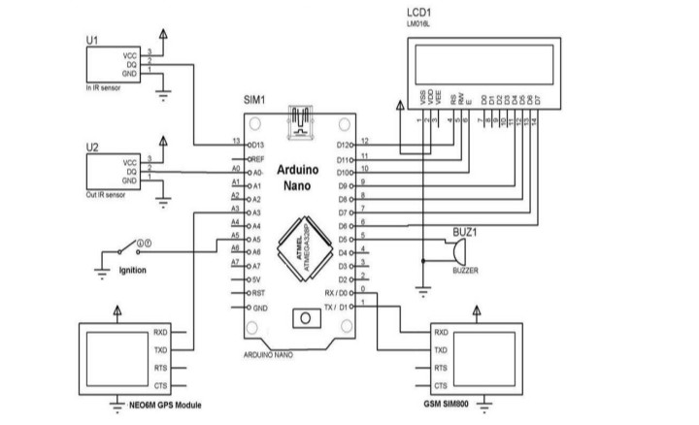

Use case design: -User end functionalities is shown in our system.

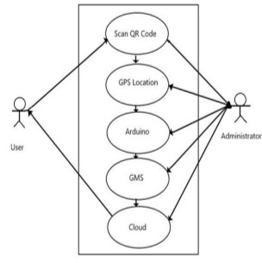

We are working with a python code to implement the above setup. The python code will be uploaded in the upcoming phases of the project.

**THANK YOU!!!**