**HA 2-tier Wordpress Application**

WordPress is a web publishing platform for building blogs and websites. It can be customized via a wide selection of themes, extensions, and plugins.

* Use this Quick Start to set up the following configurable environment on AWS:
  + - * A highly available architecture that spans two Availability Zones.
      * Elastic Load Balancing (ELB) to distribute HTTP and HTTPS requests across multiple WordPress instances.
      * Amazon RDS for MYSQL database
      * Amazon EC2 linux instances with the wordpress configuration
      * A default VPC with minimum 2 availability zones

**Architecture**

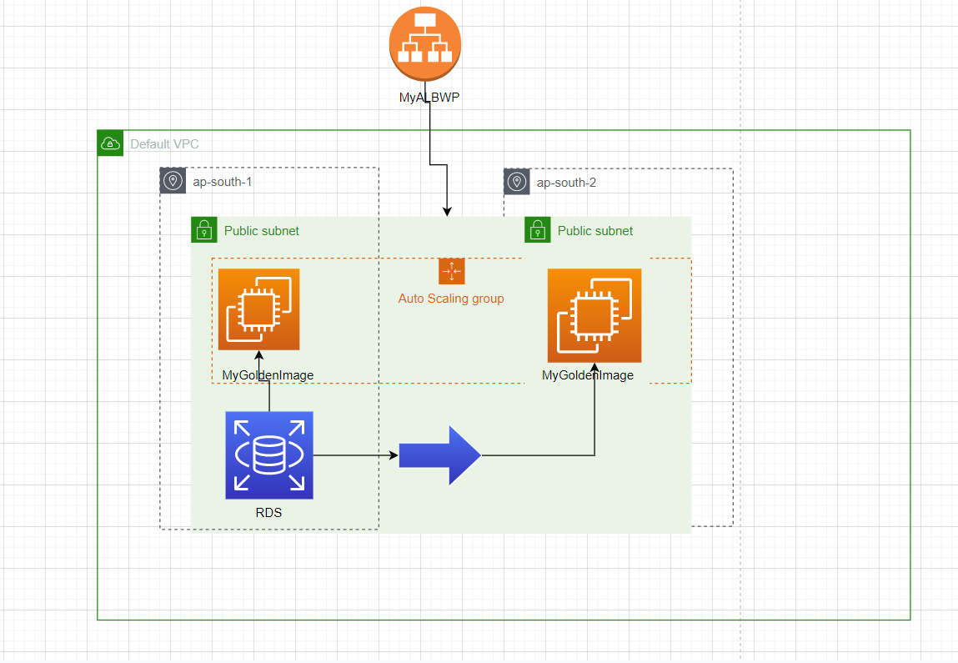

1. First create Mysql database with RDS in the default VPC.

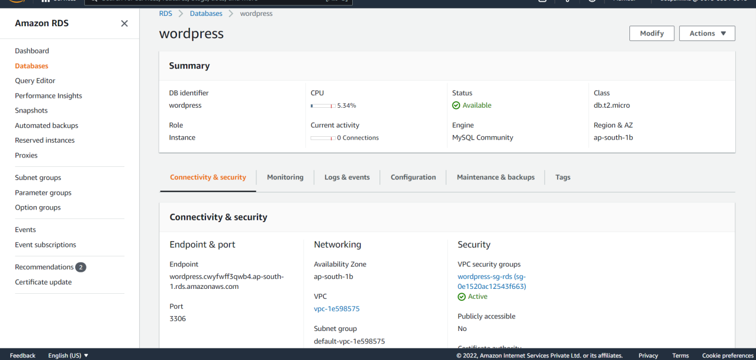

1. Create an linux instance with wordpress configuration(boot script user data) for the wordpress installation. Configured Security group for SSH and HTTP.
2. Create a target group for Application load balancer to distribute the HTTP traffic across AZs

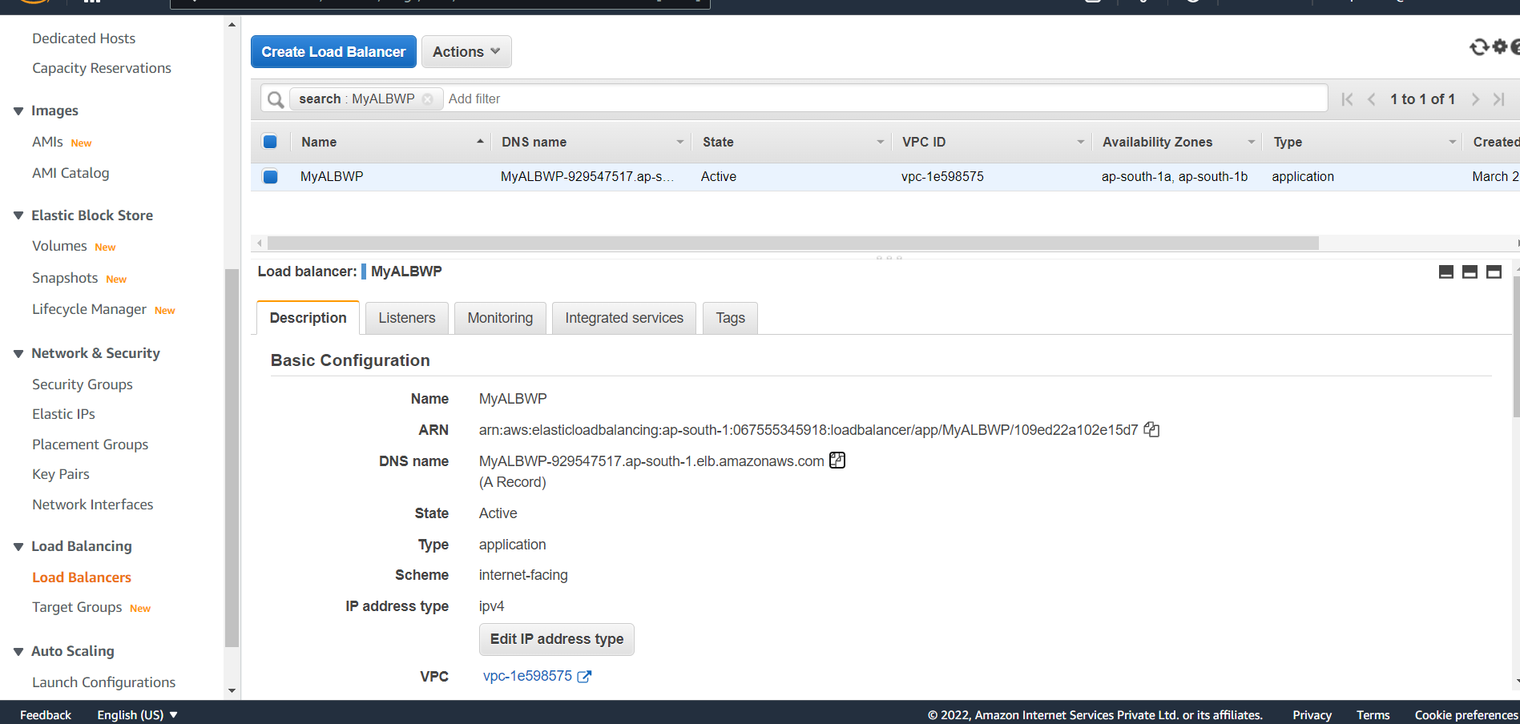

1. Create an image from the linux instance, with this image create launch configuration for the auto scaling group.
2. Create Auto scaling group to span the instances in multi az across the region.

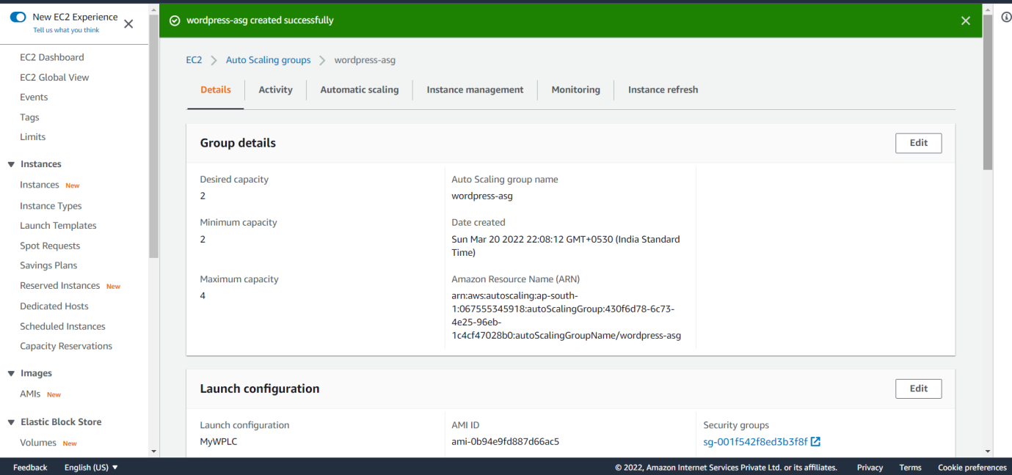

1. ASG will create instances across availability zones as per the minimum and desired capacity.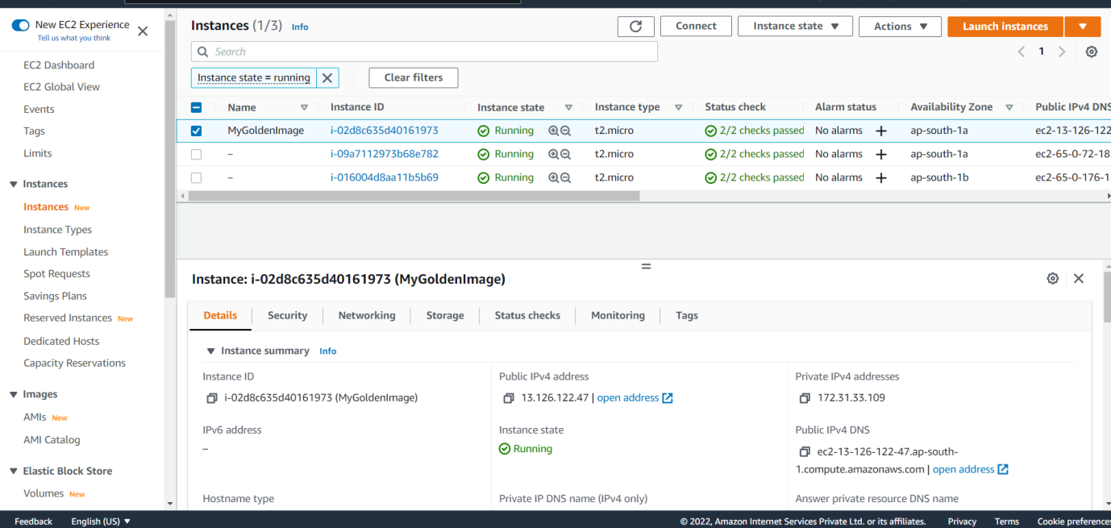
2. Register all the instances under target group, so only healthy instances will receive the traffic from the ALB.
3. Access the Application Load Balancer DNS name in the browser, it will show the wordpress page.

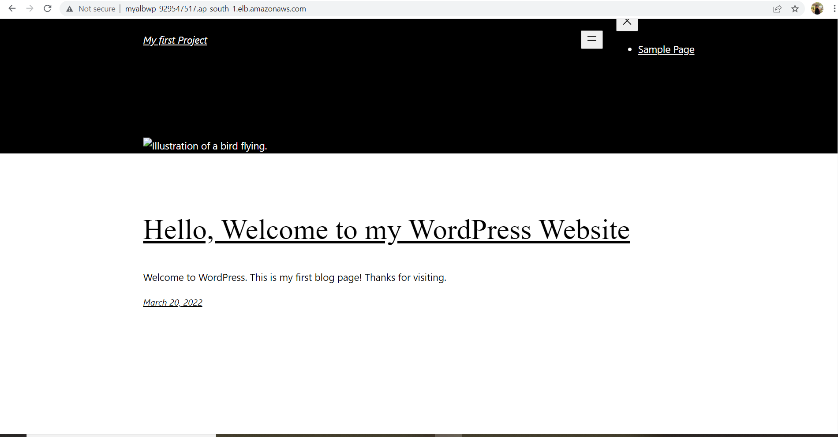

**The wordpress page is deployed successfully.**

**Thanks!**