Excel Task pane Add-ins

On the Excel , one can create small programs with User-interface to manipulate the cells in the Excel. We can create functionalities , like create a form and say to which cells they should be added to the excel cells.

Although we can manipulate the same in Python , doing it using office.js adds an add-in as a component to the excel and there is no need to use programs from outside to manipulate the excel data.

**Note: Sample Javascript code can be found in samples of Script lab.**

**Steps to setup the environment :**

<https://learn.microsoft.com/en-us/office/dev/add-ins/overview/set-up-your-dev-environment?tabs=yeomangenerator>

<https://learn.microsoft.com/en-us/office/dev/add-ins/quickstarts/excel-quickstart-jquery?tabs=yeomangenerator>

<https://learn.microsoft.com/en-us/office/dev/add-ins/testing/runtime-logging>

**Steps to get started to code in typescript:**

<https://www.youtube.com/watch?v=ajlYrtMATnE>

<https://learn.microsoft.com/en-us/office/dev/add-ins/tutorials/excel-tutorial>

<https://learn.microsoft.com/en-us/office/dev/add-ins/excel/excel-add-ins-tables>

<https://www.youtube.com/watch?v=cfc0imOXzhM>

**Tool Flow diagram:**

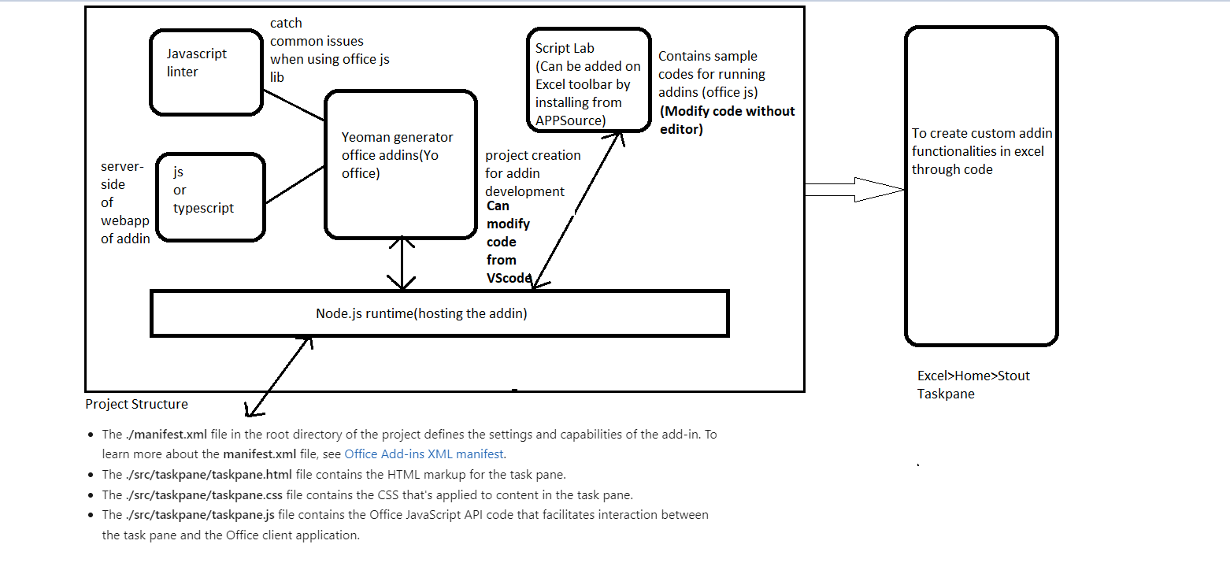

**Use-case for Add-In:**

1)Create a button to connect to database(through api call/direct) and get the data and add onto excel.

2)Provide prompts when editing the excel table.(Data Validation when changing the tables)

3)Create a plot button to plot the data by choosing the chart type and selecting colors.

4)Filter and sort the table created.

5)Comment on the text box and it should come below the plot in excel.

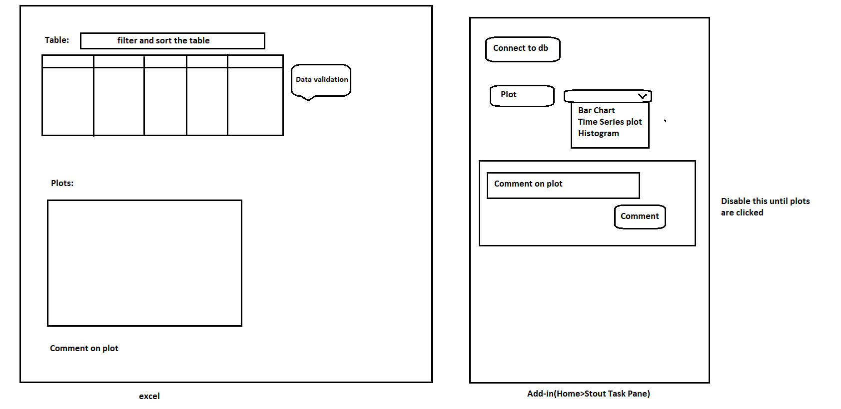

**I followed the steps to do shared-runtime:**1. Delete package-lock.json2. Modify package.json3. Modify webpack.config.js4. Run "npm install" (Found 0 vulnerabilities)5. Run "npm run build"

6.Run npm start

