Assignment-3

- Create Database
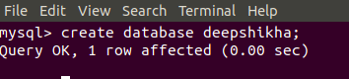
- Design Schema .
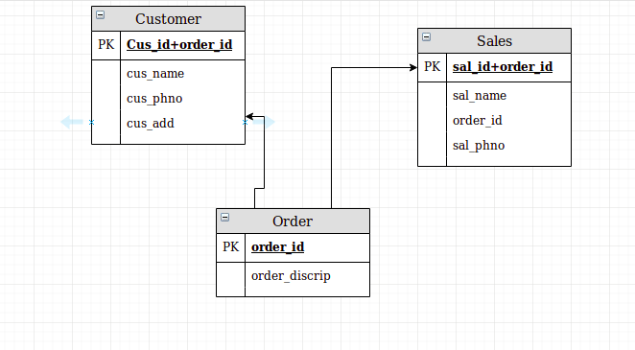
- Create tables
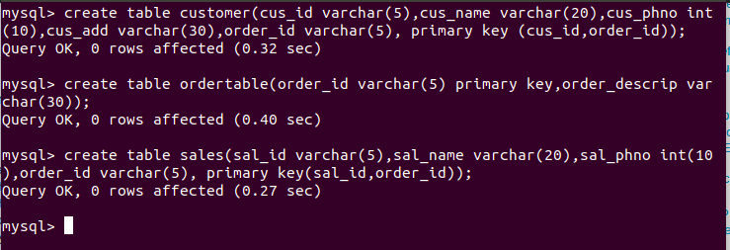
- Insert sample data .
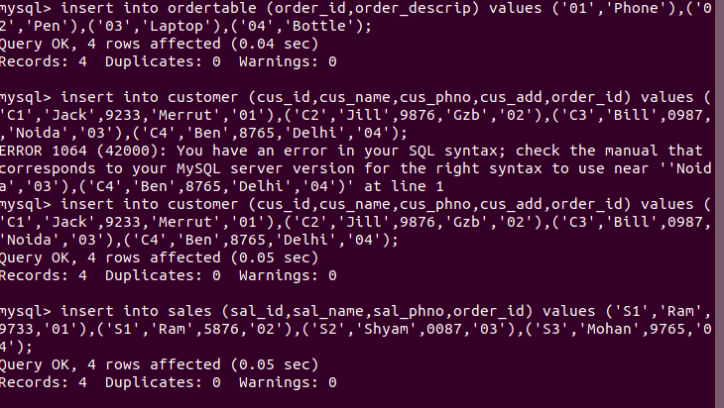
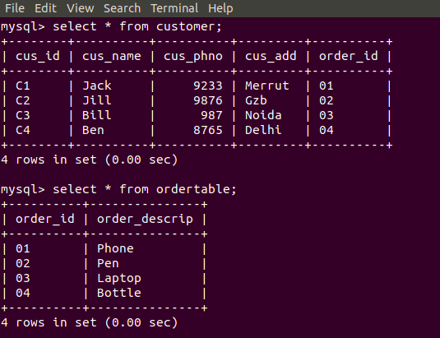
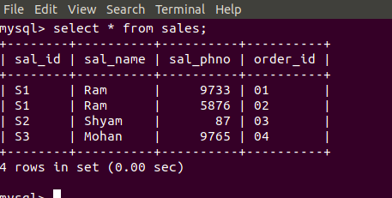
- Find the sales person have multiple orders.
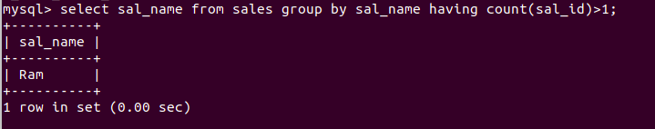
- Find the all sales person details along with order details.
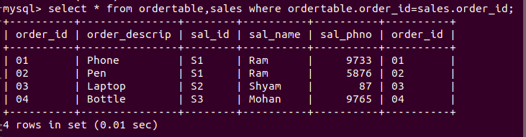
- Create index.
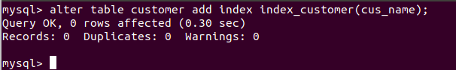
- How to show index on a table.
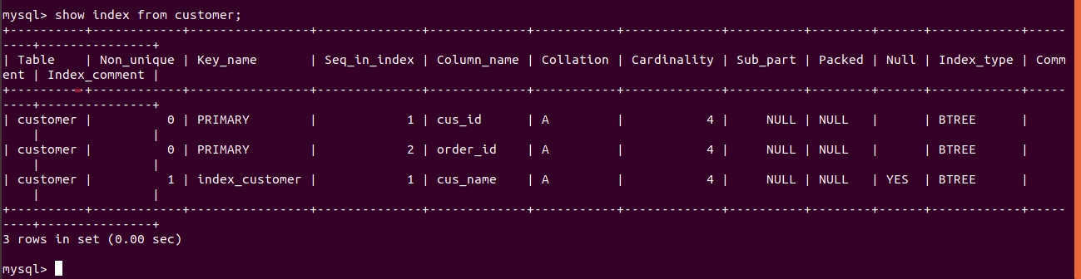
- Find the order number, sale person name, along with the customer to whom that order belongs to.
