JavaScript is an object-based scripting language which is lightweight and cross-platform.

which is used by several websites for scripting the webpages. It is an interpreted, full-fledged programming language that enables dynamic interactivity on websites when applied to an HTML document.

**JavaScript Variable**

1. [JavaScript variable](https://www.javatpoint.com/javascript-variable)
2. [JavaScript Local variable](https://www.javatpoint.com/javascript-variable#local)
3. [JavaScript Global variable](https://www.javatpoint.com/javascript-variable#gloabl)

A **JavaScript variable** is simply a name of storage location. There are two types of variables in JavaScript : local variable and global variable.

• var x = 10;

• var y = 20;

• var z=x+y;

• document.write(z);

## JavaScript local variable

**Variables in JavaScript:**

Variables in JavaScript are containers which hold reusable data. It is the basic unit of storage in a program. 

* The value stored in a variable can be changed during program execution.
* A variable is only a name given to a memory location, all the operations done on the variable effects that memory location.
* In JavaScript, all the variables must be declared before they can be used

A JavaScript local variable is declared inside block or function. It is accessible within the function or block only. For example:

1. <script>
2. function abc(){
3. var x=10;//local variable
4. }

## JavaScript global variable

A **JavaScript global variable** is accessible from any function. A variable i.e. declared outside the function or declared with window object is known as global variable. For example:

• var data=200;//gloabal variable

• function a(){

• document.writeln(data);

}

a();//calling JavaScript function

• var value=50;

• function a(){

• alert(window.value);//accessing global variable

• }

let globalVar = "This is a global variable";

function fun() {

  let localVar = "This is a local variable";

  console.log(globalVar);

  console.log(localVar);

}

fun();

* .
* If you want your code to run in older browsers, you must use var.
* Local variables have **Function Scope**:
* They can only be accessed from within the function.

## Global Scope

The variables defined outside of any **function** or **curly** brackets are known as global variables and have global scope. Global scope means that the variables can be accessed from any part of that program, any function or conditional state can access that variable.

**For example**

var name = "linuxHint";  
  
function printName(){  
// the variable can be accessed inside here  
console.log("This tutorial is by "+name);  
}  
  
printName();

## Block Scope

Before ES6 (2015), JavaScript had only **Global Scope** and **Function Scope**.

ES6 introduced two important new JavaScript keywords: let and const.

These two keywords provide **Block Scope** in JavaScript.

Variables declared inside a { } block cannot be accessed from outside the block:

{   
  let x = 2;  
}  
// x can NOT be used here

Variables declared with the var keyword can NOT have block scope.

Variables declared inside a { } block can be accessed from outside the block.

### Example

{   
  var x = 2;   
}  
// x CAN be used here

Variables declared with var, let and const are quite similar when declared inside a function.

They all have **Function Scope**:

function myFunction() {  
  var carName = "Volvo";   // Function Scope  
}

function myFunction() {  
  let carName = "Volvo";   // Function Scope  
}

function myFunction() {  
  const carName = "Volvo";   // Function Scope  
}

## Global Scope

A variable declared at the top of a program or outside of a function is considered a global scope variable.

Let's see an example of a global scope variable.

// program to print a text

let a = "hello";

function greet () {

console.log(a);

}

greet(); // hello

// program to show the change in global variable

let a = "hello";

function greet() {

a = 3;

}

// before the function call

console.log(a);

//after the function call

greet();

console.log(a); // 3

hello

3

### let is Block Scoped

The let keyword is block-scoped (variable can be accessed only in the immediate block).

### Example 2: block-scoped Variable

// program showing block-scoped concept

// global variable

let a = 'Hello';

function greet() {

// local variable

let b = 'World';

console.log(a + ' ' + b);

if (b == 'World') {

// block-scoped variable

let c = 'hello';

console.log(a + ' ' + b + ' ' + c);

}

// variable c cannot be accessed here

console.log(a + ' ' + b + ' ' + c);

}

greet();

### Example 1: Local Scope Variable

// program showing local scope of a variable

let a = "hello";

function greet() {

let b = "World"

console.log(a + b);

}

greet();

console.log(a + b); // error

[Run Code](https://www.programiz.com/javascript/online-compiler)

**Output**

helloWorld

Uncaught ReferenceError: b is not defined

* So, in javascript the whole document is **global scope** and all the other functions and variables are contained in this global scope.
* Another is the **Local Scope**, variables declared inside the functions are considered to be of the local scope and it is futher divided into function scoped and block scoped.
* **Function Scope**: When a variable is declared inside a function, it is only accessible within that function and cannot be used outside that function.
* **Block Scope**: A variable when declared inside the if or switch conditions or inside for or while loops, are accessible within that particular condition or loop. To be consise the variables declared inside the curly braces are called as within block scope.
* **var** is called as function scope that is if a variable is declared using var keyword it will be accessible throughout the function.
* **let & const** are also called as block scope that is they are accessible within that particular block. Here let is used for variable which can be changed as we proceed through the program whereas const is used for a variable which doesn’t change till the program ends, that is it remains constant throughout the program

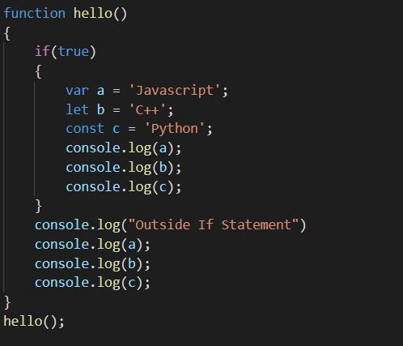

* As the output shows when we try to access the variables b and c outside the if statement it gives the error as it is declared using let and const keyword whereas these variables are accessible inside the if statement. As the output shows when we try to access the variables b and c outside the if statement it gives the error as it is declared using let and const keyword whereas these variables are accessible inside the if statement.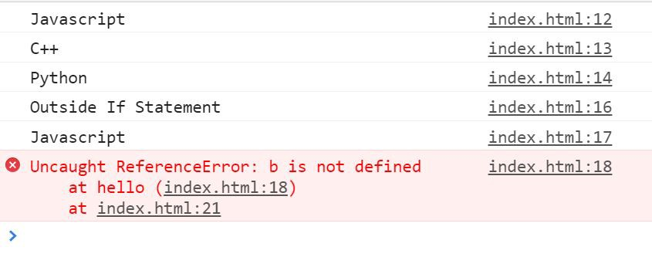

As the output shows when we try to access the variables b and c outside the if statement it gives the error as it is declared using let and const keyword whereas these variables are accessible inside the if statement.

## Function Scope

The function scope is the accessibility of the variables defined inside a function, these variables cannot be accessed from any other function or even outside the function in the main file.

**For example**  
First, we created a variable inside a function and accessed it inside the function:

function abc() {  
  
year = 2021;  
  
// the "year" variable can be accessed inside this function  
  
console.log("The year is "+ Year);  
}  
  
// the "year" variable cannot be accessed outside here  
  
abc();

marksObtained = 60  
  
if(marksObtained >= 45){  
 let status = "Passed";  
 console.log("Subject Remarks: " + status);  
}  
else{  
 let status = "Failed";  
 console.log("Subject Remarks: " + status);  
}

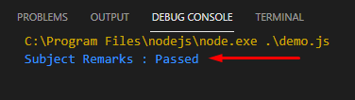

We created a block-scoped local variable enclosed within **curly brackets {}** by using the keyword **let**. We can even replace this let with the **const.** The output is as:

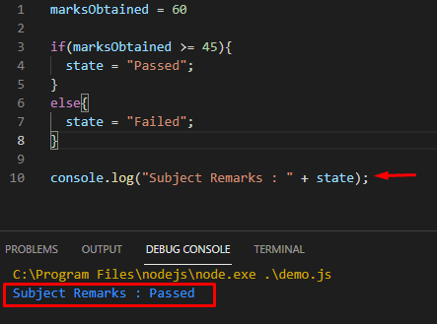

**Scope:** Global scoped or function scoped. The scope of the *var* keyword is the global or function scope. It means variables defined outside the function can be accessed globally, and variables defined inside a particular function can be accessed within the function.

**Example 1:** Variable ‘a’ is declared globally. So, the scope of the variable ‘a’ is global, and it can be accessible everywhere in the program. The output shown is in the console.

|  |
| --- |
| <script>      var a = 10          function f(){              console.log(a)          }      f();      console.log(a);  </script> |

**Output:**

10

10

**Example 2:** The variable ‘a’ is declared inside the function. If the user tries to access it outside the function, it will display the error. Users can declare the 2 variables with the same name using the *var* keyword. Also, the user can reassign the value into the *var* variable. The output shown in the console.

|  |
| --- |
| <script>      function f() {            // It can be accessible any          // where within this function          var a = 10;          console.log(a)      }      f();        // A cannot be accessible      // outside of function      console.log(a);  </script> |

**Output:**

10

ReferenceError: a is not defined

**Example 3:** User can re-declare variable using *var* and user can update *var* variable. The output is shown in the console.

|  |
| --- |
| <script>      var a = 10        // User can re-declare      // variable using var      var a = 8        // User can update var variable      a = 7  </script> |

**Output:**

7

**Example 4:** If users use the var variable before the declaration, it initializes with the *undefined* value. The output is shown in the console.

|  |
| --- |
| <script>      console.log(a);      var a = 10;  <script> |

**Output:**

undefined

[**let**](https://www.geeksforgeeks.org/javascript-let/) **keyword in JavaScript:** The *let* keyword is an improved version of the *var* keyword.

**Scope:** [**block scoped:**](https://www.geeksforgeeks.org/javascript-es2015-block-scoping/) The scope of a *let* variable is only block scoped. It can’t be accessible outside the particular block ({block}). Let’s see the below example.

**Example 1:** The output is shown in the console.

|  |
| --- |
| <script>      let a = 10;      function f() {          let b = 9          console.log(b);          console.log(a);      }      f();  </script> |

**Output:**

9

10

**Example 2:** The code returns an error because we are accessing the *let* variable outside the function block. The output is shown in the console.

|  |
| --- |
| <script>      let a = 10;      function f() {          if (true) {              let b = 9                // It prints 9              console.log(b);          }            // It gives error as it          // defined in if block          console.log(b);      }      f()        // It prints 10      console.log(a)  </script> |

**Output:**

9

ReferenceError: b is not defined

**Example 3:** Users cannot re-declare the variable defined with the *let* keyword but can update it.

|  |
| --- |
| <script>        let a = 10        // It is not allowed      let a = 10        // It is allowed      a = 10  </script> |

**Output:**

Uncaught SyntaxError: Identifier 'a' has already been declared

**Example 4:** Users can declare the variable with the same name in different blocks using the *let* keyword.

|  |
| --- |
| <script>    let a = 10    if (true) {      let a=9      console.log(a) // It prints 9    }    console.log(a) // It prints 10  </script> |

**Output:**

9

10

**Example 5:** If users use the *let* variable before the declaration, it does not initialize with *undefined* just like a *var* variable and return an error.

|  |
| --- |
| <script>      console.log(a);      let a = 10;  </script> |

**Output:**

Uncaught ReferenceError: Cannot access 'a' before initialization

[**const**](https://www.geeksforgeeks.org/javascript-const/) **keyword in JavaScript:** The *const* keyword has all the properties that are the same as the *let* keyword, except the user cannot update it.

**Scope:** [block scoped:](https://www.geeksforgeeks.org/javascript-es2015-block-scoping/) When users declare a *const* variable, they need to initialize it, otherwise, it returns an error. The user cannot update the *const* variable once it is declared.

**Example 1:** We are changing the value of the const variable so that it returns an error. The output is shown in the console.

|  |
| --- |
| <script>      const a = 10;      function f() {          a = 9          console.log(a)      }      f();  </script> |

**Output:**

a=9

TypeError:Assignment to constant variable.

**Example 2:** Users cannot change the properties of the *const* object, but they can change the value of properties of the *const* object.

|  |
| --- |
| <script>      const a = {          prop1: 10,          prop2: 9      }        // It is allowed      a.prop1 = 3        // It is not allowed      a = {          b: 10,          prop2: 9      }  </script> |

**Output:**

Uncaught SyntaxError:Unexpected identifier

**Differences between var, let, and const**

|  |  |  |
| --- | --- | --- |
| **var** | **let** | **const** |
| The scope of a *var* variable is functional scope. | The scope of a *let* variable is block scope. | The scope of a *const* variable is block scope. |
| It can be updated and re-declared into the scope. | It can be updated but cannot be re-declared into the scope. | It cannot be updated or re-declared into the scope. |
| It can be declared without initialization. | It can be declared without initialization. | It cannot be declared without initialization. |
| It can be accessed without initialization as its default value is “undefined”. | It cannot be accessed without initialization otherwise it will give ‘referenceError’. | It cannot be accessed without initialization, as it cannot be declared without initialization. |
| hoisting done , with initializing as ‘default’ value | Hoisting is done , but not initialized (this is the reason for error when we access the let variable before declaration/initialization | Hoisting is done, but not initialized (this is the reason for error when we access the const variable before declaration/initialization |

**JavaScript Course | Printing Hello World in**

**JavaScript**

* Difficulty Level : [Basic](https://www.geeksforgeeks.org/basic/)
* Last Updated : 03 Jan, 2022

• Read

• Discuss

**Previous article:** [JavaScript Course | What is JavaScript?](https://www.geeksforgeeks.org/javascript-course-what-is-javascript/)

Whenever we write javascript we make use of the *‘script’* tag. We know what a normal HTML document is made up of. The ‘script’ tag is used to write javascript code and this ‘script’ tag is either placed inside the ‘head’ tag or inside the ‘body’ tag.

**Example:**

|  |
| --- |
| <!DOCTYPE HTML>  <html>  <head>    <title></title>    <!-- Script tag can also be placed here -->  </head>  <body>        <p>Before the script...</p>        <!-- Script tag inside the body -->    <script>      // write the javascript code inside it    </script>        <p>...After the script.</p>        </body>  </html> |

We can put the script tag inside the ‘head’ or ‘body’ tag. Though it should be noted that each choice of putting the ‘script’ tag has its own consequences. For now, you can put the script tag anywhere you want.

**Printing Hello World**   
In order to print the famous ‘Hello World’ sentence to the screen, we can make use of different methods that javascript provides. Most common are:

* console.log()
* document.write()
* alert()

Each of the above method have different ways of outputting the content. Though ‘document.write()’ is used when we want to print the content onto the document which is the HTML Document. Also ‘console.log()’ is mainly used when we are debugging javascript code and same thing with ‘alert()’.

**Example:**

|  |
| --- |
| <script>  // using console.log  console.log('Hello World');  </script> |

Hit *Ctrl+Shift+J* to see the output in the browser console.

**Output:**

**Example:**

|  |
| --- |
| <script>  // using document.write  document.write('Hello World');  </script> |

**Output:**

Hello World

**Example:**

|  |
| --- |
| <script>  // using alert  alert('Hello World');  </script> |

**Output:**

**Supported Browser:**

* Google Chrome
* Microsoft Edge
* Firefox
* Opera
* Safari

**Difference between client-side scripting and server-side scripting :**

## Key Differences Between Server-side Scripting and Client-side Scripting

1. Server-side scripting is used at the backend, where the source code is not viewable or hidden at the client side (browser). On the other hand, client-side scripting is used at the front end which users can see from the browser.
2. When a server-side script is processed it communicates to the server. As against, client-side scripting does not need any server interaction.
3. The client-side scripting language involves languages such as HTML, CSS and JavaScript. In contrast, programming languages such as PHP, ASP.net, Ruby, ColdFusion, Python, C#, Java, C++, etc.
4. Server-side scripting is useful in customizing the web pages and implement the dynamic changes in the websites. Conversely, the client-side script can effectively minimize the load to the server.
5. Server-side scripting is more secure than client-side scripting as the server side scripts are usually hidden from the client end, while a client-side script is visible to the users.

| **Client-side scripting** | **Server-side scripting** |
| --- | --- |
| Source code is visible to the user. | Source code is not visible to the user because its output  of server-sideside is an HTML page. |
| Its main function is to provide the requested output to the end user. | Its primary function is to manipulate and provide access to the respective database as per the request. |
| It usually depends on the browser and its version. | In this any server-side technology can be used and it does not  depend on the client. |
| It runs on the user’s computer. | It runs on the webserver. |
| There are many advantages linked with this like faster.  response times, a more interactive application. | The primary advantage is its ability to highly customize, response  requirements, access rights based on user. |
| It does not provide security for data. | It provides more security for data. |
| It is a technique used in web development in which scripts run on the client’s browser. | It is a technique that uses scripts on the webserver to produce a response that is customized for each client’s request. |
| HTML, CSS, and javascript are used. | PHP, Python, Java, Ruby are used. |
| No need of interaction with the server. | It is all about interacting with the servers. |
| It reduces load on processing unit of the server. | It surge the processing load on the server. |

**Javascript Data Types**

JavaScript provides different **data types** to hold different types of values. There are two types of data types in JavaScript.

1. Primitive data type
2. Non-primitive (reference) data type

JavaScript is a **dynamic type language**, means you don't need to specify type of the variable because it is dynamically used by JavaScript engine. You need to use **var** here to specify the data type. It can hold any type of values such as numbers, strings etc. For example:

## JavaScript primitive data types

There are five types of primitive data types in JavaScript. They are as follows:

|  |  |
| --- | --- |
| **Data Type** | **Description** |
| String | represents sequence of characters e.g. "hello" |
| Number | represents numeric values e.g. 100 |
| Boolean | represents boolean value either false or true |
| Undefined | represents undefined value |
| Null | represents null i.e. no value at all |
| Data Type | Description |
| Object | represents instance through which we can access members |
| Array | represents group of similar values |
| RegExp | represents regular expression |

### 1. What are the different data types present in javascript?

To know the type of a JavaScript variable, we can use the **typeof** operator.

**1. Primitive types**

**String** - It represents a series of characters and is written with quotes. A string can be represented using a single or a double quote.

Example :

var str = "Vivek Singh Bisht"; //using double quotes

var str2 = 'John Doe'; //using single quotes

* **Number** - It represents a number and can be written with or without decimals.

Example :

var x = 3; //without decimal

var y = 3.6; //with decimal

* **BigInt** - This data type is used to store numbers which are above the limitation of the Number data type. It can store large integers and is represented by adding “n” to an integer literal.

Example :

var bigInteger = 234567890123456789012345678901234567890;

* **Boolean** - It represents a logical entity and can have only two values : true or false. Booleans are generally used for conditional testing.

Example :

var a = 2;

var b = 3;

var c = 2;

(a == b) // returns false

(a == c) //returns true

* **Undefined** - When a variable is declared but not assigned, it has the value of undefined and it’s type is also undefined.

Example :

var x; // value of x is undefined

var y = undefined; // we can also set the value of a variable as undefined

* **Null** - It represents a non-existent or a invalid value.

Example :

var z = null;

* **Symbol** - It is a new data type introduced in the ES6 version of javascript. It is used to store an anonymous and unique value.

Example :

var symbol1 = Symbol('symbol');

* typeof **of primitive types** :

typeof "John Doe" // Returns "string"

typeof 3.14 // Returns "number"

typeof true // Returns "boolean"

typeof 234567890123456789012345678901234567890n // Returns bigint

typeof undefined // Returns "undefined"

typeof null // Returns "object" (kind of a bug in JavaScript)

typeof Symbol('symbol') // Returns Symbol

**2. Non-primitive types**

* Primitive data types can store only a single value. To store multiple and complex values, non-primitive data types are used.
* Object - Used to store collection of data.
* Example:

// Collection of data in key-value pairs

var obj1 = {

x: 43,

y: "Hello world!",

z: function(){

return this.x;

}

}

// Collection of data as an ordered list

var array1 = [5, "Hello", true, 4.1];

### Explain Hoisting in javascript.

Hoisting is the default behaviour of javascript where all the variable and function declarations are moved on top.

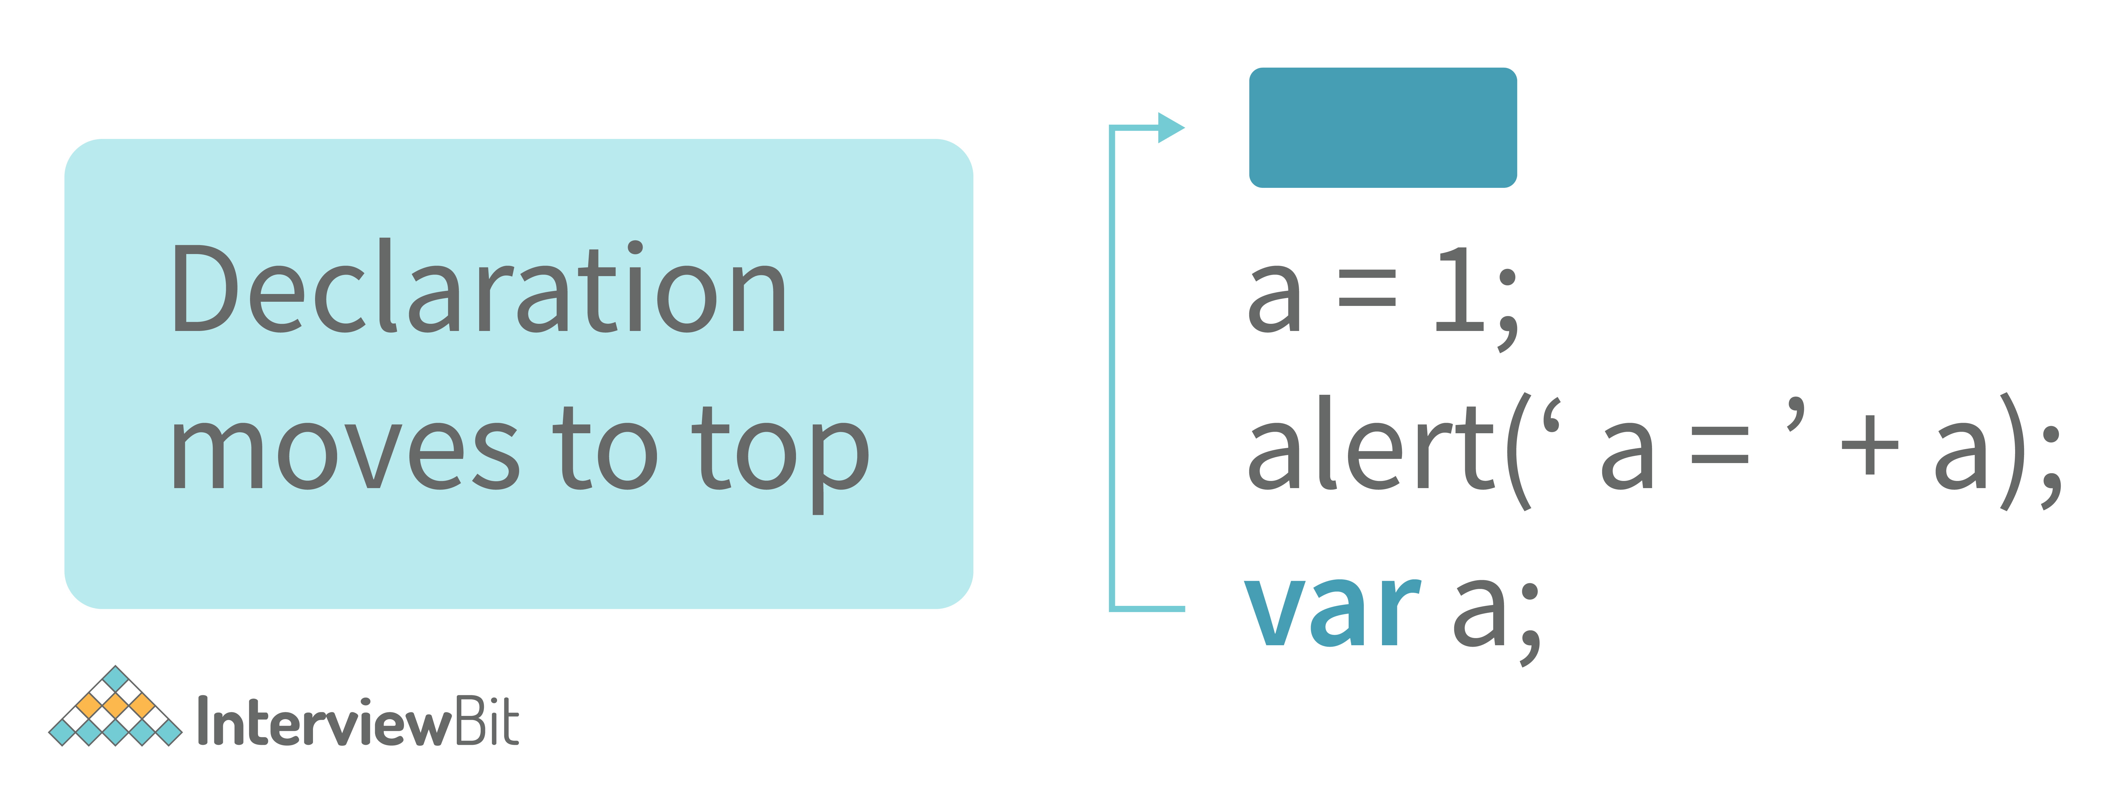

This means that irrespective of where the variables and functions are declared, they are moved on top of the scope. The scope can be both local and global.  
  
**Example 1:**

hoistedVariable = 3;

console.log(hoistedVariable); // outputs 3 even when the variable is declared after it is initialized

var hoistedVariable;

**Example 2:**

hoistedFunction(); // Outputs " Hello world! " even when the function is declared after calling

function hoistedFunction(){

console.log(" Hello world! ");

}

**Example 3:**

// Hoisting takes place in the local scope as well

function doSomething(){

x = 33;

console.log(x);

var x;

}

doSomething(); // Outputs 33 since the local variable “x” is hoisted inside the local scope

#### ****Note - Variable initializations are not hoisted, only variable declarations are hoisted:****

var x;

console.log(x); // Outputs "undefined" since the initialization of "x" is not hoisted

x = 23;

#### ****Note - To avoid hoisting, you can run javascript in strict mode by using “use strict” on top of the code:****

"use strict";

x = 23; // Gives an error since 'x' is not declared

var x;

### 3. Why do we use the word “debugger” in javascript?

The debugger for the browser must be activated in order to debug the code. Built-in debuggers may be switched on and off, requiring the user to report faults. The remaining section of the code should stop execution before moving on to the next line while debugging.

You can download a PDF version of Javascript Interview Questions.

[Download PDF](javascript:void(0))

### 4. Difference between “ == “ and “ === “ operators.

Both are comparison operators. The difference between both the operators is that “==” is used to compare values whereas, “ === “ is used to compare both values and types.

**Example:**

var x = 2;

var y = "2";

(x == y) // Returns true since the value of both x and y is the same

(x === y) // Returns false since the typeof x is "number" and typeof y is "string"

### 5. Difference between var and let keyword in javascript.

Some differences are

1. From the very beginning, the 'var' keyword was used in JavaScript programming **whereas the keyword** 'let' was just added in 2015.
2. The keyword 'Var' has a function scope. Anywhere in the function, the variable specified using var is accessible but in ‘let’ the scope of a variable declared with the 'let' keyword is limited to the block in which it is declared. Let's start with a Block Scope.
3. In ECMAScript 2015, let and const are hoisted but not initialized. Referencing the variable in the block before the variable declaration results in a ReferenceError because the variable is in a "temporal dead zone" from the start of the block until the declaration is processed.

### 6. Explain Implicit Type Coercion in javascript.

Implicit type coercion in javascript is the automatic conversion of value from one data type to another. It takes place when the operands of an expression are of different data types.

* **String coercion**

String coercion takes place while using the ‘ + ‘ operator. When a number is added to a string, the number type is always converted to the string type.

Example 1:

var x = 3;

var y = "3";

x + y // Returns "33"

Example 2:

var x = 24;

var y = "Hello";

x + y // Returns "24Hello";

#### Note - ‘ + ‘ operator when used to add two numbers, outputs a number. The same ‘ + ‘ operator when used to add two strings, outputs the concatenated string:

var name = "Vivek";

var surname = " Bisht";

name + surname // Returns "Vivek Bisht"

Let’s understand both the examples where we have added a number to a string,

When JavaScript sees that the operands of the expression x + y are of different types ( one being a number type and the other being a string type ), it converts the number type to the string type and then performs the operation. Since after conversion, both the variables are of string type, the ‘ + ‘ operator outputs the concatenated string “33” in the first example and “24Hello” in the second example.

#### Note - Type coercion also takes place when using the ‘ - ‘ operator, but the difference while using ‘ - ‘ operator is that, a string is converted to a number and then subtraction takes place.

var x = 3;

Var y = "3";

x - y //Returns 0 since the variable y (string type) is converted to a number type

* **Boolean Coercion**

Boolean coercion takes place when using logical operators, ternary operators, if statements, and loop checks. To understand boolean coercion in if statements and operators, we need to understand truthy and falsy values.  
  
Truthy values are those which will be converted (coerced) to **true**. Falsy values are those which will be converted to **false**.  
  
All values except **false, 0, 0n, -0, “”, null, undefined, and NaN** are truthy values.

**If statements:**

Example:

var x = 0;

var y = 23;

if(x) { console.log(x) } // The code inside this block will not run since the value of x is 0(Falsy)

if(y) { console.log(y) } // The code inside this block will run since the value of y is 23 (Truthy)

* **Logical operators:**

Logical operators in javascript, unlike operators in other programming languages, **do not return true or false. They always return one of the operands.**  
  
**OR ( | | ) operator** - If the first value is truthy, then the first value is returned. Otherwise, always the second value gets returned.  
  
**AND ( && ) operator** - If both the values are truthy, always the second value is returned. If the first value is falsy then the first value is returned or if the second value is falsy then the second value is returned.  
  
Example:

var x = 220;

var y = "Hello";

var z = undefined;

x | | y // Returns 220 since the first value is truthy

x | | z // Returns 220 since the first value is truthy

x && y // Returns "Hello" since both the values are truthy

y && z // Returns undefined since the second value is falsy

if( x && y ){

console.log("Code runs" ); // This block runs because x && y returns "Hello" (Truthy)

}

if( x || z ){

console.log("Code runs"); // This block runs because x || y returns 220(Truthy)

}

* **Equality Coercion**

Equality coercion takes place when using ‘ == ‘ operator. As we have stated before  
  
**The ‘ == ‘ operator compares values and not types.**  
  
While the above statement is a simple way to explain == operator, it’s not completely true  
  
The reality is that while using the ‘==’ operator, coercion takes place.  
  
The ‘==’ operator, converts both the operands to the same type and then compares them.  
  
Example:

var a = 12;

var b = "12";

a == b // Returns true because both 'a' and 'b' are converted to the same type and then compared. Hence the operands are equal.

Coercion does not take place when using the ‘===’ operator. Both operands are not converted to the same type in the case of ‘===’ operator.

Example:

var a = 226;

var b = "226";

a === b // Returns false because coercion does not take place and the operands are of different types. Hence they are not equal.

### 7. Is javascript a statically typed or a dynamically typed language?

JavaScript is a dynamically typed language. In a dynamically typed language, the type of a variable is checked during **run-time** in contrast to a statically typed language, where the type of a variable is checked during **compile-time.**

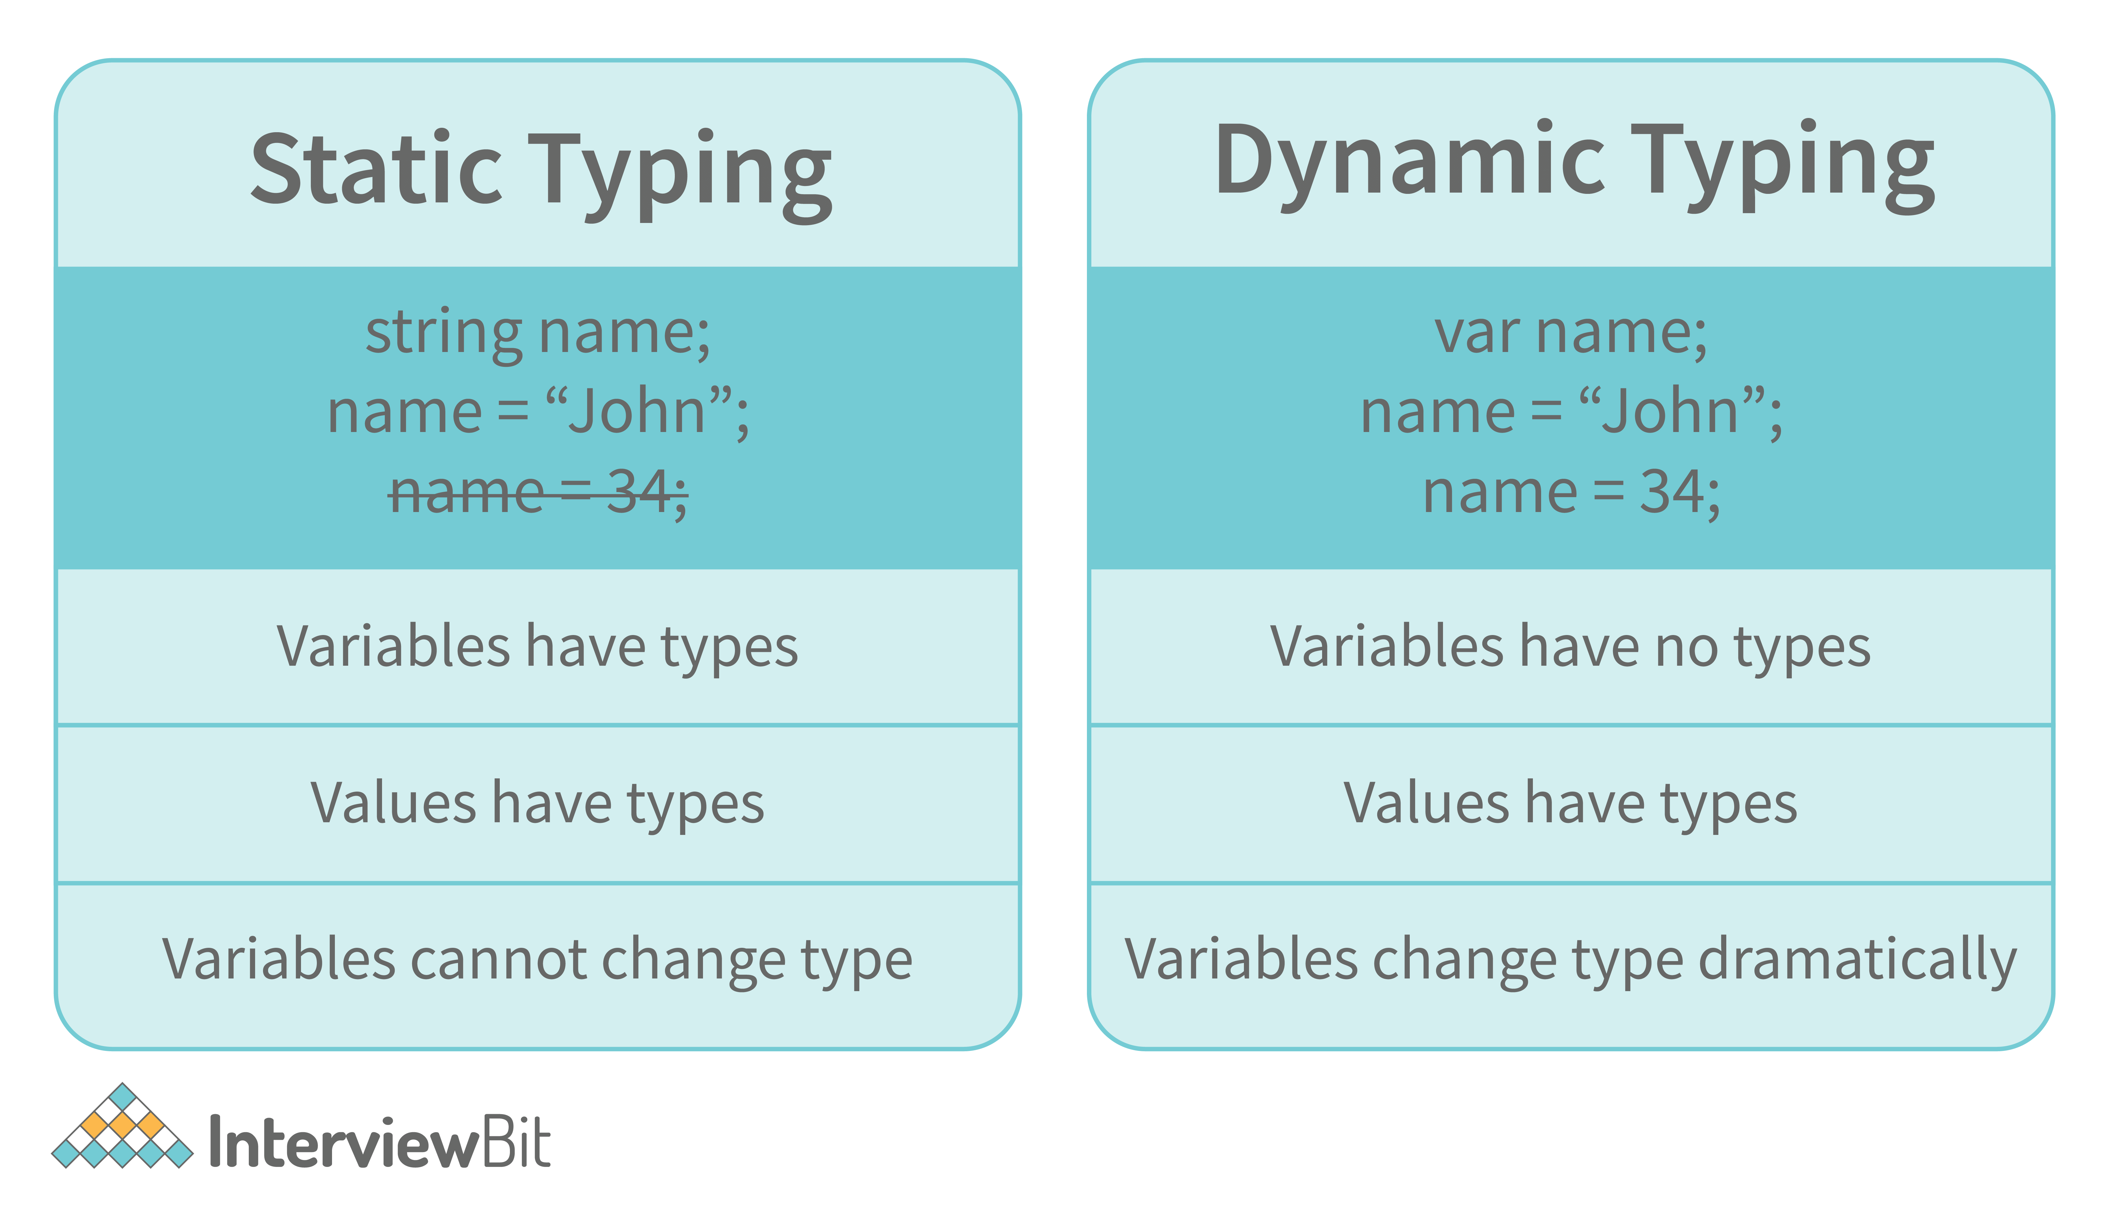

Since javascript is a loosely(dynamically) typed language, variables in JS are not associated with any type. A variable can hold the value of any data type.

For example, a variable that is assigned a number type can be converted to a string type:

var a = 23;

var a = "Hello World!";

### 8. What is NaN property in JavaScript?

NaN property represents the **“Not-a-Number”** value. It indicates a value that is not a legal number.

**typeof** of NaN will return a **Number**.

To check if a value is NaN, we use the **isNaN()** function,

#### Note- isNaN() function converts the given value to a Number type, and then equates to NaN.

isNaN("Hello") // Returns true

isNaN(345) // Returns false

isNaN('1') // Returns false, since '1' is converted to Number type which results in 0 ( a number)

isNaN(true) // Returns false, since true converted to Number type results in 1 ( a number)

isNaN(false) // Returns false

isNaN(undefined) // Returns true

### 9. Explain passed by value and passed by reference.

**In JavaScript, primitive data types are passed by value and non-primitive data types are passed by reference.**  
  
For understanding passed by value and passed by reference, we need to understand what happens when we create a variable and assign a value to it,

var x = 2;

In the above example, we created a variable x and assigned it a value of “2”. In the background, the “=” (assign operator) allocates some space in the memory, stores the value “2” and returns the location of the allocated memory space. Therefore, the variable x in the above code points to the location of the memory space instead of pointing to the value 2 directly.

Assign operator behaves differently when dealing with primitive and non-primitive data types,  
  
**Assign operator dealing with primitive types:**

var y = 234;

var z = y; 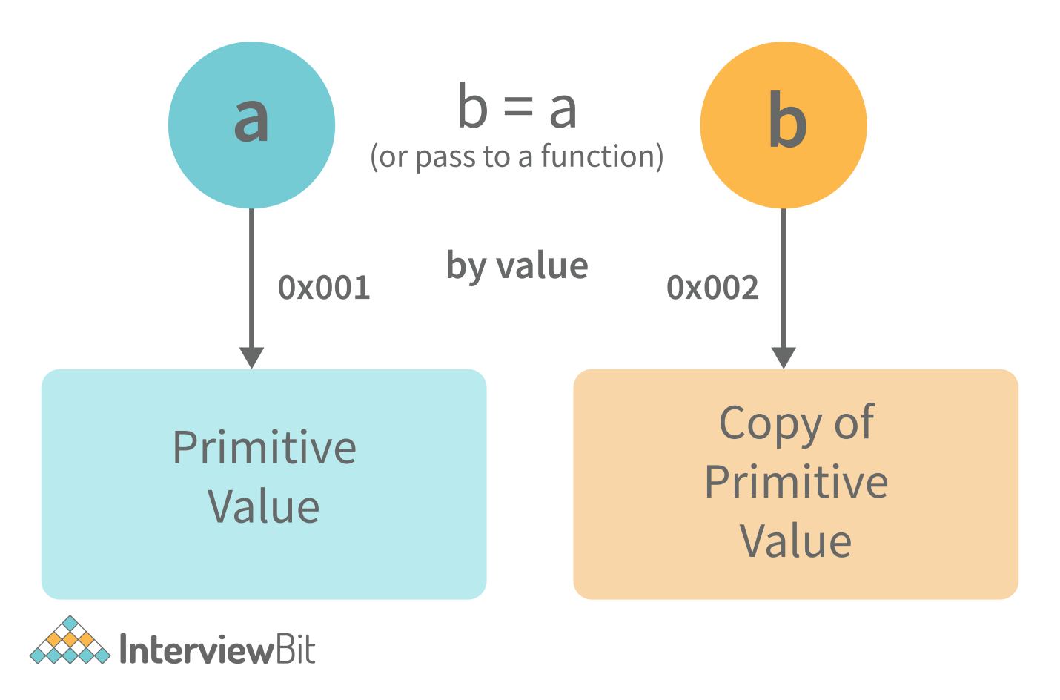

In the above example, the assign operator knows that the value assigned to y is a primitive type (number type in this case), so when the second line code executes, where the value of y is assigned to z, the assign operator takes the value of y (234) and allocates a new space in the memory and returns the address. Therefore, variable z is not pointing to the location of variable y, instead, it is pointing to a new location in the memory.

var y = #8454; // y pointing to address of the value 234

var z = y;

var z = #5411; // z pointing to a completely new address of the value 234

// Changing the value of y

y = 23;

console.log(z); // Returns 234, since z points to a new address in the memory so changes in y will not effect z

From the above example, we can see that primitive data types when passed to another variable, are passed by value. Instead of just assigning the same address to another variable, the value is passed and new space of memory is created.  
  
**Assign operator dealing with non-primitive types:**

var obj = { name: "Vivek", surname: "Bisht" };

var obj2 = obj;

In the above example, the assign operator directly passes the location of the variable obj to the variable obj2. In other words, the reference of the variable obj is passed to the variable obj2.

var obj = #8711; // obj pointing to address of { name: "Vivek", surname: "Bisht" }

var obj2 = obj;

var obj2 = #8711; // obj2 pointing to the same address

// changing the value of obj1

obj1.name = "Akki";

console.log(obj2);

// Returns {name:"Akki", surname:"Bisht"} since both the variables are pointing to the same address.

From the above example, we can see that while passing non-primitive data types, the assign operator directly passes the address (reference).  
  
Therefore, non-primitive data types are always **passed by reference.**

### 10. What is an Immediately Invoked Function in JavaScript?

**An Immediately Invoked Function ( known as IIFE and pronounced as IIFY) is a function that runs as soon as it is defined.**

Syntax of IIFE :

(function(){

// Do something;

})();

To understand IIFE, we need to understand the two sets of parentheses that are added while creating an IIFE :  
  
The first set of parenthesis:

(function (){

//Do something;

})

While executing javascript code, whenever the compiler sees the word “function”, it assumes that we are declaring a function in the code. Therefore, if we do not use the first set of parentheses, the compiler throws an error because it thinks we are declaring a function, and by the syntax of declaring a function, a function should always have a name.

function() {

//Do something;

}

// Compiler gives an error since the syntax of declaring a function is wrong in the code above.

To remove this error, we add the first set of parenthesis that tells the compiler that the function is not a function declaration, instead, it’s a function expression.  
  
The second set of parenthesis:

(function (){

//Do something;

})();

From the definition of an IIFE, we know that our code should run as soon as it is defined. A function runs only when it is invoked. If we do not invoke the function, the function declaration is returned:

(function (){

// Do something;

})

// Returns the function declaration

**Therefore to invoke the function, we use the second set of parenthesis.**

### 11. What do you mean by strict mode in javascript and characteristics of javascript strict-mode?

In ECMAScript 5, a new feature called JavaScript Strict Mode allows you to write a code or a function in a "strict" operational environment. In most cases, this language is 'not particularly severe' when it comes to throwing errors. In 'Strict mode,' however, all forms of errors, including silent errors, will be thrown. As a result, debugging becomes a lot simpler.  Thus programmer's chances of making an error are lowered.

Characteristics of strict mode in javascript

1. Duplicate arguments are not allowed by developers.
2. In strict mode, you won't be able to use the JavaScript keyword as a parameter or function name.
3. The 'use strict' keyword is used to define strict mode at the start of the script. Strict mode is supported by all browsers.
4. Engineers will not be allowed to create global variables in 'Strict Mode.

### 12. Explain Higher Order Functions in javascript.

**Functions that operate on other functions, either by taking them as arguments or by returning them, are called higher-order functions.**  
  
Higher-order functions are a result of functions being **first-class citizens** in javascript.

Examples of higher-order functions:

function higherOrder(fn) {

fn();

}

higherOrder(function() { console.log("Hello world") });

function higherOrder2() {

return function() {

return "Do something";

}

}

var x = higherOrder2();

x() // Returns "Do something"

### 13. Explain “this” keyword.

**The “this” keyword refers to the object that the function is a property of.**  
  
**The value of the “this” keyword will always depend on the object that is invoking the function.\**

Confused? Let’s understand the above statements by examples:

function doSomething() {

console.log(this);

}

doSomething();

What do you think the output of the above code will be?

Note - Observe the line where we are invoking the function.

Check the definition again:

#### ****The “this” keyword refers to the object that the function is a property of.****

In the above code, the function is a property of which object?

Since the function is invoked in the global context, **the function is a property of the global object.**

Therefore, the output of the above code will be **the global object.** Since we ran the above code inside the browser, the global object is **the window object.**

Example 2:

var obj = {

name: "vivek",

getName: function(){

console.log(this.name);

}

}

obj.getName();

In the above code, at the time of invocation, the getName function is a property of the object **obj** , therefore, **this** keyword will refer to the object **obj**, and hence the output will be “vivek”.

Example 3:

var obj = {

name: "vivek",

getName: function(){

console.log(this.name);

}

}

var getName = obj.getName;

var obj2 = {name:"akshay", getName };

obj2.getName();

Can you guess the output here?

The output will be “akshay”.

Although the getName function is declared inside the object **obj**, at the time of invocation, getName() is a property of **obj2**, therefore the “this” keyword will refer to **obj2**.

The silly way to understand the “**this”** keyword is, whenever the function is invoked, check the object before the **dot**. The value of **this** . keyword will always be the object before the **dot**.

If there is no object before the dot-like in example1, the value of this keyword will be the global object.

Example 4:

var obj1 = {

address : "Mumbai,India",

getAddress: function(){

console.log(this.address);

}

}

var getAddress = obj1.getAddress;

var obj2 = {name:"akshay"};

obj2.getAddress();

Can you guess the output?

**The output will be an error.**

Although in the code above, this keyword refers to the object **obj2**, obj2 does not have the property “address”‘, hence the getAddress function throws an error.

### 14. What do you mean by Self Invoking Functions?

Without being requested, a self-invoking expression is automatically invoked (initiated). If a function expression is followed by (), it will execute automatically. A function declaration cannot be invoked by itself.

Normally, we declare a function and call it, however, anonymous functions may be used to run a function automatically when it is described and will not be called again. And there is no name for these kinds of functions.

### 15. Explain call(), apply() and, bind() methods.

**1. call():**

* It’s a predefined method in javascript.
* This method invokes a method (function) by specifying the owner object.
* Example 1:

function sayHello(){

return "Hello " + this.name;

}

var obj = {name: "Sandy"};

sayHello.call(obj);

// Returns "Hello Sandy"

* call() method allows an object to use the method (function) of another object.
* Example 2:

var person = {

age: 23,

getAge: function(){

return this.age;

}

}

var person2 = {age: 54};

person.getAge.call(person2);

// Returns 54

* call() accepts arguments:

function saySomething(message){

return this.name + " is " + message;

}

var person4 = {name: "John"};

saySomething.call(person4, "awesome");

// Returns "John is awesome"

**apply()**  
  
The apply method is similar to the call() method. The only difference is that,  
  
**call() method takes arguments separately whereas, apply() method takes arguments as an array.**

function saySomething(message){

return this.name + " is " + message;

}

var person4 = {name: "John"};

saySomething.apply(person4, ["awesome"]);

**2. bind():**

* This method returns a new function, where the value of **“this”** keyword will be bound to the owner object, which is provided as a parameter.
* Example with arguments:

var bikeDetails = {

displayDetails: function(registrationNumber,brandName){

return this.name+ " , "+ "bike details: "+ registrationNumber + " , " + brandName;

}

}

var person1 = {name: "Vivek"};

var detailsOfPerson1 = bikeDetails.displayDetails.bind(person1, "TS0122", "Bullet");

// Binds the displayDetails function to the person1 object

detailsOfPerson1();

// Returns Vivek, bike details: TS0452, Thunderbird

### 16. What is the difference between exec () and test () methods in javascript?

* **test ()** and **exec ()** are RegExp expression methods used in javascript.
* We'll use **exec ()** to search a string for a specific pattern, and if it finds it, it'll return the pattern directly; else, it'll return an 'empty' result.
* We will use a **test ()** to find a string for a specific pattern. It will return the Boolean value 'true' on finding the given text otherwise, it will return 'false'.

### 17. What is currying in JavaScript?

**Currying is an advanced technique to transform a function of arguments n, to n functions of one or fewer arguments.**

Example of a curried function:

function add (a) {

return function(b){

return a + b;

}

}

add(3)(4)

For Example, if we have a function **f(a,b)**, then the function after currying, will be transformed to **f(a)(b).**  
  
By using the currying technique, we do not change the functionality of a function, we just change the way it is invoked.  
  
Let’s see currying in action:

function multiply(a,b){

return a*b;

}

function currying(fn){

return function(a){

return function(b){

return fn(a,b);

}

}

}

var curriedMultiply = currying(multiply);

multiply(4, 3); // Returns 12

curriedMultiply(4)(3); // Also returns 12

As one can see in the code above, we have transformed the function **multiply(a,b)** to a function **curriedMultiply** , which takes in one parameter at a time.

### 18. What are some advantages of using External JavaScript?

External JavaScript is the JavaScript Code (script) written in a separate file with the extension.js, and then we link that file inside the <head> or <body> element of the HTML file where the code is to be placed.

Some advantages of external javascript are

1. It allows web designers and developers to collaborate on HTML and javascript files.
2. We can reuse the code.
3. Code readability is simple in external javascript.

### 19. Explain Scope and Scope Chain in javascript.

Scope in JS determines the accessibility of variables and functions at various parts of one’s code.  
  
In general terms, the scope will let us know at a given part of code, what are variables and functions we can or cannot access.  
  
There are three types of scopes in JS:

* Global Scope
* Local or Function Scope
* Block Scope
* let globalVar = "This is a global variable";
* function fun() {
* let localVar = "This is a local variable";
* console.log(globalVar);
* console.log(localVar);
* }
* fun();
* let num=10;
* console.log(num);
* function fun(){
* console.log(num);
* }
* fun(); // calling the function

**Global Scope:** Variables or functions declared in the global namespace have global scope, which means all the variables and functions having global scope can be accessed from anywhere inside the code.

var globalVariable = "Hello world";

function sendMessage(){

return globalVariable; // can access globalVariable since it's written in global space

}

function sendMessage2(){

return sendMessage(); // Can access sendMessage function since it's written in global space

}

sendMessage2(); // Returns “Hello world”

**Function Scope:** Any variables or functions declared inside a function have local/function scope, which means that all the variables and functions declared inside a function, can be accessed from within the function and not outside of it.

function awesomeFunction(){

var a = 2;

var multiplyBy2 = function(){

console.log(a*2); // Can access variable "a" since a and multiplyBy2 both are written inside the same function

}

}

console.log(a); // Throws reference error since a is written in local scope and cannot be accessed outside

multiplyBy2(); // Throws reference error since multiplyBy2 is written in local scope

**Block Scope:** Block scope is related to the variables declared using let and const. Variables declared with var do not have block scope. Block scope tells us that any variable declared inside a block { }, can be accessed only inside that block and cannot be accessed outside of it.

{

let x = 45;

}

console.log(x); // Gives reference error since x cannot be accessed outside of the block

for(let i=0; i<2; i++){

// do something

}

console.log(i); // Gives reference error since i cannot be accessed outside of the for loop block

**Scope Chain:** JavaScript engine also uses Scope to find variables. Let’s understand that using an example:

var y = 24;

function favFunction(){

var x = 667;

var anotherFavFunction = function(){

console.log(x); // Does not find x inside anotherFavFunction, so looks for variable inside favFunction, outputs 667

}

var yetAnotherFavFunction = function(){

console.log(y); // Does not find y inside yetAnotherFavFunction, so looks for variable inside favFunction and does not find it, so looks for variable in global scope, finds it and outputs 24

}

anotherFavFunction();

yetAnotherFavFunction();

}

favFunction();

**As you can see in the code above, if the javascript engine does not find the variable in local scope, it tries to check for the variable in the outer scope. If the variable does not exist in the outer scope, it tries to find the variable in the global scope.**

If the variable is not found in the global space as well, a reference error is thrown.

### 20. Explain Closures in JavaScript.

Closures are an ability of a function to remember the variables and functions that are declared in its outer scope.

var Person = function(pName){

var name = pName;

this.getName = function(){

return name;

}

}

var person = new Person("Neelesh");

console.log(person.getName());

Let’s understand closures by example:

function randomFunc(){

var obj1 = {name:"Vivian", age:45};

return function(){

console.log(obj1.name + " is "+ "awesome"); // Has access to obj1 even when the randomFunc function is executed

}

}

var initialiseClosure = randomFunc(); // Returns a function

initialiseClosure();

Let’s understand the code above,  
  
The function randomFunc() gets executed and returns a function when we assign it to a variable:

var initialiseClosure = randomFunc();

The returned function is then executed when we invoke initialiseClosure:

initialiseClosure();

The line of code above outputs “Vivian is awesome” and this is possible because of closure.

console.log(obj1.name + " is "+ "awesome");

When the function randomFunc() runs, it seems that the returning function is using the variable obj1 inside it:

Therefore randomFunc(), instead of destroying the value of obj1 after execution, **saves the value in the memory for further reference.** This is the reason why the returning function is able to use the variable declared in the outer scope even after the function is already executed.  
  
**This ability of a function to store a variable for further reference even after it is executed is called Closure.**

### 21. Mention some advantages of javascript.

What is javascript?

2. Difference between var, let and cost.

3. What is NaN property?

In JavaScript, **NaN** stands for **N**ot **a** **N**umber. It represents a value which is not a valid number. It can be used to check whether a number entered is a valid number or not a number. To assign a variable to NaN value, we can use one of the two following ways.

var a = NaN

var a = Number.NaN

**Example:** In this example, we will use JavaScript Number NaN Property.

|  |
| --- |
| var monthNumber = 14;    if (monthNumber < 1 || monthNumber > 12) {        // Assigning monthNumber NaN as      // month number is not valid      monthNumber = Number.NaN;        console.log("Month number should be"                  + " between 1 and 12");  }  else {      console.log(monthNumber);  } |

**Output:**

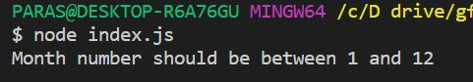

NaN property represents the **“Not-a-Number”** value. It indicates a value that is not a legal number.

**typeof** of NaN will return a **Number**.

To check if a value is NaN, we use the **isNaN()** function,

#### Note- isNaN() function converts the given value to a Number type, and then equates to NaN.

isNaN("Hello") // Returns true

isNaN(345) // Returns false

isNaN('1') // Returns false, since '1' is converted to Number type which results in 0 ( a number)

isNaN(true) // Returns false, since true converted to Number type results in 1 ( a number)

isNaN(false) // Returns false

isNaN(undefined) // Returns true

1. What is strict mode?

## The "use strict" Directive

The "use strict" directive was new in ECMAScript version 5.

It is not a statement, but a literal expression, ignored by earlier versions of JavaScript.

The purpose of "use strict" is to indicate that the code should be executed in "strict mode".

With strict mode, you can not, for example, use undeclared variables.

## The "use strict"; Syntax

The syntax, for declaring strict mode, was designed to be compatible with older versions of JavaScript.

Compiling a numeric literal (4 + 5;) or a string literal ("John Doe";) in a JavaScript program has no side effects. It simply compiles to a non existing variable and dies.

So "use strict"; only matters to new compilers that "understand" the meaning of it.

## Why Strict Mode?

Strict mode makes it easier to write "secure" JavaScript.

Strict mode changes previously accepted "bad syntax" into real errors.

As an example, in normal JavaScript, mistyping a variable name creates a new global variable. In strict mode, this will throw an error, making it impossible to accidentally create a global variable.

In normal JavaScript, a developer will not receive any error feedback assigning values to non-writable properties.

In strict mode, any assignment to a non-writable property, a getter-only property, a non-existing property, a non-existing variable, or a non-existing object, will throw an error.

# strict mode in JavaScript

ECMAScript 5 introduced the concept of **"strict mode"** . It allows you to place a program, or a function, in a "strict" operating context. This strict context prevents certain actions from being taken and throws more **exceptions** . Its main purpose is to do more checking.

## How 'strict mode'

As an example, in normal JavaScript, mistyping a variable name creates a new global variable. In **strict mode** , this will throw an error, making it impossible to accidentally create a **global variable** .

The following script will work because it is non strict mode.

str = "Hello World";

document.write(str);

The following script won't work because it is in strict mode.

'use strict';

str = "Hello World"; // => Throw a reference error

document.write(str);

The above script will throw a reference error because variable str is used without declaring it.

So, how to correct it?

'use strict';

var str = "Hello World";

document.write(str);

5. What is IIFE?

6. setTimeout vs setInterval

7. classes in javascript.

8. What is hoisting?

9. What are closures?

10. Output based question.

11. Return second largest element in the array.

12. localStorage vs sessionStorage.

13. Fetch data from api and sort the data in it.

### Pure functions

Pure functions always returns the **same result** if the same arguments are passed in. It does not depend on any state, or data, change during a program's execution. It must only depend on its **input arguments** . They do not have any side effects like network or database calls and do not modify tfunction getSquare(x) {

return x * x;

}he arguments which are passed to them.

#### example

### Impure functions

Any function that changes the **internal state** of one of its arguments or the value of some external variable is an **impure function** . They may have any side effects like network or database calls and it may modify the arguments which are passed to them.

#### example

function getSquare(items) {

var len = items.length;

for (var i = 0; i < len; i++) {

items[i] = items[i] * items[i];

}

return items;

}