**DEEPSHIKHA**

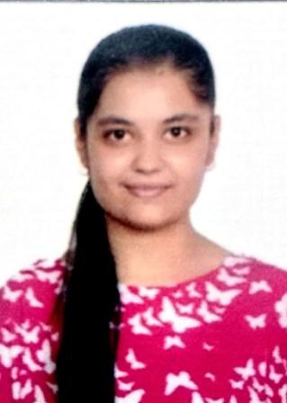

**Address:** #320,Guru Teg Bahadur Nagar, Jagadhri Workshop,

Yamunanagar,135002

**Contact No.:** 8307046535

**Email:** deepshikha2700@gmail.com

**LinkedIn:** <https://www.linkedin.com/in/deepshikha-27>

**OBJECTIVE**

#### Adaptable computer science and engineering major aiming to leverage proven leadership, teamwork and multitasking skills to successfully fulfil the demand of your company.

**EDUCATIONAL QUALIFICATION**

|  |  |  |  |  |
| --- | --- | --- | --- | --- |
| **Course** | **Board/ University** | **Name of the Institute** | **Year of Passing** | **Percentage/ CGPA** |
| B.Tech (CSE) | Kurukshetra University, Kurukshetra | Seth Jai Parkash Mukand Lal Institute of  Engg. & Technology, Radaur | 2022 | 77%/8.79GPA aggregated  (Till 5TH Semester) |
| Senior Secondary Certificate | CBSE | Springfields Public School, Yamunanagar | 2018 | 82% |
| Matriculation | CBSE | Springfields Public School, Yamunanagar | 2016 | 9.8 CGPA |

**TECHNICAL SKILLS**

* Beginner in

JavaScript Django

* Proficient in

HTML CSS Bootstrap C++

* Sufficient knowledge of

Cyber Security Data Privacy Fundamentals SIEM(QRADAR)

**TRAININGS**

* Attended 6 weeks online training on “Python Fundamentals” at “Udemy” in 1st year of graduation.

(June 2019 to August 2019)

**Brief description:** Gained knowledge about the syntax and logic of programming language python.

* Attended 6 weeks online training on “Cyber Security” at “Allsoft solutions-IBM partner” in 2nd year of graduation. (June 2020 to August 2020)

**Brief description:** Gained knowledge about different domains of Cyber security and data privacy fundamentals . Worked on open source and enterprise software of IBM and also worked on Burpsuit.

**ACADEMIC PROJECTS UNDERTAKEN**

* **Project title:** AES Cryptography tool (September 2020)

**Brief description:** A symmetric cryptography tool used to encrypt as well as decrypt text, images, files, folders saved in a system to protect them from the attackers.

**Technology used-** Python

* **Project title:** E-WARE Portal (April 2021- present)

**Brief description:** E-WARE Portal or E-mail Awareness portal or Phishing campaign portal is carried out by email spoofing; an email directs the recipient to enter personal information at a fake website that look identical to the legitimate site. These attack simulations are typically used to test the awareness of an employee towards the companies security standards.

**Technologies used-**HTML, CSS, Bootstrap, JavaScript, Django

**STRENGTHS**

#### Team Leadership – motivate and inspire everyone to do their best work

* + - * Strategic – strategize every task to complete it efficiently.
      * Dedicated- don’t give up easily, completes work on time.
      * Patient – handles the situation calmly.
      * Loyal – faithful to the work and my fellow beings.

**ACADEMIC ACHIEVEMENTS**

* Successfully completed AI for India workshop under GUVI,AICTE. (2021)
* Completed an employability focused communication skills programme by LEAP Skills, India. (2019)
* Participated in the IUCEE SCALE Regional Student Workshop. (2018)
* Secured 1st position at district level in National Science Olympiad. (2017)

**EXTRACURRICULAR ACTIVITIES/ VOLUNTEER ACTIVITIES (SOCIAL, PHILANTHROPHIC, ETC):**

* Coordinated various club activities organised by Go Green Club of the college. (2021,2020,2019)
* Secured 3rd position in Tattoo Making contest during Annual Cultural Fest. (2019)
* Participated in Annual Cultural Fest. (2019)
* Volunteered in Blood Donation Mella organised by NSS Unit of the college. (2019&2018)

**PERSONAL INFORMATION:**

**Father’s Name:** Mr. Chaman Lal

**Mother’s Name:** Mrs. Babita Rani

**Date of Birth:**  27 October 2000

**Marital Status:** Unmarried

**Hobbies:** Observing the surroundings,Spending time with myself, listening to music, watching series

and movies, travelling.

**DATE:** 24 June 2021 **SIGNATURE:** DEEPSHIKHA

**PLACE:** Yamuna Nagar **NAME:** Deepshikha