User Manual
CFD Software

Group-5

Kriti Mehta(B17087), Kanika Gupta(B17047), Khushi(B17048),Deepshikha(B17120)

- Application can be opened by double-click on icon.(Application Launcher)
- A main window along with error window gets opened. User is asked to create a new project or open an existing project. User can browse the location for the project directory.
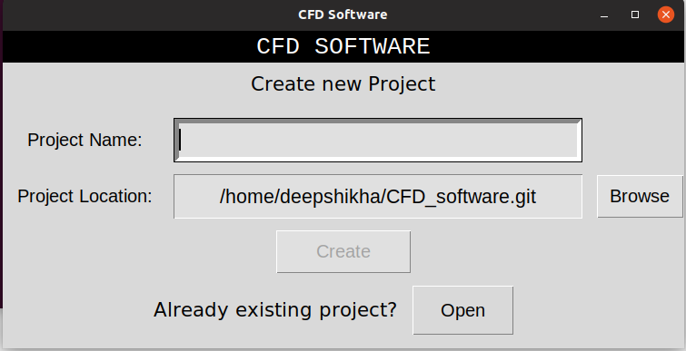
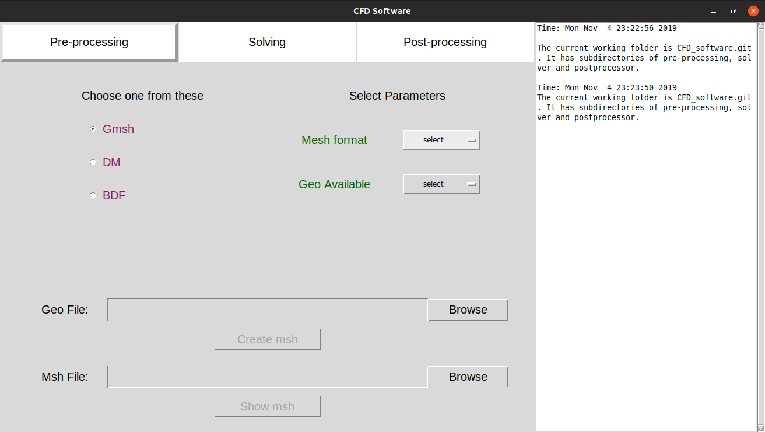
- If a new project is made, on creation, three sub-directories, namely, preprocessing, solver and post-processing are made.A window opens consisting of 3 tabs for 3 different processes. By default the pre-processing tab is open, but user can change the stage to start from. A log window is there in the right which creates a log with timestamp for each action taken.

- In pre-processor stage, user can browse the .geo file and convert it to .msh file using gmsh software. User can see the mesh created using “show mesh” button.
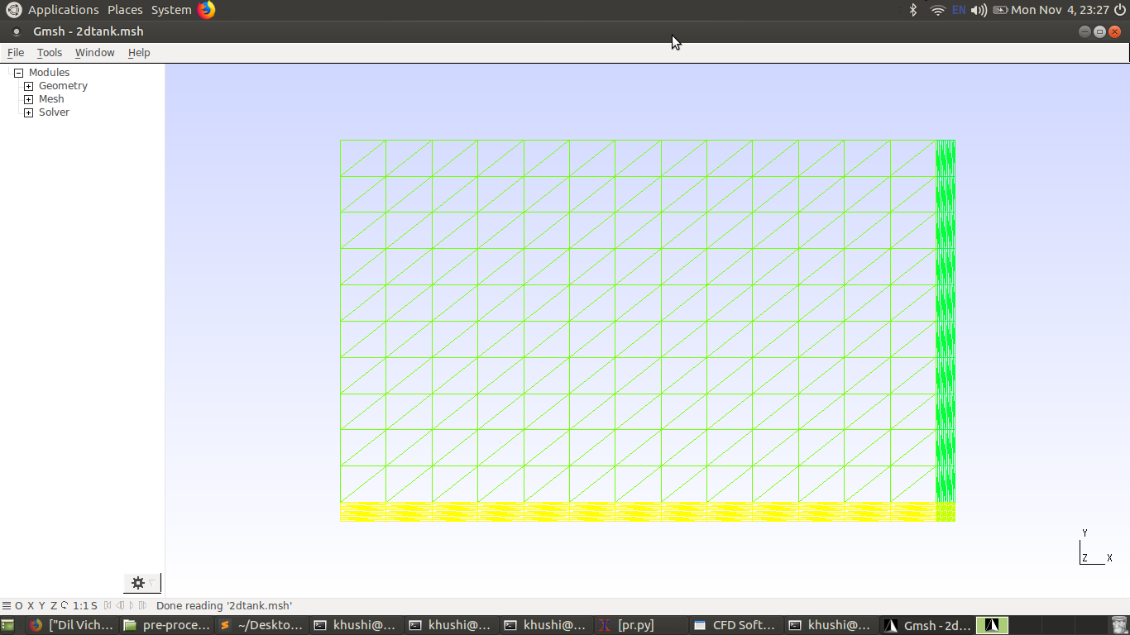
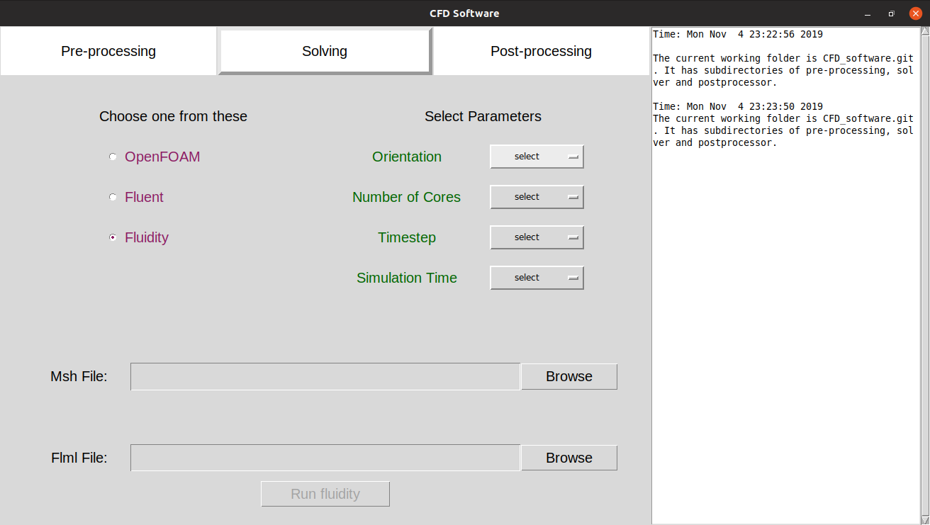
- In the solver stage, user can either use the .msh file generated in the previous stage, or browse some already .msh existing file.
If chosen fluidity: User also needs to browse .flml file. Many files with .detector and .vtu files are generated in post-processing folder after this proces
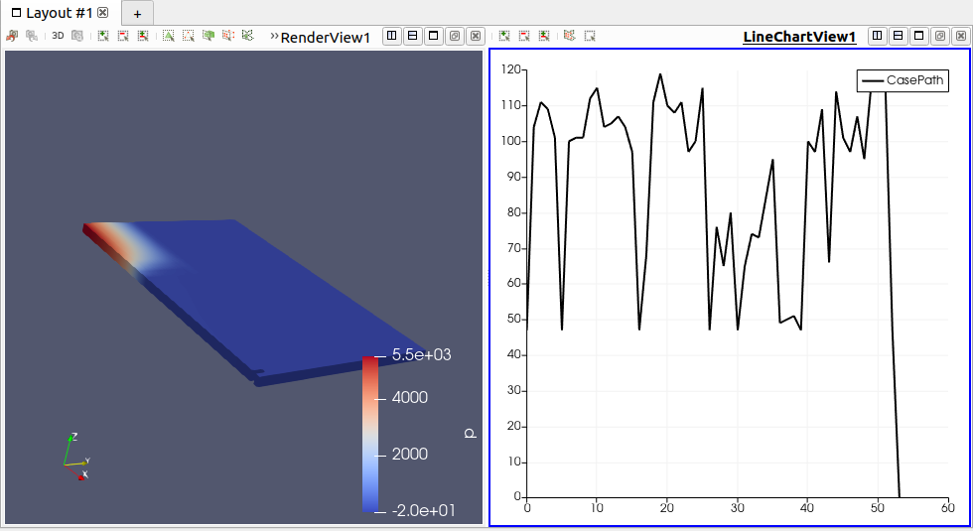
If chosen openFOAM: User gets 3D mesh and graphs as output in paraview GUI.

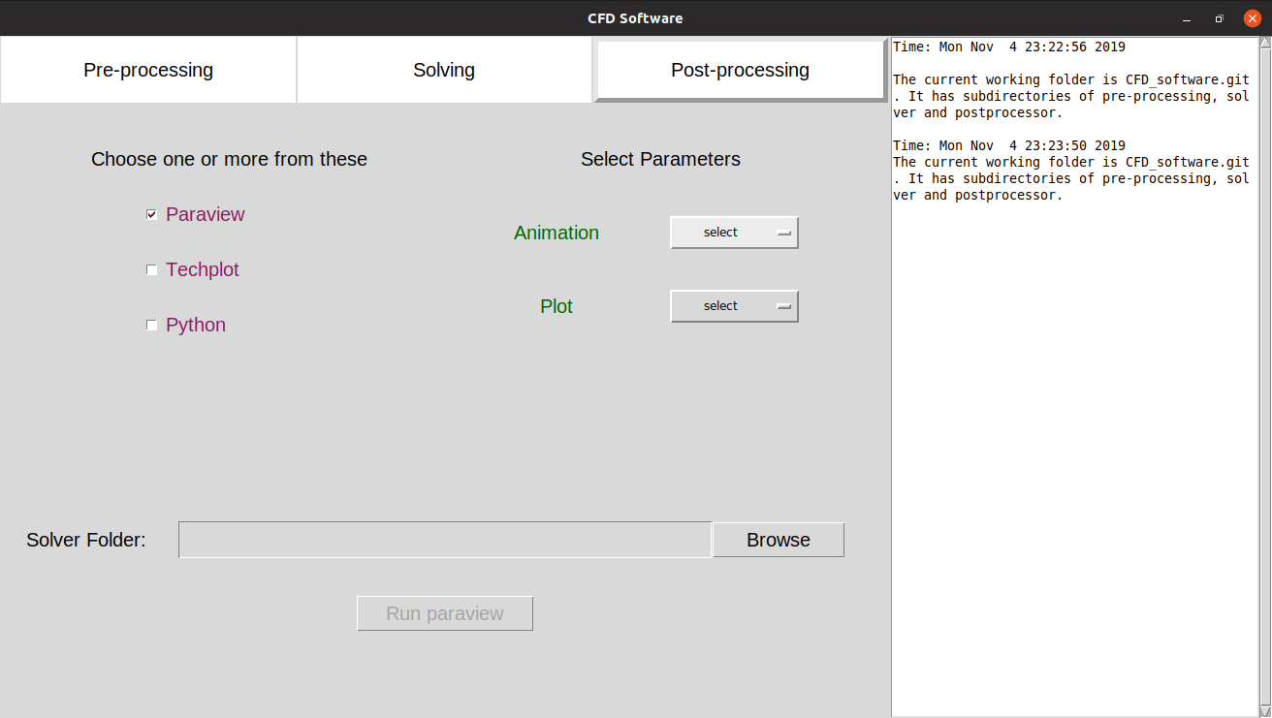
- In the post-processing stage,a python script “plot_data.py” containing paraview system call is run and output graphs are generated.
