# CONTACT

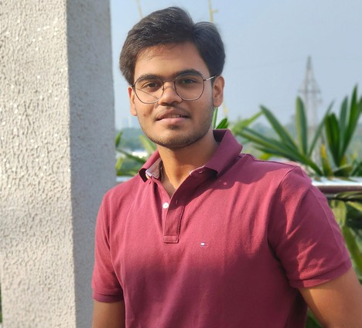

 +91 7894776067

 [srujansrujan767@gmail.com](mailto:srujansrujan767@gmail.com)  Bhubaneswar

# TECHNICAL



**SKILLS**

**Web Development:** HTML, CSS, JavaScript, React

**Programming Languages:** Python, C

### Core Concepts:

Object-Oriented Programming (OOP) in C

Data Structures and Algorithms (DSA) in C

# LANGUAGES

 English (Fluent)  Hindi (Fluent)

 Odia (Fluent)

# CERTIFICATIONS & ACHIEVEMENTS

**PROFILE**

Motivated and enthusiastic Computer Science and Engineering undergraduate from Vellore Institute of Technology, Vellore, with a strong academic foundation built at Delhi Public School Kalinga and Doon International School, Bhubaneswar. Eager to apply my technical knowledge, problem-solving abilities, and passion for innovation in real-world applications. I aim to contribute meaningfully to dynamic teams while continuing to learn and grow in the fields of Artificial Intelligence, Software Development, and Emerging Technologies.

# INTERNSHIPS

Intern – IoT, AI & ML e-Warn, NIT Rourkela

Duration: [June 2025 – July 2025]

Worked on innovative projects combining Internet of Things (IoT), Artificial Intelligence (AI), and Machine Learning (ML)

technologies under the mentorship of professionals at NIT Rourkela.

# EDUCATION

**B.Tech in Computer Science and Engineering (Core**) Vellore Institute of Technology (VIT), Vellore

2023 – 2027 (Ongoing) (Cgpa : 8.34)

## Senior Secondary (Class XII), CBSE

Doon International English Medium School 2021 – 2023

## Secondary (Class X), CBSE

Delhi Public School Kalinga 2020 – 2021

# CONTACT



 +91 7894776067

 [srujansrujan767@gmail.com](mailto:srujansrujan767@gmail.com)  Bhubaneswar

# TECHNICAL



**SKILLS**

**Web Development:** HTML, CSS, JavaScript, React

**Programming Languages:** Python, C

### Core Concepts:

Object-Oriented Programming (OOP) in C

Data Structures and Algorithms (DSA) in C

# LANGUAGES

 English (Fluent)  Hindi (Fluent)

 Odia (Fluent)

# CERTIFICATIONS & ACHIEVEMENTS

**PROFILE**

Motivated and enthusiastic Computer Science and Engineering undergraduate from Vellore Institute of Technology, Vellore, with a strong academic foundation built at Delhi Public School Kalinga and Doon International School, Bhubaneswar. Eager to apply my technical knowledge, problem-solving abilities, and passion for innovation in real-world applications. I aim to contribute meaningfully to dynamic teams while continuing to learn and grow in the fields of Artificial Intelligence, Software Development, and Emerging Technologies.

# INTERNSHIPS

Intern – IoT, AI & ML e-Warn, NIT Rourkela

Duration: [June 2025 – July 2025]

Worked on innovative projects combining Internet of Things (IoT), Artificial Intelligence (AI), and Machine Learning (ML)

technologies under the mentorship of professionals at NIT Rourkela.

# EDUCATION

**B.Tech in Computer Science and Engineering (Core**) Vellore Institute of Technology (VIT), Vellore

2023 – 2027 (Ongoing) (Cgpa : 8.34)

## Senior Secondary (Class XII), CBSE

Doon International English Medium School 2021 – 2023

## Secondary (Class X), CBSE

Delhi Public School Kalinga 2020 – 2021