**DeepskyLog, an online application for preparing and logging deepsky observations**

Always wanted to have an up to date list of the deepsky objects you have already observed? Do you want to have an indication of which objects are visible using your instrument, from your location? Do you want to know how much easier objects are visible from a darker spot? Do you want to compare your own observations with what others have seen?

All this and a lot more can be done using DeepskyLog. DeepskyLog started as an online logging application, but a lot of extra functionalities were added since development started in 2004. At this moment (end 2011), DeepskyLog has more than 56000 observations of more than 6000 different deep sky objects. You can also find more than 7600 drawings and sketches of numerous deep sky objects.

DeepskyLog is free to use for everyone. In this article, we will introduce DeepskyLog.

**First visit to DeepskyLog**

DeepskyLog can be used by directing your internet browser to <http://www.deepskylog.org/>. DeepskyLog is tested on and works in all modern browsers (Internet Explorer 8+, Firefox and Chrome).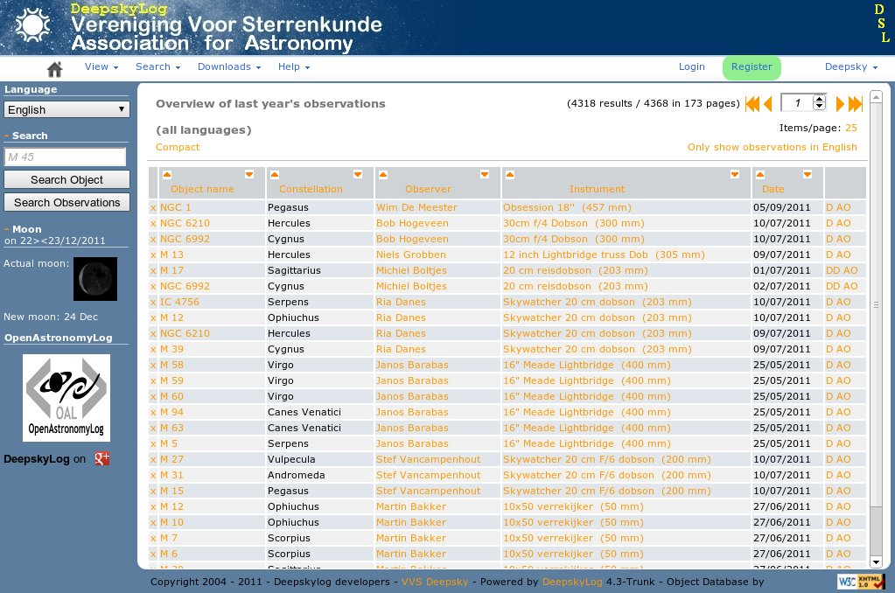

At the home page of DeepskyLog, you will find a menu where you can select a lot of views, log in or register. Registering is not mandatory, but gives you the possibility to enter your own observations, make your own observing lists, …

**Logging capabilities**

Do you also have problems remembering which deep sky objects you have already seen? It is possible to log your own observations in DeepskyLog, after you have added your observing location and instruments. You can add a description, a drawing or a sketch, the language of your description, the limiting magnitude or the sqm value, … You can even group some observations in a session, which can be shared with other people. The better your descriptions are, the better you will remember your observations later on and the better other observers can compare their observations with yours.

After entering your observations, you can use DeepskyLog to make some statistics : the number of observations done, different objects seen, drawings made, the number of object types observed, ...

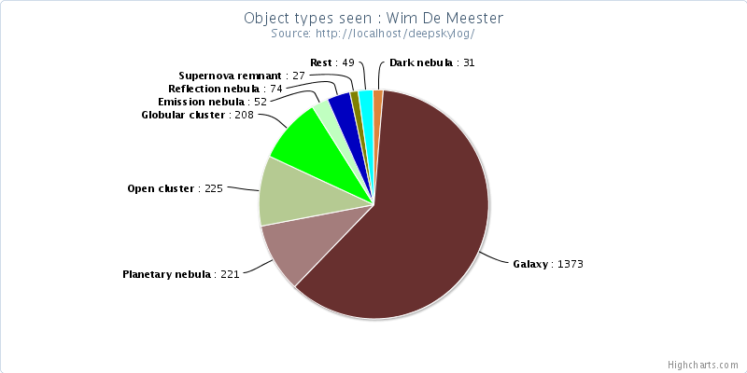

Another nice extra is that you are able to see which objects of a certain list you have already seen, and which objects you still have to observe to finish the list. This functionality can be found in ‘View -> Observers’. DeepskyLog will automatically show the number of Messier objects seen, but you can easily change this. After selecting which catalog or observing list you are interested in, clicking on the number of objects seen will show a detailed list, as shown in the screenshot below :

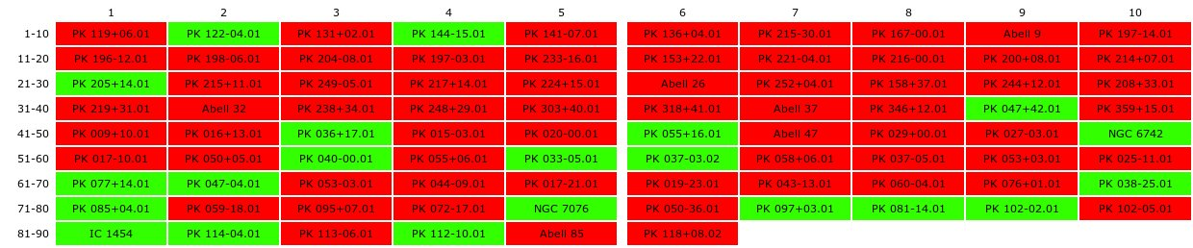

The objects you have already seen are highlighted in green, the ones in red were not yet observed by you.

**Comparing observations**

Comparing your observations can be very interesting. You can use DeepskyLog to compare your observations of a certain object to observations you have logged before. You can find out what the effect of a better sky means for this particular object. It is also immediately clear how different instruments compare to each other and even how you can discern significantly more details of the same object when you build up observer experience over the years. You can also check what others have seen and see which extra details become visible using a larger telescope.

The nice thing is that DeepskyLog already contains an enormous amount of observations, so chances are very high that the object you observed is already observed by someone else before. Most of the observations are in Dutch or English at this moment, but DeepskyLog has the possibility to translate every observation to the language you like. To make this possible, DeepskyLog uses google translate. Probably, not all descriptions will be easy to understand after the translation, but this should at least be good enough to have an idea what the other observer is talking about.

**Preparing an observing session**

DeepskyLog is also a very powerful tool to prepare an observing session. You can create your own observing list with targets you would like to see during the next clear night. These observing lists can be exported to a pdf file for printing, a csv file for importing into a spreadsheet or even to a file which can be directly uploaded to your Argo Navis digital setting circles. When you have created an interesting observing list, you can mark that list as “public”, so that other observers can also use your list. DeepskyLog has around 50 public observing lists you can use.

When viewing the details of a deep-sky object, you can directly see the DSS image of this object or download some star charts to use at your telescope. These star charts immediately indicate whether the object was already seen by yourself or someone else. You can even start an interactive atlas, to see if there are any other interesting objects nearby. The stars in this interactive atlas go down to magnitude 16, which means that DeepskyLog can generate star charts for every purpose. When an object is not yet available in DeepskyLog, you can add this object to the database and immediately, the charts will show the newly added deepsky object.

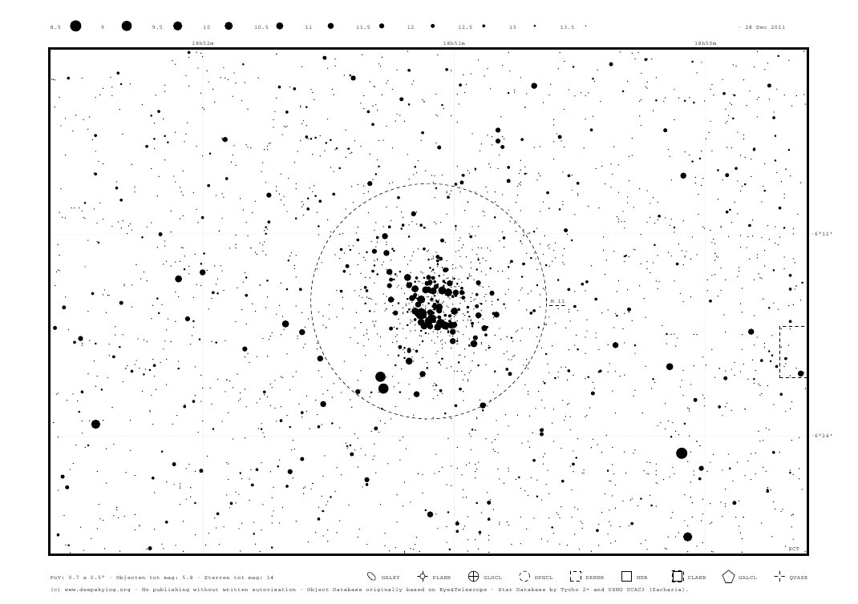

DeepskyLog also tries to predict how difficult it will be to see a particular object using your instrument from your location by calculating the contrast reserve. When the contrast reserve is positive, the object will be easily visible. However, the contrast reserve is not always correct, because it assumes objects have a uniform surface brightness and most deepsky objects don’t have this. The contrast reserve value gives you a good idea of what to expect though.

You can also create or download ‘Image catalogs’, with a small finder chart and detailed DSS images of deepsky objects.

You can even generate your own, personalized atlas of the whole sky. The most detailed atlases have pages of 5 degrees wide, and show stars down to magnitude 14. Using this atlas, you can also directly see which objects are already observed by yourself or by someone else.

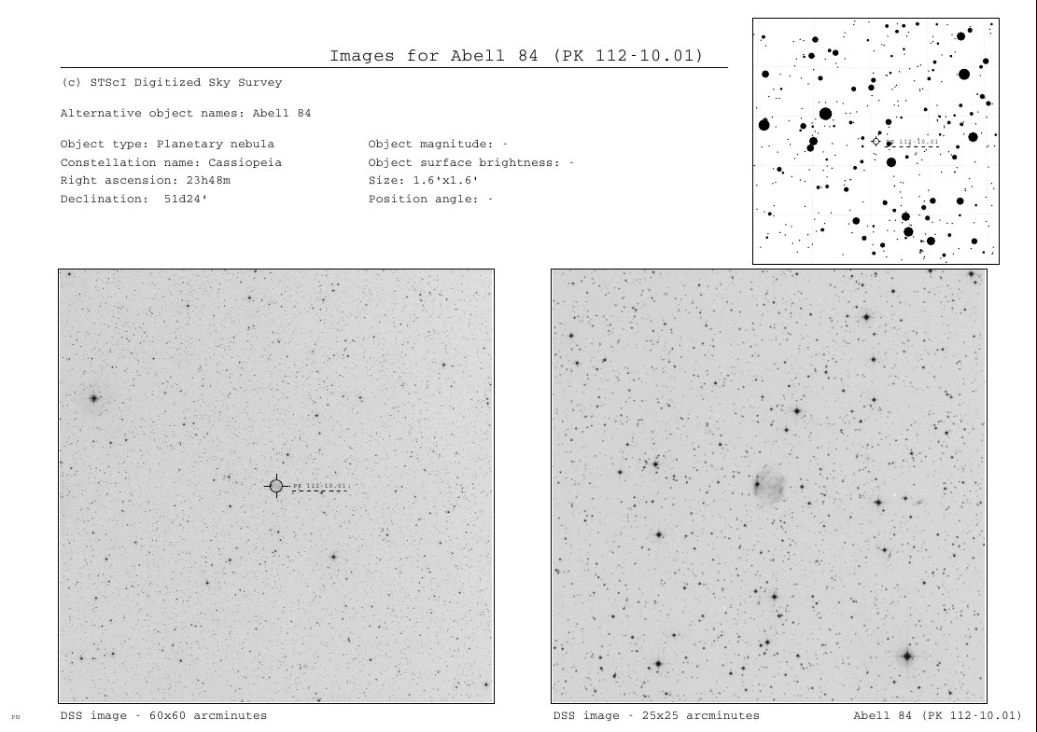

**Connecting with other observers**

DeepskyLog tries to be a tool where you can connect to other observers. When you see an interesting observation, or an observation which contains an error, you can immediately send a message to the observer to start discussing the observation. When you find an observer that was at a location near yours, you can try to set up a common observing session and exchange a lot of knowledge.

**Conclusions**

DeepskyLog is a free to use tool to log your deepsky observations online, compare them with others, prepare new observing lists and meet other observers from your neighborhood.

When you encounter some problems using DeepskyLog or have some questions, please contact [developers@deepskylog.be](mailto:developers@deepskylog.be). DeepskyLog can be found at <http://www.deepskylog.org/>