

**SWARA**

***A Music Notes Database Of South Indian Classical And Film based Songs***



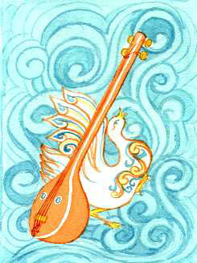

***By***

***Deepthi srinivasan***

TABLE OF CONTENTS

Executive Summary 3

Objectives 3

Entity Relationship Diagram 4

Tables 5

Composer 5

Gati 6

Jati 7

Talas 8

Ragas 9

Genre 10

Songstype 11

Songs 12

Members 13

Plan 14

Subscription 15

Reasontype 16

Notesdownload 17

Views 18

Free members 18

Paid Members 19

Members 20

Classical 21

Film 22

Reason 2

Reports 23

Member Login 23

Search options for paid members 24

Search by genre 26

Implementation Notes 28

Known pROBLEMS 28

fUTURe Enhancements 28

Reference 29

***SWARA***

# **Executive Summary**

South Indian classical music has been passed on from generation to generation in the format of Guru-Shishya parampara (Teacher-student tradition). In this format the teacher imparts knowledge to the student who then passes the knowledge to his students. Much of the music notes exists in the form of various hardcopy texts and some with a select group of people.

Swara is an attempt to collate the data in a single database which would be easily accessible to artists. Classical music also forms the basic thread for south Indian film music. In the modern times artists tend to perform a few film based songs in the events and concerts to entertain modern audiences. Hence effort has been made to collect music notes for film songs which have a common thread of Raga(tune) and tala(beat).

Swara would enable the artist to quickly search music notes based on raga(tune), genre, composer and song name. This data base also helps the artists to search music notes for songs that are generally not found in the texts as well as music notes for unique film songs. The music notes can be used to play almost all the classical instruments as well as for singing.

# **Objectives**

This database provides the music notes for both south Indian classical music as well as south Indian film music. It achieves the objective by providing data about the building blocks of the song. The database has 13 tables (10 reference table and 3 many to many tables)

* Documents about the Raga (tune) of the song (Raga name and unique signature),

the tala, Jati and Gati (Beat). This forms the basic tala structure for the song.

* Catalogues the composers and the Genre. This is especially helpful while preforming for events and concerts when the artist needs to follow a format or provide a mix of different genres.
* The above cataloguing simplifies search and enabled the members to easily access the required music notes,
* Documents the various reasons why artists download the music notes and its cost which is helpful for including relevant songs in the database
* Documents the members (free and paid) and the subscription plan structure including the cost and duration.

# Entity Relationship Diagram(ERD)

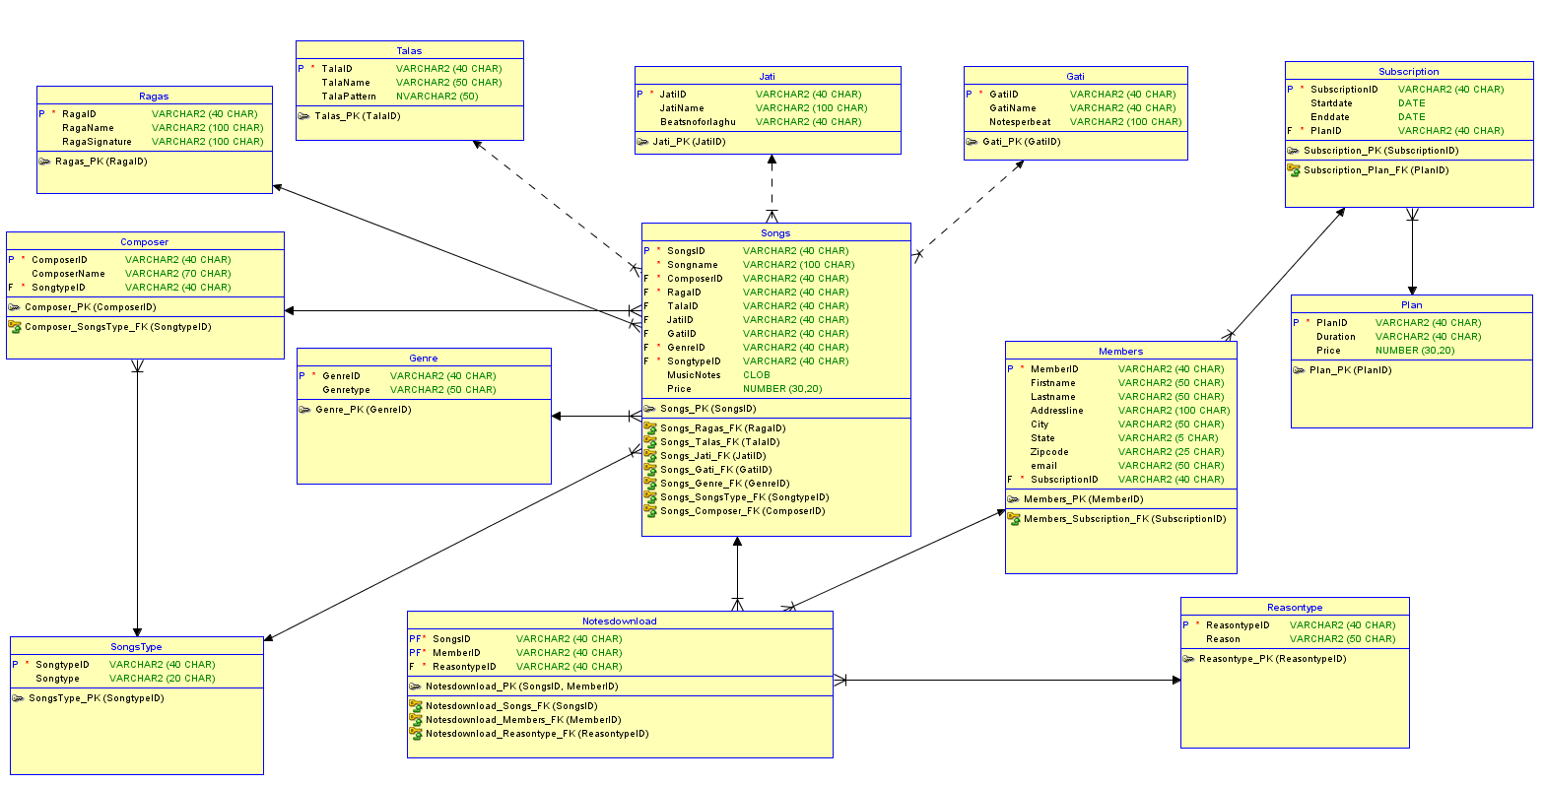

# Tables

## **Composer**

### **purpose:**

The purpose of the table composer is to document both the classical music as well as film music composers and then relate them to the songs that they have composed. The table consists of the following columns:

Composer ID (Primary Key), Composer name, SongtypeID (Foreign Key) which differentiates whether the song is classical or film.

### **Create STATEMENT**

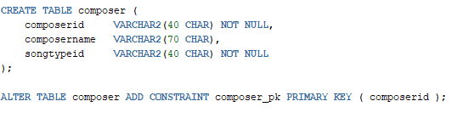

### **Functional Dependency:**

ComposerID ComposerName

### **Sample data**

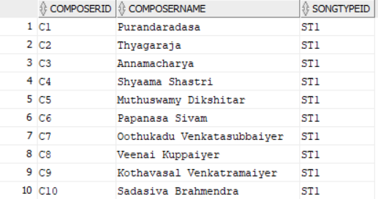

## **Gati**

### **Purpose:**

The purpose of this table is to document one element of the tala structure(beat). This table documents the number of notes per beat. This table in turn relates to the song table as one of the elements of the songs and serves as a foreign key in the songs table. The table has the following columns:

GatiID (Primary Key), GatiName, Notesperbeat.

### **CREATE STATEMENT**

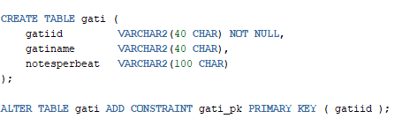

### **Functional Dependencies**

Gatiid GatiName, Notesperbeat.

### **SAMPLE dATA**

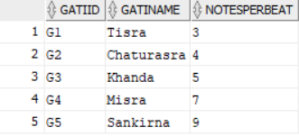

## **Jati**

### **Purpose:**

The purpose of the table is to document another element of the tala pattern (beat). This has the Jati Name and beat number for laghu. Laghu is a clap of the hand. Laghu is followed by counting of the fingers and sometimes by the wave of the hand. This relates to the song table as a foreign key. This table has the following columns:

Jati ID (Primary Key), Jati Name and Beats number for laghu.

### **Create Statement**

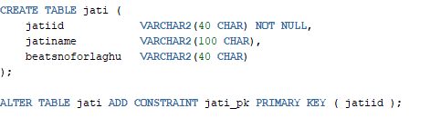

### **Functional Dependencies**

JatiID JatiName, Beatsnoforlaghu.

### **Sample data**

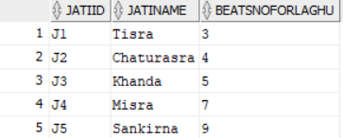

## **Talas**

### **Purpose:**

The purpose of the table is to document the tala(beat) for the song. It documents the tala name and the tala pattern which is represented by clap followed by wave of hand (U)or just a clap(O) or a clap followed by counting of the fingers(I). The table is related to the table song as a foreign key and is represented as one of the elements that make up the song. The table has the following columns:

Tala ID (Primary Key), Tala Name and Tala pattern.

### **Create Statement**

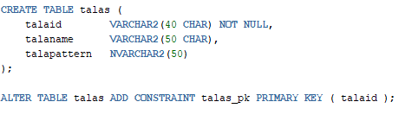

### **Functional Dependencies**

Talaid TalaName, Talapattern.

### **Sample data**

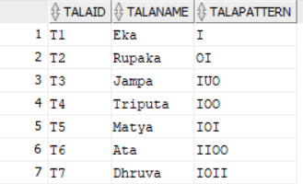

## **Ragas**

### **Purpose**:

The purpose of this table Is to capture the ragas(tune) to which the song has been set. South Indian classical music comprises of 7 swaras (S R G M P D N S) which are used as music notes similar to do re mi fa. Each raga uses a set of swara based on which the entire song is composed. These set of swaras are used in various combinations to compose the song. Hence this table also documents the set of swaras which make up the raga (Raga signature). The Ragas table is related to the Songs table as a foreign key. This is also one of the elements that make up the song. Ragas table consists of the following columns:

RagaID (Primary Key), Raga Name and Raga Signature.

### **Create statement**

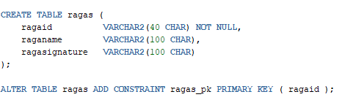

### **Functional Dependencies:**

RagaID Raganame, Ragasignature.

### **Sample Data**

### 

## **Genre**

### **Purpose:**

The purpose of the Genre table is to document the different Genres of Classical Music and Film Songs. The Genre of classical music consists of the following: Geetham, Varnam, Swarajathi, Krithis and Thillana. They are classified based on their complexity and form a major part of the recital in a concert. The South Indian film music on the other hand is classified based on the emotions the song evokes and consists of the following: Folk, Melody, Ballad and Lullaby. This table is related to the Songs table and is a foreign key to that table. Genre table consists of the following columns:

GenreID (Primary Key) and Genre Type.

### **Create Statement**

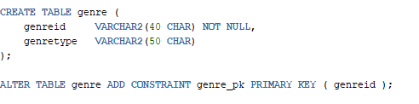

### **Functional Dependencies**

GenreID GenreType

### **sAMPLE dATA**

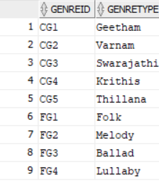

## **SongsType**

### **Purpose:**

The database documents both Classical and Film song music notes. The purpose of the table is to differentiate between the two. This table is a foreign key to Songs and Composer table. This table has the following columns

Songtypeid (Primary Key) and Songtype.

### **Create statement**

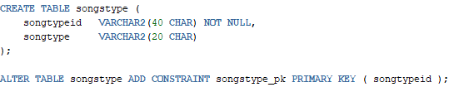

### **Functional Dependencies**

SongtypeID Songtype

### **Sample data**

### 

## **Songs**

### **Purpose:**

The purpose of the table is to document the various elements that make up the song and the respective music notes for the songs. The table also consists of the cost that is involved for the download of the music notes. This table is related to the Notesdownload table which describes the various reasons for which the members download the music notes. The tala, jati and gati are “can be null” columns, as not every song needs to have them especially film- based songs. The Songs table consists of the following columns:

SongsID (Primary Key), Songname, ComposerID (Foreign key), RagaID (Foreign Key), TalaID (Foreign Key), Jati ID (Foreign Key), GatiID (Foreign Key), GenreID (Foreign Key), SongtypeID (Foreign Key), MusicNotes and Price.

### **cREATE sTATEMENT**

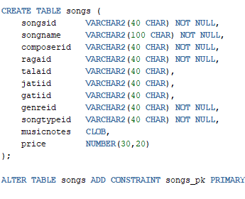

### **Functional Dependencies:**

SongsID Songname, SongtypeID, Musicnotes, Price.

### **Sample data**

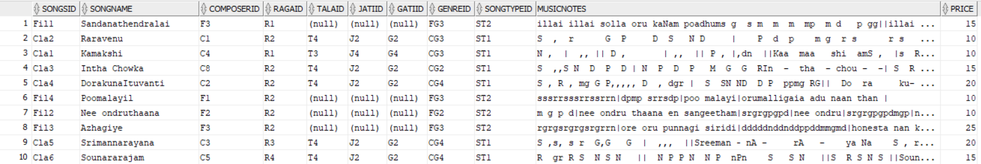

## **Members**

### **Purpose:**

The purpose of the table is to document all the members of the database. This table captures the Name, Address, Email ID and the SubscriptionID of the members. The members table is related to the Notesdownload table and is the foreign key to that table. The Members table consists of the following columns:

MemberID (Primary Key), FirstName, LastName, Addressline, City, State, Zip, Email and Subscriptionid (Foreign Key).

### **Create Statement**

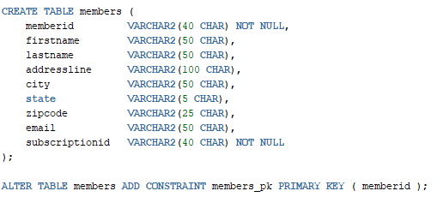

### **Functional Dependencies**

MemberID Firstname, LastName, Addressline, City, State, email, Subscription ID.

### **sAMPLE DATA**

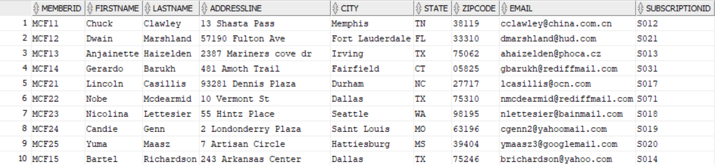

## **pLAN**

### **Purpose:**

This table summarizes the plan that are available of subscription. It documents the time period of the plan and the cost associated with it. This table is related to the subscription table and is a foreign key to that table. These plans enable members to subscribe for both paid and free membership. Free members can download the music notes for a cost but do not have access to other elements of the song such as raga, genre, tala, composer etc. Paid members have full access and are able to search based on any element of the song. The table has the following columns:

PlanID (Primary Key), Duration and Price.

### **Create Statement**

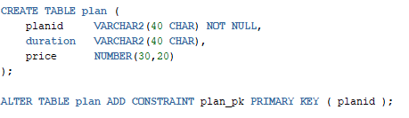

### **Functional Dependencies:**

PlanID Duration, Price.

### **Sample Data**

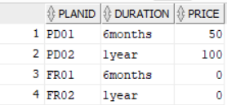

## **Subscription**

### **Purpose:**

The purpose of the table is to document the various subscription ID of the members which has information regarding their duration of their membership (the start date and end date) and the PlanID associated with every subscription. This table is related to the members table and is a foreign key to that table. This table consists of the following columns:

SubscriptionID (Primary Key), Startdate, Enddate and PlanID.

### **Create Statement**

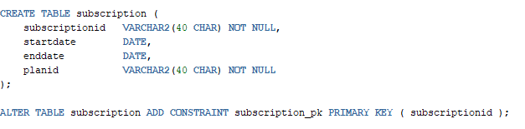

### **Functional Dependencies**

SubscriptionID Startdate, Enddate and PlanID

### **Sample data**

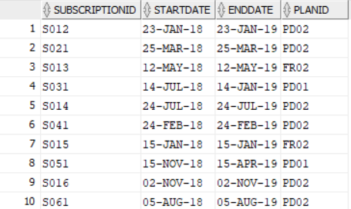

## **Reasontype**

### **Purpose**

The purpose of the table is to list out the various reasons for which a member would download a music note. The reasons are helpful for including songs that would be preferred by the members. This table is related to the notesdownload table and is a foreign key to that table. The table has the following columns:

ReasontypeID (Primary Key) and Reason.

### **CReate statement**

### **Functional Dependencies**

ReasontypeID Reason

### **Sample Data**

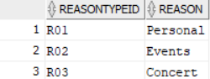

## **Notesdownload**

### **Purpose:**

The purpose of this table is to track the music notes of songs that has been downloaded by the members and associate the activity to the reason. The table gives a clear picture of what reasons are associated with the download of the notes. This table is related to the songs table, members table and reasontype table. The table consists of the following columns:

SongID (Primary -Foreign key), Members ID (Primary-Foreign Key) and Reasontypeid (Foreign key).

### **Create Statement**

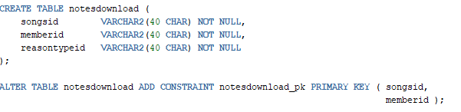

### **Functional Dependencies:**

SongsID ReasontypeID

### **sAMPLE dATA**

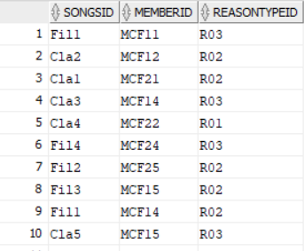

# vIEWS

## **Free Members**

### **Purpose**:

The purpose of the view is to display the data that is available to the members who have a free subscription plan. These members are able to view whether a particular song is available, the music notes and what is the cost associated with it. They will not be able to view other elements of the song. They will be able to download the music notes but they cannot access information regarding raga, tala, genre or composers.

### **create Statement**



### **Sample DATA**

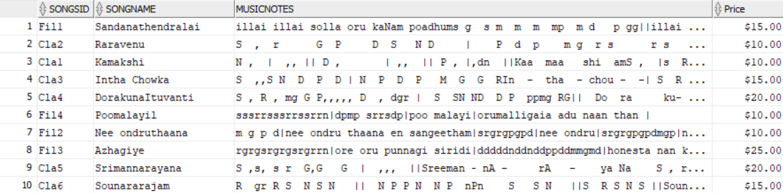

## **pAID mEMBERS**

### **pURPOSE:**

The purpose is to create a view which would include the various tables the member is able to view. The Paid members are able to view all the elements of a song and search based on those keywords for music notes.

### **Create Statement**

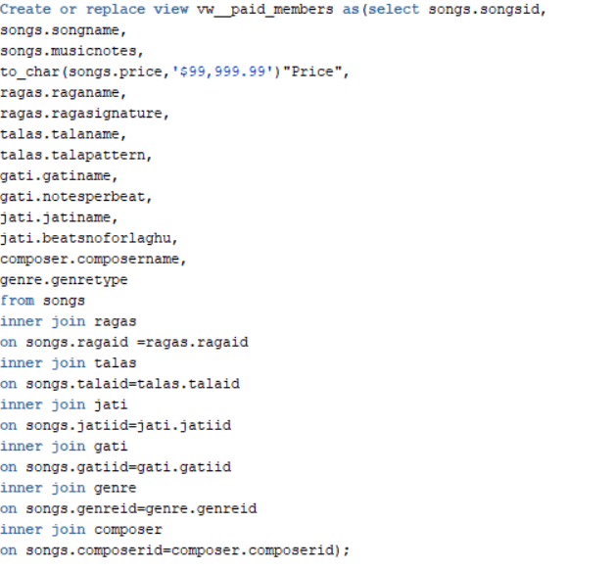

### **sample Data**

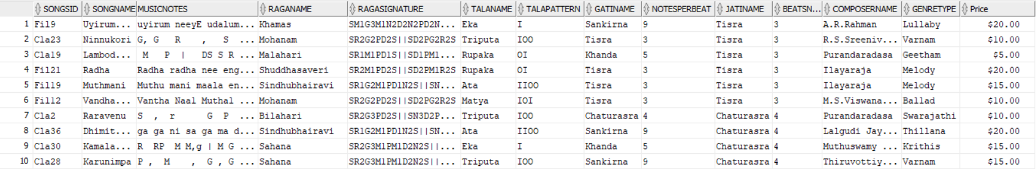

## **Members**

### **Purpose:**

The purpose of the view is to document all the members signed up for the database and relate them with their respective subscription and plan information. This will be helpful in sending reminders to the members when their subscription is about to expire, update plan information for the database. This view would be useful to look up free members and send them promotional offers in order to convert them into paid members.

### **Create statement**

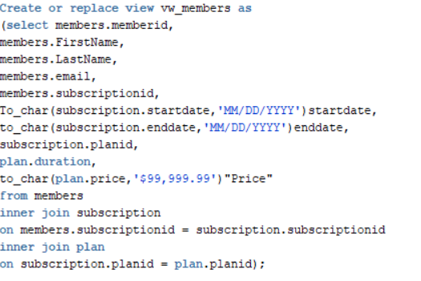

### **Sample Data**

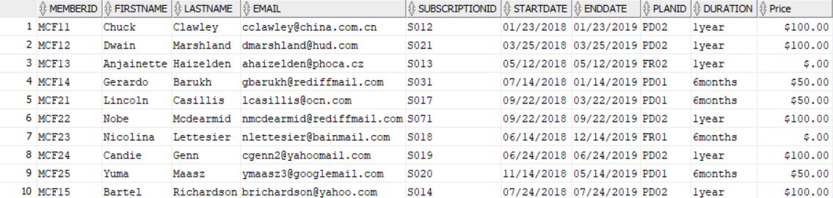

## **Classical**

### **Purpose:**

The database documents music notes for both classical and film songs. They are related to each other by different elements of the songs like Raga, Composer etc. This view documents the important elements of the Classical songs alone. This can be used to generate a report of all the classical music songs that exists in the database and add or enhance them.

### **Create Statement:**

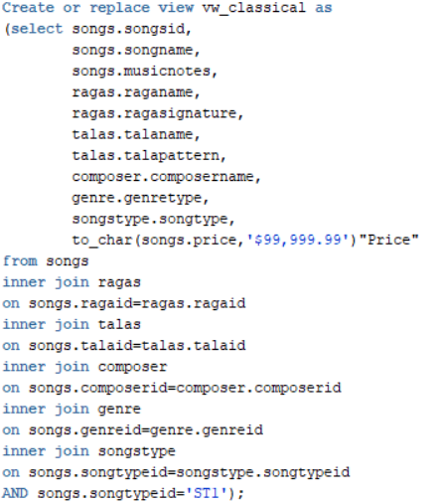

### **Sample Data**

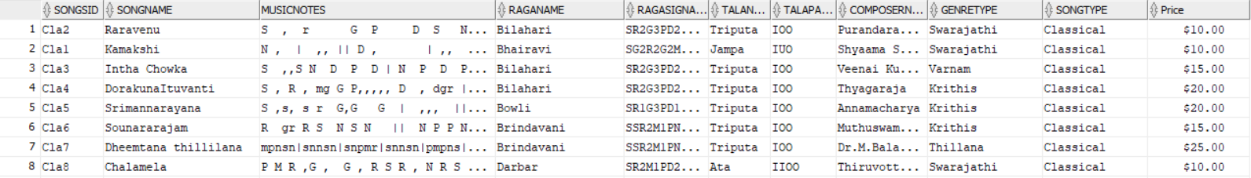

## **Film**

### **Purpose:**

The purpose of this view is to group together all the music notes of the film songs along with their important elements. This would help in viewing, updating and generating a report of all the film songs that exists in the database.

### **Create Statement**

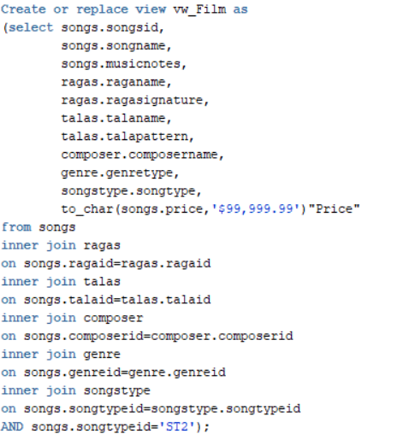

### **Sample data**

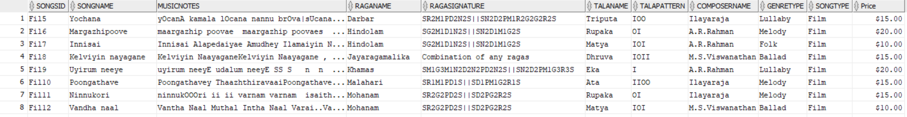

## **Reason**

### **Purpose**

The purpose of the view is to list the various reasons for which the member downloads the song. It also displays the Raga, Songname and the Composer name. This would give a good picture as to what Ragas are being used in concerts and events. It also gives a view of whose compositions are being used for the performance. This report can be used to enhance the database by including songs with similar Raga and compositions of the Composers which are used in events and concerts.

### **Create Statement**

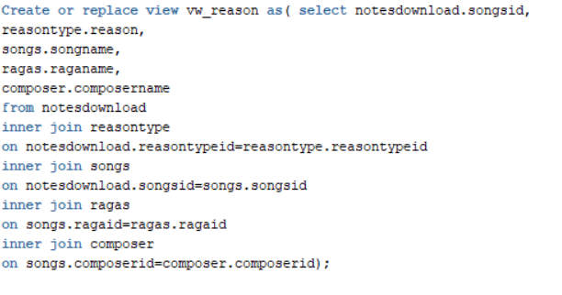

### **Sample data**

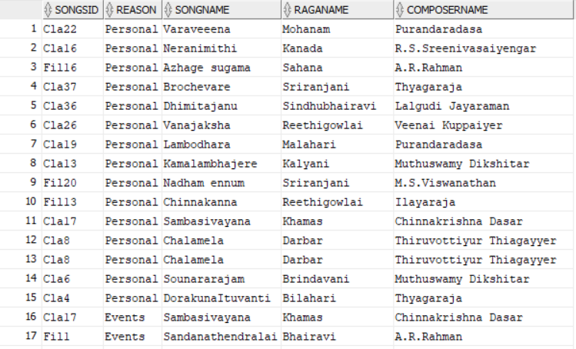

# Reports

## **Member Login**

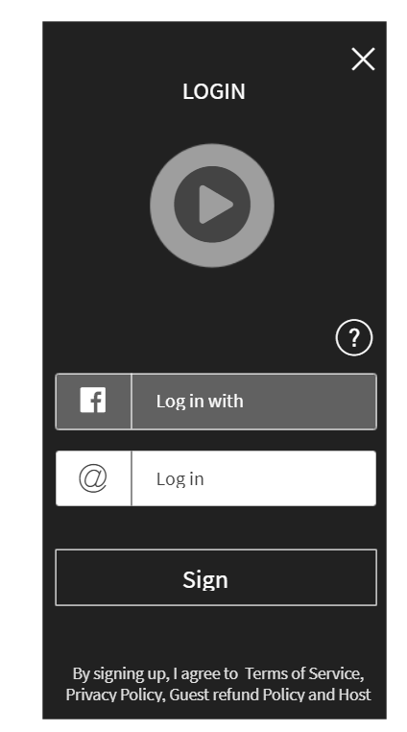

* Based on the report from Member View, Members will be able to log in and search for the music notes based on the elements available to them according to their subscription plan.

### **Sql Query**

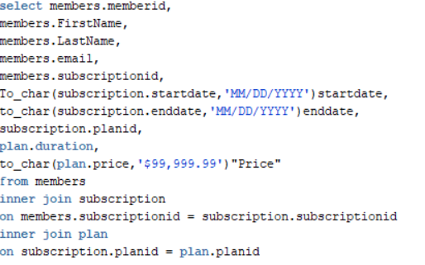

### **Sample result**

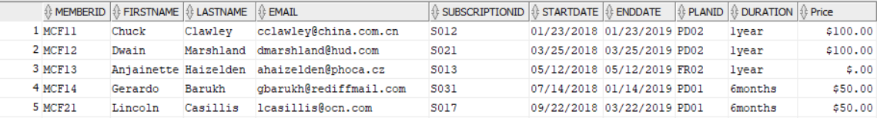

## **Search option for Paid Members**

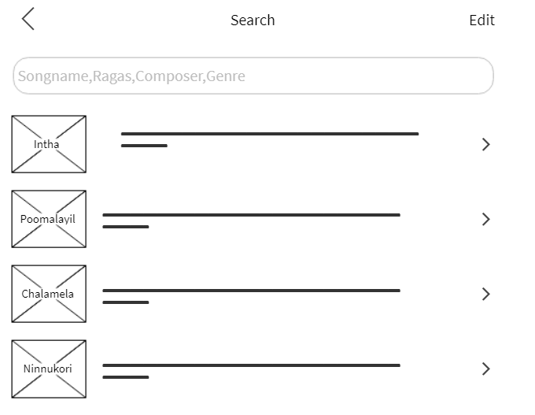

* The Paid Members will be able to search with the following parameters to download the music notes. The parameters are Songname, Ragas, Composer and Genre.
* This would list the songs along with the price to download and also the music notes once downloaded.
* The members with a free subscription plan are able to download songs but they would be able to view or search only by the songname. They would not have access to Raga, Tala, genre, composer, gati or jati information even after the download
* Below is an example of a search and its result utilizing the raga parameter “Bilahari”.
* It would list the Song name,Raga,Composer name,Genre,Musicnotes and the price to download.

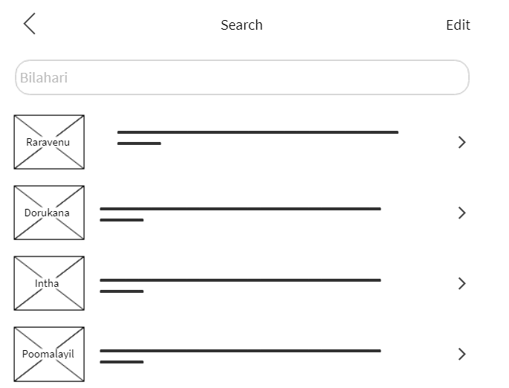

### **SQL Query**

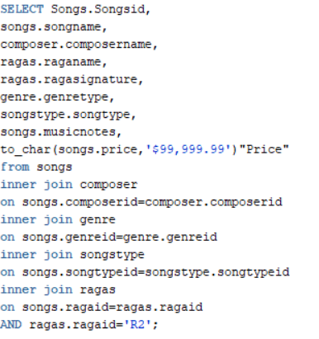

### **Sample Result**

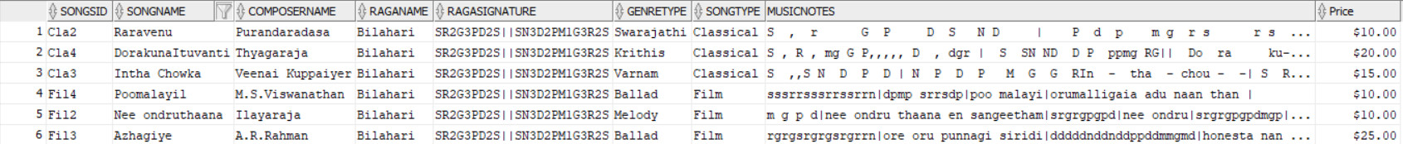

## **Search By genre**

* A paid member can click on the listed genres to access the list of songs and their music notes under each genre. Genres are grouped based on the songtype and hence indirectly help in searching based on the parameter whether the song is a classical or film-based song.

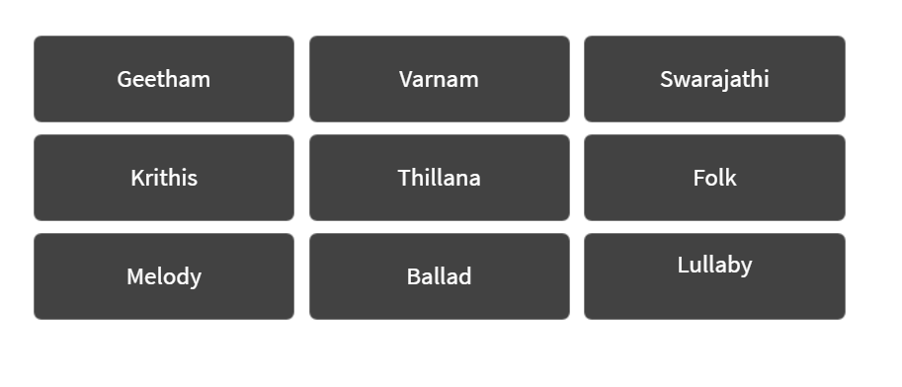

* For example, if the member clicks on melody it would list the songs under the genre Melody.

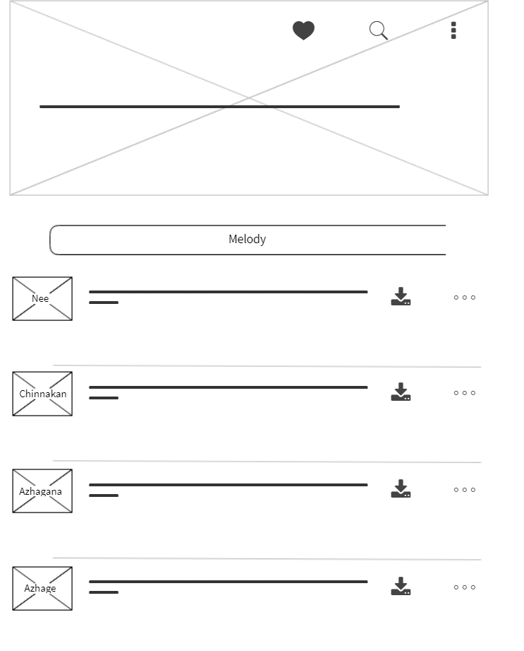

### **SQL Query**

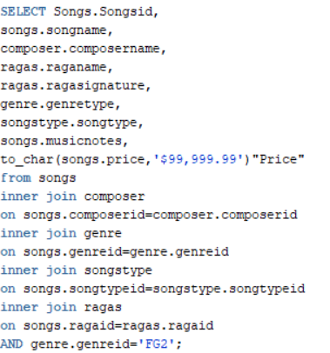

### **Sample Result**

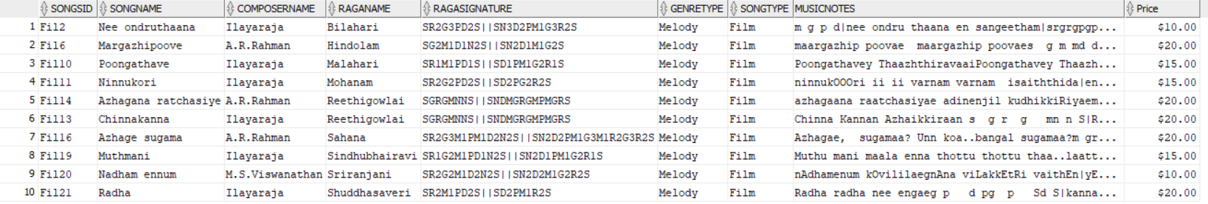

# Implementation Notes

* Members on a free subscription plan should be given access only to the columns in the free member view.
* Gati, Jati and Tala tables can be placed in a disc with slower access as they are not important for all the songs especially the film songs. Plan table can also place in the disc with slower access.
* Songs, Ragas, Composer, Genre needs to be placed in a disc capable of providing faster access.

# Known Problems

* The database cannot store the songs (music files). The song names especially the classical music ones can be similar and hence music files will help differentiate what songs the artists really need to download. There are other genres in classical music like neraval, swarakalpana and alapana which can only be captured through music files as there are no set music notes for this.
* The database does not have a comment section or rating section for the members. This can be used to better the database quality as well as list the song’s music notes based on the popularity rating.
* There are other south Indian language film songs which derive the basis from the same Carnatic (South Indian classical music) songs. This has not been captured in this database. This database captures Tamil language songs exclusively.

# Future enhancements

* Incorporate an application to the database that stores the music files which can be accessed by the members. This would help in defining other genres of classical music and also help in the correct identification of the songs.
* Document other south Indian language music notes to make a wider variety of film-based music notes available.
* A rating section in the songs table would improve the quality of music notes.
* A comment section would enhance not only the quality of music notes but would also help in incorporating the music notes of songs which the members would like.
* Ability to recognize the songs being played and its raga by utilizing the data available in the database (using an algorithm).

Reference:

Radiosai- <http://media.radiosai.org/journals/Vol_04/01JAN06/tyagaraja.htm> (Picture Courtesy)

Ganamrutha Bodhini by A.S. Panchapakesa Iyer -Data source

Ganamrutha Varna Malika by A.S.Panchapakesa Iyer -Data Source