**FEEDBACK OF ONLINE COURSES**

**HOME PAGE:**



**LOGIN PAGE:**

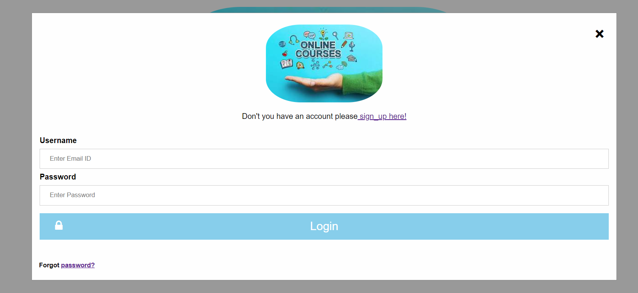

**SIGN UP PAGE:**

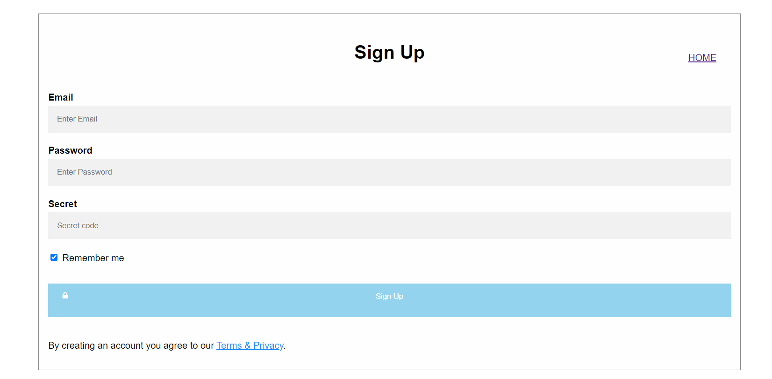

**FEEDBACK PAGE:**

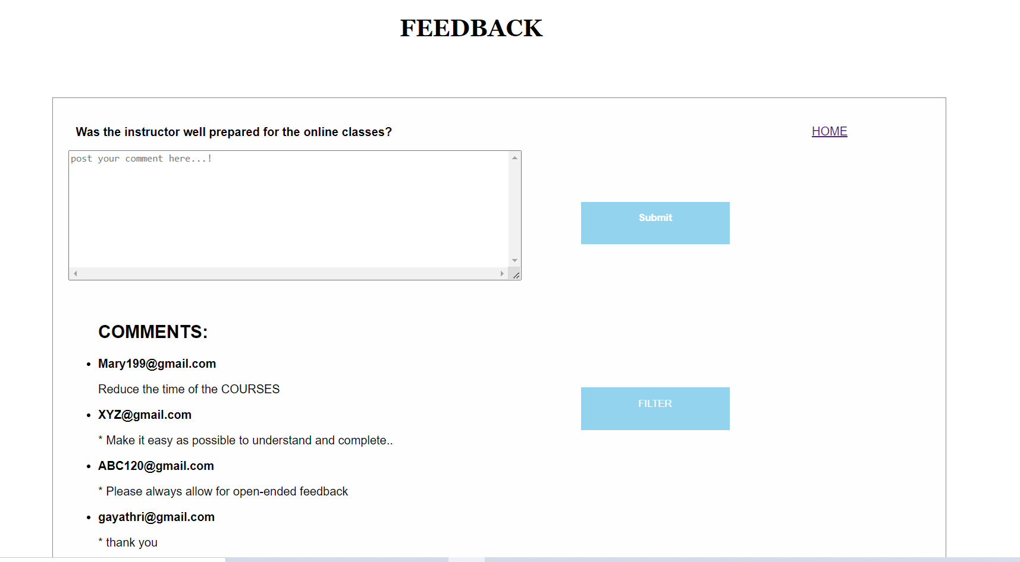

**FORGOT PASSWORD PAGE:**

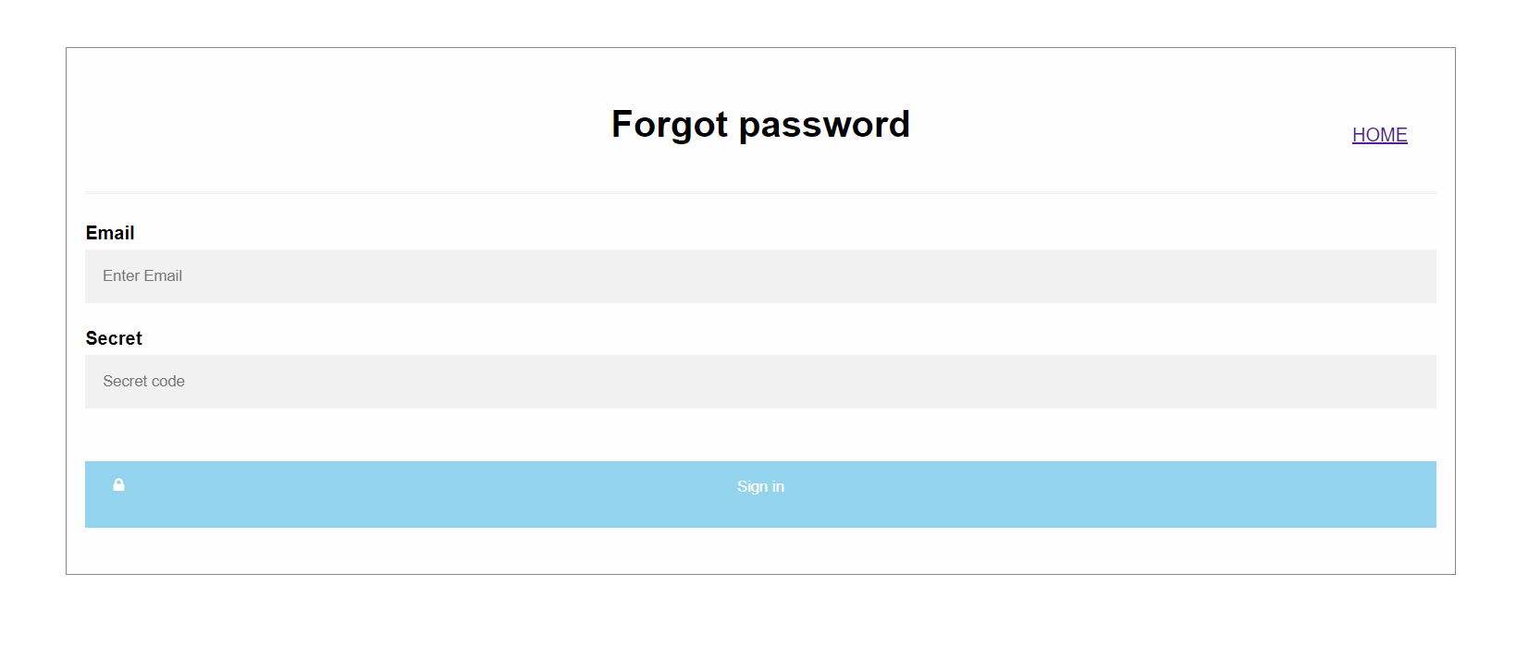

**NOTE: PLEASE NOTE I’VE USED HTML, CSS AND JAVASCRIPT IN FRONT END.**

**I’VE HAVE A ISSUE IN BACKEND TOOL. I’M NOT ABLE TO CONNECT INTO A DATABASE.**

**Functionalities: I’ve used a filter and validations in java script. Filter should be sort out in ascending order.**