Code-
#exp-1
print(" 1. Addition\n 2. Subtraction\n 3. Multiplication\n 4. Division\n 5. Exit")
ch = int(input("Enter Your Choice: "))

a = float(input("Enter first value: "))
b = float(input("Enter second value: "))

if ch == 1:
print("Answer of %.2f + %.2f = %.2f"%(a , b, a+b))

elif ch==2:
print("Answer of %.2f - %.2f = %.2f"%(a, b, a-b))

elif ch==3:
print("Answer of %.2f x %.2f = %.2f"%(a, b, a*b))

elif ch==4:
print("Answer of %.2f / %.2f = %.2f"%(a, b, a/b))

else:
print("BYE")

OUTPUT-
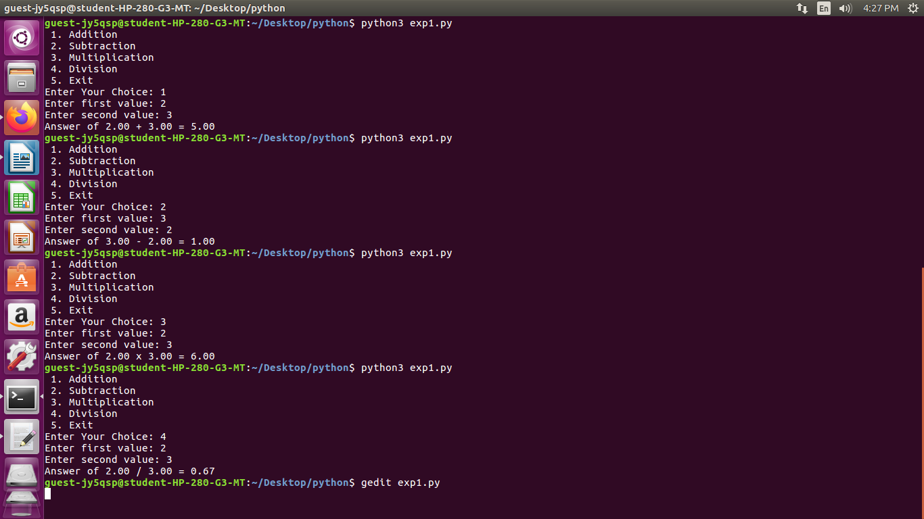

Code-
#exp-2
print("1.Factorial")
print("2.Palindrome")
print("Press any other key to EXIT")

ch = int(input("Enter Choice: "))

if ch == 1:
fact = 1
n = int(input("Enter a value: "))

while n != 1:
fact = fact * n
n = n - 1

print("Factorial is",fact)

elif ch == 2:
str1 = input("Enter a sting: ")

if str1 == str1[::-1]:
print("YES, It's a palindrome")
else:
print("NO, It's not a palindrome")

else:
print("BYE")

OUTPUT-
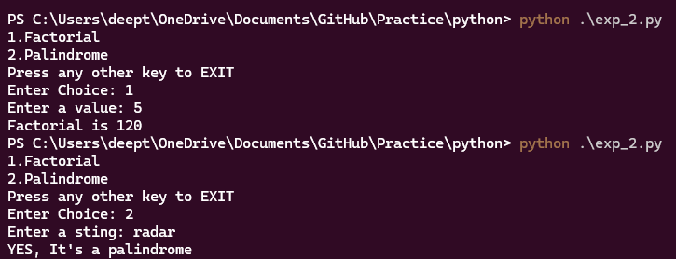

Code-
#exp-3
def separate_even_odd(lst):
even_list = []
odd_list = []
for num in lst:
if num % 2 == 0:
even_list.append(num)
else:
odd_list.append(num)
return even_list, odd_list

def merge_and_sort(even_list, odd_list):
merged_list = even_list + odd_list
merged_list.sort()
return merged_list

def update_and_delete(lst, x):
if len(lst) > 0:
lst[0] = x
if len(lst) % 2 == 0:
middle_index = len(lst) // 2 - 1
else:
middle_index = len(lst) // 2
lst.pop(middle_index)
return lst

def find_max_min(lst):
if len(lst) > 0:
return max(lst), min(lst)
else:
return None, None

def add_names_and_check(lst, names):
lst.extend(names)
return 'python' in [name.lower() for name in lst]

def main():
while True:
print("\nMenu:")
print("1. Separate even and odd elements into different lists")
print("2. Merge and sort two lists")
print("3. Update first element with X value and delete the middle element")
print("4. Find max and min element from the list")
print("5. Add N names into the existing number list and check if 'python' is present")
print("6. Exit")

choice = int(input("Enter your choice: "))

if choice == 1:
n = int(input("Enter the number of elements: "))
lst = []
for i in range(n):
element = int(input(f"Enter element {i+1}: "))
lst.append(element)
even_list, odd_list = separate_even_odd(lst)
print("Even List:", even_list)
print("Odd List:", odd_list)

elif choice == 2:
n1 = int(input("Enter the number of elements in the first list: "))
list1 = [int(input(f"Enter element {i+1}: ")) for i in range(n1)]
n2 = int(input("Enter the number of elements in the second list: "))
list2 = [int(input(f"Enter element {i+1}: ")) for i in range(n2)]
merged_sorted_list = merge_and_sort(list1, list2)
print("Merged and Sorted List:", merged_sorted_list)

elif choice == 3:
n = int(input("Enter the number of elements: "))
lst = [int(input(f"Enter element {i+1}: ")) for i in range(n)]
x = int(input("Enter the value of X: "))
updated_list = update_and_delete(lst, x)
print("Updated List:", updated_list)

elif choice == 4:
n = int(input("Enter the number of elements: "))
lst = [int(input(f"Enter element {i+1}: ")) for i in range(n)]
max_val, min_val = find_max_min(lst)
if max_val is not None:
print(f"Max Element: {max_val}, Min Element: {min_val}")
else:
print("List is empty")

elif choice == 5:
n = int(input("Enter the number of elements: "))
lst = [input(f"Enter element {i+1}: ") for i in range(n)]
name_count = int(input("Enter the number of elements: "))
names = [input(f"Enter name {i+1}: ") for i in range(name_count)]
python_present = add_names_and_check(lst, names)
if python_present:
print("'python' is in the list.")
else:
print("'python' is NOT in the list.")

elif choice == 6:
print("BYE")
break

else:
print("Invalid choice!")

if __name__ == "__main__":
main()

OUTPUT-
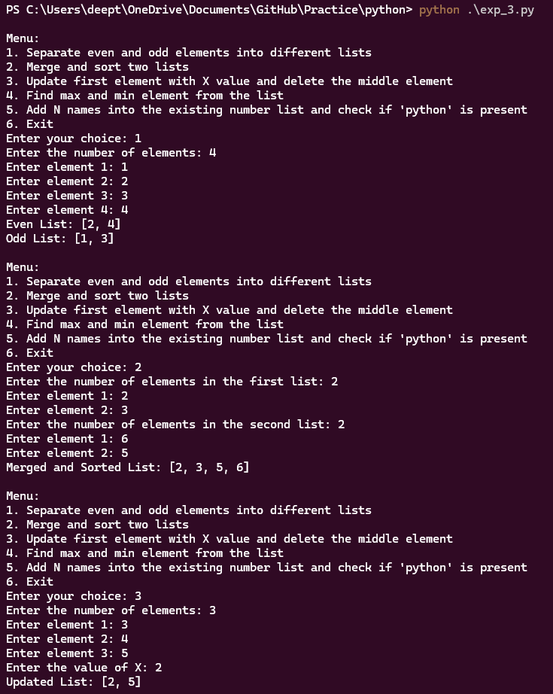

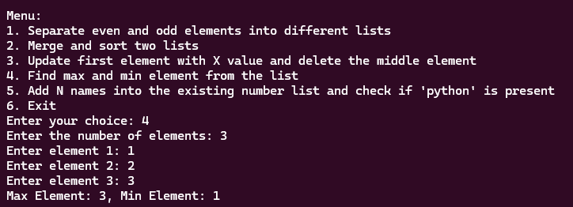
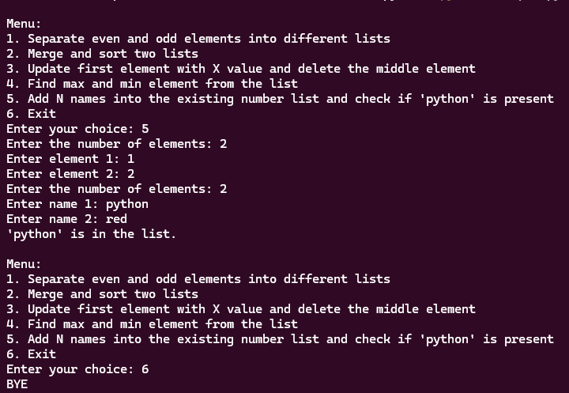
Code-
#exp-4
def add_students(student_list, n):
for i in range(n):
roll_no = input(f"Enter roll number for student {i+1}: ")
name = input(f"Enter name for student {i+1}: ")
marks = []
for j in range(1, 4):
mark = float(input(f"Enter mark {j} for {name}: "))
marks.append(mark)
student_list.append((roll_no, name, tuple(marks)))
return student_list

def display_student_by_name(student_list, search_name):
found = False
for student in student_list:
roll_no, name, marks = student
if name.lower() == search_name.lower():
print(f"Roll Number: {roll_no}, Marks: {marks}")
found = True
if not found:
print(f"No student found with the name {search_name}.")

def sort_students_by_name(nested_tuple):
return sorted(nested_tuple, key=lambda x: x[1].lower())

def main():
student_list = []

while True:
print("\nMenu:")
print("1. Add and show N student roll number, name, and 3 subject marks")
print("2. Display student roll number and marks whose name is 'Python'")
print("3. Demonstrate nested tuple and sort nested tuple by name")
print("4. Exit")

choice = int(input("Enter your choice: "))

if choice == 1:
n = int(input("How many students do you want to add? "))
student_list = add_students(student_list, n)
print("\nStudent List:")
for student in student_list:
print(student)

elif choice == 2:
search_name = "Python"
display_student_by_name(student_list, search_name)

elif choice == 3:
sorted_students = sort_students_by_name(student_list)
print("\nSorted Student List by Name:")
for student in sorted_students:
print(student)

elif choice == 4:
print("Exiting...")
break

else:
print("Invalid choice! Please choose again.")

if __name__ == "__main__":
main()

OUTPUT-
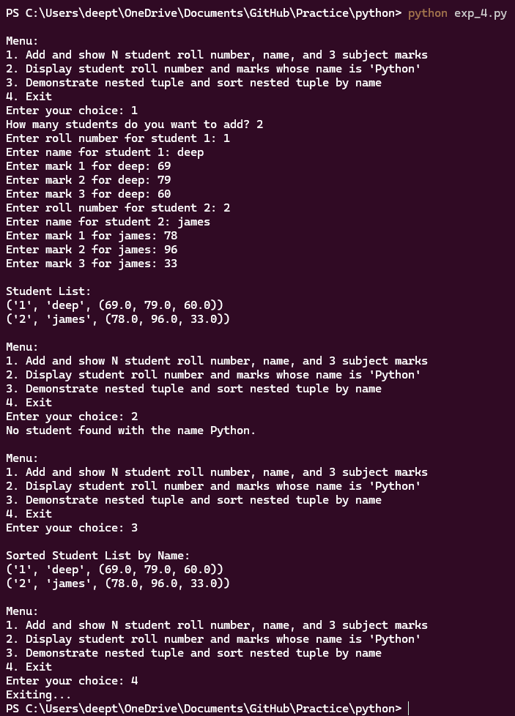
Code-
#exp-5
class Student:
def __init__(self, roll_no, name, marks):

self.roll_no = roll_no
self.name = name
self.marks = marks

def display_details(self):
print(f"Student Roll Number: {self.roll_no}")
print(f"Student Name: {self.name}")
print(f"Student Marks: {self.marks}")

student1 = Student(101, "Alice", [85, 90, 88])

print("Details of the Student class and the object created:")
student1.display_details()

OUTPUT-
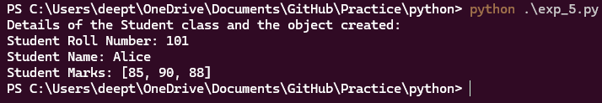

Code-
#exp-6
class Person:
def __init__(self, id, name):
self.id = id
self.name = name

def display_details(self):
print(f"ID: {self.id}")
print(f"Name: {self.name}")

class Student(Person):
def __init__(self, id, name, academic_marks, sports_marks=None):
super().__init__(id, name)
self.academic_marks = academic_marks
self.sports_marks = sports_marks

def display_details(self):
super().display_details()
print(f"Academic Marks: {self.academic_marks}")
if self.sports_marks is not None:
print(f"Sports Marks: {self.sports_marks}")
total_marks = self.academic_marks + self.sports_marks
print(f"Total Marks (Including Sports): {total_marks}")
else:
print(f"Total Marks (Without Sports): {self.academic_marks}")

def main():
student1 = Student(101, "Alice", 85)
print("Details of Student 1:")
student1.display_details()
student2 = Student(102, "Bob", 80, 15)
print("\nDetails of Student 2:")
student2.display_details()

if __name__ == "__main__":
main()

OUTPUT-
