**Code-**

#exp-7

def main():

    try:

        num1 = int(input("Enter the first number: "))

        num2 = int(input("Enter the second number: "))

        result = num1 / num2

        print(f"The result is: {result}")

    except ZeroDivisionError:

        print("Error: Cannot divide by zero!")

    except ValueError:

        print("Error: Invalid input! Please enter numbers only.")

    finally:

        print("Program execution completed.")

if __name__ == "__main__":

    main()

OUTPUT-

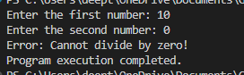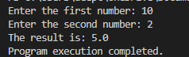

**CODE-**

#exp-8

def read_and_write_file(input_file, output_file):

    try:

        with open(input_file, 'r') as infile:

            content = infile.read()

        with open(output_file, 'w') as outfile:

            outfile.write(content)

        print(f"Content from {input_file} has been written to {output_file}")

    except FileNotFoundError:

        print(f"Error: {input_file} not found!")

    except Exception as e:

        print(f"An error occurred: {e}")

def append_and_display_file(file_name, data_to_append):

    try:

        with open(file_name, 'a') as file:

            file.write(data_to_append + '\n')

        with open(file_name, 'r') as file:

            content = file.read()

            print(f"Updated content of {file_name}:\n{content}")

    except FileNotFoundError:

        print(f"Error: {file_name} not found!")

    except Exception as e:

        print(f"An error occurred: {e}")

def count_file_content(file_name):

    try:

        with open(file_name, 'r') as file:

            lines = file.readlines()

            num_lines = len(lines)

            num_words = sum(len(line.split()) for line in lines)

            num_chars = sum(len(line) for line in lines)

        print(f"Lines: {num_lines}, Words: {num_words}, Characters: {num_chars}")

    except FileNotFoundError:

        print(f"Error: {file_name} not found!")

    except Exception as e:

        print(f"An error occurred: {e}")

def main():

    input_file = 'input.txt'

    output_file = 'output.txt'

    data_to_append = 'Appended content'

    read_and_write_file(input_file, output_file)

    append_and_display_file(output_file, data_to_append)

    count_file_content(output_file)

if __name__ == "__main__":

    main()

OUTPUT-

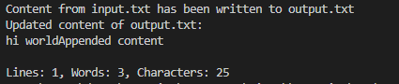

**Code-**

#exp-9

import os

def count_file_content(file_name):

    try:

        with open(file_name, 'r') as file:

            lines = file.readlines()

            num_lines = len(lines)

            num_words = sum(len(line.split()) for line in lines)

            num_chars = sum(len(line) for line in lines)

        print(f"Lines: {num_lines}, Words: {num_words}, Characters: {num_chars}")

    except FileNotFoundError:

        print(f"Error: {file_name} not found!")

    except Exception as e:

        print(f"An error occurred: {e}")

def display_files_in_directory():

    try:

        files = os.listdir('.')

        print("Files in the current directory:")

        for file in files:

            print(file)

    except Exception as e:

        print(f"An error occurred: {e}")

def main():

    file_name = 'output.txt'

    count_file_content(file_name)

    display_files_in_directory()

if __name__ == "__main__":

    main()

OUTPUT-

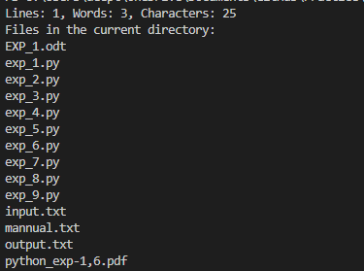

**Code-**

#exp-10

import sqlite3

# Creating a connection object

conn = sqlite3.connect('student_database.db')

# Creating a cursor object using the connection

cursor = conn.cursor()

# Creating a table in the database

def create_table():

    cursor.execute('''CREATE TABLE IF NOT EXISTS students (

                        id INTEGER PRIMARY KEY AUTOINCREMENT,

                        name TEXT NOT NULL,

                        age INTEGER NOT NULL,

                        grade TEXT NOT NULL)''')

    print("Table created successfully!")

# Inserting values into the table

def insert_values(name, age, grade):

    cursor.execute('''INSERT INTO students (name, age, grade)

                      VALUES (?, ?, ?)''', (name, age, grade))

    conn.commit()

    print("Values inserted successfully!")

# Displaying values from the table

def display_values():

    cursor.execute('SELECT * FROM students')

    rows = cursor.fetchall()

    for row in rows:

        print(row)

# Updating values in the table

def update_values(student_id, new_grade):

    cursor.execute('''UPDATE students SET grade = ? WHERE id = ?''', (new_grade, student_id))

    conn.commit()

    print("Values updated successfully!")

# Main function

def main():

    create_table()

    insert_values('John Doe', 20, 'A')

    insert_values('Jane Smith', 22, 'B')

    display_values()

    update_values(1, 'A+')

    display_values()

# Calling the main function

if __name__ == "__main__":

    main()

conn.close()

print("Connection closed successfully!")

OUTPUT-

