PROJECT REPORT

URBAN AIR QUALITY

INTELLIGENCE

Developed by :
Deeptanu Sen
Developed as part of the IBM SkillsBuild Data Analytics with AI Internship 2026.





Table
Of Contents

- Project Overview
- Dataset and Preparation
- Technology Stack
- Dashboard
Analysis Controls AQI Intelligence Tab City Intelligence Tab
Pollution Intelligence Tab Diagnostic Intelligence Tab Data Quality Tab

- Conclusion

IBM SKILLSBUILD · DATA ANALYTICS WITH AI INTERNSHIP 2026

Urban Air Quality Intelligence
(Descriptive and Diagnostic Analysis)
An interactive Streamlit dashboard for analysing urban air quality across 26 Indian cities using CPCB city-day measurements (2015–2020).

· Project Overview

Urban Air Quality Intelligence is an interactive Streamlit dashboard for exploring air-quality patterns across 26 Indian cities from 2015–2020. Built using the CPCB city-day dataset, it combines descriptive statistics, interactive visualizations, and diagnostic analysis to examine AQI trends, seasonal patterns, pollutant relationships, city-level differences, and high-risk periods through a clean, ﬁlter-driven interface.
Results describe observed associations in the dataset. Correlation does not establish causation.
ANALYTICAL CAPABILITIES

Area | Methods & Features
AQI Analysis | Distribution · categories · yearly / monthly / seasonal trends
City Comparison | Rankings · city × year heatmaps
Pollutant Profiling | Distribution by city · normalised radar profiles · AQI relationships
Correlation | Pearson r · 13×13 matrix · per-pollutant p-values (AQI pairs)
Risk Analysis | AQI ≤ 100 vs AQI > 200 · Mann–Whitney U test
Spike Detection | 30-day rolling z-score · threshold > 2.0
Driver Analysis | Normalised pollutant contribution by city, year & season

· Dataset and Preparation

Dataset Overview
The dataset powering this project is city_day.csv - a publicly available air-quality measurements dataset compiled by the Central Pollution Control Board (CPCB) of India. It captures daily pollutant readings from oﬃcial monitoring stations across 26 major Indian cities, spanning over ﬁve years from January 2015 to July 2020.
AT-A-GLANCE SUMMARY

Attribute | Detail
Dataset Name | city_day.csv [Kaggle] or, [Google Drive]
Source | Central Pollution Control Board (CPCB), Government of India
Date Range | January 1, 2015 → July 1, 2020 (5.5 years)
Total Records | 29,531 daily observations (rows)
Total Columns | 16 (City, Date, 12 Pollutants, AQI, AQI_Bucket)

CITIES COVERED

North India | South India | East India | West India
Delhi | Chennai | Kolkata | Mumbai
Gurugram | Bengaluru | Patna | Ahmedabad
Lucknow | Hyderabad | Brajrajnagar | Jaipur
Amritsar | Kochi | Jorapokhar | Bhopal
Chandigarh | Thiruvananthapuram | Talcher
 | Coimbatore | Guwahati
 | Visakhapatnam · Amaravati | Shillong · Aizawl

COLUMN SCHEMA
The dataset contains 16 columns categorised into identiﬁers, pollutant measurements, and AQI output ﬁelds. All pollutant concentrations are in µg/m³ except CO, which is in mg/m³

# | Column | Type
1 | City | Categorical
2 | Date | DateTime
3 | PM2.5 | Float (µg/m³)
4 | PM10 | Float (µg/m³)
5 | NO | Float (µg/m³)
6 | NO2 | Float (µg/m³)
7 | NOx | Float (µg/m³)
8 | NH3 | Float (µg/m³)
9 | CO | Float (mg/m³)
10 | SO2 | Float (µg/m³)
11 | O3 | Float (µg/m³)
12 | Benzene | Float (µg/m³)
13 | Toluene | Float (µg/m³)
14 | Xylene | Float (µg/m³)
15 | AQI | Float
16 | AQI_Bucket | Categorical

INDIA CPCB AQI SCALE
The Air Quality Index (AQI) used in this project follows the oﬃcial India CPCB scale. This scale deﬁnes six bands, each associated with a health advisory. The dashboard uses these same bands for category-based ﬁltering, colour coding, and diagnostic thresholds.

AQI Range | AQI Range | AQI Range | AQI Range
0 – 50 | Good | Minimal impact | Green
51 – 100 | Satisfactory | Minor breathing discomfort to sensitive persons | Light Green
101 – 200 | Moderate | Breathing discomfort to asthma patients & elderly | Yellow
201 – 300 | Poor | Breathing discomfort to most people on prolonged exposure | Orange
301 – 400 | Very Poor | Respiratory illness on prolonged exposure | Red
401 – 500 | Severe | Health impacts even on light physical activity; serious risk | Purple

Data Quality & Cleaning
The raw dataset required a structured cleaning pipeline before analysis. The pipeline addresses -
- Date parsing errors
- Exact duplicate records
- Extreme AQI instrument spikes
- Below-detection-limit zeros in VOC sensors
- Pervasive missing pollutant readings - which ranged from ~7% (CO) to over 60% (Xylene) in the original data.

CLEANING PIPELINE

Steps | Action | Records Affected
1. Parse Date | Converted to datetime; coerce errors → NaN, then dropped | 0
2. Drop Duplicates | Removed exact (City, Date) duplicate rows | 0
3. Cap Extreme AQI | AQI > 999 capped at 999 (instrument spike suppression) | 93
4. Zero BTX/CO → NaN | Below-detection-limit zeros in Benzene, Toluene, Xylene, CO treated as missing | 10,738
5. City-Month Imputation | Missing pollutants filled with city-month median (preserves seasonal & regional patterns) | All rows
6. City Median Fallback | Residual NaN filled with city-level median | All rows
7. Global Median Fallback | Cities with zero data for a pollutant filled with global dataset median | All rows
8. AQI Imputation | Missing AQI filled with city-month median AQI | All rows
9. AQI_Bucket Re-derived | Bucket recomputed from final imputed AQI values | All rows

KEY DATASET STATISTICS
After the full cleaning pipeline, the dataset retained all 29,531 records with zero remaining missing values in pollutant or AQI columns.

Metric | Value
Total Observations (clean) | 29,531
Number of Cities | 26
Date Range | 2015-01-01 to 2020-07-01
Pollutants Tracked | 12 (PM2.5, PM10, NO, NO2, NOx, NH3, CO, SO2, O3,  Benzene, Toluene, Xylene)
Overall Average AQI | 165.2 (Moderate category)
Pollution Risk Rate (AQI > 200) | 25.8% (7,605 of 29,531 days)
Dominant Pollution Driver | PM10 (highest normalised mean concentration)
Missing Values After Cleaning | 0 across all pollutant and AQI columns

· Technology Stack

The project uses Python and Streamlit for application logic and the interactive dashboard, with Pandas and NumPy handling data processing and numerical analysis. Plotly provides interactive visualizations, while SciPy supports statistical tests and correlation analysis.

Technology | Role
Python | Application logic & analysis
Streamlit | Interactive dashboard framework
Pandas | Data loading, cleaning, aggregation
NumPy | Numerical operations & rolling statistics
Plotly | Interactive charts (bar, line, scatter, heatmap, radar, pie)
SciPy | Pearson correlation, Mann–Whitney U, p-values

· Dashboard

The Urban Air Quality Intelligence dashboard is a fully interactive, dark-mode web application built with Streamlit. It is designed around a single-page architecture: one persistent sidebar for global ﬁltering controls and a main area that exposes ﬁve distinct analytical modules. Every chart, table, and KPI on the page is derived from the same ﬁltered data slice - adjusting any sidebar control instantly recomputes and re-renders the entire dashboard in real time.
The layout follows a top-down narrative: the hero banner establishes context, three headline KPIs deliver the immediate story, a supporting stats strip adds depth, and the tab modules enable deep-dive exploration across AQI, city, pollutant, diagnostic, and data quality dimensions.

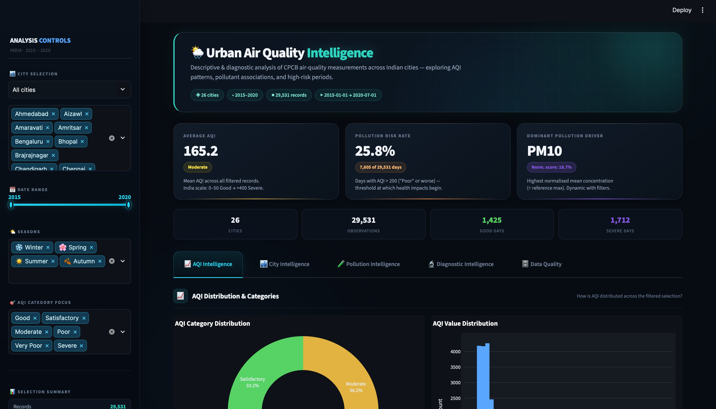
Figure 1: Urban Air Quality Intelligence - Live Dashboard Overview

HEADLINE KPI CARDS
Three KPI cards span the top of the main content area. Each card is driven entirely by the active ﬁlter selection and recomputes on every interaction:

KPI Card | Metric Definition | Dynamic Behaviour
Average AQI | Arithmetic mean of AQI across all filtered rows. Colour-coded badge shows the AQI category (Good → Severe). | Changes with every city / year  / season selection
Pollution Risk Rate | % of days with AQI > 200 (India threshold for 'Poor' - first level with broad health impact). Shows raw count as a badge. | Risk level badge shifts colour: green < 10%, amber 10–25%,  orange 25–50%, red ≥ 50%
Dominant Pollution Driver | Each pollutant's mean is normalised by its reference ceiling (NAAQS/WHO max). The pollutant with the highest normalised score is declared dominant - never hardcoded. | Can change city-to-city: PM10 for East India, Toluene for West India in winter


Figure 2: 3 KPI cards - showing a filtered view for 10 cities, 2015–2016, Winter

NAVIGATION TABS
The tab bar provides access to ﬁve analytical modules. All tabs operate on the same ﬁltered dataset derived from the sidebar - no extra ﬁltering is needed inside each tab.

Tab | What It Covers
AQI Intelligence | AQI distribution, category donut, value histogram, category breakdown table, worst pollution days, yearly/monthly trend lines, seasonal bar chart
City Intelligence | Per-city AQI ranking bar chart, city × year AQI heatmap, descriptive statistics table per city
Pollution Intelligence | Pollutant-AQI correlation bar, normalised pollution driver radar, seasonal pollutant boxplots, city-wise pollution distribution by pollutant
Diagnostic Intelligence | Auto-generated text insights, full correlation matrix, AQI spike & anomaly detection, normal vs. high-risk day comparison, pollutant-to-AQI drilldown, dominant driver shifts
Data Quality | Dataset overview stats, 9-step cleaning pipeline table, original missing value rate chart

Figure 3: Navigation tab bar - 5 analytical tabs

Analysis Controls - The Sidebar
The sidebar is the single source of truth for all ﬁltering in the dashboard. Labelled ANALYSIS CONTROLS with the scope indicator 'INDIA · 2015 – 2020', it contains four stacked ﬁlter controls and a live selection summary panel at the bottom. Every control operates independently and can be combined - the dashboard always reﬂects the intersection of all active ﬁlters simultaneously.

FILTER CONTROLS

Control | Type | Behaviour & Options
City Selection | Preset dropdown + multi-select | Five regional presets:  - All cities  - North India  - South India  - East India  - West India  and Custom. Selecting a preset pre-fills the multi-select with the relevant cities. Individual cities can be added or removed freely.
Date Range | Dual-handle year slider | Slide both handles to restrict the analysis to any year window from 2015 to 2020. The slider label updates to reflect the selected range.
Seasons | Multi-select (4 options) | Winter (Dec–Feb), Spring (Mar–May), Summer (Jun–Aug), Autumn (Sep–Nov). Deselect any season to exclude it. Default = all four seasons selected.
AQI Category Focus | Multi-select (6 options) | Filter to only records matching specific AQI buckets (Good, Satisfactory, Moderate, Poor, Very Poor, Severe). Useful for studying a single pollution tier in isolation.

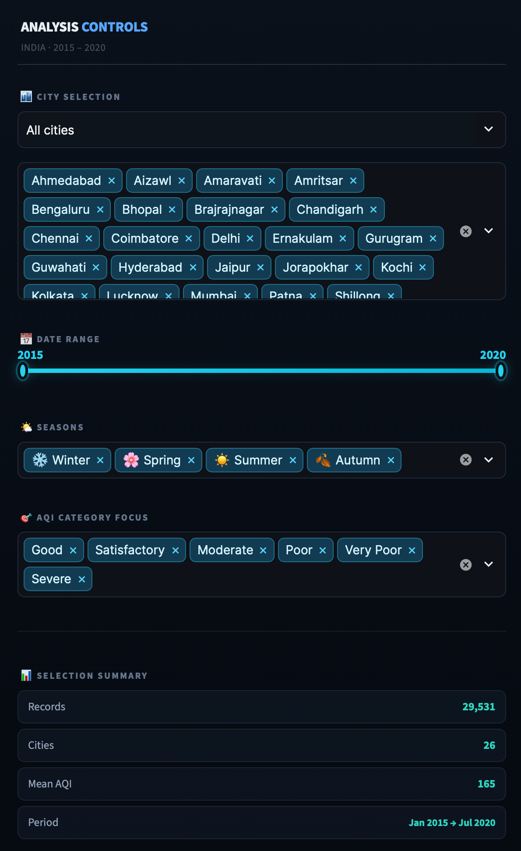
Figure 4: Full sidebar - all four filter controls and live Selection Summary panel
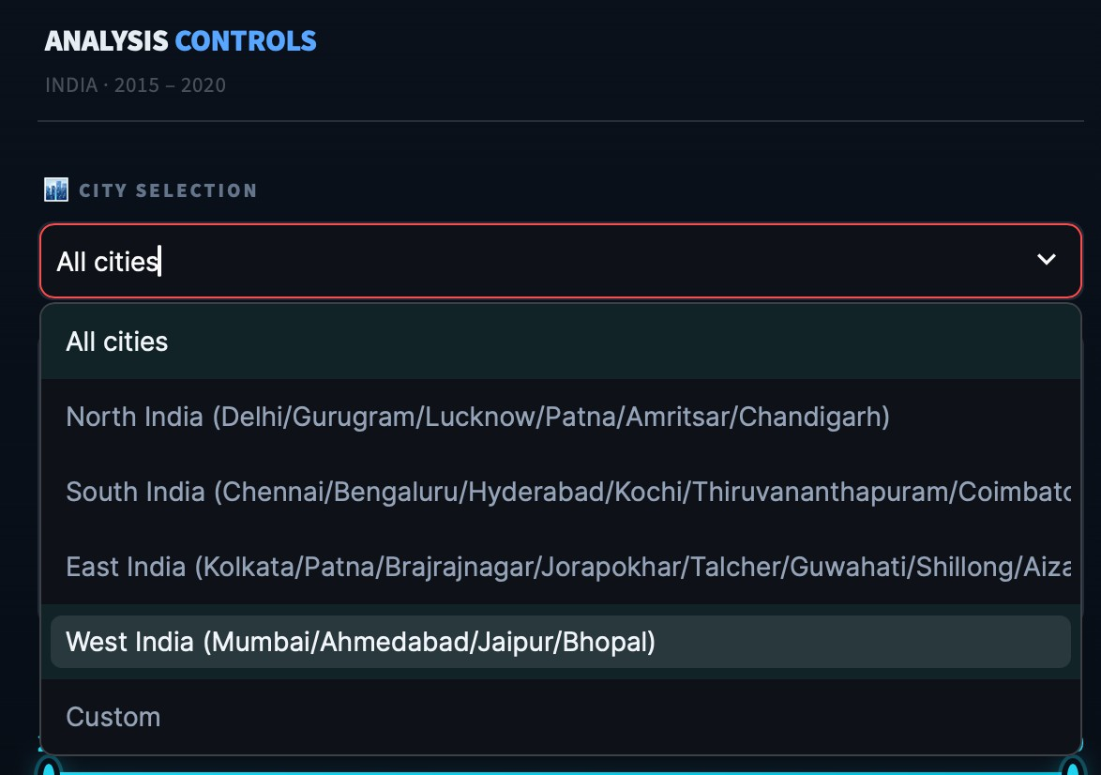
Figure 5: City Selection preset dropdown - regional zone presets

LIVE SELECTION SUMMARY PANEL
At the bottom of the sidebar, a Selection Summary panel provides immediate feedback on the active ﬁlter state. It displays four live metrics that update in real time as the user adjusts any ﬁlter:

Summary Metric | What It Shows
Records | Total number of rows in the filtered dataset
Cities | Count of unique cities in the current selection
Mean AQI | Average AQI across the filtered records
Period | Date span of the filtered data (e.g. Jan 2015 → Jul 2020)

DYNAMIC FILTER EXAMPLES
The sidebar's power becomes evident when ﬁlters are combined. The two examples below demonstrate how dramatically the KPIs shift when the same analysis is restricted to speciﬁc regions, years, and seasons - illustrating the dashboard's real-time contextual intelligence.
Example A - East India, Year 2017, Winter:
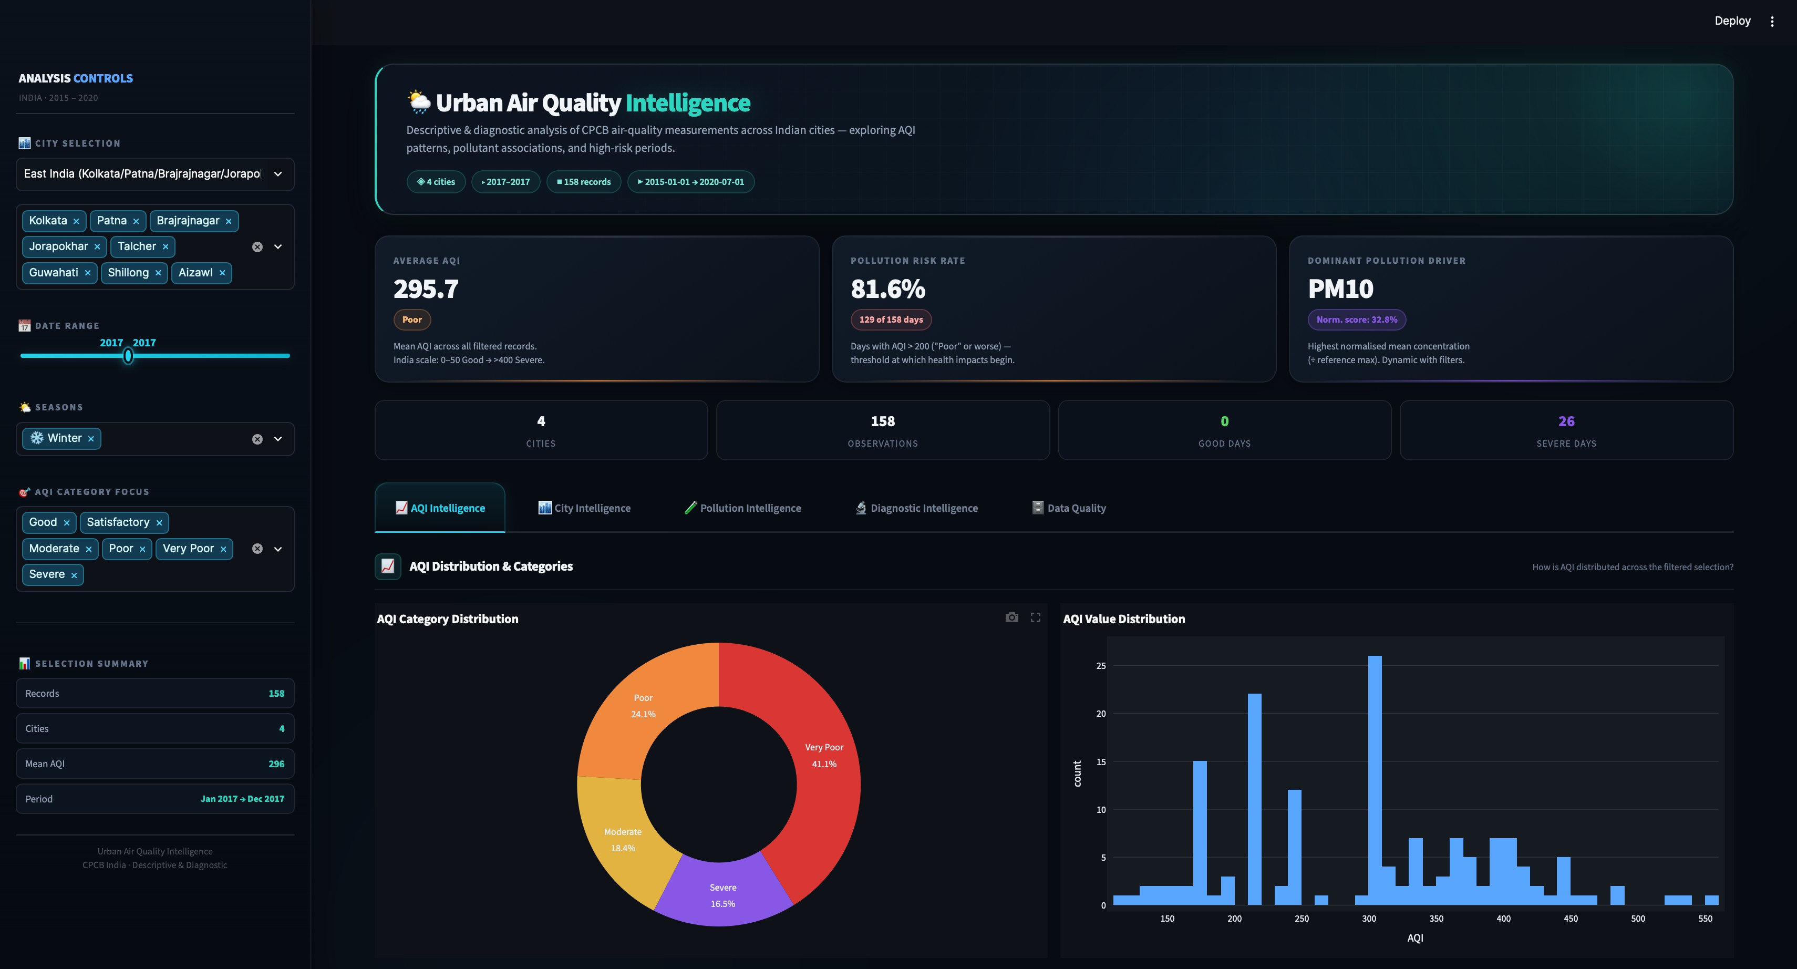
Cities: Kolkata, Patna, Brajrajnagar, Jorapokhar, Talcher, Guwahati, Shillong, Aizawl | Records: 158 | Avg AQI: 295.7 (Poor) | Risk Rate: 81.6% | Dominant Driver: PM10
Figure 6: Dynamic filter - East India preset, Year 2017, Winter season. AQI jumps to 295.7 with 81.6% risk rate and 26 Severe Days

Example B - West India, 2015–2016, Winter:
Cities: Mumbai, Ahmedabad, Jaipur, Bhopal | Records: 362 | Avg AQI: 301.5 (Very Poor) | Risk Rate: 49.4%
| Dominant Driver: Toluene
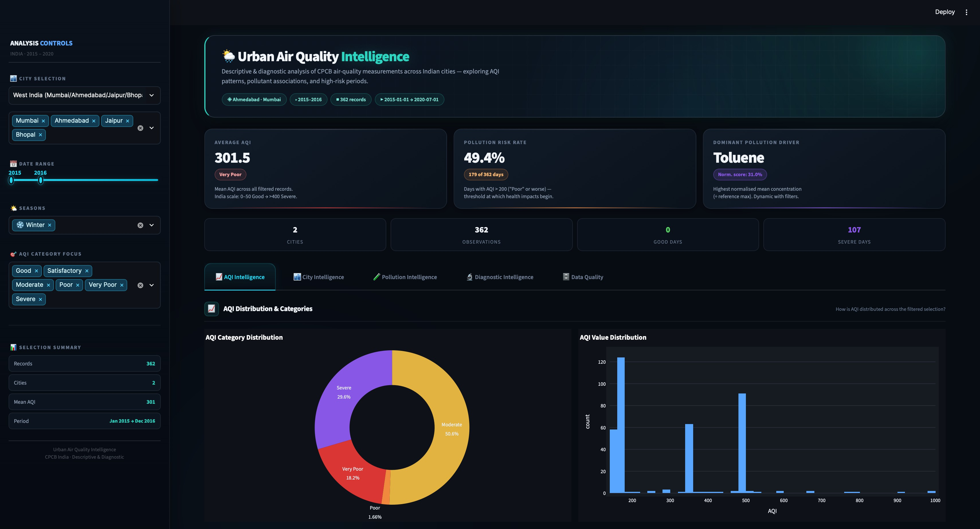
Figure 7: Dynamic filter - West India preset, 2015–2016, Winter. Dominant driver shifts from PM10 to Toluene, reflecting industrial solvent emissions in western cities

KEY OBSERVATIONS FROM THE FILTER EXAMPLES
The two ﬁlter examples above reveal analytically signiﬁcant contrasts that the sidebar makes immediately discoverable:

Observation | East India 2017 Winter | West India 2015–16 Winter
Average AQI | 295.7 - Poor | 301.5 - Very Poor
Pollution Risk Rate | 81.6% (4 in 5 days hazardous) | 49.4% (1 in 2 days hazardous)
Good Days | 0 | 0
Dominant Driver | PM10 - vehicular & industrial dust | Toluene - industrial solvents & petrochemicals

The shift in the dominant driver from PM10 (East India) to Toluene (West India) is particularly notable - it reﬂects a genuine difference in the emission proﬁles of these regions rather than a data artefact. This kind of region-speciﬁc insight is made instantly accessible by the dashboard's dynamic normalised driver computation.

AQI Intelligence Tab
The AQI Intelligence tab is the primary analytical module of the dashboard. It answers the foundational question: how is air quality distributed, and how has it changed over time? The tab is structured into two major sections: AQI Distribution & Categories and AQI Trends Over Time, each containing multiple Plotly charts and data tables that respond dynamically to the sidebar ﬁlters.

SECTION 1 - AQI DISTRIBUTION & CATEGORIES
The ﬁrst section answers: 'How is AQI distributed across the ﬁltered selection?' It presents four components side-by-side - a category donut chart, a value histogram, a category breakdown table, and a worst pollution days table - all computed from the same ﬁltered data slice.

DONUT CHART & HISTOGRAM
A Plotly donut chart shows the proportion of records across AQI categories, ordered from Good to Severe and colour-coded using the India AQI palette. Percentages are displayed directly on each segment.
A 60-bin histogram displays the distribution of AQI values, revealing the overall shape and concentration of pollution levels. In the full dataset, notable clusters appear around 150–200 and 300–400.
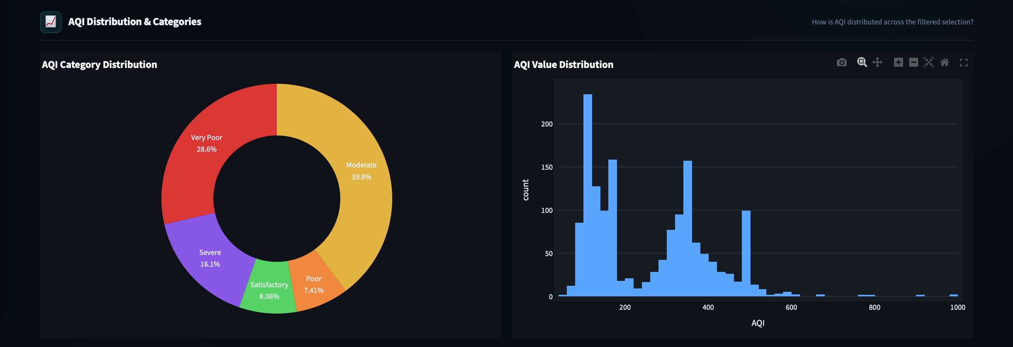
Figure 8: AQI Distribution & Categories - Left: category donut (Moderate 39.8%, Very Poor 28.6%, Severe 16.1%); Right: AQI value histogram revealing bimodal distribution with peaks at ~150 and ~350

CATEGORY BREAKDOWN TABLE
A compact AQI category table shows day counts and percentage shares, while the adjacent Worst Pollution Days table lists the 10 highest-AQI records with key pollutant values for quick comparison.

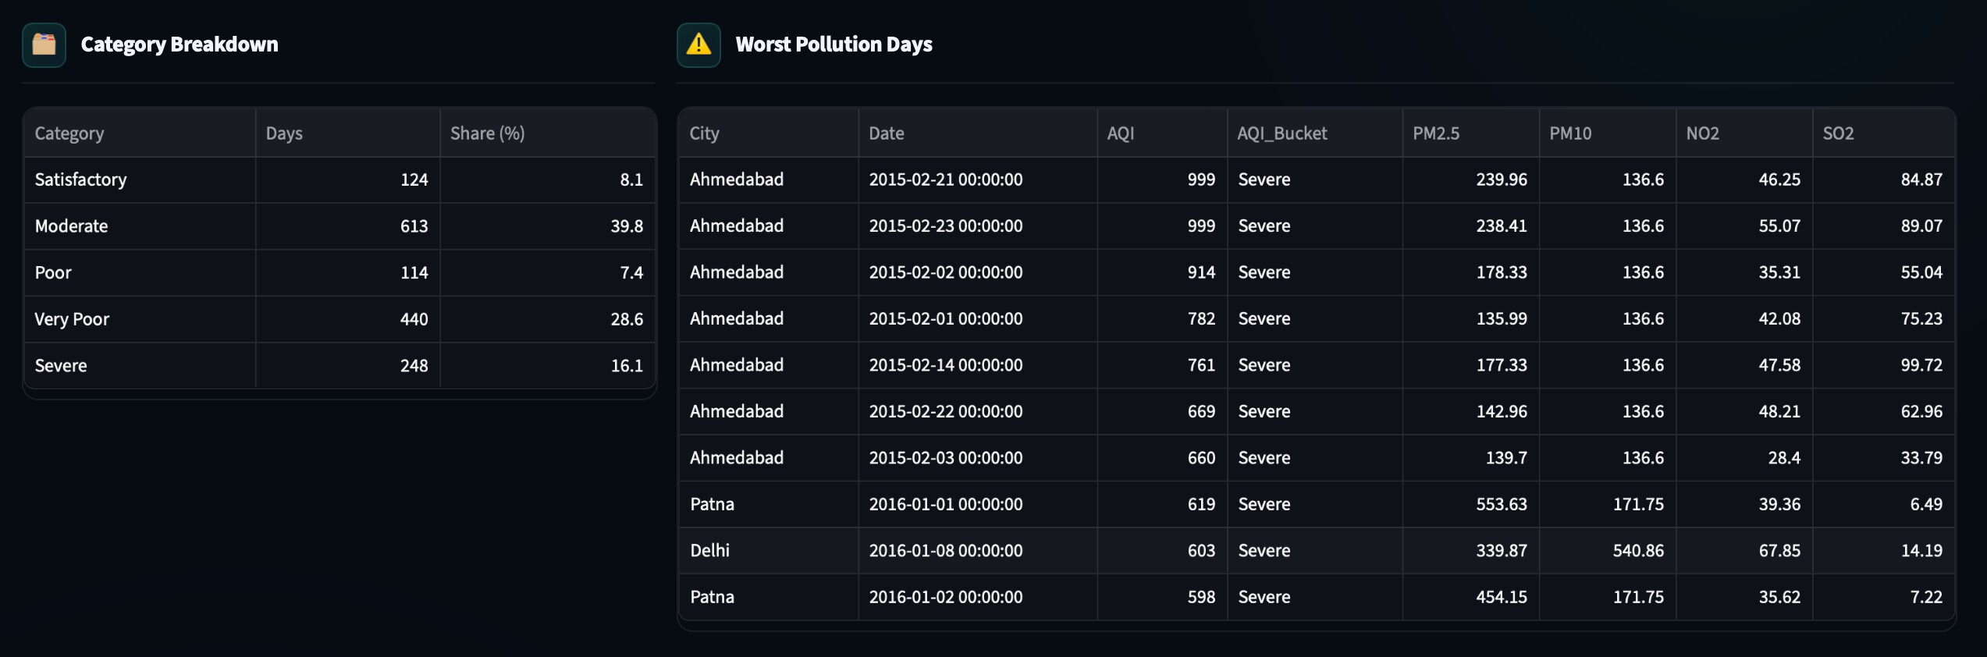

Figure 9: Category Breakdown table (left) and Worst Pollution Days table (right) - Ahmedabad dominates the worst days list in Feb 2015, followed by Patna and Delhi in Jan 2016

SECTION 2 - AQI TRENDS OVER TIME
The section examines AQI variation across years, months, and seasons using interconnected time-series and seasonal analyses.
Yearly trends show a decline in average AQI, while monthly patterns highlight higher pollution during winter months and lower levels during the monsoon. Seasonal analysis further shows a strong contrast between Winter and Summer AQI, supported by a summary table of mean AQI and record counts.
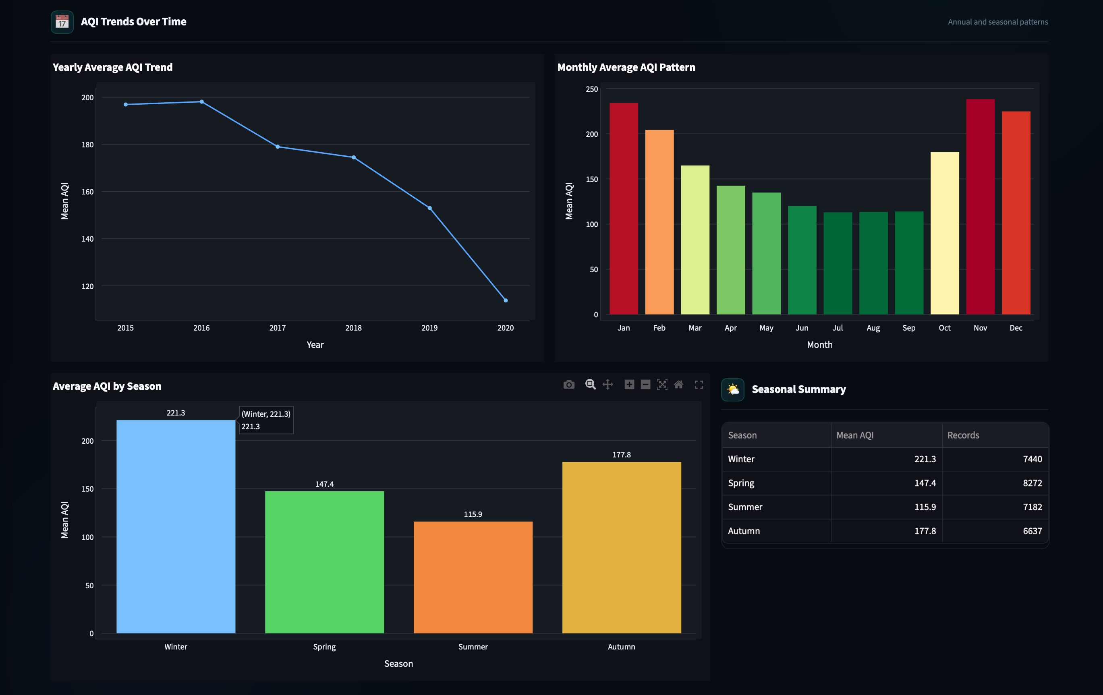

Figure 10: AQI Trends Over Time - yearly decline (2015→2020), monthly inversion-driven winter peaks, seasonal bar chart (Winter = 221.3 highest), and Seasonal Summary table

City Intelligence Tab
The City Intelligence tab answers the comparative question: how does air quality differ across Indian cities, and how has each city's pollution evolved over time?
While the AQI Intelligence tab shows the aggregate picture for the selected ﬁlter, this tab disaggregates it by geography - ranking cities by their pollution burden, quantifying variability within each city, and tracking individual city trajectories year by year through a fully annotated heatmap.
The tab contains two primary visualisations - the City AQI Ranking bar chart and the City × Year AQI Heatmap - plus an expandable full city summary statistics table. Both charts use the RdYlGn_r (red–yellow–green reversed) colour scale to provide instant visual encoding of pollution severity.

CITY AQI RANKING - BAR CHART WITH ERROR BARS
The chart_city_aqi_bar() function renders a Plotly Express bar chart showing all cities sorted by descending mean AQI. Two pieces of information are encoded per city:

Visual Encoding | What It Communicates
Bar height + RdYlGn_r fill colour | Mean AQI - red bars signal the most polluted cities (Ahmedabad, Delhi), green bars signal the cleanest (Aizawl, Shillong, Coimbatore)
Black error bars (± 1 SD) | Variability of AQI within each city. A tall error bar means the city has extreme pollution events alongside cleaner periods; a short bar means consistently uniform air quality

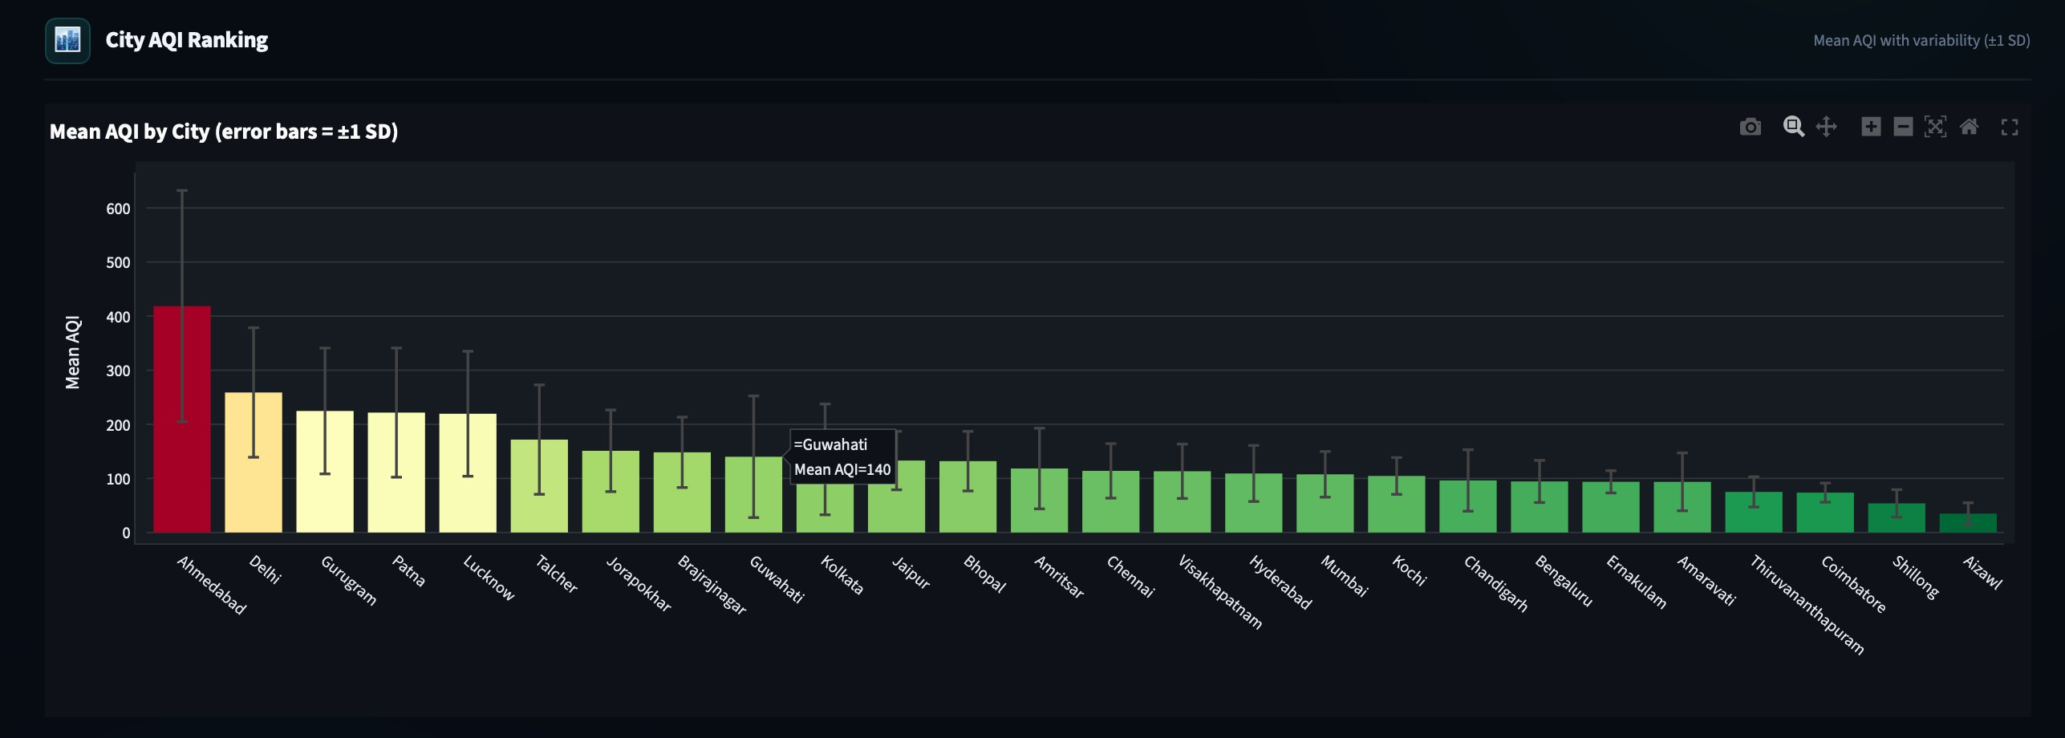
Figure 11: City AQI Ranking - all 26 cities sorted by mean AQI. Ahmedabad (red, ~420) towers over Delhi (~260) and the rest. Aizawl and Shillong are the cleanest at ~20–35. Error bars show high within-city variability for Ahmedabad and Delhi

The ranking chart exposes a sharp and statistically signiﬁcant geographic divide. All top-5 most polluted cities are in the North-Central Indo-Gangetic Plain (Ahmedabad, Delhi, Gurugram, Patna, Lucknow). All top-3 cleanest cities are in hilly or coastal South/Northeast India (Aizawl, Shillong, Coimbatore). This north-south gradient is driven by several compounding factors:

Factor | Effect on Northern Cities
Geography / topography | The Indo-Gangetic Plain is flat and enclosed by the Himalayas to the north, trapping pollutants in winter inversions with minimal dispersion
Industrial density | Heavy industry (steel, power plants, chemicals) concentrated in North and East India - Talcher, Jorapokhar, Brajrajnagar are coal-belt cities
Crop residue burning | Stubble burning in Punjab/Haryana (Oct–Nov) is a major seasonal PM2.5 contributor affecting Delhi, Gurugram, Amritsar
Vehicle & population density | Delhi NCR has the highest vehicle population in India; Patna and Lucknow show rapid urbanisation without corresponding emission controls
CITY × YEAR AQI HEATMAP
The chart_city_heatmap() function constructs a pivot table (City × Year → mean AQI) using pandas groupby, then renders it as a Plotly annotated heatmap. Each cell is labelled with the mean AQI value rounded to the nearest integer. The RdYlGn_r colour scale provides immediate visual scanning: deep red cells are the worst (high AQI), and deep green cells are the cleanest. Black cells indicate that monitoring data was not yet available for that city-year combination.

Dimension | Reading
Row (Y-axis) | Each row is a city - all 26 cities are listed alphabetically on the Y-axis
Column (X-axis) | Each column is a year from 2015 to 2020
Cell colour + number | Mean AQI for that city in that year. Deep red = Severe/Very Poor, yellow = Moderate/Poor, deep green = Good/Satisfactory. Black  (0) = no data available for that year

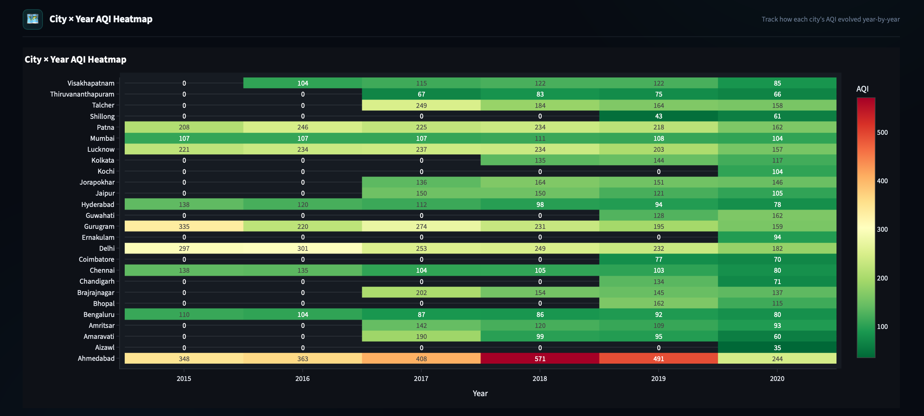
Figure 12: City × Year AQI Heatmap - Ahmedabad's 2018 cell (571, deep red) is the dataset's most extreme annual average. Delhi remains yellow-orange every year. South Indian cities are consistently deep green. Black cells mark years without monitoring data

FULL CITY AQI SUMMARY STATISTICS TABLE
Beneath the heatmap, an expandable section labelled 'Full City AQI Summary Table' (implemented with st.expander) reveals a six-metric per-city statistics table produced by the city_aqi_summary() function. Columns include Mean, Median, Std (standard deviation), Min, Max, and Count - providing a complete descriptive statistical proﬁle of each city's AQI distribution.
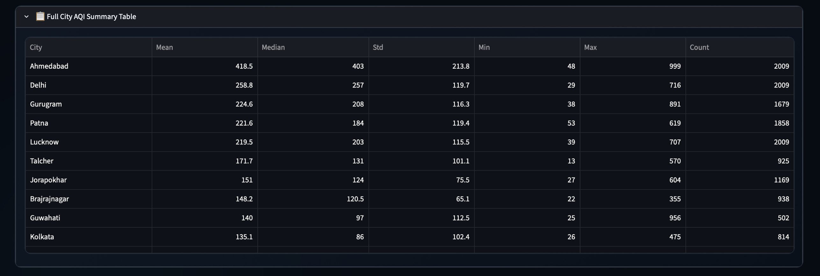
Figure 13: Full City AQI Summary Statistics Table

Pollution Intelligence Tab
The Pollution Intelligence tab shifts focus from AQI as an aggregate index to the individual pollutants that drive it. It answers three layered questions: Which pollutants contribute most to overall pollution load? How strongly does each pollutant correlate with the AQI score? And how does each pollutant's concentration vary across cities?
The tab is built around three components: a normalised radar chart, a Pearson correlation bar chart, and a pollutant-switchable city-level box plot - plus an expandable full descriptive statistics table.

SECTION 1 - POLLUTANT PROFILE
The Pollutant Proﬁle section combines a normalised contribution radar with a pollutant–AQI correlation bar chart, both dynamically updated with the selected ﬁlters. The radar compares all 12 pollutants on a common 0–1 scale using reference ceilings, highlighting dominant contributors such as PM10, NO₂, NOₓ and PM2.5. The correlation chart uses Pearson’s r to show each pollutant’s statistical association with AQI. Together, the charts reveal both the relative pollutant load and which pollutants are most closely associated with AQI variation.
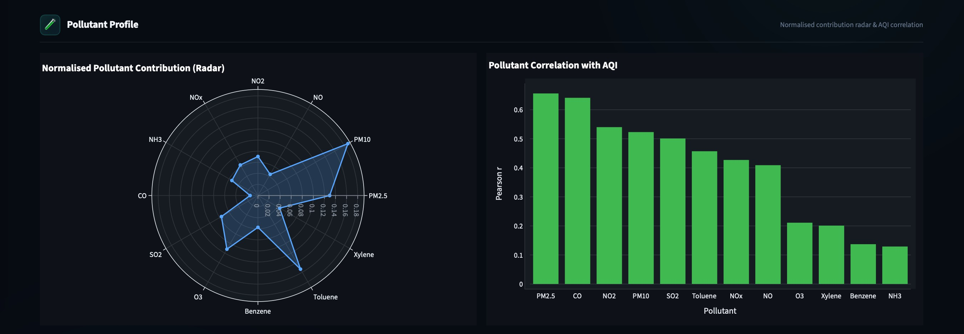
Figure 14: Pollutant Profile - Left: Normalised Contribution Radar showing PM10 with the largest spike (~0.18) followed by NO2 and NOx; Right: Pollutant Correlation bar chart with PM2.5 (r ≈ 0.67) and CO (r ≈ 0.65) as the strongest AQI predictors

SECTION 2 - POLLUTANT DISTRIBUTION BY CITY
The section provides a city-level distribution analysis for any selected pollutant across the ﬁltered cities. A dropdown allows users to choose from all 12 pollutants, with PM2.5 selected by default. The corresponding box plot updates dynamically, ranking cities by descending median concentration to highlight the highest-concentration cities ﬁrst.

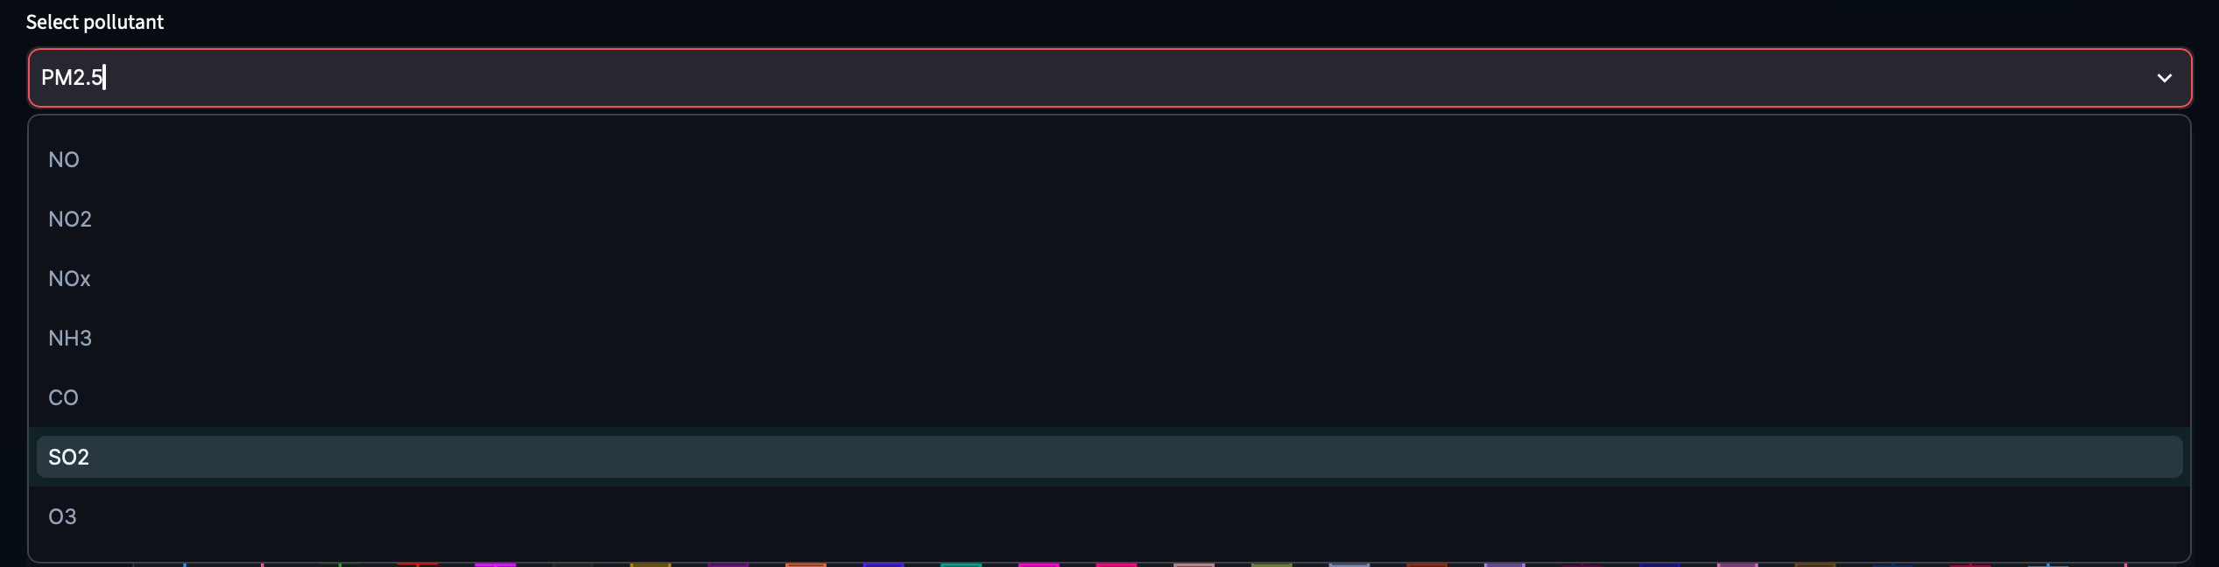

Figure 15: Pollutant selector dropdown - all 12 pollutants available.

POLLUTANT DISTRIBUTION EXAMPLES - BOX PLOT
Example A - PM2.5 Distribution:
The PM2.5 box plot displays the full daily concentration distribution for each city, ordered by descending median PM2.5. Each box shows the minimum, Q1, median, Q3, and maximum, with individual points highlighting outliers. Delhi, Gurugram, Lucknow, and Patna show higher typical concentrations, while several southern and northeastern cities exhibit lower and tighter distributions.
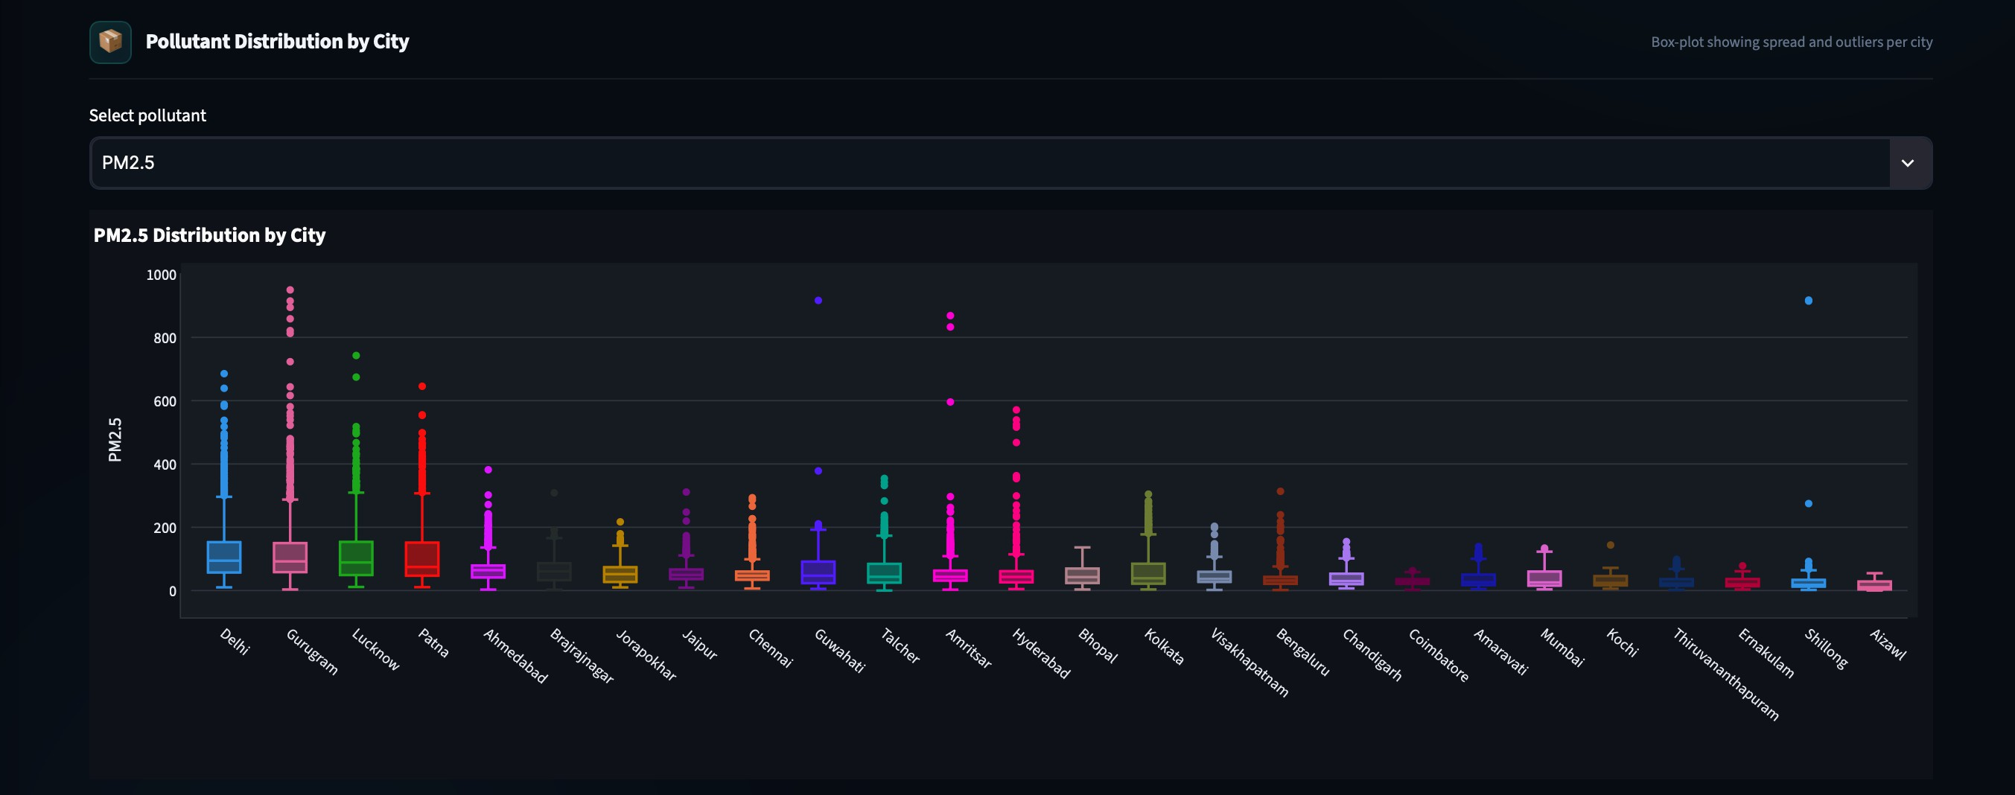
Figure 16: PM2.5 Distribution by City - Delhi, Gurugram, Lucknow, Patna lead with high median boxes (100–200 µg/m³). Outlier dots reaching 600–1000 µg/m³ visible for Delhi, Gurugram, Patna. Southern cities compressed near zero

Example B - SO2 Distribution:
Switching the selector to SO₂ produces a different city ranking, highlighting pollutant-speciﬁc patterns. Ahmedabad, Talcher, and Jorapokhar show higher SO₂ concentrations, while Delhi ranks much lower than it does for PM2.5. This interactive comparison reveals distinct pollution proﬁles across cities from a single dashboard view.

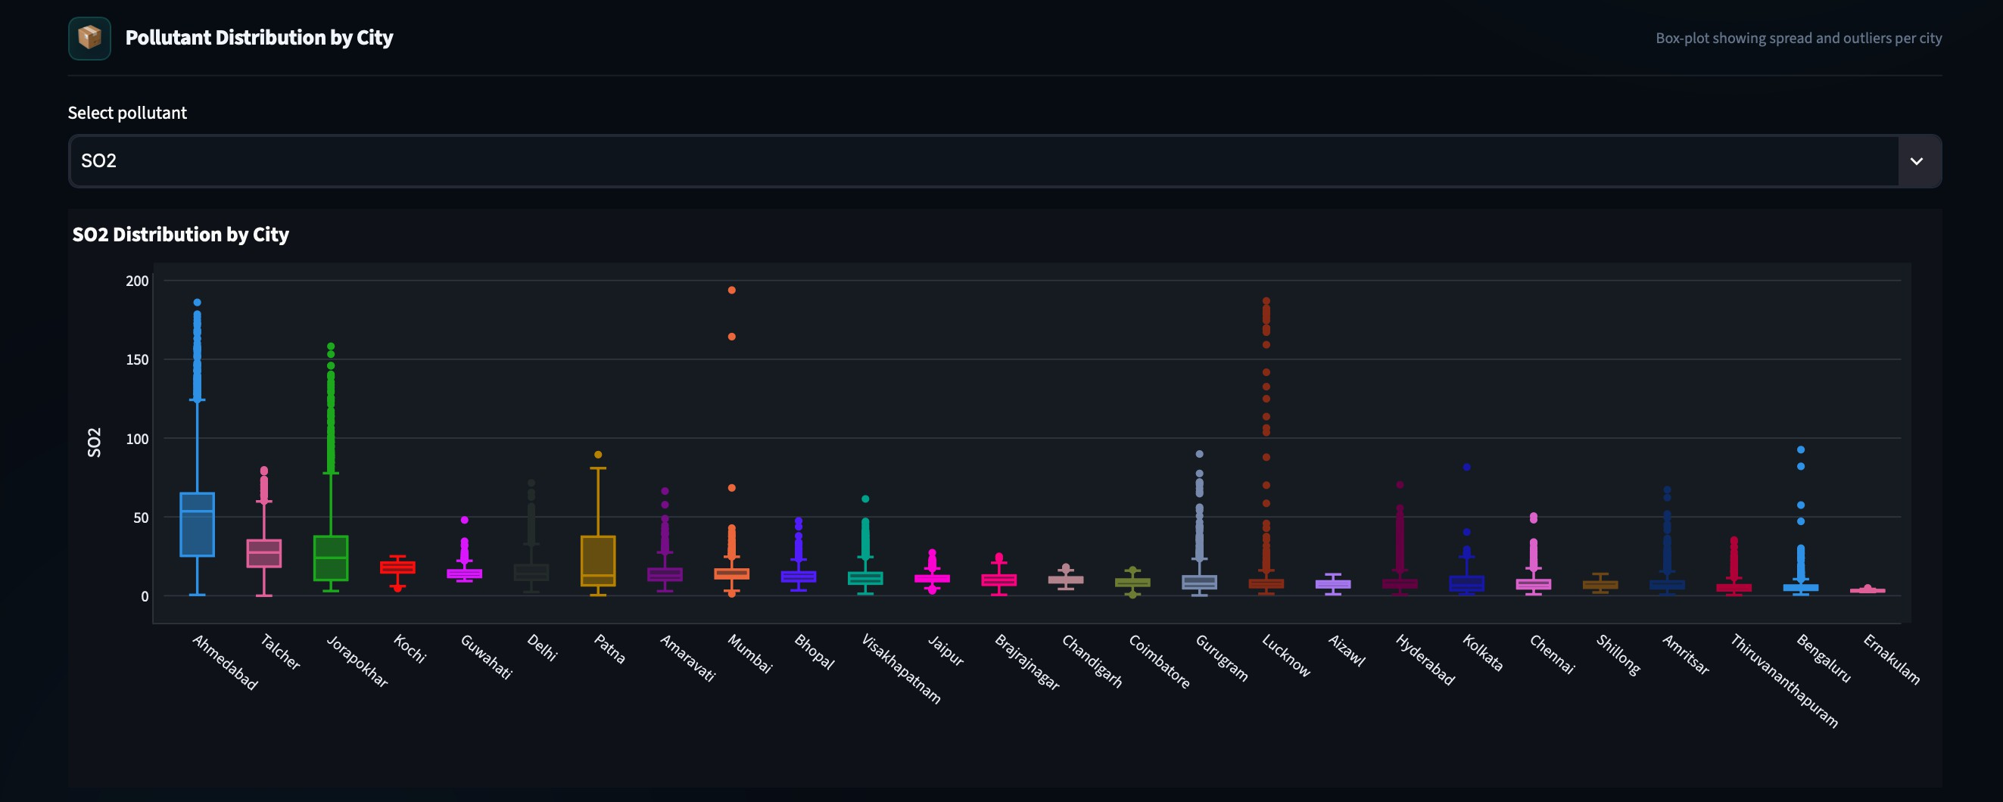

Figure 17: SO2 Distribution by City - Ahmedabad leads (median ~50, outliers ~190 µg/m³), followed by Talcher and Jorapokhar (coal-belt cities). Delhi drops to rank 6, revealing that its pollution is PM-driven, not SO2-driven

POLLUTANT DESCRIPTIVE STATISTICS TABLE
An expandable st.expander labelled 'Pollutant Descriptive Statistics' reveals a transposed pandas .describe() table with ﬁve columns per pollutant: Mean, Std Dev, Min, Median (50th percentile), and Max. All values are rounded to two decimal places. This table is the most compact way to compare the absolute magnitude, spread, and extreme values of all 12 pollutants side by side in a single view.

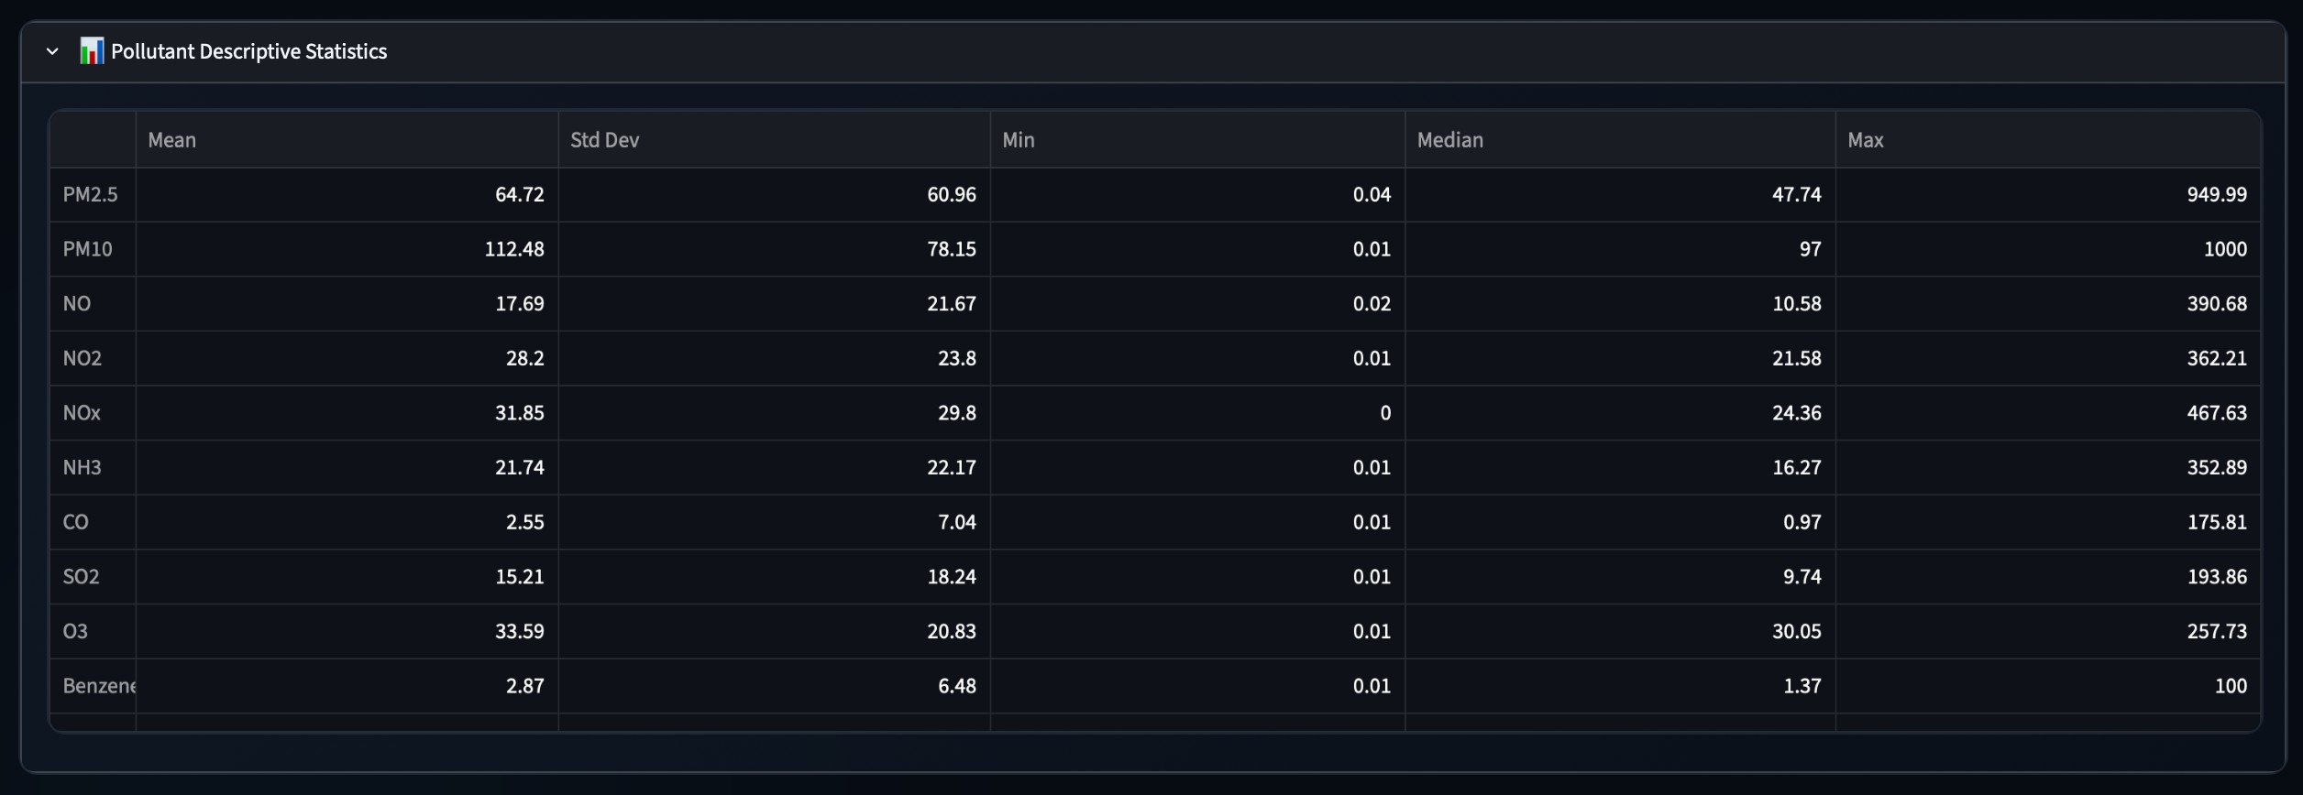
Figure 18: Pollutant Descriptive Statistics Table

Diagnostic Intelligence Tab
The Diagnostic Intelligence tab forms the statistical core of the dashboard, examining relationships between pollutants and AQI. It combines correlation analysis, risk-day comparisons, pollutant drilldowns, anomaly detection, and driver-shift analysis. All results are dynamically recalculated according to the active dashboard ﬁlters. The tab helps identify statistical associations, elevated pollution patterns, and changes in dominant pollutant behaviour.

INSIGHTS SUMMARY
Auto-generated insight cards highlight the most important statistical ﬁndings and patterns from the current selection.
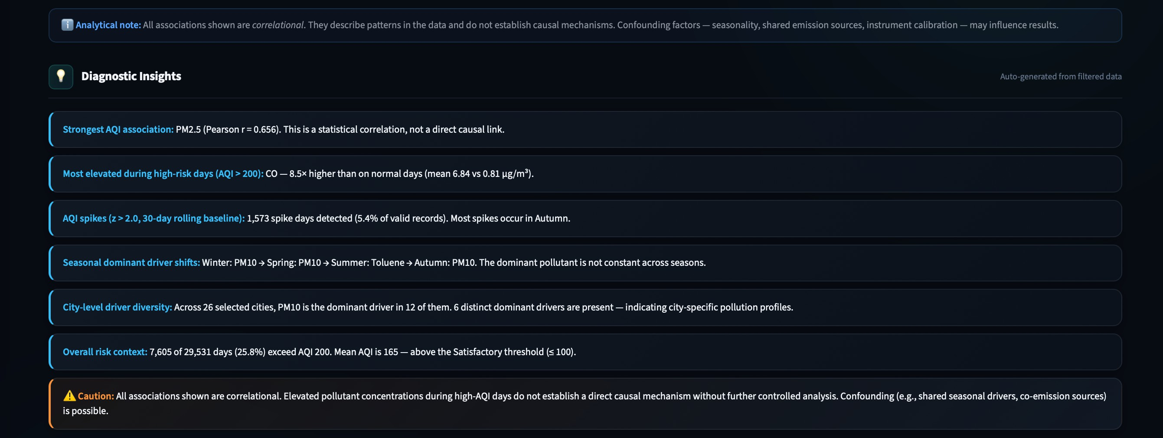
Figure 19: Auto-generated plain-language insight cards summarising key statistical findings for the current filter

POLLUTANT-AQI CORRELATION & CORRELATION MATRIX
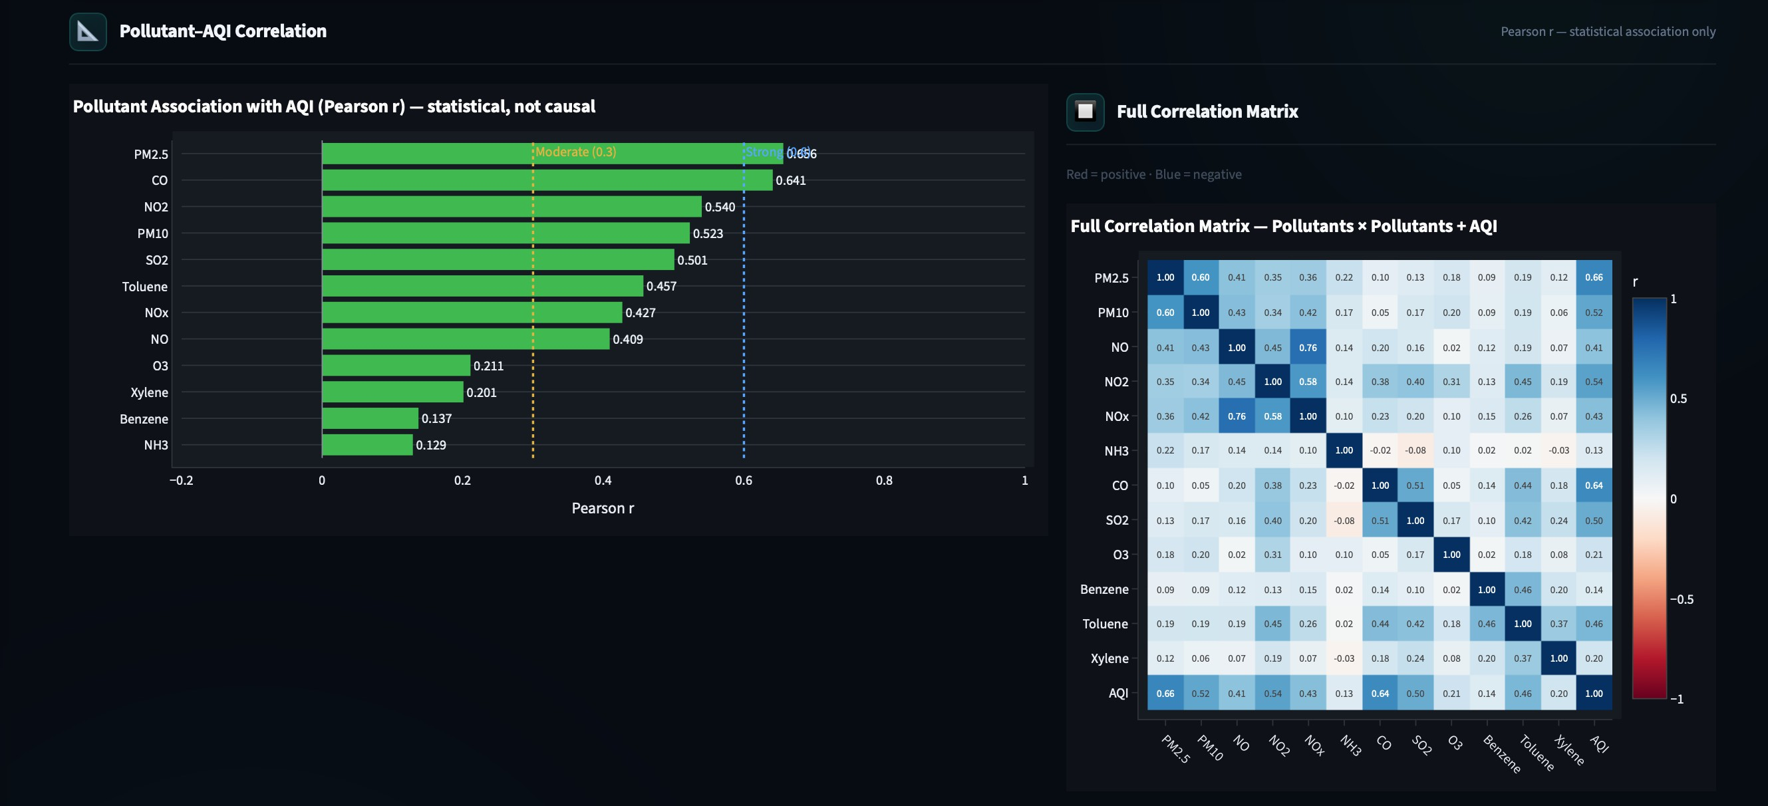
Figure 20: Per-pollutant Pearson r bar chart (with p-values) and the full 13×13 correlation matrix heatmap

Pearson correlation results and the 13×13 heatmap show relationships among the 12 pollutants and AQI.

NORMAL VS RISK-DAY COMPARISON
Compares mean pollutant concentrations between normal days (AQI ≤ 100) and high-risk days (AQI > 200), supported by a Mann-Whitney U test.
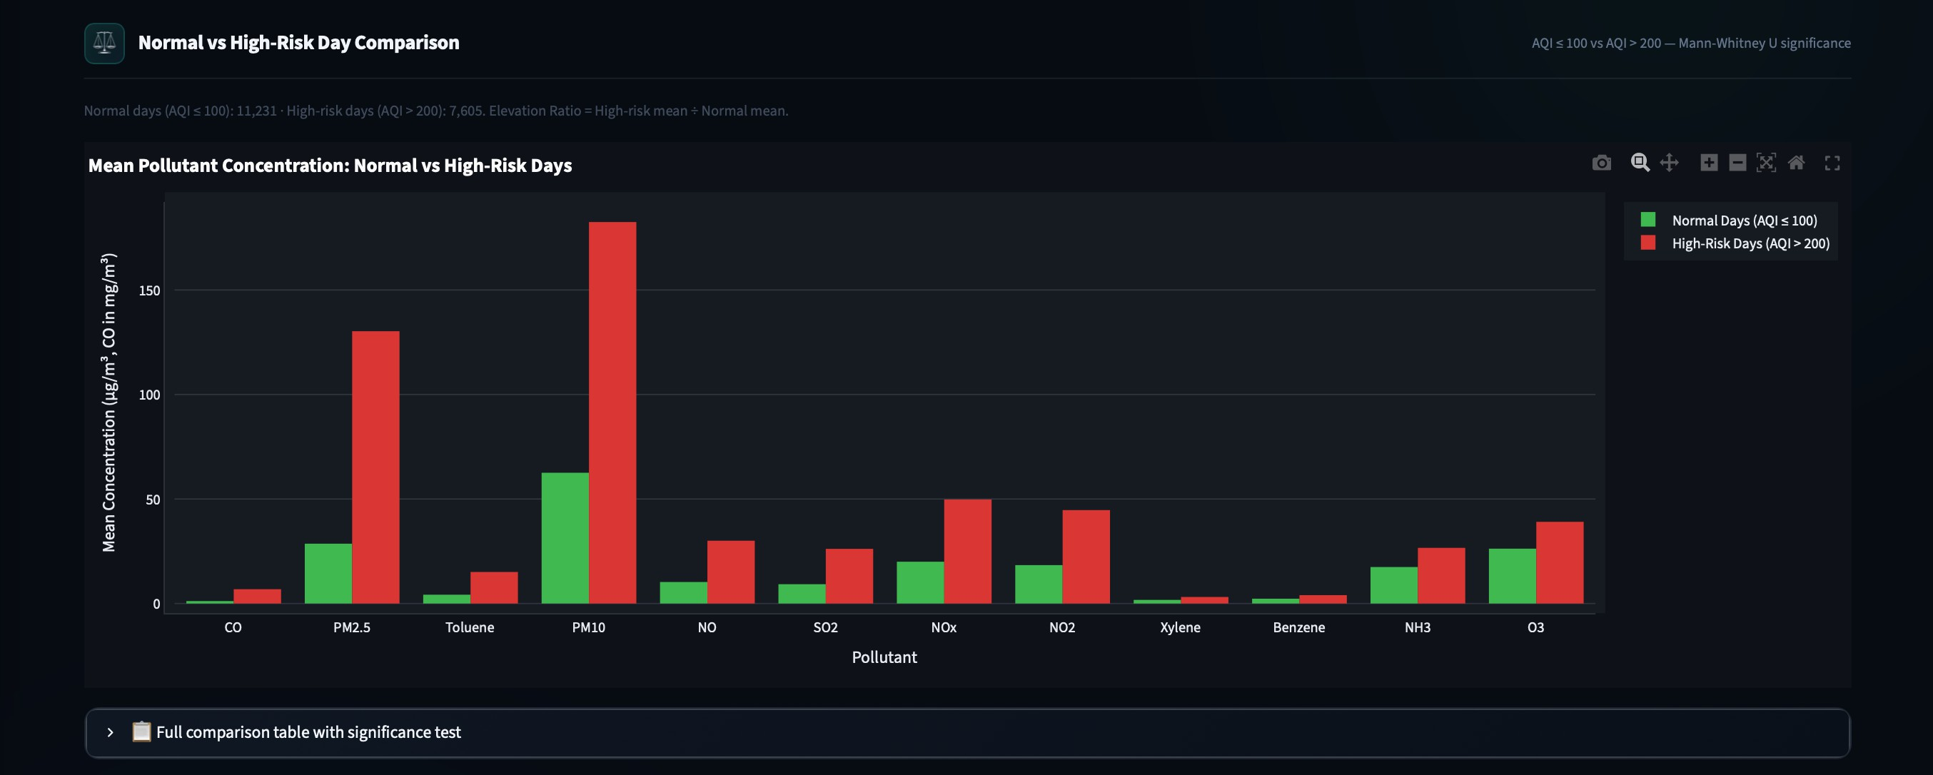
Figure 21: Mann–Whitney U test comparing pollutant concentrations on normal days (AQI ≤
100) vs risk days (AQI > 200)

POLLUTANT-TO-AQI DRILLDOWN
Shows how pollutant concentrations vary across AQI categories, with median and mean values for the selected pollutant.
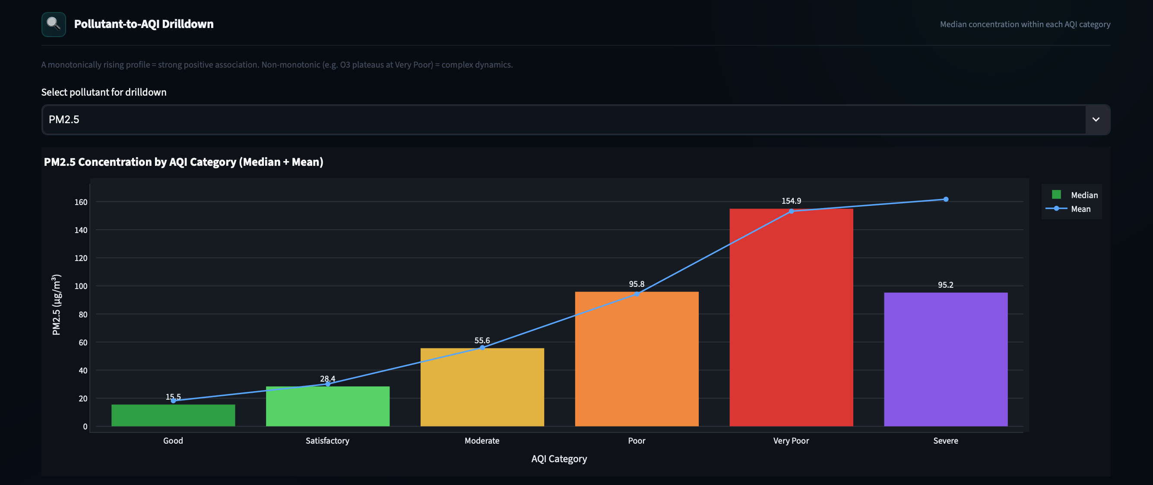
Figure 22: Scatter drilldown - individual pollutant concentration vs AQI with trend line for the selected filter

AQI SPIKE & ANOMALY ANALYSIS
Identiﬁes unusual AQI events using a 30-day rolling z-score threshold of >2.0 and examines pollutant elevation during spike days.
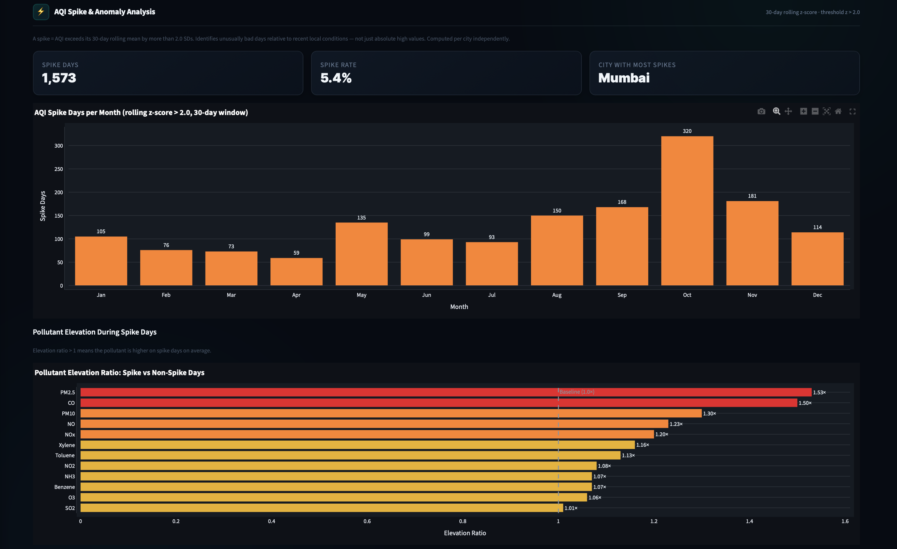
Figure 23: 30-day rolling z-score spike detection (threshold > 2.0) highlighting pollution anomaly events

DOMINANT DRIVER SHIFTS
Shows how the pollutant with the highest normalised concentration changes across seasons, years, and cities.
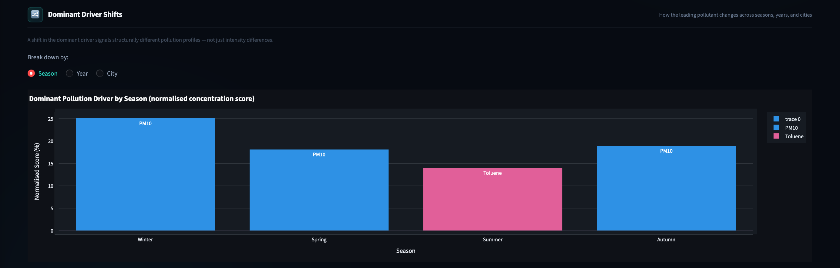
Figure 24: Stacked area chart showing how the dominant pollution driver shifts across years and seasons

Data Quality Tab
Full data-quality transparency is exposed in a dedicated tab, covering the cleaning pipeline steps and the original missing value rates per column and city.

CLEANING PIPELINE
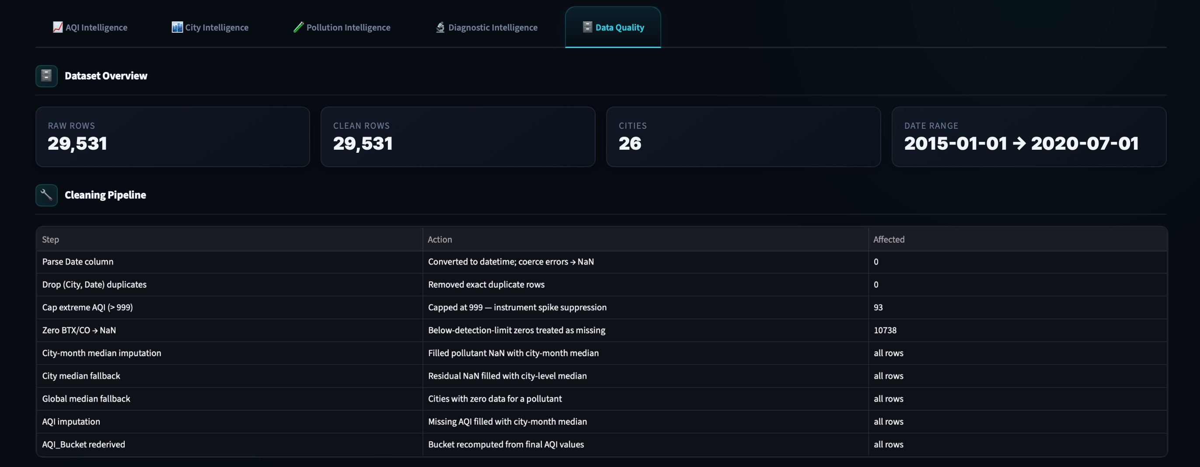

Figure 25: Step-by-step cleaning pipeline: validation → imputation → feature engineering, with record counts at each stage

ORIGINAL MISSING VALUE RATES
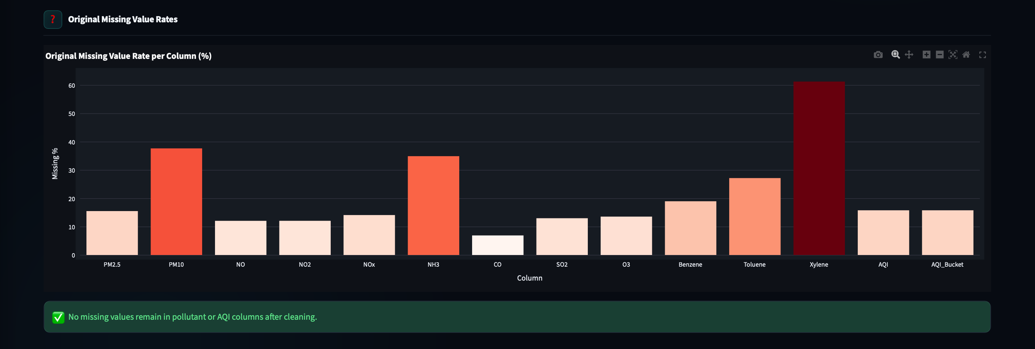
Figure 26: Per-column and per-city original missing value rates before any imputation

· Conclusion

The Urban Air Quality Intelligence dashboard transforms the CPCB city-day dataset into an interactive analytical platform for exploring AQI patterns, pollutant relationships, city-level differences, seasonal behaviour, and pollution anomalies. Through descriptive visualisation and statistical diagnostics, the project provides a clearer understanding of how air quality varies across Indian cities and time periods. The interactive ﬁltering and drill-downs make the analysis easier to explore and interpret.

