A Project Report On

**VIRTUAL LEARN ONLINE TRAINING WEBSITE**

Submitted in partial fulfilment of requirement

for the award of the degree

**MASTER OF COMPUTER APPLICATIONS**

Of

**Visvesvaraya Technological University, Belagavi**

By

**DEEPTHI NAYAK**

**4NM20MC021**

2020-2022



(An Autonomous Institute affiliated to VTU, Belagavi)

Nitte Mahalinga Adyanthaya Memorial Institute of Technology

Nitte – 574110, Karkala, Udupi District

A Project report on

**VIRTUAL LEARN ONLINE TRAINING WEBSITE**

Submitted in partial fulfilment of requirement

for the award of the degree

Of

Visvesvaraya Technological University, Belagavi

By

**DEEPTHI NAYAK**

**4NM20MC021**

2020-2022

Under the guidance of

**Internal Guide External Guide**

Dr. Pallavi Shetty Karthik Kodandaram K

Associate Professor Project Manager

Department of MCA Robosoft Technologies

NMAMIT, Nitte Santhekatte, Udupi



(An Autonomous Institution affiliated to VTU, Belagavi)

Nitte Mahalinga Adyanthaya Memorial Institute of Technology

Nitte – 574110, Karkala, Udupi District



(An Autonomous Institution affiliated to VTU, Belagavi)

Nitte Mahalinga Adyanthaya Memorial Institute of Technology

Nitte – 574110, Karkala, Udupi District

2020-2022

**CERTIFICATE**

This is to certify that the project entitled

**VIRTUAL LEARN ONLINE TRAINING WEBSITE**

Submitted in partial fulfilment of requirement

for the award of the degree

**MASTER OF COMPUTER APPLICATIONS**

is a result of the bonafide work carried out by

**DEEPTHI NAYAK (4NM20MC021)**

During the academic year 2021-2022



**Internal Guide External Guide**

Dr. Pallavi Shetty Karthik Kodandaram K

Associate Professor Project Manager

Department of MCA Robosoft Technologies

NMAMIT, Nitte Santhekatte, Udupi

**Dr. Surendra Shetty** **Dr. Niranjan N Chiplunkar**

Professor & Head Principal

Department of MCA MAM. Institute of Technology,

NMAM. Institute of Technology, Nitte Nitte

Semester End Viva Voce Examinations

Name of the examiners Signature with date

1.

2.

**ACKNOWLEDGEMENT**

It gives me great pleasure to express my sincere heart-felt thanks to each and every one associated with this project, without whom the successful accomplishment of this piece of work would not have been possible.

I am thankful to Dr. Niranjan N Chiplunkar, Principal, NMAMIT. Nitte, for providing me an opportunity to undertake this project.

I am thankful to Dr. Surendra Shetty, Professor & Head, Department of MCA, NMAMIT, Nitte for his continuous support, suggestions and encouragement.

I’m highly indebted to my mentor and project guide Dr. Pallavi Shetty, Associate Professor, Department of MCA, NMAMIT, Nitte for his guidance, support and constant supervision in completing this project.

I would like to express my sincere thanks to Mr. Karthik Kondandaram, Project Manager, Robosoft Technologies, Santhekatte, Udupi, where I carried outthis project, for his help and guidance throughout this project.

Finally, I acknowledge with great gratitude, the encouragement provided by everyone who were a part of this in one or the other way.

Deepthi Nayak

**ABSTRACT**

In contrast to traditional learning systems, virtual learning, or e-learning, satisfies the hunger for knowledge and delivers online content that may be given for the student at any time, anywhere, and at any age. Additionally, it offers quick access to specialized expertise and data. The learning process has evolved as a result of the time crunch and the quick expansion of extensive knowledge sources. Instead of manual teaching and learning, learners get knowledge using e-Learning technologies. This research study suggests an e-learning management system with a framework focused on online services. This solution fully integrates with many databases and provides cross-browser usage.

E-learning is the process of learning through digital instruments. One of the most common tools is distant learning, followed by learning management systems. Collaborations and hybrid learning opportunities, however, are threatening the E-learning landscape. The emergence of social networking and online learning groups, the widespread use of smartphones, and a growing understanding of the potential for computer games to revolutionize learning are recent developments. Other significant breakthroughs include improvements in Intelligent Tutoring Systems, the free Open Educational Resources movement, and the development of immersive environments that let users interact with virtual worlds and enhance their perception of the physical world through technology.

|  |  |
| --- | --- |
| **TABLE OF CONTENTS** | Page No |
| **1. INTRODUCTION** |  |
| 1.1 Overview | 1 |
| 1.2 Aims and Objectives | 2 |
| 1.3 Scope of the Project | 2 |
| **2. LITERATURE SURVEY** | 3 - 4 |
| **3. SYSTEM STUDY** |  |
| 3.1 Existing System with Limitations | 5 |
| 3.2 The Future System | 5 |
| 3.3 Objective of the Project | 6 |
| 3.4 Definitions | 7 |
| 3.5 Significance | 8 |
| 3.6 Statement of Research Hypothesis | 8 |
| **4. SYSTEM ANALYSIS** |  |
| 4.1 Software Requirements | 9 |
| 4.2 Programming Languages | 9 - 15 |
| 4.3 Hardware Requirements | 15 |
| **5. System Design** |  |
| 5.1 Workflow | 16 |
| 5.2 Activity Diagram | 17 - 18 |
| 5.3 Use case Diagram | 19 |
| 5.4 Sequence Diagram | 20 |
| **6. IMPLMENTATION** |  |
| 6.1 Modules Description | 21 – 22 |
| 6.1.1 Student Interface | 21 |
| 6.1.2 Instructor Interface | 22 |
| **7. Testing** |  |
| 7.1 Testing of Initialization and UI Components | 23 |
| 7.2 Screenshots | 26 - 32 |
| **8.Conclusion and Future enhancements** | 33 |
| **7. References** | 34- 35 |

**CHAPTER 1**

**INTRODUCTION**

* 1. **OVERVIEW**

Our everyday routines have undergone a transformation thanks to information technology. For instance, the internet has completely changed how information can be obtained, turning the world into a small, interconnected village. Many colleges and universities now offer online courses as a practical substitute for conventional face-to-face instruction due to the Internet's rapid expansion. However, a lot of worries and issues have arisen, especially in regards to the online education. Online education is a new field of study that blends face-to-face instruction with distance learning through computer-mediated communication. The following requirements must be met by online education:

Due to the fact that every student is unique, it offers a learning experience that is different from that of a regular classroom. The World Wide Web and a computer are used for communication. Learners' participation in the classroom varies, Changes have been made to the social dynamic of the classroom, and prejudice and discrimination are reduced.

Virtual Learn – Online Training Website is developed using programming languages like [HTML,](file:///C:\Users\HP\Downloads\report.docx#_bookmark0) [CSS,](file:///C:\Users\HP\Downloads\report.docx#_bookmark0) and [ReactJs.](file:///C:\Users\HP\Downloads\report.docx#_bookmark0) Reusable UI components are created using the JavaScript package ReactJs. what it means A library for creating private UIs is called React. Respond fundamentally facilitates the development of large-scale, complicated electronic applications that can modify their information without causing page enlivens. In the Model View Controller, it serves as the View (MVC). Respond encapsulates the Document Object Model (DOM) and provides a simple, effective, and active application improvement experience. Respond primarily uses Node Java-Script (NodeJS) on the server to render pages, and support for local mobile applications using React Native is provided. Respond implements a unidirectional information stream, streamlining the standard and making it significantly less complicated than conventional information officials.

The website looks good on all devices thanks to responsive web design (desk- tops, tablets, and phones). The goal of responsive web design is to make content seem beautiful on any screen by utilizing HTML and CSS to resize, conceal, shrink, grow, or move it. The standards for creating and rendering web pages, such as HTML, CSS, ReactJS, device APIs, and other web application technologies, are a part of web design and applications.

* 1. **AIMS AND OBJECTIVES**

The purpose of this project is to create an online tutorial system for university students, and its goals include:

* to design a system that is as basic and user-friendly as possible.
* to develop a system that makes an unlimited number of students able to participate in a virtual class available.
* increasing the number of students that could attend a certain tutorial lesson per unit hour in order to boost throughput.
* to modify the way that tutorials are delivered using internet technology.
* To create a system that made many types of materials, including videos, audios, photos, and texts, available for learning systems.

**1.3 SCOPE OF THE PROJECT**

This project's scope includes the registration of students' personal information, assigning tutorial classes to each student, and creating a special password to protect the privacy of personal data like login information. The absence of real-time video chatting is the project's constraint.

**CHAPTER 2**

**LITERATURE SURVEY**

Despite the rapid expansion of e-learning in the educational sector and its widely accepted advantages, the effectiveness of such tools won't be fully realized if the users are unable to embrace and employ the system. Therefore, the adoption and acceptance of technology by the students will determine how successfully e-learning technologies are implemented. In order to improve the learning experience for students, it is crucial for practitioners and policy makers to comprehend the elements influencing user acceptance of web-based learning systems (Tarhini et al., 2014a). However, recent studies have demonstrated that the implementation of e-learning is not just a technological solution but also a process of many different factors, including social factors, individual factors, organisational factors, such as facilitating conditions (Sun and Zhang, 2006), behavioural and cultural factors, as well as technological factors (Schepers and Wetzels, 2007; Tarhini et al., 2014b; 2015). (Masoumi, 2010). The development and application of information technology are significantly influenced by these important aspects (Kim and Moore, 2005). [1]

Fischer et al. (2015) investigated the use of scientific conference proceedings for trend analyses in the e-learning industry. They looked at the abstracts of 427 scholarly papers from renowned conferences on e-learning held in German-speaking countries. Society for Media in Science and E-Learning Conferences of the Sells [2]

Students' achievement is impacted by e-learning technologies, as demonstrated by Moravec et al. (2015). Nearly 2000 pupils took part in the study. Moravec et al. (2015) state that the study contrasts the answers to questions from the area of law where the e-learning tool was offered in a pilot form with the answers to questions from the domain of law where it was not. The findings of the students were impacted, according to the researchers, by the e-learning tools. However, it was proven false the theory that the e-learning tool might harm pupils who rely on the materials provided. [3]

Mothibi (2015) investigated the connection between e-learning and students' academic achievement in higher education using the Cohen's model and based on data collected from 15 documents from pertinent research studies conducted on the effect of ICT based e-learning on academic achievement during 2010–2012. The study discovered that ICT had a statistically significant favorable impact on students who used e-learning to further their academic goals. In addition, the findings showed that ICT significantly improved pupils' general academic performance. [4]

Enterprise resource planning (ERP) systems can leverage mobile learning (m-learning) methodologies, according to studies by Scholtzand Kapeso (2014), Almajali et al (2016), and Shannak (2013). The acceptance, utility, and perceived usability of the m-learning were evaluated using the technology acceptance model (TAM). The researchers discovered a significant correlation between perceived simplicity of use and perceived usefulness of the m-learning system. These findings supported previous research that emphasised the significance of high-quality course content in e-learning and m-learning projects. [5]

In order to conduct their research, Pieri and Diamantini (2014) used data from the academic year 2011–2012 of e-learning web 2.0 at the University of Milano–Bicocca. The goal of the study was to make explicit and hence more accessible the implicit and tacit information that the users already possess. The researchers began elaborating the transition from Web 2.0 to e-learning and the aggregation of the power of Web 2.0 with social networks in the learning process because ICTs have become a key component of the learning experience for people of all ages. In order to train 137 students in two subjects (tourism and sociology of innovation), they used Thinktag Smart, a new Web 2.0 platform that combines the learning opportunities offered by the web 2.0 with the learning opportunities of social networks for sharing knowledge. After this experience, they gave the students a questionnaire to evaluate the learning experience and the platform. The most popular features of Thinktag Smart were resources, shelves, and groups, while the least popular features were wiki, collections, and chat. These features made Thinktag Smart a popular platform because they allowed users to exchange and share information with one another, support teaching by allowing them to share notes and materials related to the courses they need, and provide interactivity. [6]

**CHAPTER 3**

**SYSTEM STUDY**

**3.1 EXISTING SYSTEM WITH LIMITATIONS:**

Because there are now so few resources available, students cannot learn much beyond what is taught in lectures. Because all a student learns comes from lectures in class, this ultimately limits students' performances. Here are a few issues with the existing system:

* In any university today, lectures download references for either the students or for instructing.
* Students turn in their homework to lectures via paper copies or personal emails.
* Only when lectures are held in the students' offices do students receive assistance from them.
* A course's new lectures must procure their own resources.
* Students must physically be present in the classroom in order to learn, foregoing all other obligations.
* Lectures cannot adequately monitor or supervise group discussions or allow students to effectively share resources.

**3.2 THE FUTURE SYSTEM**

The system will hopefully act as a central repository for the university's course syllabus, making them accessible to students and faculty (past, present, and future). By allowing access to information and other resources at any time and from any location, the system will ultimately facilitate effective communication between the students, instructors, and administration.

Here are some of the project's anticipated outcomes:

* Resource for each unit is available to student to refer later. They can use them for further preparation.
* Students can download assignments and resources and upload assignments after completed by them.
* It offers a simple approach to control course websites that contain schedule details, quizzes, and course discussions.

**3.3 OBJECTIVE OF THE PROJECT**

By enabling quick access to specialized knowledge and information, e-learning represents a revolutionary change in the field of education. Through a variety of electronic learning solutions, including Web-based courseware, online discussion groups, live virtual courses, video and audio streaming, Web chat, online simulations, and virtual mentorship, it offers online teaching that can be provided at any time and from any location. By offering a unified virtual learning environment, e-learning enables firms to overcome distance and other organizational obstacles. To remain competitive, businesses must educate and train their partners, clients, employees, and suppliers. E-learning can deliver this just-in-time training in an economical manner. One may need to connect the dots between the goods and services offered by many suppliers in order to develop and implement efficient E-Learning programs. Identifying the objectives of the intended learning solution is a good place to start. The following variables influence how an e-learning solution's objectives are defined:

* **To perform task analysis**

Identify the tasks that need to be taught, their subtasks, and other components, as well as the knowledge, abilities, and attitudes needed to carry them out successfully.

* **To perform training needs analysis**

Determine who will receive the training. Determine the audience's knowledge, skill, and attitude gaps and what the target learners need to know.

* **To review existing capabilities**

Examine current systems and infrastructure for delivering instruction or addressing learning requirements.

* **To determine expectations**

Identify specific demands for ROI and/or expectations from the desired e-learning solution. Setting objectives is the first step in developing an E-Learning plan. What is the goal of the E-Learning strategy? Without a thorough grasp of the objectives of the E-Learning plan, success will be challenging, if not impossible. Organizations must establish common goals or objectives prior to implementing e-learning. The following are typical objectives and goals:

* **To reduce learning costs**

As a small business owner, you are aware that internet transactions are significantly less expensive than those involving paper or personnel. The same is true of online learning because there are no papers, delays, or travel costs. Employees that receive this type of training are able to apply what they have just learned to the work at hand.

* **To motivate employees**

E-learning is regarded as a successful method for keeping up with current technologies, generating fresh ideas, and inspiring your team.

* **To improve flexibility of course delivery**

Smaller companies lack the personnel to oversee their training and development programs. These administrative limitations can be circumvented by e-learning technologies.

**3.4 DEFINITIONS OF TERMS (UNFAMILIAR)**

* **Learning Management System (LMS):-** A learning management system, or LMS for short, is a piece of software or web-based technology used to organize, carry out, and evaluate a particular learning activity. An teacher can often use an LMS to produce and distribute curriculum, track student involvement, and evaluate student performance.
* **Course Management System (CMS):-** A course management system is a collection of tools that frees up the instructor from needing to learn HTML or other programming languages in order to produce and publish online course materials.

##### **3. 5 SIGNIFICANCES OF E-LEARNING SYSTEM**

Education can be transformed by technology. It must be used in the classroom in order to enhance learning. Here are a few of the causes (and their importance/significance).

1. For better learning outcomes, students must be involved in what they are doing.
2. Encourages kids to develop as thinkers, learners, and risk-takers in a safe setting.
3. Develop self-reliance and accountability by being independent of your teacher.
4. Because it exposes pupils to the outside world, it broadens the horizons of many students.
5. Fits in with rural education, where students in small rural schools need not suffer from isolation and distance because technology allows them to learn virtually and maintain their subject choices, allowing for the virtual teaching of LOTE (languages other than English) and other specialized subjects across schools.
6. Enables a mobile learning environment that may be used anywhere, whenever, and however.

##### **STATEMENT OF RESEARCH HYPOTHESIS**

The primary objective of this study is to learn more about five significant characteristics that were applied as independent variables in earlier studies, with assessed e-Learner satisfaction used as a dependent variable.

* **Hypothesis 1**. Learner attitudes toward computers will have a beneficial impact on how satisfied e-Learners feel with e-Learning.
* **Hypothesis 2**. Learner computer phobia will have a detrimental impact on how satisfied e-Learners feel about e-Learning.
* **Hypothesis 3**. Flexibility in e-learning course design will have a favorable impact on how satisfied e-learners feel about e-learning.
* **Hypothesis 4**. E-Learner satisfaction with e-Learning will be positively influenced by the caliber of the e-Learning course.

.

**CHAPTER 4**

**SYSTEM ANALYSIS**

**REQUIREMENT SPECIFICATIONS**

The Virtual Learn-Online Training Website's major goal is to create an online training platform with tools including video lectures, quizzes, doubt-clearing sessions, and a certificate of course completion.

* 1. **Software Used to Program**

**4.1.1 Microsoft Visual Studio Code (Version-1.66)**

Visual Studio Code is a desktop-based source code editor that runs on Windows, macOS, and Linux. It is compact but effective. It contains support for JavaScript, TypeScript, and Node.js built in, as well as a robust community of extensions for other languages and runtimes (such Network Enabled Technologies (.NET) and Unity).

* 1. **Programming Languages**

* + 1. **[HTML](file:///C:\\Users\\HP\\Downloads\\report.docx" \l "_bookmark0) 5**

The most fundamental component of the Web is HTML. It describes the purpose and organisation of web content. The appearance/presentation (CSS) and functionality/behavior (JS) of a web page are typically described using technologies other than HTML (JavaScript). Links that join online pages together, either within a single website or between websites, are referred to as "hypertext." An essential component of the Web are links. You can participate actively in the World Wide Web by publishing content online and linking it to other people's web pages. "Tags," which consist of the element name enclosed by "" and ">," are used to distinguish HTML elements from other content in a page. Case is not relevant when naming an element inside a tag. In other words, it can be written in uppercase, lowercase, or a combination of the two.

* + 1. **[CSS](file:///C:\\Users\\HP\\Downloads\\report.docx" \l "_bookmark0) (Version-3)**

A stylesheet language called CSS is used to describe how a page written in HTML or XML (including XML dialects like Extensible Hypertext Markup Language (XHTML)) is presented. CSS specifies how items should be shown in various media, including speech, paper, screens, and other media.

* + 1. [**ReactJs**](file:///C:\Users\HP\Downloads\report.docx#_bookmark0) **(Version-18.0.0)**

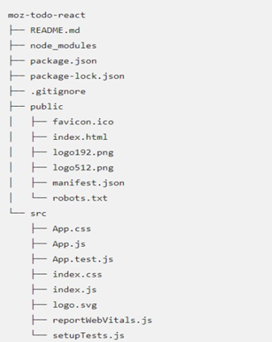

Figure 4.1: React Application Structure

A library called React is used to create user interfaces. Not only is React not a framework, but it is also not just for the web. It renders to particular surroundings when combined with other libraries. React Native, for instance, can be used to create mobile applications. Developers use React in conjunction with ReactDOM to create web-based applications. React and ReactDOM are frequently discussed together and used to address similar issues as other real web development frameworks. It accomplishes this by using components, which are logical, self-contained bits of code that describe a section of the user interface. These elements can be combined to form a complete user interface (UI), and React abstracts away much of the rendering effort so you can focus on UI design.

The source code for the program is located in the 'src' directory, as seen in Figure 4.1. The most crucial of these files, index.html, may be found in the "public" directory and will be read by your browser when the app is being developed. When creating and deploying a production version of the app, the "public" directory will also be published. The information about our project that "Node.js/npm" utilizes to keep it organized is contained in the "package.json" file. Create-react-app only populates this file; React applications are not the only ones that can use it.

* 1. [**UI**](file:///C:\Users\HP\Downloads\report.docx#_bookmark0) **/** [**UX**](file:///C:\Users\HP\Downloads\report.docx#_bookmark0) **DESIGNING TOOL**
     1. **Figma (Version-114.2.1**

**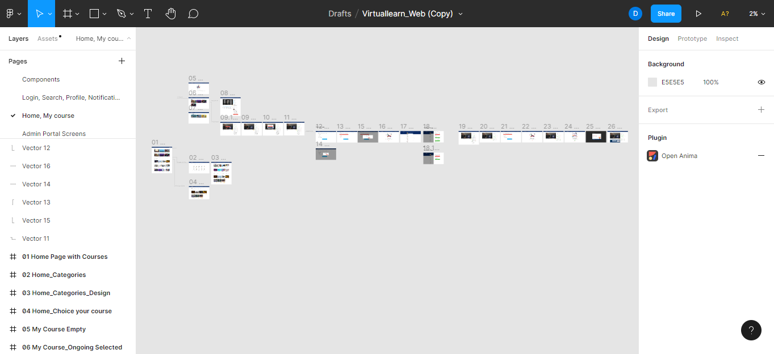**

Figure 4.2: Figma [UI](file:///C:\Users\HP\Downloads\report.docx#_bookmark0)

An online tool for designing user interfaces and altering visuals is called Figma. It may be used to create social media posts, prototype designs, wireframe websites, build mobile app interfaces, and a variety of other graphic design tasks. Compared to other graphic editing software, Figma is unique. mostly because it directly affects the browser. In other words, you may browse the projects and begin designing from any computer or platform without having to install the software or purchase additional licences.

* 1. **[APIs](file:///C:\\Users\\HP\\Downloads\\report.docx" \l "_bookmark0)**

A set of definitions and protocols known as an API are used to create and integrate application software. It's sometimes referred to as a contract between a provider of information and a user of that information, outlining the content that the consumer (the call) and the producer (the producer) are obligated to deliver (the response). For instance, the API design for a weather service may need the user to provide their zip code and the producer to respond with two parts, the first of which would be the high temperature and the second, the low.

* + 1. **[RESTful](file:///C:\\Users\\HP\\Downloads\\report.docx" \l "_bookmark0)** [**APIs**](file:///C:\Users\HP\Downloads\report.docx#_bookmark0)

A set of restrictions for using in the development of web services are defined by the architectural style known as RESTful. RESTful APIs are a simple and flexible way to access online services without any processing. A request is transmitted from the client to the server as an HTTP GET, POST, PUT, or DELETE request using a web Uniform Resource Locator (URL), as shown in Figure 3.3. After that, the server replies with a resource, which may be anything like HTML, XML, an image, or JSON. However, JSON is currently the most widely utilised format in Web Services. The working of [RESTful API](file:///C:\Users\HP\Downloads\report.docx#_bookmark0) Methods are explained in Table [4.1.](file:///C:\Users\HP\Downloads\report.docx#_bookmark34)

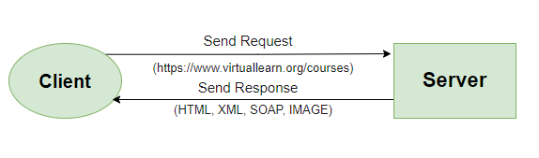

Figure 4.3: [RESTful API](file:///C:\Users\HP\Downloads\report.docx#_bookmark0) Working

* + 1. **POSTMAN** [**API**](file:///C:\Users\HP\Downloads\report.docx#_bookmark0)

It's simple to construct and deliver API calls with Postman. Send a request to an end point, get information from a source, or check how well an API works. No need to create any code or type instructions into a terminal. When you create a new request and choose Send, Postman immediately displays the API response.

Table 4.1: [RESTful API](file:///C:\Users\HP\Downloads\report.docx#_bookmark0) Methods

Method Operation Description

GET Read or retrieve the data

GET returns an XML or JSON representation along with the HTTP response code 200. (OK). It typically returns a 404 (NOT FOUND) or 400 in an error event (BAD REQUEST).

POST Create new data It is employed to produce inferior resources. That is

beneath some other resource (such as a parent resource). Return HTTP status 201 after a successful creation, along with a Location header with a URL to the newly created resource.

PUT Update the data When the resource ID is selected by the client rather

than the server, PUT can also be used to build the resource. In other words, if the PUT is to a URI that has the value of a resource ID that doesn't exist. If an update is successful, a PUT should return 200 (or 204 if no information in the body is being changed). Return HTTP status 201 upon successful creation when using PUT for creation. Although PUT is idempotent, it is not a safe operation.

PATCH Modify the data Only the resource’s modifications, not the entire re-

source, must be included in the PATCH request. This is similar to PUT, except the body includes a set of instructions outlining how to alter a source that is currently on the server to create a new version. This indicates that the PATCH body should use a patch language, such as JSON Patch or XML Patch, rather than simply being a modified portion of the resource. Neither PATCH is safe nor is it idempotent.

DELETE Delete the data Upon deletion, send an HTTP status 200.

* 1. **WEB HOSTING**

* + 1. **[AWS](file:///C:\\Users\\HP\\Downloads\\report.docx" \l "_bookmark0)**

The most widely used cloud platform in the world, AWS consists of over 200 different cloud data services that use data centers all around the globe. Elastic Compute Cloud (EC2), Glacier, a service for virtual machines, and Simple Storage Service (S3), Amazon's inexpensive storage solution, are the three core components of AWS. AWS is responsible for roughly 13Facebook/Meta. Using a global network of edge sites, Amazon CloudFront may be utilized to distribute your website, including dynamic, static, and streaming content. Your content is provided with the best performance possible thanks to automated routing of requests to the closest edge pointSecurity groups is a function offered by Amazon EC2. Similar to an incoming network firewall, a security group allows users to set the protocols, ports, and source Internet Protocol (IP) ranges that are permitted to connect to EC2 instances. One or more security groups may be given to each EC2 instance, and each of these groups directs the necessary traffic to each instance. A redundant and highly available service is offered by Amazon S3. For assets that are largely static or slowly changing, such as pictures, videos, and other static material, Amazon S3 is a wonderful storage option[.](file:///C:\Users\HP\Downloads\report.docx#_bookmark65)

**CHAPTER 5**

**SYSTEM DESIGN**

## WORKFLOW

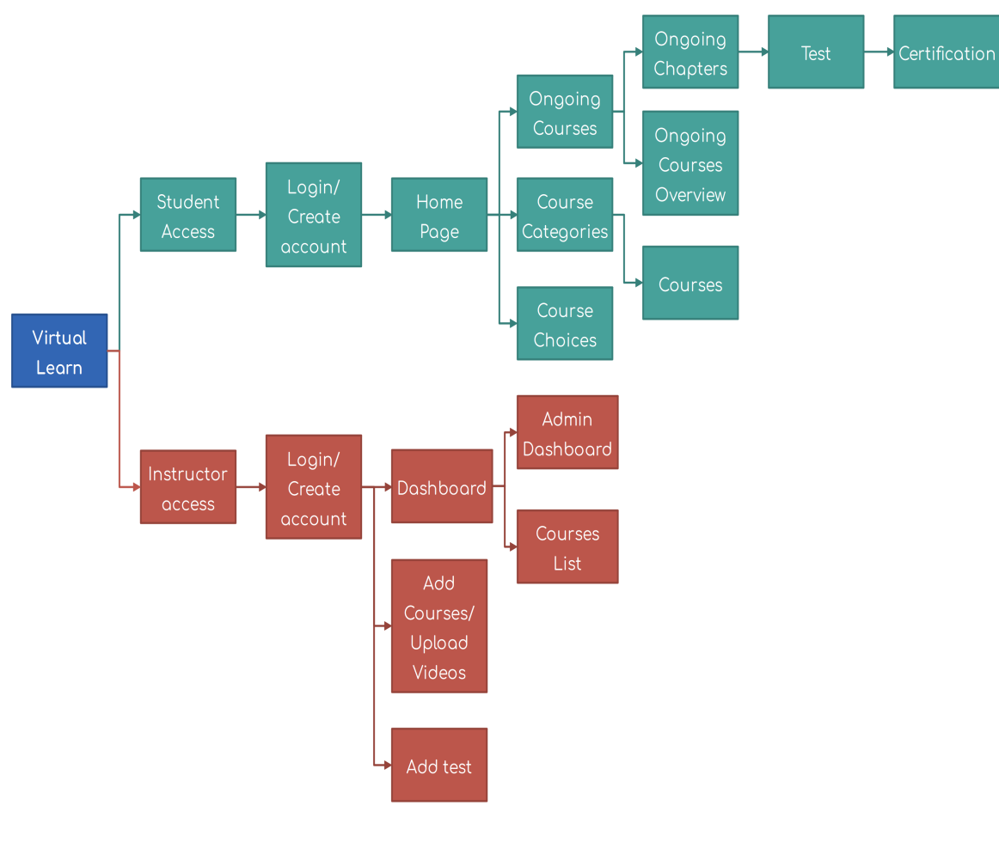Figure 5.1 displays a block diagram of the Virtual Learn website. It demonstrates that the frontend of the website is divided into two sections: the student interface and the teacher interface. The website can be accessed using a login page depending on the student or instructor. Additionally, if a user is new to the website, they can register a new account.

Figure 5.1: Block diagram of Virtual Learn website

**5.2 ACTIVITY DIAGRAM**

Another crucial UML diagram for describing the system's dynamic elements is the activity diagram. An activity diagram is essentially a flowchart that shows how one activity leads to another. The action might be referred to as a system operation. One operation leads to the next in the control flow. This flow may be parallel, contemporaneous, or branched. Activity diagrams use many features, such as fork, join, etc., to cope with all types of flow control.

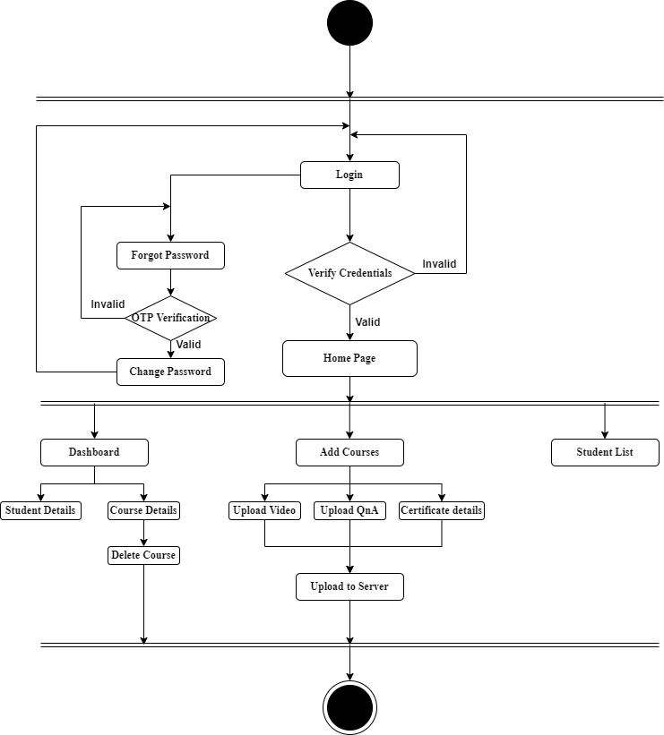

Figure 5.2: Activity diagram of Virtual Learn website(Admin)

**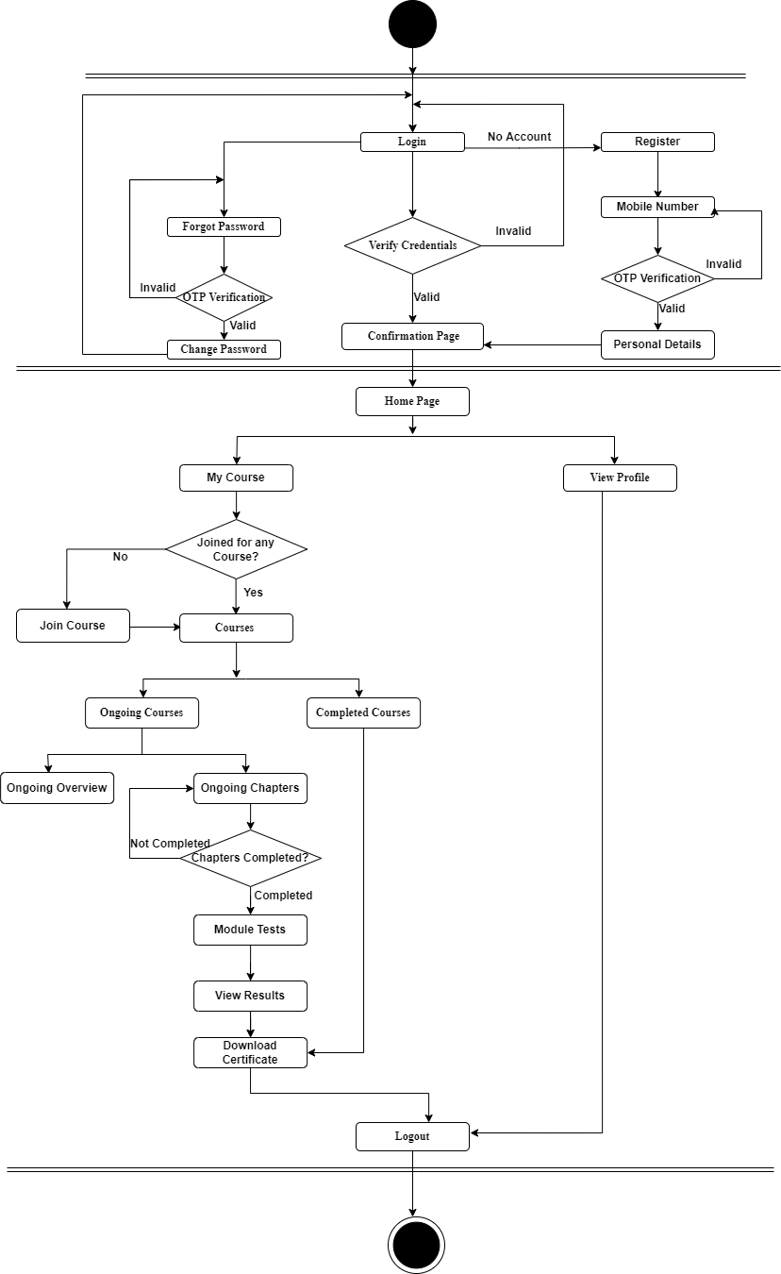**

Figure 5.3: Activity diagram of Virtual Learn website(Student)

* 1. **USE CASE DIAGRAM**

The dynamic behavior of a system is represented by a use case diagram. It incorporates use cases, actors, and their interactions to encapsulate the functionality of the system. It simulates the duties, services, and operations needed by a system or application subsystem. It shows a system's high-level functionality and also describes how a user interacts with a system.

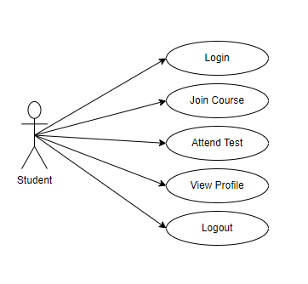

Figure 5.4: Use case diagram of Virtual Learn website (Student)

**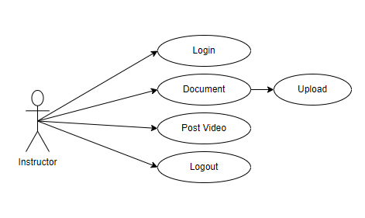**

Figure 5.5: Use case diagram of Virtual Learn website (Instructor/Admin)

* 1. **SEQUENCE DIAGRAM**

The sequence diagram, which is also known as an event diagram, shows how messages move through the system. It aids in creating a variety of dynamic settings. It depicts communication between any two lifelines as a chronologically ordered series of activities, implying that these lifelines were active at the moment of communication. The message flow is represented by a vertical dotted line that crosses the bottom of the page in UML, whereas the lifeline is represented by a vertical bar. Both branches and iterations are included.

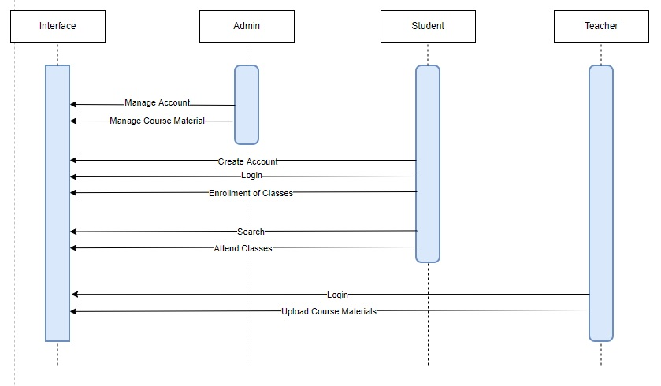

Figure 5.6: Sequence diagram of Virtual Learn website

**CHAPTER 6**

**IMPLEMENTATION**

The goal of this project is to create an online training website with features like video lectures, quizzes, doubt clearing, and a certificate of course completion. Figma, a graphic design program used for creating user interfaces, was used to build the website's design. The website was created using the ReactJs framework and programming language.

The website primarily has two user interfaces: one for students and one for instructors. The login page is in charge of verifying the user's identity so they can access the website. When a user enters their username and password, their credentials are sent to a back-end server. If the user is present and their credentials are valid, they will be able to access the website; otherwise, they will receive an error message and be prompted to create a new account or change their password. If the user does not already have an account, they will be given the option to do so.

When a user searches for a term in the student interface, data is retrieved from a backend JSON server and returned along with a course suggestion option for the user. A user can sign up for a specific course. The courses are video tutorials. The user can get his learning status like currently, what course he is doing and where he stopped previously. The user will take a test after completing the course, and if their score is higher than the cut-off point, they will receive a certificate of completion.

The administrator can manage the courses by adding, renaming, and deleting them through the Instructor interface. Videos can be added to the server using the JSON POST method. The instructor is also able to monitor student participation in the course, such as attendance and exam results.

**6.1 MODULES DESCRIPTION**

The website mainly contains two interfaces namely,

* Student interface
* Instructor interface.

### STUDENT INTERFACE

The administrator can manage the courses by adding, renaming, and deleting them through the Instructor interface by utilizing the JSON POST method to upload videos to the server. Involvement in the class, such as attendance and exam results, can also be monitored by the instructor. Access to the online course is made possible through the Student interface. A login screen appears when a user first accesses a website; if a user enters a valid user name and password, the website opens to a dashboard screen. If the user doesn't already have an account, they can sign up for one, and if they've forgotten their password, they can reset it by using the OTP that was sent to their email address.

There is a search option to locate the required course on the home page. The entire course entails watching the online videos, taking the test, and receiving the certificate. There is also a course selection feature that encourages the user to select courses. The user's course information, such as the number of courses taken, test results, and course status, is displayed on the profile pane. including the user's private information, such as their username, email address, and phone number. In the profile section, the user can also amend their profile and change their password. Additionally, the settings area offers notification settings as well as details on the terms of service and privacy policy, and the notification part allows users to subscribe to website updates.

**6.1.2 INSTRUCTOR INTERFACE**

The registration or login process is identical to that in the student portal. The instructor can control the course videos, upload quizzes, monitor student course participation data, and address students' concerns about the course using the instructor interface.

The add courses area, the student list section, and the dash-board section make up the majority of the instructor interface or admin interface. The dashboard section contains data on the overall number of students who registered for the course, the total number of courses, the average grade each student earned, and the status of each student's courses. The teacher can manage and add course videos in the section titled "Add Courses." A section with questions and answers and a section with a certificate template are also included. The settings section allows the instructor to manage the profile and modify the password, while the student list section allows the instructor to monitor the student's progress in the course.

**CHAPTER 7**

**TESTING**

Testing is a key quality control tool used in software development. Its fundamental purpose is to find problems in the program during requirement analysis and design, as well as in the output of the document, which is often textual and non-executable after the coding process. Since computer programs are readily available and may be used for testing, it follows that testing must also find mistakes that were created during the previous stage.

* 1. **Objectives of Testing**

The process of testing involves running a software with the goal of identifying errors. A test case that identifies errors that haven't been found yet is successful. Testing is essential to the success of a sy stem because it makes the logical assumption that if all system components are correct, the goal will be accomplished. System testing is a stage of implementation that aims to ensure that the system operates accurately and efficiently in accordance with the used needs before the live operation begins. Before the system is prepared for the user acceptance test, a number of tests are run.

* 1. **TESTING OF INITIALIZATION AND UICOMPONENT**

**Table 7.1 Test cases for student interface**

|  |  |  |  |  |
| --- | --- | --- | --- | --- |
| **ID** | **TEST CASE** | **INPUT DESCRIPTION** | **EXPECTED OUTPUT** | **TEST STATUS** |
| 1. | Login | If user clicks on login button without entering email and password. | Please fill out the email and password. | Successful |
| 2. | Registration | If the registration details are properly not filled. | Please enter valid details. | Successful |
| 3. | oMain Page | When the user clicks the Categories, Courses, my profile etc. in the menu. | It displays the respective page. | Successful |
| 4. | Categories | When the user clicks the desired “Categories” in the page. | It displays all the courses related to that category | Successful |
| 5. | Selected Courses | When the user clicks the “My Courses” in the header. | It displays the ongoing and completed courses of user. | Successful |
| 6. | Course Overview | When the user clicks the “Course” in the page. | It displays the overall description of course. | Successful |
| 7 | Module Test | After completion of course, module test will be conducted. | It displays the result and certificate will be provided. | Successful |
| 8 | Settings | When the user clicks the “Settings icon” in the menu. | It displays the upload post page. | Successful |
| 9 | My Profile | When the user clicks the “My profile” in the header. | It displays 1the details of user profile | Successful |
| 10 | Notifications | When the user clicks the Notification icon in the header | It displays the notification of application. | Successful |

**Table 7.2 Test cases for student interface**

|  |  |  |  |  |
| --- | --- | --- | --- | --- |
| **ID** | **TEST CASE** | **INPUT DESCRIPTION** | **EXPECTED OUTPUT** | **TEST STATUS** |
| 1. | Login | If user clicks on login button without entering email and password. | Please fill out the email and password. | Successful |
| 2. | Dashboard | After successful login it navigates to Dashboard | It displays student details and courses. | Successful |
| 3. | oAAdd courses | When the user clicks the “Add course” in the sidebar. | It asks for video upload, question and answers for test and certificate template. | Successful |
| 4. | Student List | When the user clicks the “Students” in the sidebar. | It displays details the all the registered students. | Successful |
| 5 | My Profile | When the user clicks the “My profile” in the header. | It displays 1the details of user profile | Successful |
| 6 | Settings | When the user clicks the “Settings icon” in the menu. | It displays the upload post page. | Successful |

* 1. **Screenshots**
     1. **Main Page**

This is the main page where it contains two buttons. One button for login and another button to register where user can click any one of them for either register or login.

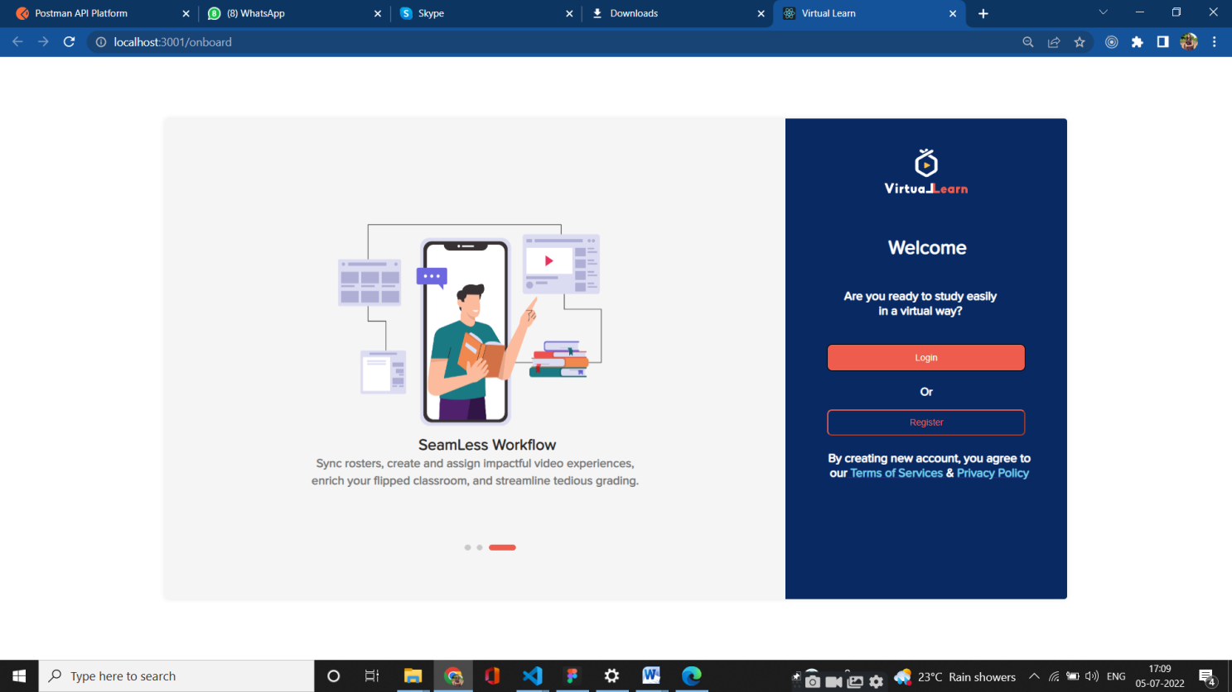

Fig 7.3.1: Main Page

* + 1. **Student Register**

If User is using website for the first time new then they have to first register. User will enter his phone number to register into the website.

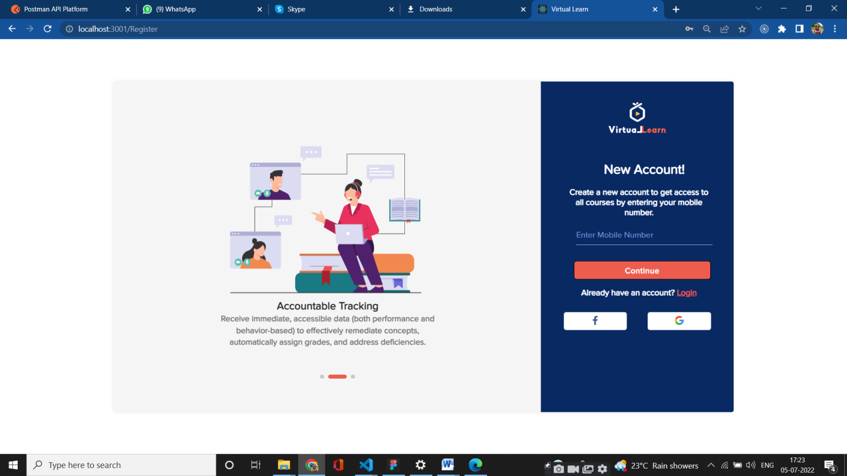

Fig 7.3.2 : Register Page for Student

* + 1. **OTP Verification Page**

After entering mobile number the user need to enter the OTP sent to registered mobile number to verify and to proceed with the next steps. Once the otp is verified successfully then the user need to enter his personal details to register.

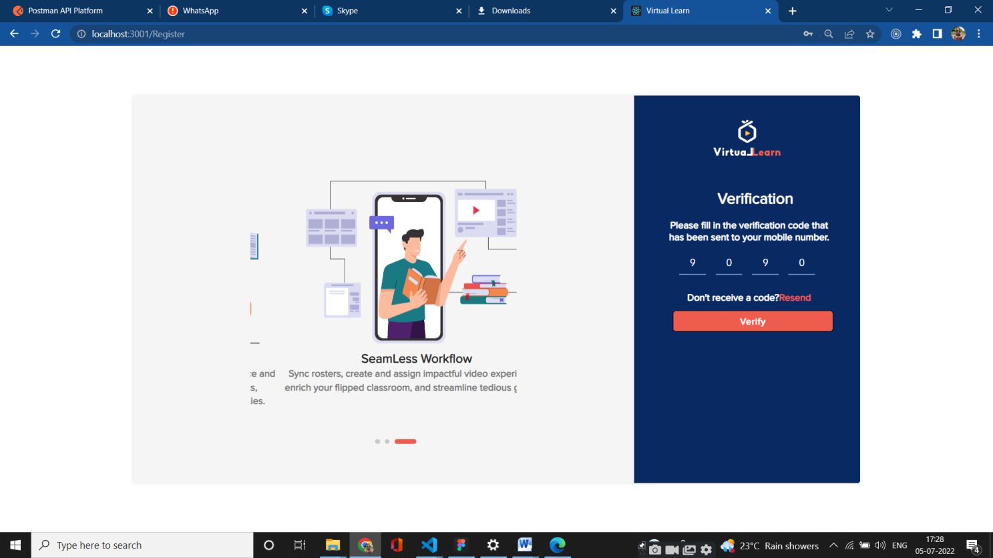

Fig 7.3.3: OTP verification Page

* + 1. **Personal Details Page**

The user has to enter the personal details after successfully OTP is verified. After entering the details the user will enter the home page

**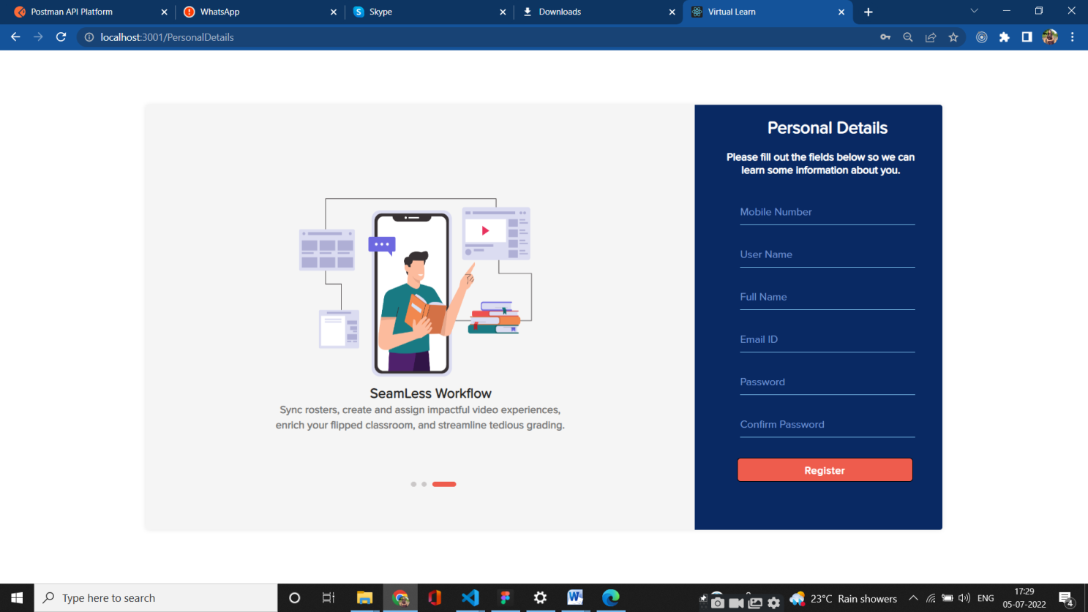** Fig 7.3.4 : Page for entering the Personal Details

* + 1. **Student Login**

This module designed with the intention to provide security to the users of the application. User can access the application using login session with valid user id and password. If username and password are invalid, they won’t allow to see courses.

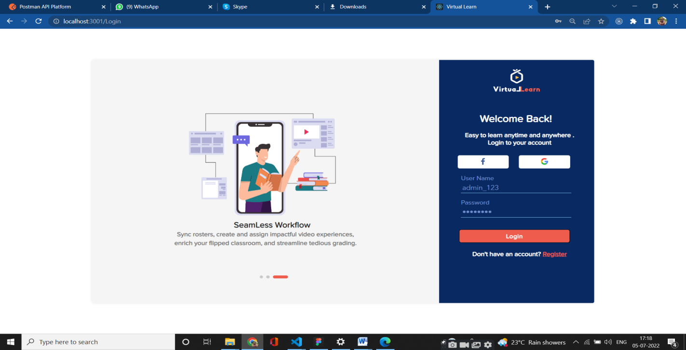

Fig 7.3.5 : login Page

* + 1. **Student Home Page**

After successfully logged and registered to system this page on a website that is frequently accessed first and usually has connections to other pages on the site. After user login/register to the portal user can see the home page.

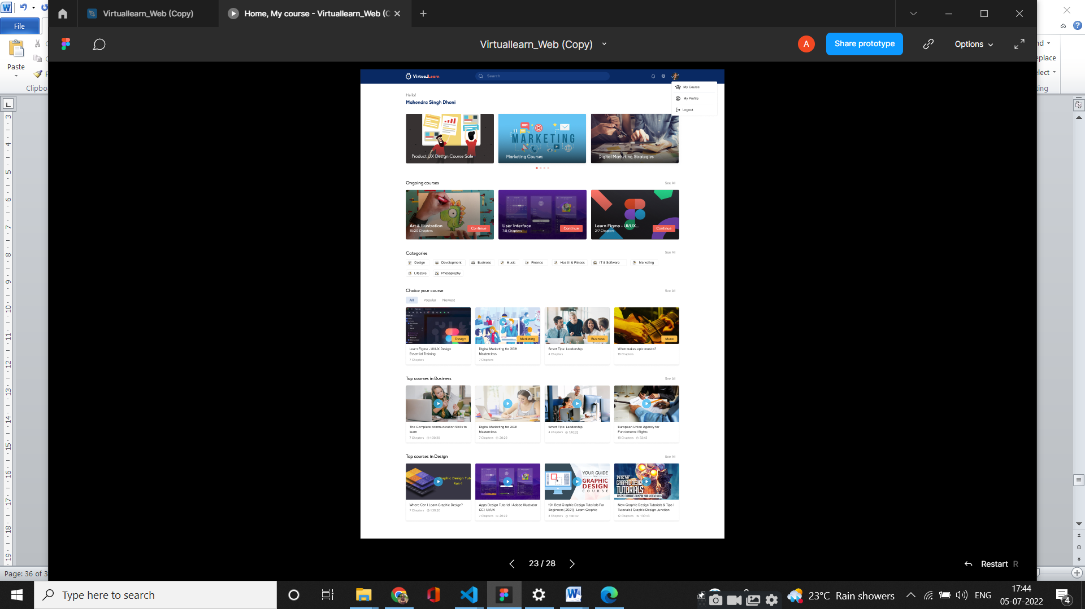

Fig 7.3.6 : Home Pag

* + 1. **Student Course Page**

This Page displays the courses that students are enrolled. This shows how many courses the student is completed and currently ongoing courses details.

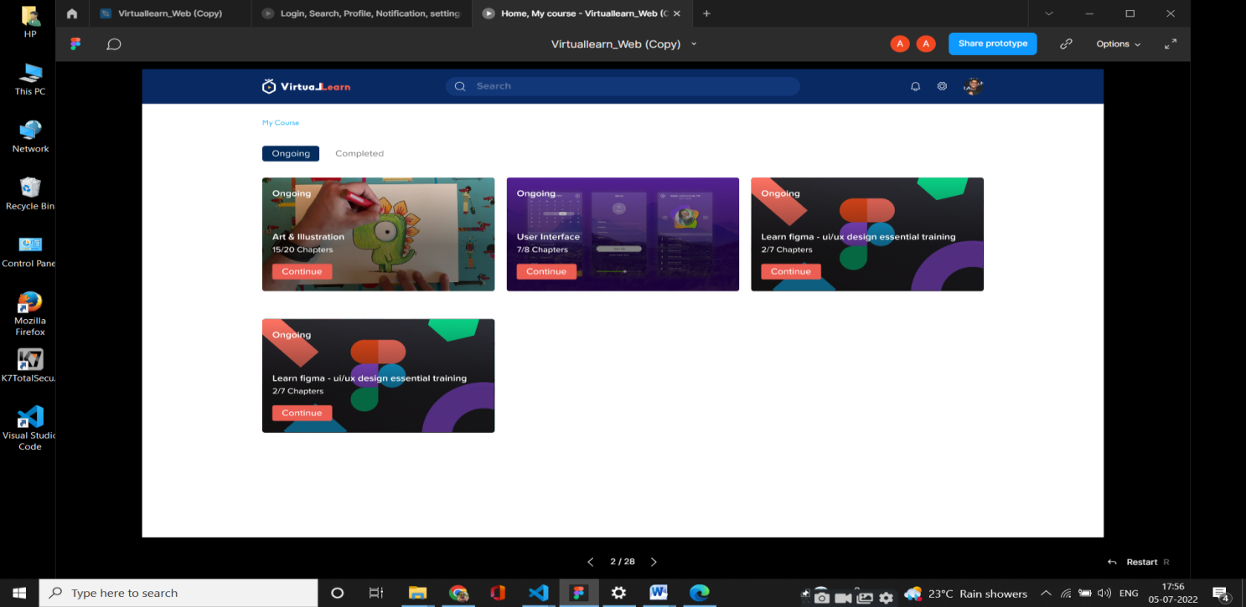

Fig 7.3.7 : Course taken by student

* + 1. **Student Profile Page**

This Page shows the profile of student with their details provided during registration. And student can edit his details and change the password if he wants.

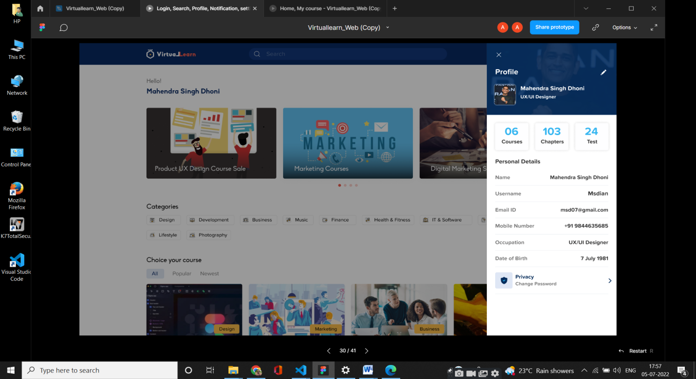

Fig 7.3.8: Profile Page

* + 1. **Course Preview Page**

This page shows the preview of the course with details of course, chapters included in the course, modules test, about the author and other important information about the course.

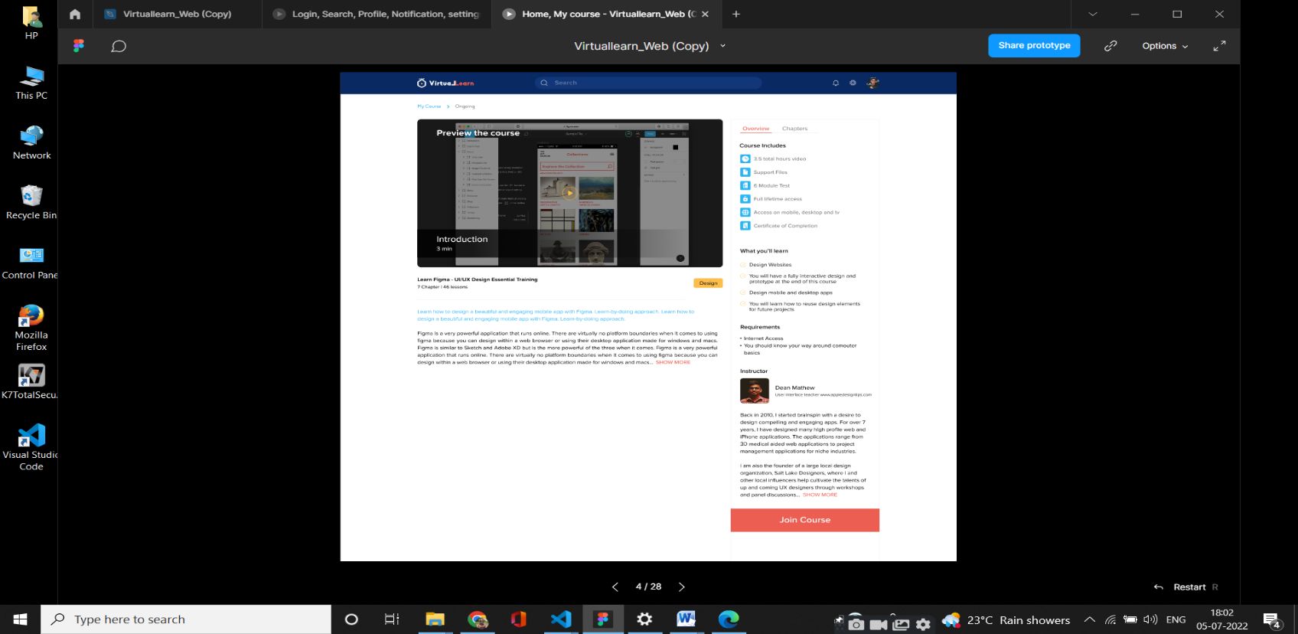

Fig 7.3.9: Preview of course Page

* + 1. **Module Test Page**

This Page contains the results of the module test which contains set of questions related to chapters that are completed.

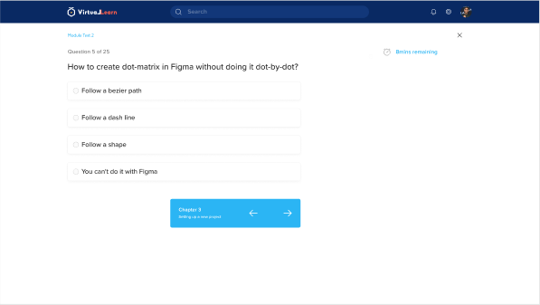

Fig 7.3.10 : Quiz result of course Page

* + 1. **Certificate Page**

This page contains the certificate provided by the course with percentage.

****

Fig 7.3.11: Certificate of course Page

* + 1. **Admin Login Page**

This module designed to login for the instructor (Admin) of the application. Instructor can login session with valid user id and password to upload courses, tests and videos.

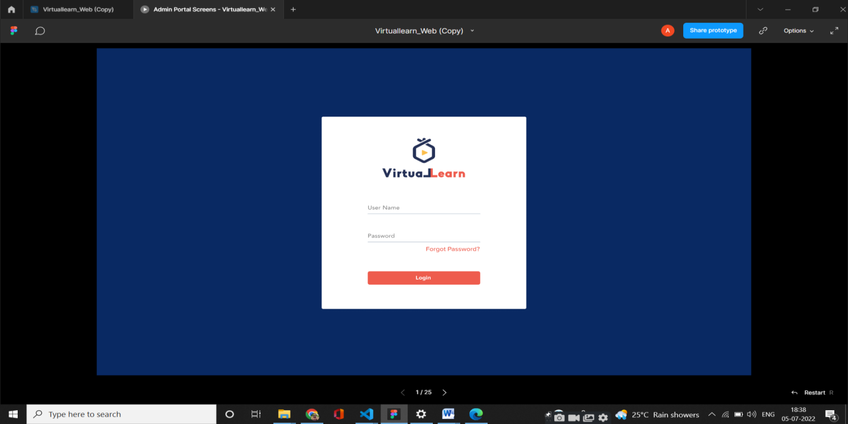

Fig 7.3.12: Admin Login Page

* + 1. **Dashboard Page**

This page specifies the dashboard where all the details of students who joined to courses are displayed. And also the instructor can upload and add videos of their particular course, they can generate certificate, upload quizzes.

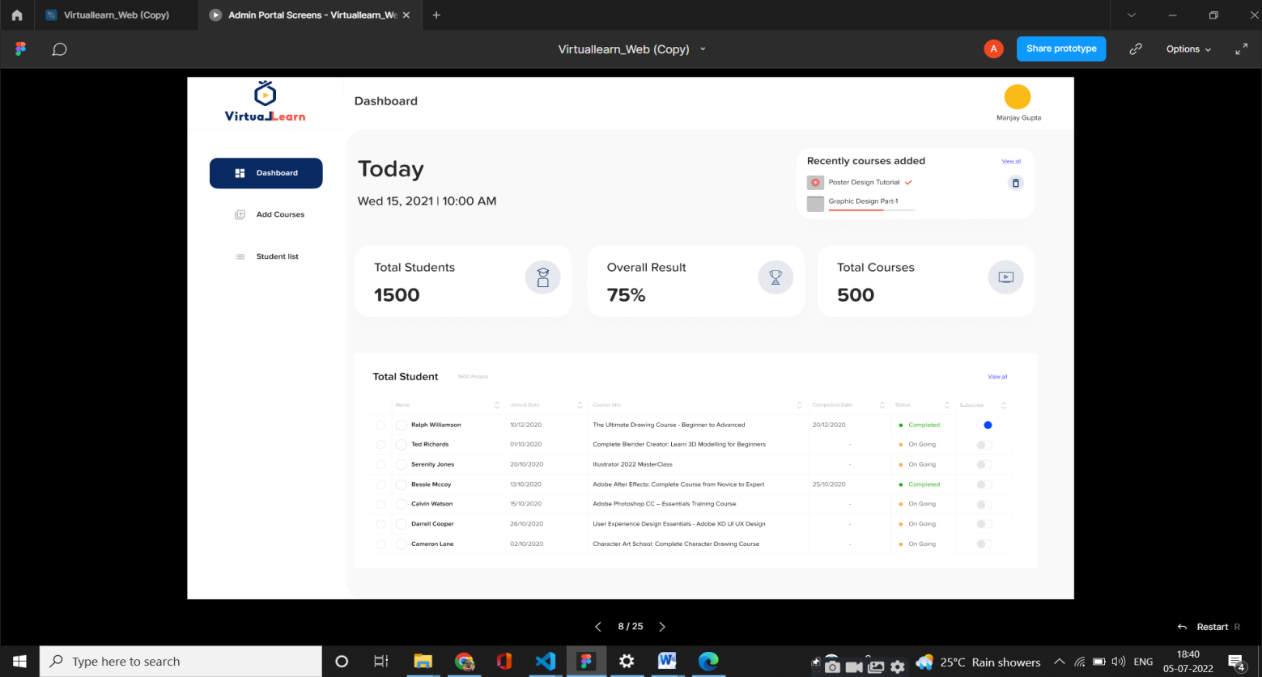

Fig 7.3.13 : Dashboard Page

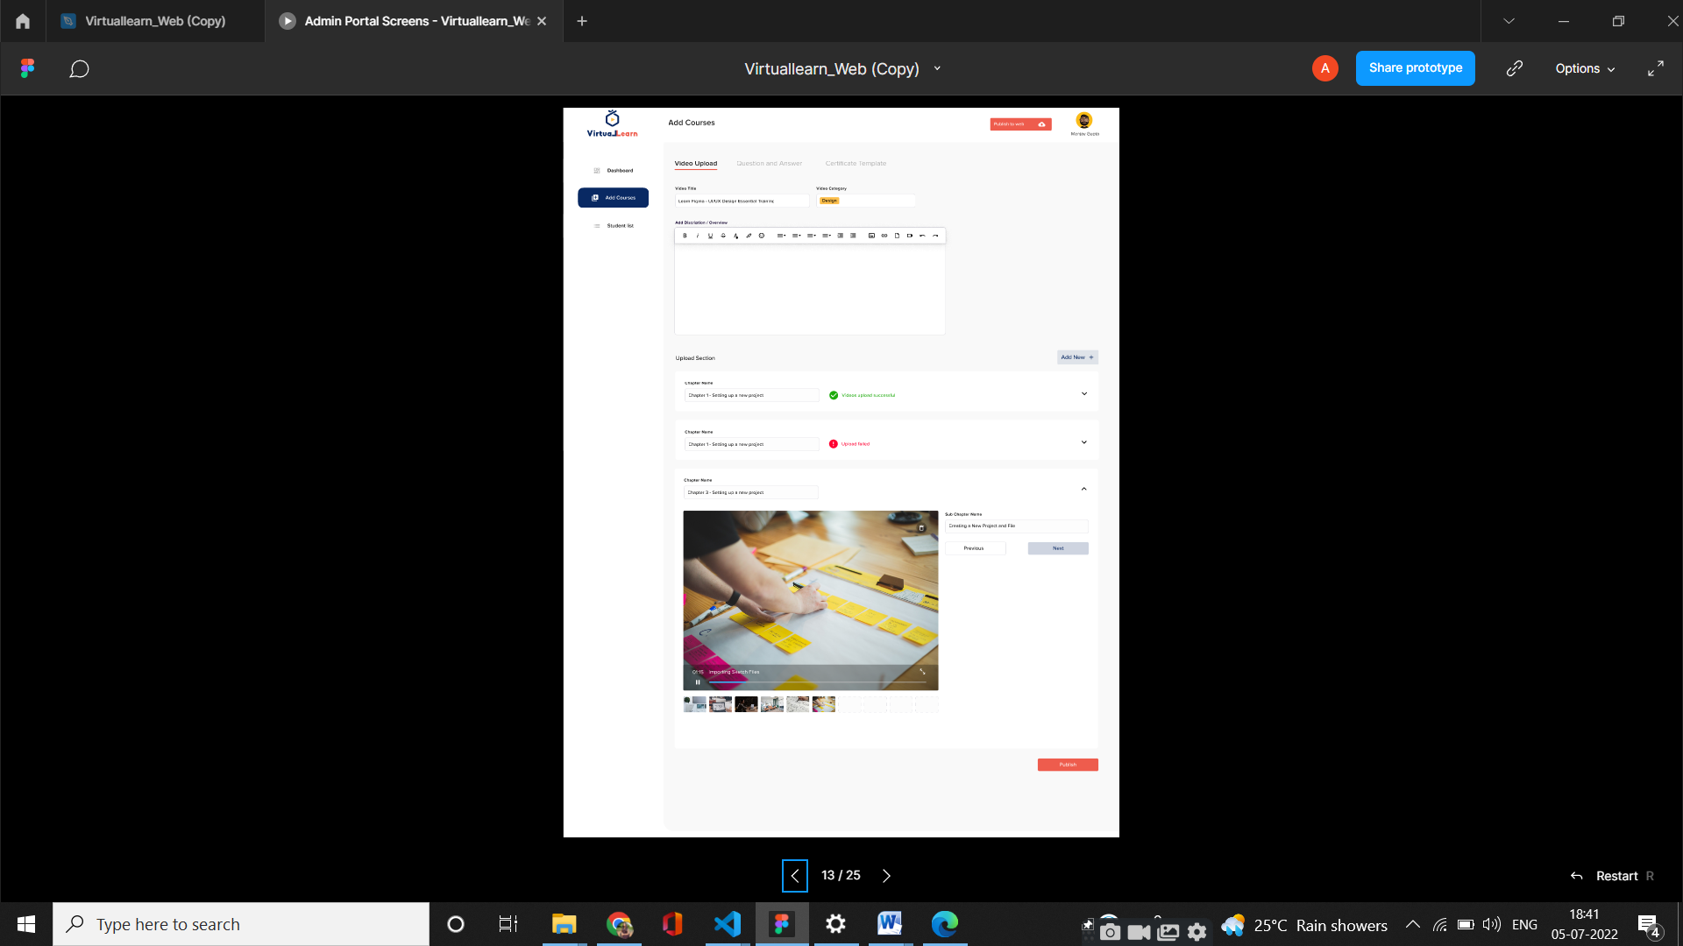

Fig 7.3.14 : Uploading Video Page

**CHAPTER 8**

**CONCLUSION AND FUTURE ENHANCEMENT**

In this project, the literature on e-learning systems was critically examined, and some of the most important variables used in information systems research were identified. More precisely, this research provided insight into the history, traits, and restrictions of web-based learning systems in addition to their advantages and disadvantages. Especially in a collaborative e-learning environment, student variables like behaviours and attitudes, cultural origins, and other demographic features are crucial factors that affect student learning. Now that they are aware of these factors, educators may more effectively and attractively create engaging learning activities that support student knowledge construction. This study specifically contributes to a deeper understanding of the characteristics of students in Lebanon and England, which can aid policymakers, educators, and specialists in understanding what students anticipate from learning management systems. This can assist management in deploying the system in the most efficient way possible and also improve their strategic technological decision-making going forward. They can choose the method that will work best for their students before introducing any new technology.

**FUTURE ENHANCEMENT**

* Lectures to upload assignments and resources for their units.
* Students to download the resources and upload assignments.
* It provides an easy-to-use way to manage course websites that include schedule information, announcements, as well as course discussions.

**CHAPTER 9**

**BIBLIOGRAPHY**

1. Maki, R.H., Maki, W.S., Patterson, M., & Whittaker, P.D. (2000). Evaluation of a web-based introductory psychology course, Behavior Research Methods, Instruments, & Computers, 32, 230-239.
2. Fallah, M. H., & Ubell, R. (2000). Blind scores in a graduate test. Conventional compared with web-based outcomes. ALN Magazine, 4 (2).
3. Freeman, M.A. & Capper. J. M. (1999). Exploiting the web for education: An anonymous asynchronous role simulation. Australian Journal of Educational Technology, 15 (1), 95-116
4. Arbaugh, J.B. (2000). Virtual Classroom Versus Physical Classroom: an exploratory study of class discussion patterns and student learning in an asynchronous Internet-based MBA course. Journal of Management Education, 24 (2), 213-233.
5. Blackley, J.A., & Curran-Smith, J. (1998). Teaching community health nursing by distance methods: development, process, and evaluation. Journal of Continuing Education for Nurses, 29 (4), 148-153.
6. Nesler, M.S., & Lettus, M. K. (1995). A follow-up study of external degree graduates from Florida. Paper presented at the 103rd Annual Convention of the American Psychological Association, New York, August.
7. Barry, M., & Runyan, G. (1995). A review of distance-learning studies in the U.S. military. The American Journal of Distance Education, 9 (3), 37-47.
8. Hiltz, R., Zhang, Y., Turoff, M. (2002). Studies of effectiveness of learning networks. Elements of Quality Online Education: Volume 3 in the SloanC Series. SCOLE.
9. Zare, M.; Pahl, C.; Rahnama, H.; Nilashi, M.; Mardani, A.; Ibrahim, O.; Ahmadi, H. Multi-criteria decision making approach in E-learning: A systematic review and classification. Appl. Soft Comput. 2016, 45, 108–128.
10. Maurer, H.; Salman Khan, M. Research trends in the field of e-learning from 2003 to 2008: A scientometric and content analysis for selected journals and conferences using visualization. Interact. Tech. Smart Ed. 2010, 7, 5–18.
11. Shih, M.; Feng, J.; Tsai, C.-C. Research and trends in the field of e-learning from 2001 to 2005: A content analysis of cognitive studies in selected journals. Comput. Educ. 2008, 51, 955–967.
12. Rodrigues, H.; Almeida, F.; Figueiredo, V.; Lopes, S.L. Tracking e-learning through published papers: A systematic review. Comput. Educ. 2019, 136, 87–98.