**Notes from Kevin’s presentation:**

You will evaluate your projects to identify:

* + Physical Hazards
  + Fault Hazards
  + Operational Hazards
  + Expected Use and Foreseeable Misuse

Quantify Hazards and Assess Risk

Redesign, Guard or Warn

Potential Physical or Fault Hazard?

**Physical**

* Electricity (Shock)‏
* Sharpness (Cuts)‏
* Pieces (Choking)‏
* Temperature (Hot and Cold)‏
* Stability (Tipping)‏
* Sounds (Intensity)
* Light (Intensity)

**Fault**

* Buttons, Switches, Connectors
* Bad Solder Joint
* Fastener Failure
* Component Failure
* Fatigue
* Logic Error
* Programming Bug

**Operational/User**

**Expected Use/Forseeable Misuse**

* Use in an unintended environment
* Use by children
* People who do not speak the language
* People who are cognitively impaired
* People who display destructive behaviour

**IV**

**IV**

**IV**

**IV**

Incredible

**III**

**III**

**IV**

**IV**

Improbable

**II**

**III**

**III**

**IV**

Remote

**I**

**II**

**III**

**III**

Occasional

**I**

**I**

**II**

**III**

Probable

**I**

**I**

**I**

**II**

Likely

Catastrophic

Critical

Marginal

Negligible

**Occurrence**

**Severity of Consequence**

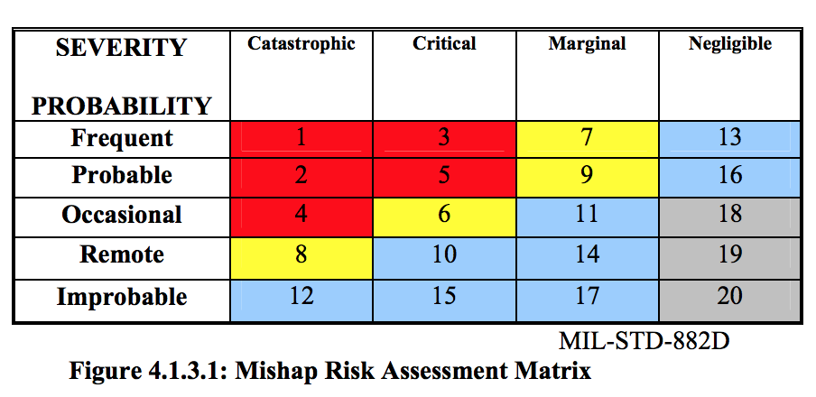

APPENDIX A – HAZARD IDENTIFICATION & RISK DETERMINATION

|  |  |  |  |  |  |  |
| --- | --- | --- | --- | --- | --- | --- |
| Item | Hazard | Cause | Unmitigated Risk Level | Prevention/Mitigation | Potential Impact | Mitigated Risk |
| 1. | Tripping | Extension cord | Level 2  Critical  Occasional | Tape/fix to the ground  Houskeeping to minimize trip hazards | Fall  Sprains | Level 19  Negligible  Remote |
| 2. | Choking(Strangulation) – foreseeable misuse | Extension cord | Level 3  Catastrophic  Improbable | Tape/fix out of reach of patient  Training of personnel in hazard recognition and support | Death of asphyxiation | Level 12  Catastrophic  Improbable |
| 3. | Stability(Tipping) | Clamp | Level 3  Negligible  Occasional |  | Physical impact on device |  |
| 4. | Hot Device Temperature | Battery | Level 3  Critical  Remote | Heatsink CAD or PCB | Mild burn upon elongated touch | Level 19  Negligible  Remote |
| 5. | Environmental | Spills | Level 3  Marginal  Remote | Airtight enclosure | Burn internal components of device | Level 19  Negligible  Remote |
| 6. | Failure to call nurse | Software or hardware failure | Level 3  Marginal  Remote | Manual inspection by personnel  Installation of a plan B system | No access to aid/nurse | Level 19  Negligible  Remote |
| 7. |  |  |  |  |  |  |