Week 7 – Major Assignment 2: Geospatial Visualization (D3.js)

Overview
This document includes full source code for the examples used in Week 7: Simple Zoom Function and Marching Squares (animated and Perlin noise variants). Auto-generated sample screenshots are included.

Map A — Simple Zoom Function (Full Code)
Description: Demonstrates D3 zoom behavior and panning.
Full HTML code:
<!doctype html>
<html lang="en">
<head>
<meta charset="UTF-8">
<meta name="viewport"
content="width=device-width, user-scalable=no, initial-scale=1.0, maximum-scale=1.0, minimum-scale=1.0">
<meta http-equiv="X-UA-Compatible" content="ie=edge">
<title>Simple Zoom Function</title>
<script src="https://d3js.org/d3.v7.min.js"></script>
<style>
#container{
display: flex;
justify-content: center;
align-items: center;
height: 100vh;
margin: 0;
}
</style>
</head>
<body>
<div id="container"></div>
<script>
const width = 1000,height =800
const svg = d3.select("#container")
.append("svg")
.attr("width","100vw")
.attr("height","100vh")
.attr("viewBox",`0 0 ${width} ${height}`)
const main = svg.append('g')
.attr('id',"main")
main.append("g")
.attr("transform",`translate(${width/2-50},${height/2-50})`)
main.selectAll('g')
.data(d3.range(100))
.join('g')
.attr("transform",()=>`translate(${Math.floor((1+Math.random())*(width/3))},${Math.floor((1+Math.random())*(height/3))})`)
.append("circle")
.attr("r","10")
.attr("fill","steelblue")
.attr("opacity",".5")
svg.call(
d3.zoom()
.extent([[0,0],[1000,800]])
.scaleExtent([1,12])
.on('zoom',d=>{
main.attr("transform",d.transform)
}
)
)
console.log(
d3.zoom()
.extent([[0,0],[1000,800]])
.scaleExtent([1,12])
.on('zoom',d=>{
main.attr("transform",d.transform)
}
))
</script>
</body>
</html>

Output Screenshot:
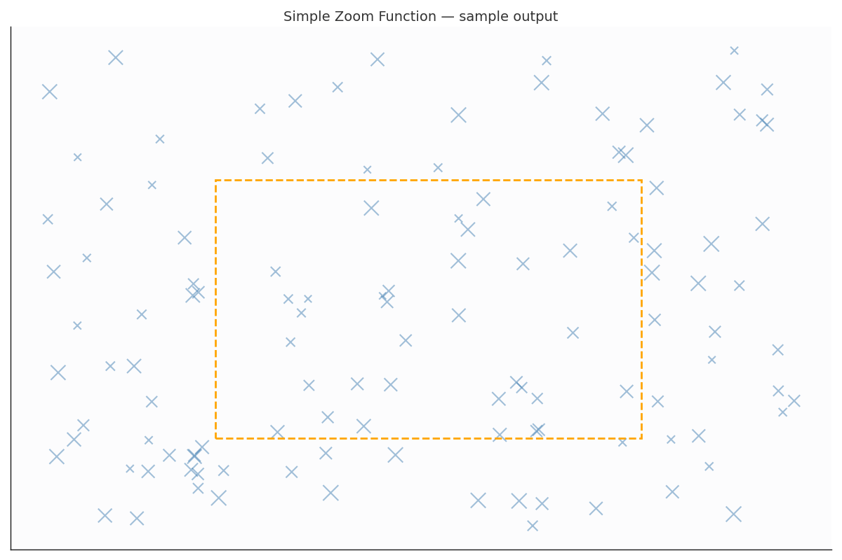

Map B — Marching Squares (Animated) (Full Code)
Description: Animated Marching Squares example using Simplex noise.
Full HTML code:
<!DOCTYPE html>
<html lang="en">
<head>
<meta charset="UTF-8">
<title>Isoline</title>
<script src="https://d3js.org/d3.v5.min.js"></script>
<script src="simplexNoise.js"></script>
<style>
.container{
display: flex;
justify-content: center;
align-items: center;
margin: 0;
font-family: sans-serif;
}
.cells{
width: 50%;
}
</style>
</head>
<body>
<div class="container">
<h1 class="cells">Isolines generated by Marching Squares</h1>
</div>
<div class="container">
<p class="cells">The red and blue dots are used to represent the binary values of two differnt regions generated by <a href="https://en.wikipedia.org/wiki/Perlin_noise">Perling noise</a>.Perlin noise is a type of gradient noise developed by Ken Perlin in 1983. </p>
</div>
<div class="container">
<div style="width: 800px;height: 600px" id="figure">
</div>
<script>
const openSimplex = openSimplexNoise(100);
const figure = document.getElementById("figure");
const w = figure.clientWidth;
const h = figure.clientHeight;
const radius = 4;
const padding = 5;
const xDim = 40; // number of the nodes in x axis direction
const yDim = 40; // number of the nodes in y axis direction
const anim_len = 500;
const offsetX = 1;
const offsetY = 1;
function draw(frame) {
let old_svg=d3.select('svg');
if(old_svg!==undefined){
old_svg.remove();
}
function rand_bit() {
if (Math.random(1) > .5) {
return 1;
} else {
return 0;
}
}
function rand_frame(frame,offsetX,offsetY)
{
return Math.ceil(openSimplex.noise3D(offsetX, offsetY,frame))
}
function detect_Type_2(Matrix, i, j) {
let edges = [
[(Matrix[i][j] + Matrix[i + 1][j]) / 2,
(i + i + 1) / 2,
(j + j) / 2],
[(Matrix[i + 1][j] + Matrix[i + 1][j + 1]) / 2,
(i + 1 + i + 1) / 2,
(j + j + 1) / 2],
[(Matrix[i + 1][j + 1] + Matrix[i][j + 1]) / 2,
(i + i + 1) / 2,
(j + 1 + j + 1) / 2],
[(Matrix[i][j + 1] + Matrix[i][j]) / 2,
(i + i) / 2,
(j + j + 1) / 2]
]
let connections = []
for (let k = 0; k < 4; k++) {
if (edges[k][0] === .5) {
connections.push({x: edges[k][1], y: edges[k][2]})
}
}
return connections;
}
let svg = d3.select(figure).append("svg")
.attr('width', '100%')
.attr('height', '100%');
let plot = svg.append('g')
.attr('id', 'plot')
let canvas = []
let xScale = d3.scaleLinear()
.domain([0, xDim])
.range([padding, w - padding])
let yScale = d3.scaleLinear()
.domain([yDim, 0])
.range([padding, h - padding])
let color = d => {
if (d === 0) {
return 'red'
} else {
return 'steelblue'
}
}
for (let i = 0; i < xDim; i++) {
let tmp = [xDim]
canvas.push(tmp)
}
// create random bits
let offsetX = 0.0;
let offsetY = 0.0;
for (let i = 0; i < xDim; i++) {
offsetX+=1;
for (let j = 0; j < yDim; j++) {
canvas[i][j] = rand_frame(frame, offsetX,offsetY);
offsetY +=1;
plot.append('circle')
.attr('cx', xScale(i))
.attr('cy', yScale(j))
.attr('r', radius)
.style('fill', color(canvas[i][j]))
}
}
const lineGen = d3.line()
finalLine = ""
for (let i = 0; i < xDim-1; i++)
for (let j = 0; j < yDim-1; j++) {
let tmp = detect_Type_2(canvas, i, j);
if (tmp.length === 2) {
plot.append('line')
.attr('stroke', 'black')
.attr('stroke-width', 1.5)
.attr("stroke-opacity",.5)
.attr('x1', xScale(tmp[0]['x']))
.attr('y1', yScale(tmp[0]['y']))
.attr('x2', xScale(tmp[1]['x']))
.attr('y2', yScale(tmp[1]['y']));
}
if (tmp.length === 4) {
plot.append('line')
.style('stroke', 'black')
.attr('x1', xScale(tmp[0]['x']))
.attr('y1', yScale(tmp[0]['y']))
.attr('x2', xScale(tmp[1]['x']))
.attr('y2', yScale(tmp[1]['y']));
plot.append('line')
.style('stroke', 'black')
.attr('x1', xScale(tmp[2]['x']))
.attr('y1', yScale(tmp[2]['y']))
.attr('x2', xScale(tmp[3]['x']))
.attr('y2', yScale(tmp[3]['y']));
}
}
}
function callme(duraion){
if (duraion>=anim_len*100)
{
timer.stop()
}
//if(parseInt(duraion)%2===0){
draw(frame_count);
frame_count++;
//}
}
let frame_count = 0
const intervalId = setInterval(callme, 100);
</script>
</body>
</html>

Output Screenshot:
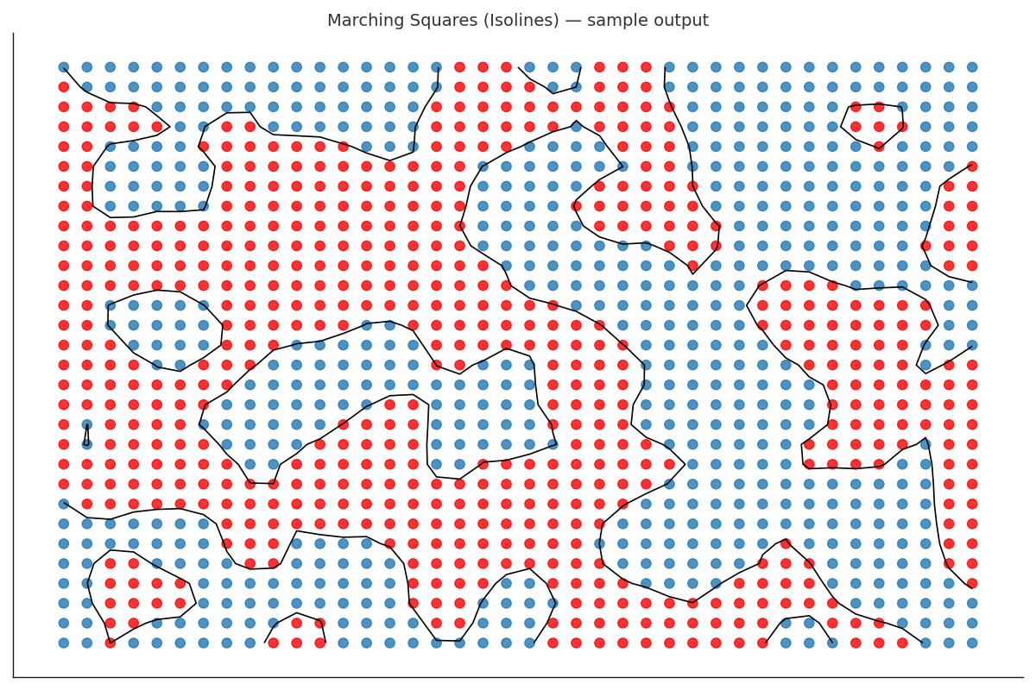

Map C — Marching Squares (Perlin Noise)
Description: Marching Squares variant using random bits (Perlin-like output).
Full HTML code:
<!DOCTYPE html>
<html lang="en">
<head>
<meta charset="UTF-8">
<title>Isoline</title>
<script src="https://d3js.org/d3.v7.min.js"></script>
<style>
.container{
display: flex;
justify-content: center;
align-items: center;
margin: 0;
font-family: sans-serif;
}
.cells{
width: 50%;
}
</style>
</head>
<body>
<div class="container">
<h1 class="cells">Isolines generated by Marching Squares</h1>
</div>
<div class="container">
<p class="cells">The red and blue dots are used to represent the binary values of two differnt regions generated by <a href="https://en.wikipedia.org/wiki/Perlin_noise">Perling noise</a>.Perlin noise is a type of gradient noise developed by Ken Perlin in 1983. </p>
</div>
<div class="container">
<div style="width: 800px;height: 600px" id="figure"></div>
</div>
<script>
const figure = document.getElementById("figure");
const w = figure.clientWidth;
const h = figure.clientHeight;
const radius = 5;
const padding = 10;
const xDim = 30; // number of the nodes in x axis direction
const yDim = 30; // number of the nodes in y axis direction
const anim_len = 1000;
const dem_color = "#FF0000"
const gop_color = "#0015BC"
function draw(frame)
{
// as in animation we will clean ana redraw data
let old_svg=d3.select('svg');
if(old_svg!==undefined){
old_svg.remove();
}
const svg = d3.select(figure).append("svg")
.attr('width', '100%')
.attr('height', '100%');
const plot = svg.append('g')
.attr('id', 'plot')
const xScale = d3.scaleLinear()
.domain([0, xDim])
.range([padding, w - padding])
const yScale = d3.scaleLinear()
.domain([yDim, 0])
.range([padding, h - padding])
// random bit generator
function rand_bit() {
if (Math.random(1) > .5) {
return 1;
} else {
return 0;
}
}
//function color(d) {if (d === 0){return dem_color} else{return gop_color}}
const color = (d) => (d === 0 ? dem_color : gop_color); // shorter format
const canvas = [] // is the matrix of 0 and 1 that we will use for contour generation
// this is the grid of the data
for (let i = 0; i < xDim; i++) {
canvas.push([])
for (let j = 0; j < yDim; j++) {
if (i < xDim - 1) {
plot.append('line')
.style("stroke", "black")
.style("opacity", ".1")
.attr('x1', xScale(i))
.attr('y1', yScale(j))
.attr('x2', xScale(i + 1))
.attr('y2', yScale(j))
}
}
}
// create random bits
for (let i = 0; i < xDim; i++) {
for (let j = 0; j < yDim; j++) {
canvas[i][j] = rand_bit()
plot.append('circle')
.attr('cx', xScale(i))
.attr('cy', yScale(j))
.attr('r', radius)
.attr('fill', color(canvas[i][j]))
.attr("fill-opacity",.5)
}
}
function detect_Type_2(Matrix, i, j) {
let edges = [
[(Matrix[i][j] + Matrix[i + 1][j]) / 2,
(i + i + 1) / 2,
(j + j) / 2],
[(Matrix[i + 1][j] + Matrix[i + 1][j + 1]) / 2,
(i + 1 + i + 1) / 2,
(j + j + 1) / 2],
[(Matrix[i + 1][j + 1] + Matrix[i][j + 1]) / 2,
(i + i + 1) / 2,
(j + 1 + j + 1) / 2],
[(Matrix[i][j + 1] + Matrix[i][j]) / 2,
(i + i) / 2,
(j + j + 1) / 2]
]
let connections = []
for (let k = 0; k < 4; k++) {
if (edges[k][0] === .5) {
connections.push({x: edges[k][1], y: edges[k][2]})
}
}
return connections;
}
for (let i = 0; i < xDim-1; i++){
for (let j = 0; j < yDim-1; j++) {
let tmp = detect_Type_2(canvas, i, j);
if (tmp.length === 2) {
plot.append('line')
.style('stroke', 'black')
.attr('x1', xScale(tmp[0]['x']))
.attr('y1', yScale(tmp[0]['y']))
.attr('x2', xScale(tmp[1]['x']))
.attr('y2', yScale(tmp[1]['y']))}
if (tmp.length === 4) {
plot.append('line')
.style('stroke', 'black')
.attr('x1', xScale(tmp[0]['x']))
.attr('y1', yScale(tmp[0]['y']))
.attr('x2', xScale(tmp[1]['x']))
.attr('y2', yScale(tmp[1]['y']));
plot.append('line')
.style('stroke', 'black')
.attr('x1', xScale(tmp[2]['x']))
.attr('y1', yScale(tmp[2]['y']))
.attr('x2', xScale(tmp[3]['x']))
.attr('y2', yScale(tmp[3]['y']));
}}
}
function callme(duraion){
if (duraion>=anim_len*100)
{ timer.stop() }
draw(frame_count);
frame_count++;
}
let frame_count = 0
//let timer = d3.timer(callme);
//let timer = d3.interval(callme,1000);
let timer = d3.timeout(callme,500)
</script>
</body>
</html>

