1. Create a schema based on the given dataset.
2. Dump the data inside the hdfs in the given schema location.



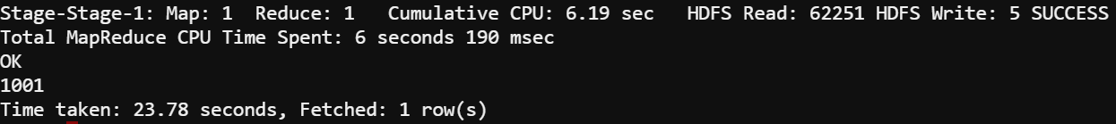

1. List of all agents' names.



1. Find out agent average rating.



1. Total working days for each agents



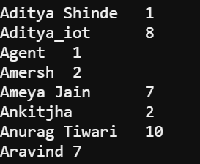

1. Total query that each agent have taken



1. Total Feedback that each agent have received



1. Agent name who have average rating between 3.5 to 4

1. Agent name who have rating less than 3.5

1. Agent name who have rating more than 4.5

1. How many feedback agents have received more than 4.5 average



12. Find the number of chat on which they have received a feedback 

13. Perform inner join, left join and right join based on the agent column and after joining the table export that data into your local system.



Left join:



Right join:



