**Pets Chewy**

Software Requirements Specification

* Android Studio – v3.6
* GitHub
* Firebase

9th June 2020

Team Members

Priyanka Bodapati

Deepthi Tejaswani Chokka

Nikitha Kethireddy

Suma Soma

Sushma Yedugani

Submitted in partial fulfilment

Of the requirements of

CSIS 44-691 Graduate Directed Project 1

# Revision History

|  |  |  |  |
| --- | --- | --- | --- |
| **Date** | **Description** | **Author** | **Comments** |
|  |  |  |  |
|  |  |  |  |
|  |  |  |  |
|  |  |  |  |

# Document Approval

The following Software Requirements Specification has been accepted and approved by the following:

|  |  |  |  |
| --- | --- | --- | --- |
| **Signature** | **Printed Name** | **Title** | **Date** |
|  |  |  |  |
|  |  |  |  |
|  |  |  |  |

1. **Table of Contents**

**Table of Contents Page Number**

1. Introduction
   1. Purpose
   2. Scope
   3. Definitions, Acronyms, and Abbreviations
   4. References
   5. Overview
2. General Description
   1. Product Perspective
   2. Product Functions
   3. User Characteristics
   4. General Constraints
   5. Assumptions and Dependencies
3. Specific Requirements
   1. External Interface Requirements
      1. User Interfaces
      2. Hardware Interfaces
      3. Software Interfaces
      4. Communications Interface
   2. Functional Requirements
   3. Use Cases
   4. Class/Objects
   5. Non-Functional Requirements

3.5.1. Performance

3.5.2. Reliability

* + 1. Availability
    2. Security
    3. Portability
  1. Inverse Requirements
  2. Design Constraints
  3. Logical Database Requirements
  4. Other Requirements
  5. Prototypes (for complete project)
  6. Use Case Diagrams

1. Design

4.1. ER diagram

4.2. GUI

1. Analysis Models

4.1. Data Flow Diagram

4.2. Sequence Diagram

**1. Introduction**

# Purpose

E-commerce is fast gaining ground as an accepted and used business paradigm. More and more business houses are implementing mobile apps providing functionality for performing commercial transactions over the web. It is reasonable to say that the process of shopping on the web is becoming commonplace.

The prime objective of this project is to develop a general purpose e-commerce store where products for pets like food, and their toys can be bought from the comfort of home through the Internet. An online store is a virtual store on the Internet where customers can browse the category and select products of interest. The selected items may be collected in a shopping cart. At checkout time, the items in the shopping cart will be presented as an order. At that time, more information will be needed to complete the transaction. Usually, the customer will be asked to fill or select a billing address, a shipping address, a shipping option, and payment information such as credit card number. An e-mail notification is sent to the customer as soon as the order is placed.

* 1. **Scope**

10 years ago, when the idea of having a website was in its infancy, only a bunch of academics went ahead to launch their websites and eventually made the most of its ability to reach to the masses. The history is repeating itself with the advent of smartphone apps. Yet again, only a small percentage of E-commerce academics have their apps built so far while the rest is continuing to lose on the opportunity.

With mobile applications, customers can interact in the simplest an easiest of way with enormous products and services. The products and services on sale can be easily viewed along with their descriptions and all other details. All users would have to do is touch, speak or type on their smartphones to connect to these apps. With mobile applications, users are always connected to diverse applications, options that in a very easy manner.

With ecommerce mobile applications, it is estimated that the sales might increase by 30 times in the next five years. Ecommerce mobile applications offer notifications and other important details that send out alerts to customers as soon as a particular event takes place. These notifications could be everything from product news, sale offers, events, or things that a company implements for taking on its strategies.

There are many benefits with E-commerce Mobile Application Like as Follows.

* Easier Registration process.
* Fewer clicks away to purchase an online product.
* Better navigation than a web application.

### Fastened Push notifications.

* Would have great user experience.
* Wish list option to short list the products.
* Easy to check out.
* Easy to filter and search products.
* Offline mode.

# Definitions, Acronyms, and Abbreviations

# 

# References

1. <http://www.w3schools.com/>

2. <http://msdn.microsoft.com/>

3. <http://agilemodeling.com/>

4. <https://opus.govst.edu/cgi/viewcontent.cgi?article=1079&context=capstones>(image)

5. <https://www.v-softinc.com/importance-e-commerce-mobile-applications/>

1. General Description

2.1. Product Perspective

## Any member can register and view available products.

## Only registered member can purchase multiple products regardless of quantity.

## Contact us page is available to contact Admin for queries.

## There are three roles available: Visitor, User and Admin.

## • Visitor can view available products but not be able purchase the products.

## • User can view and purchase products only after his successful login.

## • An Admin has some extra privilege including all privilege of visitor and user.

## Admin can add products, edit product information and add/remove product.

## Admin can ship order to user based on order placed by sending confirmation mail.

* 1. Product Functions

**The android application functions in two different ways based on the person logged in. If admin provider is logged in, their functionalities will be enabled like adding, editing, deleting the products and tracking the orders placed by customers, view order history, view complaints (if any). And if the customer logged in, their functionalities are like finding products and searching for the products by giving some filter options. Then to add them to cart/wish list and order online.**

* 1. ****User Characteristics****

**Two types of users are there for this app.**

1. **Admin needs to fill license id, email id, name, Mobile number, address and password for signup.**
2. **Customer: User needs to fill Name, Email password, phone.** 
   1. ****General Constraints****

**The following constraints are required for this application.**

1. **User should have android mobile phone to access the app.**
2. **Internet is required.**
3. **Should have a mail id to login to the app.**
   1. ****Assumptions and Dependencies****

**The users can easily identify the product by product brand which is mentioned in the description.**

**The owners can accept online orders and payments.**

**The users can purchase the product easily by searching.**

**The users can do online payments.**

**The users can check the status of the order.**

**Dependencies:**

**Owners need to purchase different products from different vendors**

****3. Specific Requirements****

# 3.2. Functional Requirement

# Customer:

1. **Welcome page:** This is the initial screen which is displayed as soon as the app runs. It displays three buttons namely sign in, signup and skip buttons wherein sign in and signup buttons, further have their own individual functionality and skip button enables the user to redirect to the homepage so as to view the items.
2. **Login in Page:** As soon as the user clicks upon the sign-in button, entering username and password so as to log in successfully after validating.
3. **Sign up Page:** As soon as the user clicks on signup button, the user has to register into the app wherein they have to type certain basic information about them.
4. **Reset Password:** If user forgets his password. He can reset his password by requesting to reset password link to his registered email.
5. **Home Page:** This page displays all of the products list in grid format.

* **Search bar:** There is a search bar to type for product name or some related information,
* **Filter for searching a Product:** The process of filtration for a particular product is done based upon the category or.

1. **Wish list:** User can shortlist the products to wish list further can be added to cart.

* **Delete:** User can delete the shortlisted products from the wish list.

1. **Add to Cart:** This functionality is used to add products to their cart from any of their product collection lists on their homepage and from wish list page.

* **Quantity**: User can change the quantity of the product.
* **Delete**: User can delete the product from cart list placing final order.

1. **Checkout:** This is used to quickly buy the product they are viewing.
2. **Offers:** There is an option to apply PROMO CODE. This provides a discount to the overall items in the cart.
3. **Order history:** keep track of all current and past orders and their status in the order process.
4. **Sign-Out:** This button sign out the currently signed-in user. When no user is signed in, pressing this button has no effect.
5. **Contact us:** This is used to provide a set of contacts so as to reach people for assistance.
6. **Share App:** This is used to share this application with other users.
7. **About Us:** This gives a detailed information of about the application.
8. **FAQ’s:** Provides information about frequently asked questions.

# Admin:

1. **Login in Page:** As soon as the admin gives his login details and clicks upon the sign-in button, it validates the details to log in successfully.
2. **Home page for admin:** After login, this page will show the list of all categories.

* **Add new products:** Whenever the admin clicks on category, it show a form with fields name, price and description of the product.

1. **Managing products page:**

This shows the list of products already added.

* **Edit product details:** Whenever admin clicks on the product it allows to edit the price, name, and description.
* **Delete Product:** There will be a delete button below every product, whenever the admin clicks on delete, it asks for confirmation to delete.

1. **Check for orders placed:**

This page shows all the orders so far ordered by customers.

# Use Cases

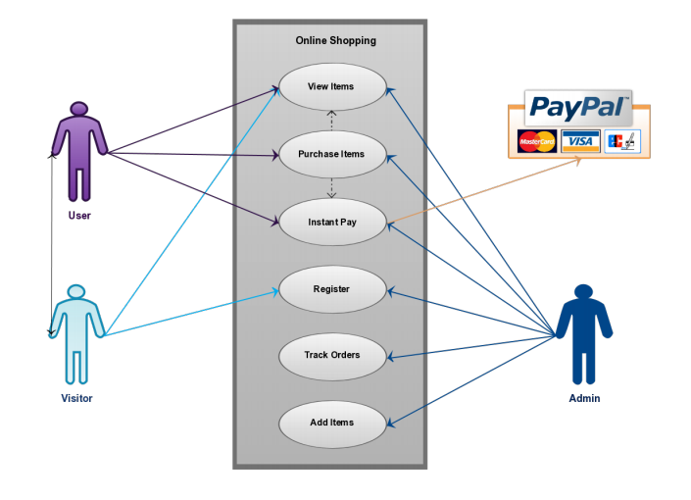

The image reference is given in the references.

4. Design

# 4.1. ER diagram

## ER-Diagram

For this app we need to store admin information, Product information, Customer information, Order information, Payment information. Admin Table contains all the employees who has right to edit the website information. Customer Table contains all the information about customer. We can back track the payment and order information by placing CheckNum and Order ID in the customer table.

All the products in the website will be there in the product table. Product table contain attributes ID, SKU, Name, Price, Weight, Qty, Image, Description. Order_Product contains orderID and productID. So that we can tract both order information and product information. Order table contains order id and customer ID. So, we track which customer has which order.

# 4.2. GUI

# Customer’s Flow:

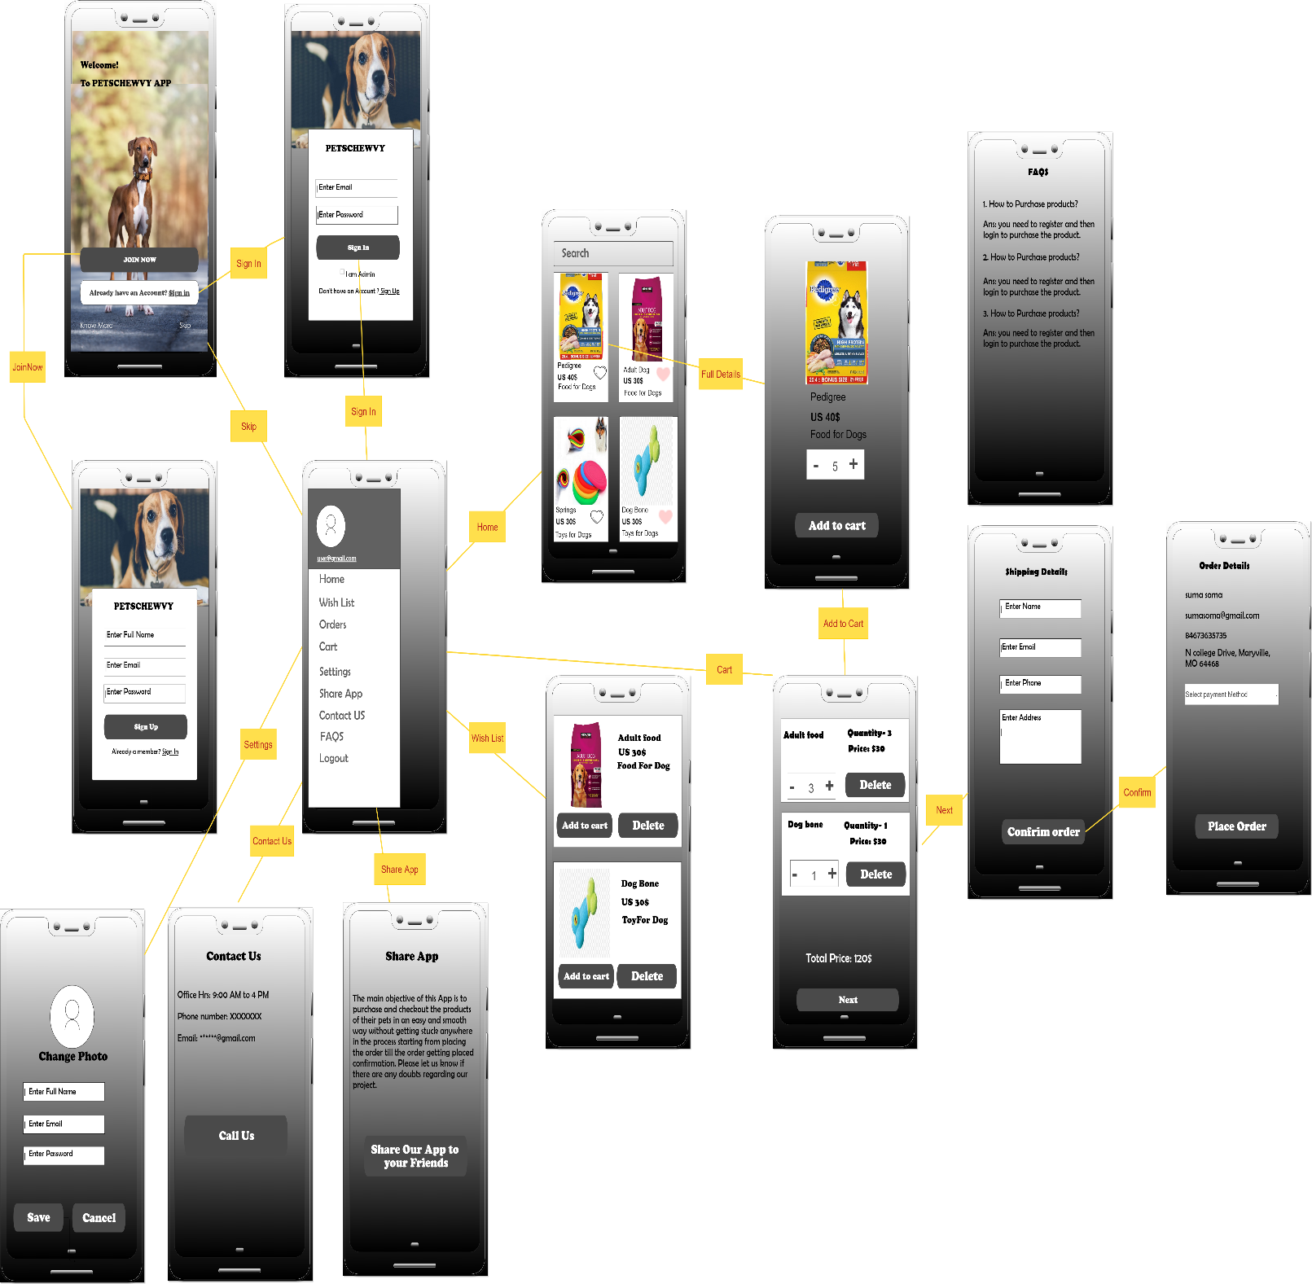

# Admin’s Flow

