“CRICKET PLAYERS DATA ANALYSIS REPORT”

1.Introduction:
This project analysis cricket players data from around the world. The dataset contains 472 players with information about their batting hand, bowling skill, date of birth and country.

2.Data Description:
The dataset contain 5 columns: Player Name, Date of Birth, Batting Hand, Bowling skill and Country. Total 472 players from 8 countries are included.

3.Steps Performed :
-Removed duplicate records
-Removed blank rows
-Cleaned inconsistent data
-Created Pivot Table
-Built Dashboard with 3 charts

4.Dashboard Screenshorts:

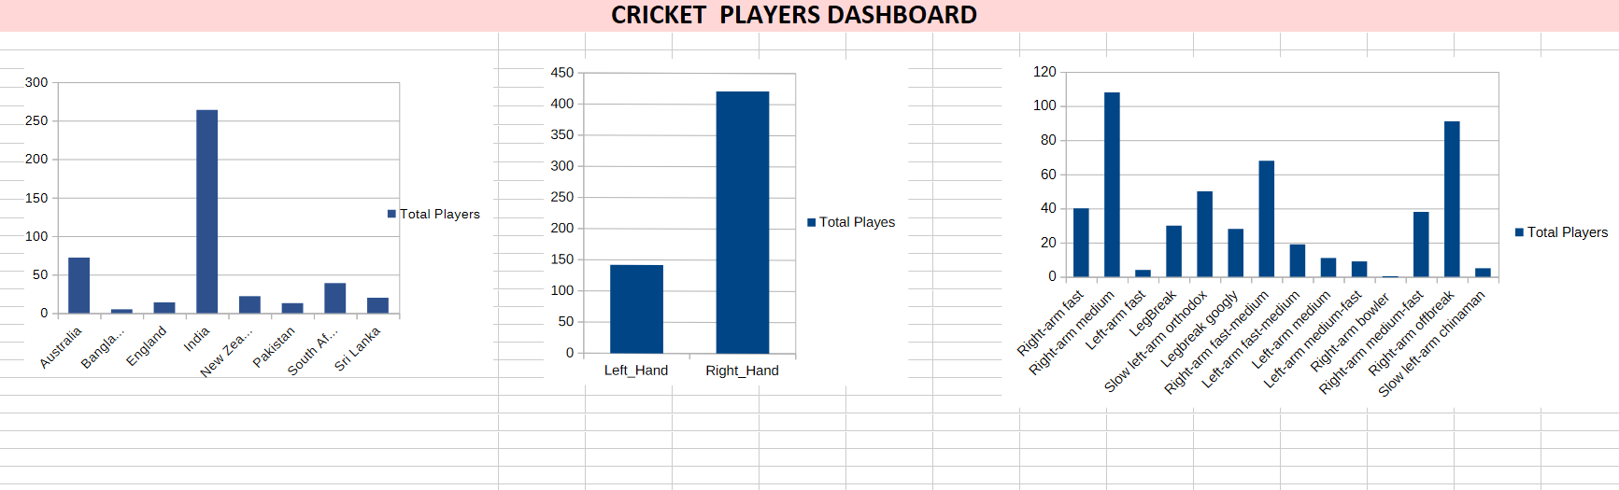
5.Insights:
India has the highest number of players with 264 players. Australia is second with 72 players. Right Hand Batsmen are more than Left Hand batsmen. Right-am medium is the most popular bowling skill.

6.Business Recommendation:
Focus on developing Left Hand batsmen. India should be primary market for cricket tournaments. Bangladesh and Pakistan need more players development programs.

7.Conclusion:
This analysis of 472 cricket players reveals that India dominates world cricket with 55% of total players. Right Hand batting and Right-arm medium bowling are the most common styles worldwide.

